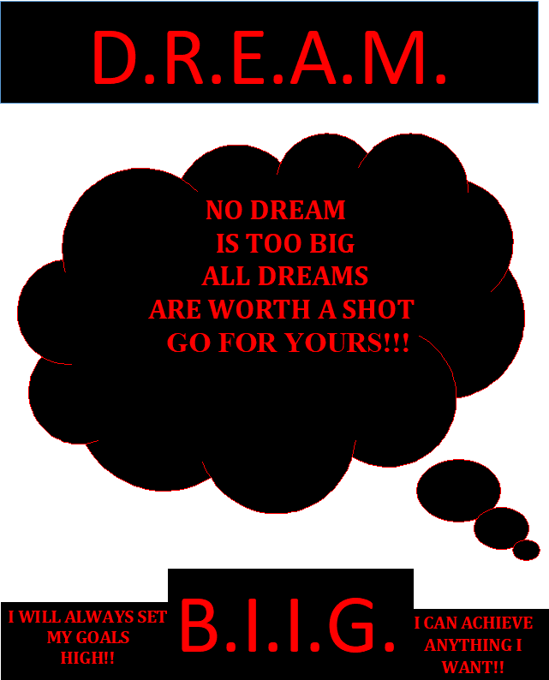

D.R.E.A.M. B.I.I.G.

Delivering Real Effective Alternative Methods For Black Youth Involved In Gun Violence Portland Gang Outreach Program

Syllabus

Introductions

  - Facilitator Intro
  - Each Participants Intro
  - Icebreaker (What do you want your future to look like?)

Class Objectives:

Introduce ourselves and create an ice breaker

  - Have participants understand the purpose of the program
  - Ask each participant why they joined a gang?
  - Collectively create class conduct guidelines 10 Minutes
  - Individual definition of gang culture 15 Minutes
  - Homework: Write about how you would feel if someone killed your child (minimum 1 and a half pages)

Part 1 – Black History

  - Slavery
  - Blacks who fought for our human rights
  - MLK Jr., Black Panthers, Malcolm X and many others
  - Where we are today

Class Objective:

Understanding Black History so our youth can see how long our people have been fighting hard for our Human Rights. We want youth to know that our ancestors are turning over in their graves because today – we are

killing each other over revenge killings and many of them died so WE can have a better life. At some point we have to STOP.

Part 2 – Insight and Understanding About Portland Oregon’s Street Gang Culture

  - Who are involved in gang-related activity and what is the history of these gangs?
  - Misplaced Value
  - Lack of Effective Leadership

Class Objective:

Look inside Portland’s Gang Culture.

Part 3 – Identifying The Root Cause That Can Lead African American Youth Toward Gang Affiliation

  - Parenting
  - Mentorship
  - Effective Leadership
  - Unity

Class Objective:

Provide parenting skills. Show the purpose of mentorship. Create effective leaders and show we are stronger with unity.

Part 4 – Recognizing, Understanding, And Dealing With The Effects That Are Often Associated With Gang Affiliation

  - Trauma (PTSD), etc.
  - Murdered (Photos of Gang Related Homicides)
  - Drug and Alcohol Addiction
  - Law Enforcement Harassment/Statistics
  - Mass Incarceration

Class Objective:

Reveal that trauma must be treated. Show possibilities that can come from gang banging. Treat drug and alcohol addictions. Discuss law enforcement harassment/statistics and why there is mass incarceration in American.

Part 5 – Traumatic Effects of Being Exposed To Gang Culture

  - Trauma
  - PTSD, Depression, etc.
  - Psychological Evaluation
  - Therapy /EMDR

Class Objective:

Learn how trauma mental disorders affect us, provide psychological evaluations for each participant and therapy to reprocess the trauma sustained through natural means and very little, if any, medication.

Part 6 – Cognitive Behavior Therapy

  - Trauma-Focused Cognitive Behavior Therapy
  - Family Functional Therapy
  - MultiSystemic Therapy
  - Multidimensional Treatment Foster Care
  - Racial Trauma Therapy

Class Objective:

Our aim is to provide several cognitive and behavioral psychotherapies that treat defined psychotherapies using evidence based teaching and strategies.

Part 7 -- Financial Literacy

  - The Importance of Financial Literacy
  - Financial Literacy Mitigates Criminal Activity
  - Investment Strategies In Black communities
  - Blacks Can Achieve Economic Empowerment
  - Setting Goals

Class Objective:

We want youth to know that financial literacy is important to know. With financial literacy youth can create businesses and make money legitimately, without risking their life or getting a prison sentence. It’s imperative that youth understand that we need economic empowerment so can invest in our communities, and we can do this by setting goals and

conquering them one goal at a time until we reach our ultimate goals. Goals provide direction.

Part 8 – Business Mindset

  - Acquiring a Business Mindset
  - Investment Account In Our Businesses
  - Investing In Income-producing Assets/Not Liabilities
  - The importance of Separating Assets
  - Teaching Our Youth To Be Business Minded

Class Objective:

Part 9 -- Recreating Yourself

  - Recreating Yourself
  - Identify Your WHY
  - Legacy

Class Objective:

Getting rid of old thoughts and habits and replace them with new thoughts and habits. Know what you are working towards and WHY you are doing what you’re doing. Create the legacy you want to leave behind. We only have one life to live so make BOSS MOVES.

Part 10 -- Overview and Graduation

  - Presentation
  - Parent(s) Thoughts
  - Scholarship Awarded

Class Objective:

Have the youth summarize what they’ve been through in life, speak abut what they learned from D.R.E.A.M. B.I.I.G., what they want for their future, and how do they feel about all they have learned from being a participant for D.R.E.A.M. B.I.I.G.

D.R.E.A.M. B.I.I.G.
Delivering Real Effective Alternative Methods For Black Youth Involved In Gun Violence

PORTLAND GANG OUTREACH PROGRAM

INTRODUCTION
Dwayne McClinton and Aaron Gee, created this gang prevention program called DREAM BIIG (Delivering Real Effective Alternative Methods For Black Youth Involved In Gun Violence) while in prison because we saw all the gun violence the News and wanted to help the City of Portland combat gun violence. We are well respected in the gang culture and have a lot of influence and WANT to assist the Portland community and other cities across the country with our program. We plan to start the first chapter in Portland.

The nonprofit will cover:

- Black History
- Insight and Understanding About Portland, Oregon’s Street Gangs
- Identify Roots Causes That Lead Youth Towards Gang Affiliation
- Recognizing, Understanding, And Dealing With The Effects That Are Often Associated With Gang Affiliation
- Traumatic Effects of Being Exposed To Gang Culture
- Cognitive Behavior Therapy (CBT)
- Financial Literacy
- Business Mindset
- Recreating Yourself
- Overview and Graduation Programs:
- Black History
- Business Mindset
- Cognitive Behavior Therapy (CBT)
- Early Childhood Home Visitation
- Effective Leadership/Mentors
- Family Functional Therapy (FFT)
- Financial Literacy Program
- Multidimensional Treatment Foster Care (MTFC)

- Multisystemic Therapy (MST)
- Racial Trauma Therapy
- Trauma-Focused Cognitive Behavior Therapy
- Parenting Skills and Family Relationship

What will make our nonprofit unique is we will only have respectable former gang members hired. We know the importance of having well respected former gang members to share their thoughts and experiences regarding the gang culture. The youth today will not listen to someone that’s not respected, or someone that they cannot relate to.

At DREAM BIIG our mission is engendering change within the culture of the streets. It isn’t only our goal, it’s a social obligation. An obligation that D.R.E.A.M B.I.I.G is willing to take on.

Delivering real effective alternative methods for black youth involved in gun violence to communities that have been plagued for decades by gangs, drugs, and guns is our sole focus.

For too many years communities of color have demanded solutions to this outer- city epidemic of gang and gun violence, but instead of regaining a sense of safety and solace back to our neighborhoods gun violence continue to perpetuate.

Due to over-policing, racism, and the planting of evidence, has lead to mass- incarceration. All of the far-reaching affects that have come with implementing these inhumane and overt racist policies have put the black communities in disarray by these indescribable under-achievements that we must rectify.

However, money is still being funneled into policing knowing it hasn’t decreased gang and gun violence in no way, shape, or form. We need to be investing more money into Nonprofit organizations in black communities that’s designed to combat gang and gun violence. We need to start educating the black community so they can have more tools to utilize as they develop into adults and beyond so we can create successful young entrepreneurs, business owners, community leaders, and most importantly, establish unity.

The solution is bigger than locking black youth up for the remainder of their lives for a mistake. Mistakes are meant to be learned from. If we continue to disregard the humanity within a person and discard him or her like a piece of garbage, that doesn’t teach them anything other than thinking society view them as being worthlessness.

It is imperative that as a community we identify, study, and then gather as much knowledge and understanding that we can about the underlining forces which seem to pull our youth into a life of crime, chaos, and destruction. We must vigorously and

aggressively attack those underlining forces into submission and then replace them with constructive and productive alternatives.

For example: We believe that poverty is one of the strongest underlying forces that pull black youth into a life of crime. Therefore, poverty has to be replaced with something tangible in an intellectual sense. That’s why we have included a financial literacy and business programs in our nonprofit. We want to teach and show the youth from improvised backgrounds how to create multiple streams of legitimate income so they can provide better lives for their family and themselves.

We must replace ignorance with intelligence by re-programming our youth how to become critical thinkers instead of moving through life recklessly without educational goals or a plan. We must replace their bad habits with good ones; especially the youth who are deeply immersed within the gang culture, where criminal behavior is considered productive and healthy. If these unproductive and unhealthy behaviors aren’t replaced with behaviors that are predicated on positivity, those very same individuals won’t ever have the luxury of enjoying a normal and happy life. We have to change this narrative.

Our youth should have a life that’s free from premature death, debt, destitution, and total destruction. As a community, we must never become complacent with allowing our youth to accept a lifestyle filled with unnatural and horrific experiences and unspeakable tragedies.

We cannot sit back and watch our children, as precious as they are, to continue murdering one another. Guns have become the primary option for black youth to use as a means to solving something they feel is a problem.

Let us ask you a serious question.

Have you ever seen or even heard of murder being utilized as a successful tool to definitively mitigate or prevents problems?

In response to this alarming and socially dysfunctional problem of gang and gun violence, prisons have become the primary, and in many cases the only solution to this socioeconomic and sub-cultural issue that has been transpiring out of control throughout communities of color.

Allow me to pose another question.

When have you ever seen or even heard of prison official actually taking the step to rehabilitate the prisoners in their custody for the specific crimes they are in prison for, whether it’s for gang violence or other non gang related crimes?

Prison officials need to create programs for each individual crime that people come to prison for. This is a no brainer. How can prison officials say that prison is about

rehabilitation when they haven’t even taken the steps to create programs for each individual crime?

If someone is in prison for rape, then that person need to be in a program that’s tailored specifically for the crime. The same thing goes for robbery, murder, attempted murder, a gang related program, etc. This has NOT been done and it’s a shame. Why? It’s a question that need to be posed to prison officials and legislators.

A part of our mission is to get programs for specific crimes introduced into prisons across this country. Somebody have to do it.

Our DREAM is BIIG so with the support of our entire community, D.R.E.A.M B.I.I.G can and will shift the culture of the streets back into a sane and safe environment, one street, and one community at a time. We want our youth to remember and never forget to always… DREAM BIG!

DEDICATION:

Artist: Tupac
Album: Until The End of Time
Track: They Don’t Give A Fuck About Us

To all State Legislators, City and County Officials, Department of Corrections, Communities of Color, Gang Bangers, Mothers and Fathers who have loss a child or children in the streets, Kids who loss Fathers and Mothers to gang and gun violence…LISTEN to the words of Tupac Amaru Shakur and his friends (family) The Outlawz. This is how a lot of our youth feel.

*****
“Due to public safety and to seek unity in our communities, we are giving this manual to Portland, Oregon and other communities across this nation, and abroad, that’s dealing with gun violence in their respective community in hopes that the contents herein can bring peace to communities. You are free to use it as you see fit.”

- Dwayne McClinton and Aaron Gee.

D.R.E.A.M. B.I.I.G. Program

CONTENTS

12 Month Program

- Black History

- Insight and Understanding About Portland, Oregon’s Street Gang Culture

- Identifying The Root Cause/Parenting

- Recognizing, Understanding, And Dealing With The Effects That Are Often Associated With Gang Affiliation

- Traumatic Effects of Being Exposed To Gang Culture

- Cognitive Behavior Therapy (CBT)

- Financial Literacy

- Business Mindset

- Recreating Yourself

- Overview and Graduation

PART 1 BLACK HISTORY
What is a Slave?
What is a slave? A slave is a person owned by another person, has no rights and works without pay. The word “slave” was originally applied to a European ethnic group. According to the encyclopedia, it came from “Slav,” a Russian people captured by the Germans.

Other sources say the word “Slav” originally meant “the people of glory” and suggested some kind of a religious identification or purification. In any event, the last enslavement of European whites occurred in the 14th century, when Arabs held the Mamelukes in captivity. Ancient slavery was an individual matter, resulting from a war, religious differences, or personal indebtedness. But, in any of these instances, enslavement was based on a power relationship between the slave and the master that allowed the slave to earn his freedom eventually. In ancient slavery, intermediaries such as the Catholic Church protected the rights and property of the enslaved and required the master to pay “freedom dues” to the slave upon his release.

The modern enslavement of blacks was different. Black slavery was a new socioeconomic system. Unlike all previous forms of enslavement, black enslavement was based upon the “accident of skin color.” Further, for the first time in the history of mankind, all formal religions, nations, and ethnic groups collectively moved against and supported the enslavement of black people. These first time occurrences against blacks at the time the rest of the world was espousing the concepts of freedom, liberty, and equality for all men, led to enslavement being called a “peculiar institution.”

Perhaps another reason it was called a peculiar institution was because it marked the beginning of Europe’s social engineering of the black race. Before the Diaspora, or scattering of African blacks, Europeans considered nations became slave traders and began to enjoy the wealth that it produced, Europeans came to classify Africans as stupid, uncivilized and less than human. They used all reasoning at their disposal to justify why whites treated blacks like no other human beings on earth.

First Black Born in America Was Not a Slave
In 1619, an unknown Dutch frigate brought 20 blacks from Africa to Jamestown, Virginia, where sailors traded them into indentured servitude in exchange for food, water, and ship supplies. By early 1624, the first black child, William, was born to a couple, Anthony and Isabella Tucker, in Elizabeth City, Virginia.

Shortly after William’s birth, the Tuckers took him back to Jamestown to be baptized in the local Church of England. Thus William, the first African born in an American colony, had the double first “honor” of also being the first black to be baptized.

Equally noteworthy is the fact that he was born at a time when neither he nor his parents were considered slaves. After the Tucker’s arrived on the Dutch warship, they traded into indentured servitude for approximately three to four years. By the time of William’s birth, they were out of servitude and intermingling with white immigrants just arriving in the colony. Formal slavery did not start in America for another 40 years after William’s birth, but records were not kept on blacks, so it is unclear what happened to William or the parents of the first black born in America.

Red summer
Ownership of land, property, and business’s isn’t a topic that is new to black people in America, we have been diligently vying for all of this and more for centuries, however, there have always been mechanism put in place to stagnate or sabotage the economical prosperity, all black people dream of achieving someday.

However, no matter how high we climb the financial ladder that is afforded by the fruits of capitalism, white supremacy and its filthy hands always in some form or another, figures out an ingenious way to grab a hold to us and relegate us back to a position of servitude and poverty.

For example: before we ever heard of the destruction and atrocities that took place at the famous “ Black Wall Street” in Tulsa, Oklahoma, 1921. Two years prior to that, in 1919 there was an even more infamous and disturbing historical event that transpired throughout America known as “ The Red Summer,” or as I prefer to say “The Red Purge.”

The year of 1919 was literally a red summer. Black people blood was shed and spelt across this entire country, in unimaginable ways, this racist driven blood lust directed toward black people was often rooted within the soil of white’s anger, and envy toward blacks, compounded with resentment at black people’s ability to

overcome adversity and hardship and still be resilient enough to comeback from any given setback, re-create another blueprint and re-attempt to ascend to the same economic and financial status as our white counterparts.

This 20th century race-related purge was indiscriminate; the rod of racism spared no one, of African descent: Throughout America in 1919, an explosion of race-related riots occurred. Below are a few dates and locations, where black American lives were brutally taken, and black businesses, and other property was destroyed beyond repair.

This list is primarily, but not exclusively, based on George Edmund Haynes' report, as summarized in the New York Times (1919).
January 22 [a] Bedford County, Tennessee, February 8 Blakeley, Georgia [a] [b], March 12 Pace, Florida, March 14 Memphis, Tennessee [a] [c] April 10 Morgan County, West Virginia April 13 Jenkins County, Georgia April 14 Sylvester, Georgia April 15 Millen, Georgia [d] May 5 Pickens, Mississippi May 10 Charleston, South Carolina May 10 Sylvester, Georgia [a] [e] May 21 El Dorado, Arkansas May 26 Milan, Georgia May 29 New London, Connecticut May 27–29 Putnam County, Georgia May 31 Monticello, Mississippi [a] June 13 Memphis, Tennessee[a] June13 New London, Connecticut [f] June 27 Annapolis, Maryland [g] June 27 Macon, Mississippi Dublin, Georgia July 3 Bisbee, Arizona July 5 Scranton, Pennsylvania [h] July 6 July 7 Philadelphia, Pennsylvania July 8 Coatesville, Pennsylvania July 9 Tuscaloosa, Alabama [a] [i] July 10–12 Longview, Texas [35] July 11 Baltimore, Maryland July 15 Louise, Mississippi July 15 Port Arthur, Texas July 19–24 Washington, D.C. July 20 New York City, New York July 21 Norfolk, Virginia July 23 New Orleans, Louisiana [a] July 23 Darby, Pennsylvania July 26 Hobson City, Alabama [j] July 27 – August 3 Chicago, Illinois July 28 Newberry, South Carolina [k] July 31 Bloomington, Illinois a] July 31 Syracuse, New York July 31 Philadelphia, Pennsylvania August 1 Whatley, Alabama August 3 Lincoln, Arkansas August 4 Hattiesburg, Mississippi [a] August 6 Texarkana, Texas [36] August 21 New York City, New York August 22 Austin, Texas August 27–29 Ocmulgee, Georgia August 30 Knoxville, Tennessee August 31 Bogalusa, Louisiana September 10 Clarksdale, Mississippi September 28–29 Omaha, Nebraska September 29 Montgomery, Alabama October 1–2 Elaine, Arkansas October 1–2 Baltimore, Maryland October 31 Corbin, Kentucky November 2 Macon, Georgia November 11 Magnolia, Arkansas November 13 Wilmington, Delaware December 27, West Virginia.

As I conveyed earlier, the cause of most, but not, all violent race-related altercations and encounters were rooted in white’s resentment and envy toward black people’s habitual tenacity to continue chasing the American dream at any all cost.

However, the underlining forces that drove the already growing racial tensions in 1919, was attributed to defending the honor of white women whom were so-called sexually assaulted by black males and governmental fueled propaganda that was spread through mass- news publications about black males coming back from WW1 and conveying bolshevism to America and as a result, bringing socialism and communism to American soil.

Racial unrest, is one of the many symptoms of economic instability, for instance, once one group begins to believe that financial security can’t for whatever reason be

obtained by one’s own labor or intelligence, the looming threats of poverty start to seem like a reality, than that particular group, will begin to point fingers and place blame on an opposing group for how the economy operates.

For instance, if resources are scares amongst two different opposing groups with long histories of clashing and violence, competition can become extremely dangerous when these specific groups struggle to vie for financial opportunity, like employment and housing.

Below are excerpts of articles of events that transpired through out the Red Summer, taken from wikipedia that will show the correlation between white’s resentment toward black’s trying to become financially sound which lead to most of the race-related violence that was unleashed upon black people throughout the Red Summer:

“The anti-black riots developed from a variety of post- World War I social tensions, Generally related to the demobilization of both black and white members of the United States Armed Forces following World War I; an economic slump; and increased competition in the job and housing markets between ethnic European Americans and African Americans.[4] The time would also be marked by labor unrest, for which certain industrialists used black people as Strikebreakers, further inflaming the resentment of white workers.”

And:

“With the mobilization of troops for World War I, and with immigration from Europe cut off, the industrial cities of the American Northeast and Midwest experienced severe labor shortages. As a result, northern manufacturers recruited throughout the South, from which an exodus of workers ensued. [5]

By 1919, an estimated 500,000 African Americans had emigrated from the Southern United States to the industrial cities of the Northeast and Midwest in the first wave of the Great Migration (which continued until 1940). African-American workers filled new positions in expanding industries, such as the railroads, as well as many existing jobs formerly held by whites.

In some cities, they were hired as strikebreakers, especially during the strikes of 1917. This increased resentment against blacks among many working-class whites, immigrants, and first-generation Americans.”

Here is an additional excerpt out of the same wikipedia article as the other’s above, to add emphasis on my point about the correlation between white’s resentment toward black prosperity and how, when those are both intertwined with one transformed into race-related violence directed at black people.

“In the summer of 1917, violent racial riots against blacks due to labor tensions broke out in East St.Louis, Illinois and Houston, Texas. [6] Following the war, rapid demobilization of the military without a plan for absorbing veterans into the job market, and the removal of price controls, led to unemployment and inflation that increased competition for jobs. Jobs were very difficult for African Americans to get in the South due to racism and segregation.”

The red summer was a precursor to Black Wall Street and a harbinger for all of the race-related riots and violent clashes to come.

It’s currently 2021, and as black people we’re still fighting for our right to be recognized and treated as human beings, we’re still fighting for equality and financial and economical equity, we’re still fighting the powers that be, for continuing to allow the police a shield of safety from punishment for being indifferent to our way of life and beating and killing us because their blatant ignorance of it.

The way black people have fought and continue to fight, reminds me of an essay
W.E.B Dubois published “ returning soldier” in may following the first serious racial incidents:

“We return from the slavery of uniform, which the world's madness demanded us to don to the freedom of civil garb. We stand again to look America squarely in the face and call a spade a spade. We sing: This country of ours, despite all its better souls have done and dreamed, is yet a shameful land… We return. We return from fighting. We return fighting.”

Although, 1919 was 122 years ago, the similarities aren’t really far apart, except for the hysteria driven propaganda governmental induced white on black race- related riots spreading like wildfires across this country, we still see vestiges of 1919.

For instance, even though, today black neighborhoods and black business districts aren’t being physically and literally destroyed, by white rage. Black property and everything that encompass it, is symbolically, being destroyed instead by means of gentrification, exuberant rental fees, evictions, forced foreclosures, unknown, unethical and racially designed city and building ordinances that target black residence for a number of minuscule reasons, and extreme over policing with racist white officers who swore to protect and serve our communities but instead, serve to protect their own interest at all cost.

Below, are examples that I’ve taken out of a pamphlet on Oregon Black History, by Walidah Imarisha, of black neighborhoods and black own businesses that were affected by the things that I’ve explained above:

1906: The golden west hotel was opened by black businessman W.D. Allen, and was the center of a thriving black-owned business district. In the early 1900’s, the area around the golden west hotel and union station was home to most of the city’s 1,000 black residents.

The golden west was designed primarily to serve the black railway porters, cooks, barbers and waiters recruited by the major railroads, who were denied accommodations in Portland’s white-owned hotels.

1919: The Portland realty board’s code of ethics mandated real estate agents not to sell to individuals whose race would “ be determined to lower property values in that neighborhood,” and was later changed to specifically reference black and Asian people.

This practice of only allowing people of color to live in small segregated areas of cities by not selling to them and banks not approving loans is called redlining.

1943: Vanport city was a hastily constructed city of public housing between Portland and the Columbia River, created to house workers at wartime Kaiser shipyards. Vanport become the second largest city in Oregon, with a population that was 40% black, and the largest U.S. public housing project. Blacks from all over the country, but especially the south, were heavily recruited to work in the shipyards, but were barred from joining the segregated unions. Blacks in Portland were not allowed to unions until the 1960’s.

1948: The Columbia River flooded and the dike protecting Vanport broke. Vanport was especially vulnerable to flooding, since it was built on reclaimed lowlands along the Columbia River. It was also vulnerable to flooding because the hasty construction was shoddy and never meant to be permanent.

15 were killed, the entire city was underwater, and nearly 17,000 people, disproportionately black, were left homeless.

1956: after Vanport flooded, black people were redlined into the Albina neighborhood. In 1960, 4 out of 5 black people lived in this thriving close-knit community.

In 1956, voters approved construction of memorial coliseum in the Eliot neighborhood, ensuring the destruction of more than 450 Albina homes and businesses.

Federal officials also approved highway construction funds that would pave interstate 5 and 99 right through hundreds of homes and storefronts, destroying over 100 more housing units in south Albina.

1970: The black community protested the expansion of Emanuel hospital, which demolished thousands of homes in Albina’s traditional black community. Residents were given 90 days to move out; homeowners were given a maximum $15,000 payment, and renters $4,000.

Emanuel hospital’s expansion was funded by federal money earmarked for “ urban renewal.” The money ran out after the homes were demolished, but before construction finished. The expansion took decades to complete.

1980: Property values in the Albina district fell so low in the 1980’s, houses were assessed at half or less of their original value.

Rampant unemployment swept the nation as companies moved production overseas to exploit cheaper labor. Hardest hit were communities of color. Some neighborhoods had 60 to 80% unemployment.

Into the economic collapse stepped drug dealing as a means of economic survival, and self-medication. Combined with gangs, originally formed for protection, the result was intercine warfare.

1981: Two Portland police officers, Craig ward and Jim Galloway, tossed four dead opossums in front of the burger barn, a black-owned popular soul food restaurant. Many in the black community viewed this as a racist hate crime, only one of numerous reported to have been committed by Portland police.

The two officers were fired by their commander, but reinstated two months later during arbitration. This provoked a large outcry from the black community, culminating in demonstrations and protest.

1990: During this time, the city of Portland put effort into the revitalizing of Albina. In response to complaints on neighborhood activist and recommendations of a citywide task force report on abandoned

housing, the city began using building code enforcement to confront the extreme level of housing abandonment, and begin a process of urban renewal.

1999: Black owned 36% fewer homes, while whites had 43% more than a decade earlier. Whites bought homes, displacing many low-income black families to more affordable far-flung areas.

The events that occurred in 1919’s red summer left so many different kinds of negative financial implications upon black people., that some would argue that the damage from it is irreparable.

Millions of dollars were estimated to lost, however never returned to those whom were affected by the devastation. Imagine what a million dollars would translate into today?

Imagine if we were to re-build what was destroyed and put a halt to the current high rates of black impoverishment, below are a few excerpts from the same red summer article that I’ve been referencing courtesy of wikipedia, about the destruction of property and the devastating financial effects it left.

The above references are for emphasis, only to show what structures were put in place to restrict us from obtaining certain opportunities that whites were afforded and to also show how these racially predicated obstacles snowballed throughout the decades into the avalanche it currently is the city of Portland today.

Early July: A white race riot in Longview, Texas led to the deaths of at least 4 men and destroyed the African-American housing district in the town.

April 13: In rural Georgia, the riot of Jenkins County led to 6 deaths, as well as the destruction of various property by arson, including the Carswell Grove Baptist Church, and 3 black Masonic lodges in Millen, Georgia.

Beginning on July 27, the Chicago race riot marked the greatest massacre of Red Summer. Chicago's beaches along Lake Michigan were segregated by custom. When Eugene Williams, a black youth, swam into an area on the South Side customarily used by whites, he was stoned and drowned. Chicago police refused to take action against the attackers, thus young black men responded with violence, lasting for 13 days, with the white mobs led by the Ethnic Irish. White mobs destroyed hundreds of mostly black homes and businesses on the South Side of Chicago.

The State of Illinois called in a militia force of 7 regiments: several thousand men, to restore order. The resulting casualties of the riots include: 38 fatalities (23 blacks

and 15 whites); 527 injured; and 1,000 black families left homeless. Other accounts reported 50 people were killed, with unofficial numbers and rumors reporting even more.

August 30–31, the Knoxville Riot in Tennessee broke out after the arrest of a black suspect on suspicion of murdering a white woman. Searching for the prisoner, a lynch mob stormed the county jail, where they liberated 16 white prisoners, including suspected murderers. African-American business district, where they fought against the district's black business owners, leaving at least 7 dead and wounding more than 20 people. From September 28–29, the race riot of Omaha, Nebraska erupted after a mob of over 10,000 ethnic whites from South Omaha attacked and burned the county courthouse to force the release of black prisoner accused of raping a white woman. The mob lynched the suspect, Will Brown, hanging him and burning his body. The group then spread out, attacking black neighborhoods and stores on the north side, destroying property valued at more than a million dollars.

In most instances, attacks consisted of white-on-black violence. However, numerous African Americans also fought back, notably in the Chicago and Washington, D.C. race riots, which resulted in 38 and 15 deaths, respectively, along with even more injuries, and extensive property damage in Chicago. Still, the highest number of fatalities occurred in the rural area around Elaine, Arkansas, where an estimated 100–240 black people and five white people were killed—an event now known as the Elaine massacre

If our duty is to live and die in the for neighborhoods and communities we no longer own or even live in for that matter, or for the O.G’s who are resting in peace or for the homies doing life for the set. What is our duty to our ancestors whom lost their homes, businesses, and lives all because they wanted to secure, and lives all because they wanted to secure a better future for those to come?

The duty to our ancestors is greater than the one we’ve picked up in the streets. What is more honorable the sacrificing ourselves for something greater than us, nothing!

Those before us put it all on the line, just so we can enjoy the freedoms that we more than often take for granted. Out of the respect for those that paved the way. DO NOT ALLOW THEIR SACRIFICES TO BE IN VAIN.

WE MUST RE-THINK, RE-BUILD, AND RE-INVEST!

Black Wall Street
By Josie Pickens on May 31, 2013

Black Wall Street was in Greenwood, Oklahoma, a suburb of Tulsa, was the type of community that African Americans are still, today, attempting to reclaim and rebuild. Black Wall Street was modern, majestic, sophisticated and unapologetically Black. Tragically, it was also the site of one of the bloodiest and most horrendous race riots (and acts of terrorism) that the United States has ever experienced.

Today marks ninety-two years since as many as 300 African Americans lost their lives and more than 9,000 were left homeless when the small town was attacked, looted and literally burned to the ground beginning in 1921. It’s impossible, however, to realize what was lost in Greenwood, which was affectionately known as “Black Wall Street.”

The Greenwood community, where Black Wall Street existed, seems almost imagined when we examine it through a historical lens. The oil booms of the early 1900’s had many moving to Tulsa for a shot at quick economic gains and high life, and African Americans hoped to prosper from the new industry as well. Tulsa, the area created entrepreneurial opportunities for themselves, which housed an impressive business center that included banks, hotels, cafes, clothiers, movie theaters, and contemporary homes. Greenwood residents enjoyed many luxuries that their White neighbors did not, including indoor plumbing and a remarkable school system that superiorly educated Black children.

It was pure envy, and a vow to put progressive, high achieving African Americans in their place that would cause the demise of the Black Mecca many called “Little Africa,” and its destruction began the way much terrorism, violence and dispossession against African Americans did during that era. A young White woman accused a young Black man of attempted sexual assault, which gave local mobs and White men acting as police just cause to invade the unsuspecting community. On the malevolent and horrifying attack, Linda Christenson writes the following:

“The term “race riot” does not adequately describe the events of May 31-June 1, 1921 in Greenwood…In fact, the term itself implies that both blacks and whites might be equally to blame for the lawlessness and violence. The historical record documents a sustained and murderous assault on black lives and property. This assault was met by a brave but unsuccessful armed defense of their community by some black World War I veterans and others.

During the night and day of the riot, deputized whites killed more than 300 Africans Americans. They looted and burned to the ground 40 square blocks of 1,265 African American homes, including hospitals, schools, and churches, and

destroyed 150 businesses. White deputies and members of the National Guard arrested and detained 6,000 black Tulsans who were released only upon being vouched for by a white employer or other white citizen. Nine thousand African Americans were left homeless and lived in tents well into the winter of 1921.”

Recently, the mother of a Palestian activist friend of mine asked me why African Americans don’t fight harder for reparations. It was a difficult question to answer, but my most immediate response centered on the historical erasure of communities like Greenwood and the state-sponsored violence against African Americans that created its expiry. Even after slavery was abolished, any advancements towards the American dream, that Blacks paid most dearly to establish, was met with revulsion and terror, often from those whose legal obligation was to serve and protect. For that a debt is surely owed. Further, when we consider the deaths of those Black Tulsans that built Black Wall Street and the inevitable property loss that followed, we again see one example of many that proves how wealth inequities and disparities became a part of the substance of this nation-inequities and disparities that must be considered before we go blaming Black youth for the catastrophes this nation has endorsed.

- Josie Pickens is a cultural critic and educator.

MARTIN LUTHR KING JR.
“I’ve decided that I’m going to battle for my philosophy…I can’t make myself believe that God wants me to hate. I’m tired of violence…and I’m not going to let my oppressor dictate to me what method I must use.”

Martin Luther King Jr.
Mississippi, 1966
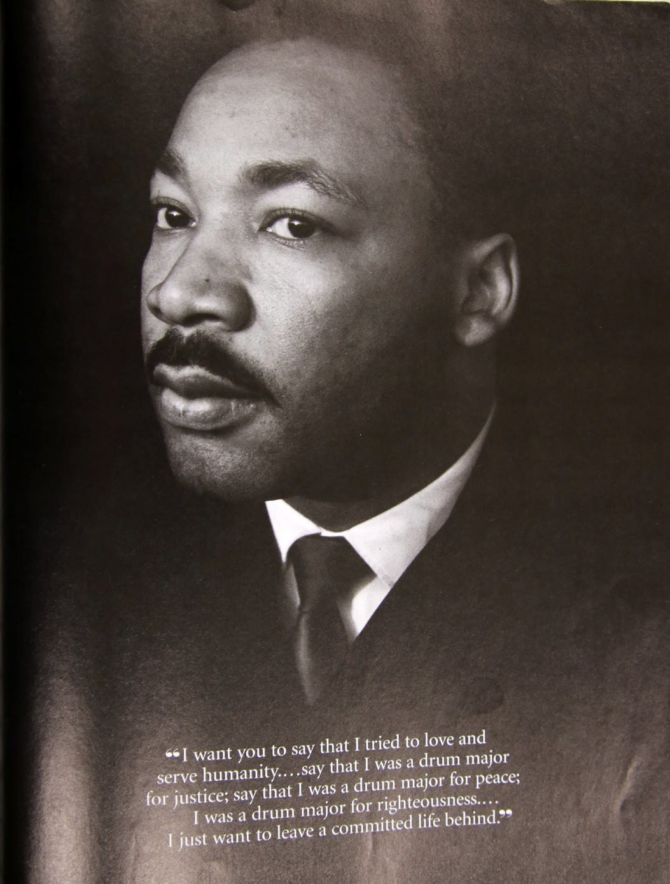

“I want you to say that I tried to love and serve humanity…say that I was a drum major for justice; say that I was a drum major for peace; I was a drum major for righteousness…I just want to leave a committed life behind.”

This was a man who fought for and put his life on the line for our Black race. He sacrificed his own life. Even though he said: “Like anybody I would like to live a long life…”

Martin Luther King Jr.
Memphis April 3, 1968.

Martin Luther King Jr. Memphis April 3, 1968.
In his speech at Ohio Northern University, MLK Jr. said something that many didn’t catch. He said:

“The important thing that America must realize id this: That at the same time that she refused to give the black man anything, she was giving away millions of acres of land in the West and the Midwest through an act of Congress. Not only did she give the land, she built land grant colleges to teach them to farm. She provided county agents to help them and to get them expert, to give them expertise in farming. But not only that, the nation provided low interest rates in later years so that they could mechanize their farms. Not only that, many of these persons are being paid today not to farm, and these are many of the persons who are telling the Negro that he should lift himself by his own bootstraps. A wonderful. (applause) I guess that it is all right to tell a man to lift himself by his own bootstraps, but it is a cruel jest to say to a bootless man that he ought to lift himself by his own bootstraps. Through centuries of denial, centuries of neglect, and centuries of injustice many, many Negros have been left bootless. This does not mean that we do nothing for ourselves. It does not mean that we should not amass our economic and political resources to reach our legitimate goals. It simply means recognizing, the nation recognizing, that it owes a great debt on the basis of the injustices of the past.”

Martin Luther King Jr. is pretty much saying that Blacks have been treated horribly wrong in this country, and many of us are bootless. So how can we lift ourselves by our bootstrap if we have no boots?

SUMMARY
He knew he was being targeted, but he never gave up the fight. He fought all the way to his death…for us. He was so powerful the government had him killed. See the photos below.

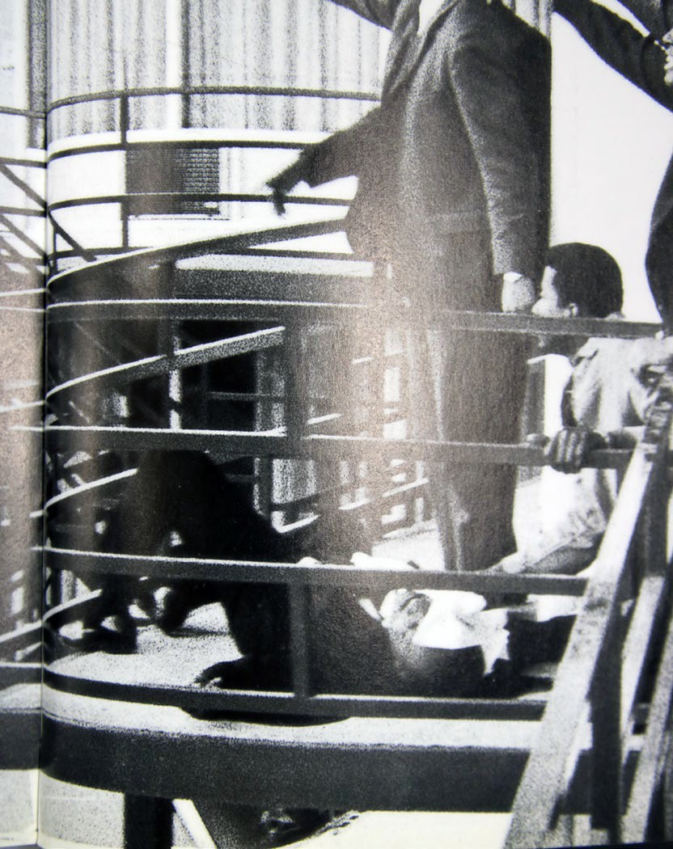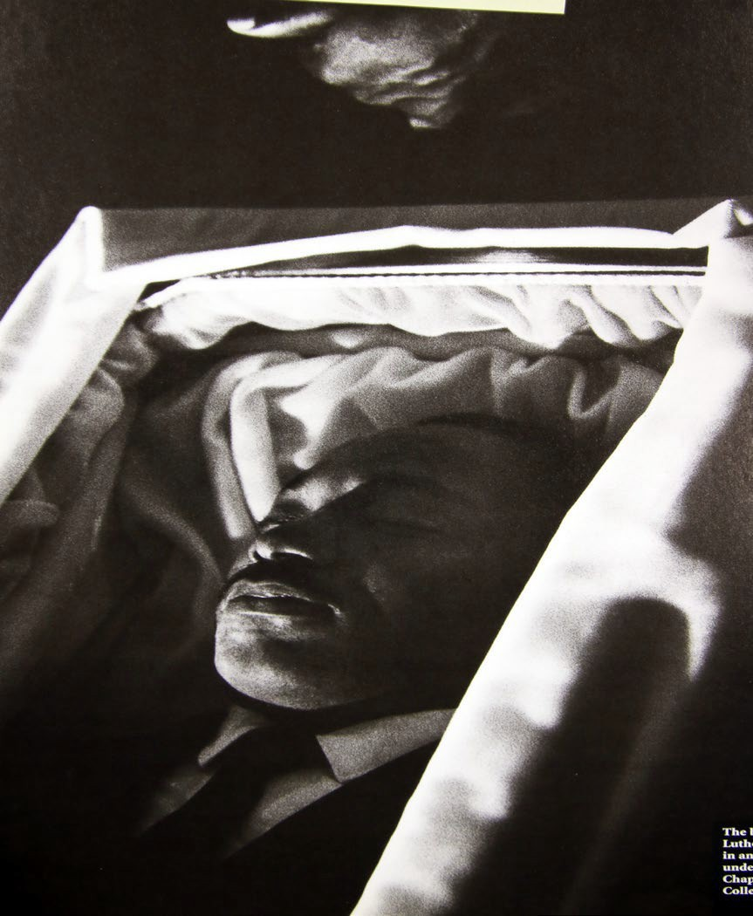

Tell me, do you think its right for us as a Black race to commit genocide when our ancestors fight so hard for our freedom, our rights? Millions of our people died and/or was murdered.

Now, we are killing our own people over revenge killings that will NEVER end if we don’t end it TODAY. We understand that many lives were loss…but how many more have to be loss?

So many parents have buried their child or children. Life process is supposed to be the other way around. Children are supposed to bury their parents due to old age/health conditions. A parent should never have to bury their children over a gang war from black on black violence.

It just baffles me how we came from going up against the government for our freedoms and rights, to killing each other over gang wars. Some how, some way, we have to STOP killing each other.

I will say this, after gang banging for so long, then actually began talking to Crips, I found out a lot of them are cool as hell. We hit it off, like we were real brothers. Once you quit banging then getting to know those who were once your rivals, you find out that they are cool people. But the gang crap is what kept us segregated. This is what the government does best, divide and conquer. That is why when Bloods and Crips call a truce, the police are the ones who will shot at or murder a rival to get the gangs to continue shooting at each other.

Now, we are killing our own people over revenge killings that will NEVER end if we don’t end it TODAY. We understand that many lives were loss…but how many more lives have to be loss?

We HAVE to turn all this killing each out around. We owe it to MLK, Malcolm X, and all the other Blacks that put in work in for us to have a better life. Their sacrifices should not be in vain.

Dr. Martin Luther King Jr. states that America need to recognize the transgressions it inflicted upon the Black race in this country for all the injustices it has done to our race. This includes the slavery of our ancestors, the hangings of our people, the brutal murders of our people, the raping of Black women, destroying the economic growth in Tulsa, Oklahoma, of Black Wall Street, and much more.

The Blacks in this country has had it the toughest out of all the races. We’ve been enslaved, beaten to death, hung, raped, tortured, and killed by racist whites and police.

Dr. Martin Luther King Jr. was right. We need to amass our economic and political resources, this is the only way for our race to give ourselves a chance to advance in life. Also we must teach this to our kid(s). Our kids must be prepared to take the reigns sometime in the future.

How can we tie up our bootstraps when we are bootless?

Reparations are DUE. America need to pay what it owes to the Black race. Our ancestors and the Blacks after them HELPED building this country. Our ancestors and those after them should not die in vain.

We must demand them the U.S. Government pay us what they OWE.

Oregon Black History 1805
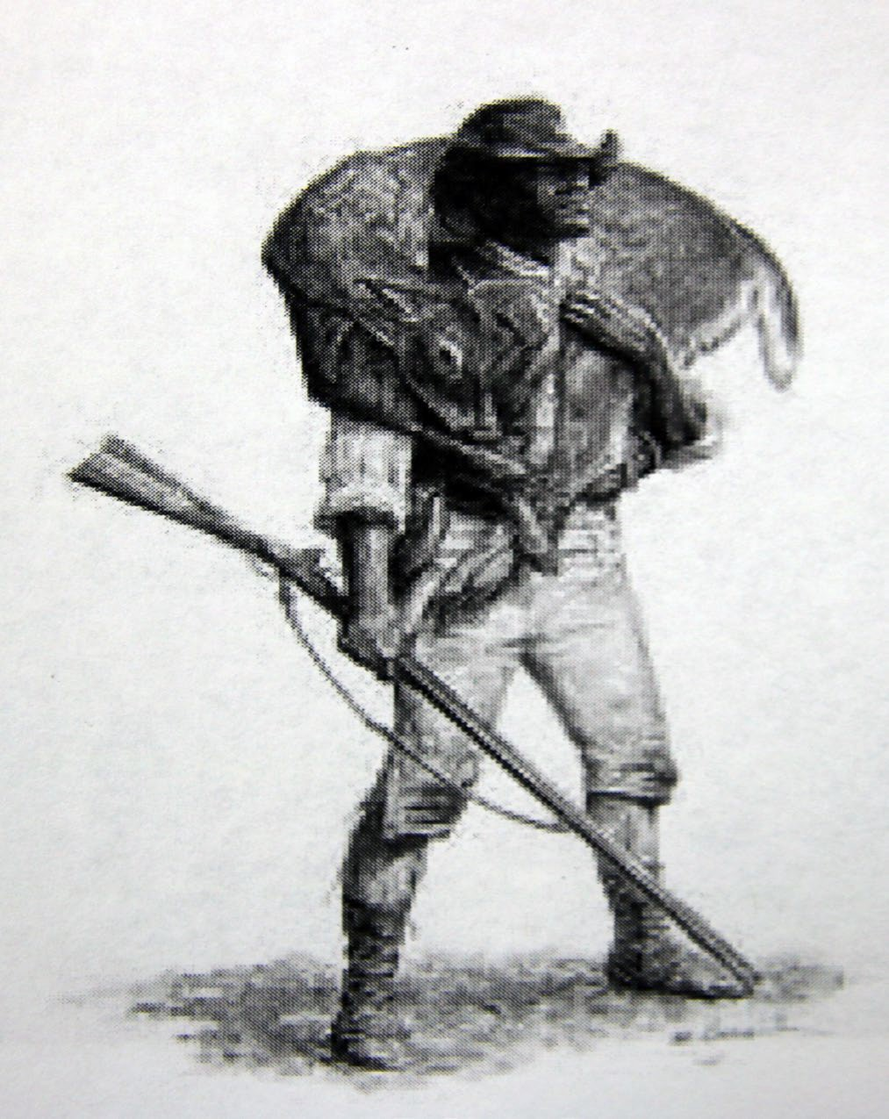

York, William Clark’s slave, was part of Lewis and Clark’s Expedition, the first overland expedition of the Pacific Northwest by Americans. Native nations treated York with respect and he was key in stabling diplomatic relations.

Upon returning to the East, Clark called York “insolent and sulky,” whipped and jailed him, and threatened to sell him.

York’s fate is unknown; some historians suggest he returned to the West and lived with the Crow in Wyoming.

1844

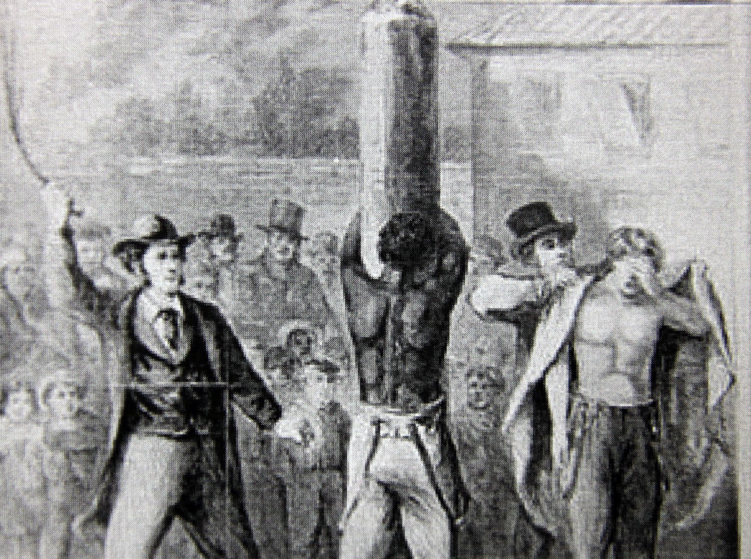

The provisional Government of Oregon declared slavery illegal. Slave owners was required to free enslaved Black people within 3 years. However, also included the infamous “Lash Law,” requiring that Black people – be they free or enslaved – be whipped twice a year “until he or she quit the territory” – later changed to forced labor.

Oregon, through legislature and ballot, passed several Exclusion Laws over the years, forbidding Black people from moving to Oregon.

Jacob Vanderpool, a Black saloonkeeper in Salem, was the only person known to have been kicked out of the state.

1865

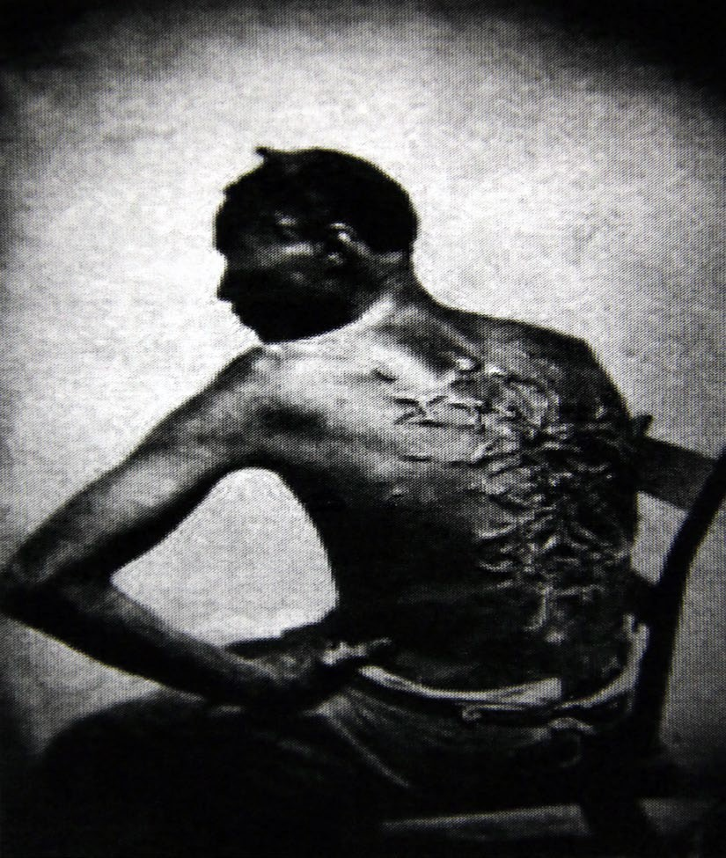

The Civil War ended in 1865, and the Thirteenth Amendment, abolishing slavery (except in the case of punishment) in passed.

However, it was still another three years before the Constitution assured Black people citizenship rights; during this time, Black communities were without legal protection or status, and by and large still under control of those who enslaved them, and fought to keep them enslaved.

1902

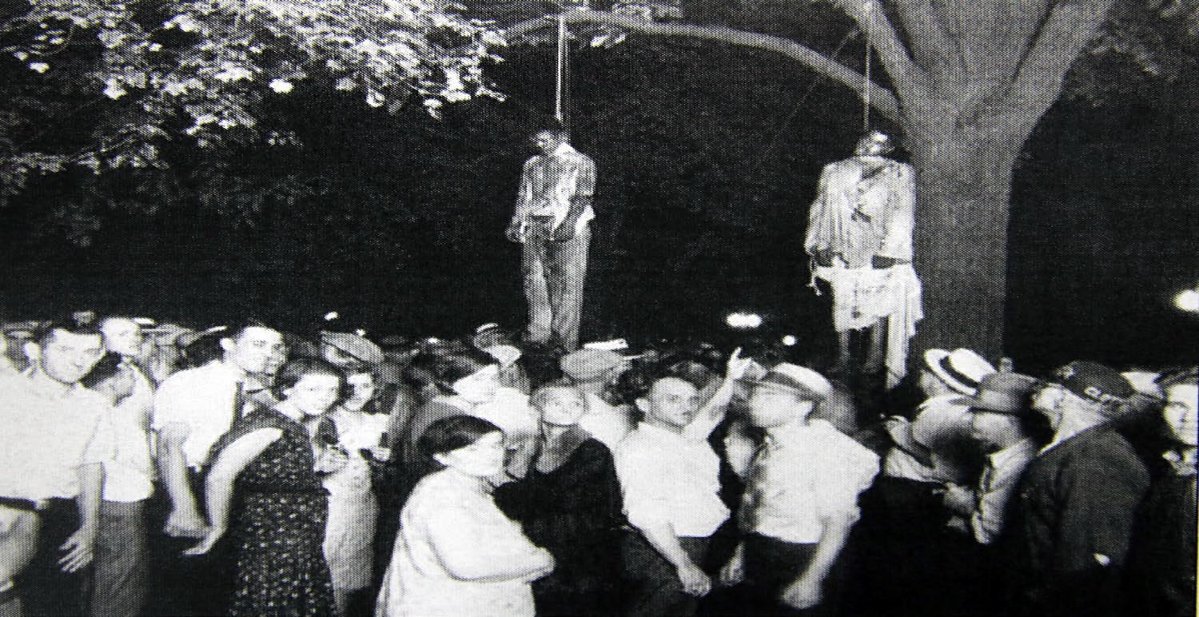

Alonzo Tucker, a Black man in coos Bay (whose Black population was 36), was accused of raping a white woman. Released from jail, 200 armed white men hunted him. Alonzo was hung off a bridge after being shot twice.

The local Newspaper described the lynch mob as “quiet and orderly.” The Oregon Journal went further, calling Tucker a “black fiend” who got the death “he so thoroughly deserved.

No one was indicted for Alonzo Tucker’s brutal murder. This is the only officially recorded Oregon lynching, through Black community members say many more went uninvestigated.

1925 – 1950s

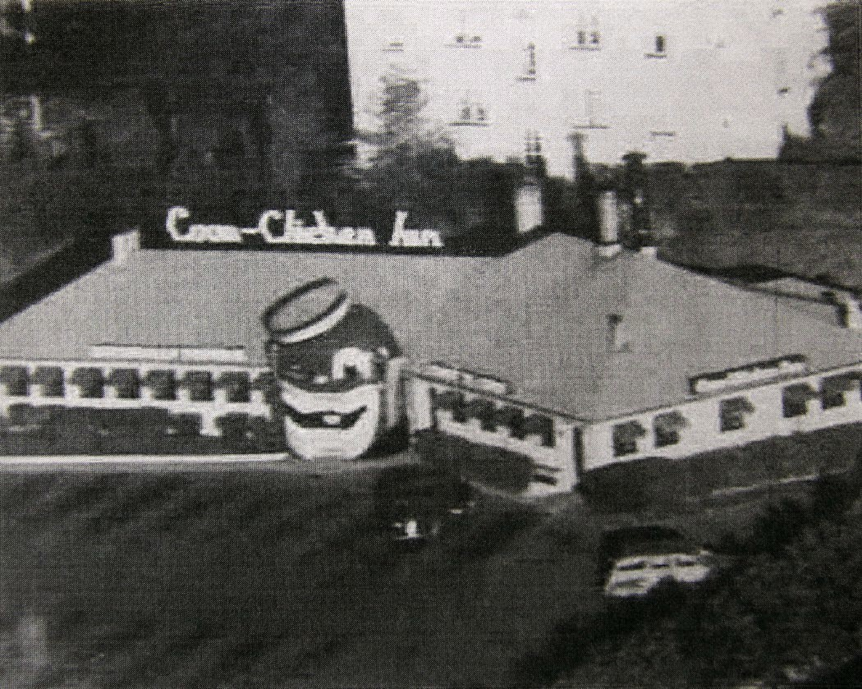

The Coon Chicken Inn was an American chain of three restaurants. Diners entered through the mouth of a smiling blackface caricature. The third restaurant was opened in 1931 in the Hollywood District in Portland.

A restaurant with a similar history, Lil Sambos (Formerly Lil Black Sambos), founded in the 1950s, is still operating in Lincoln City.

1970

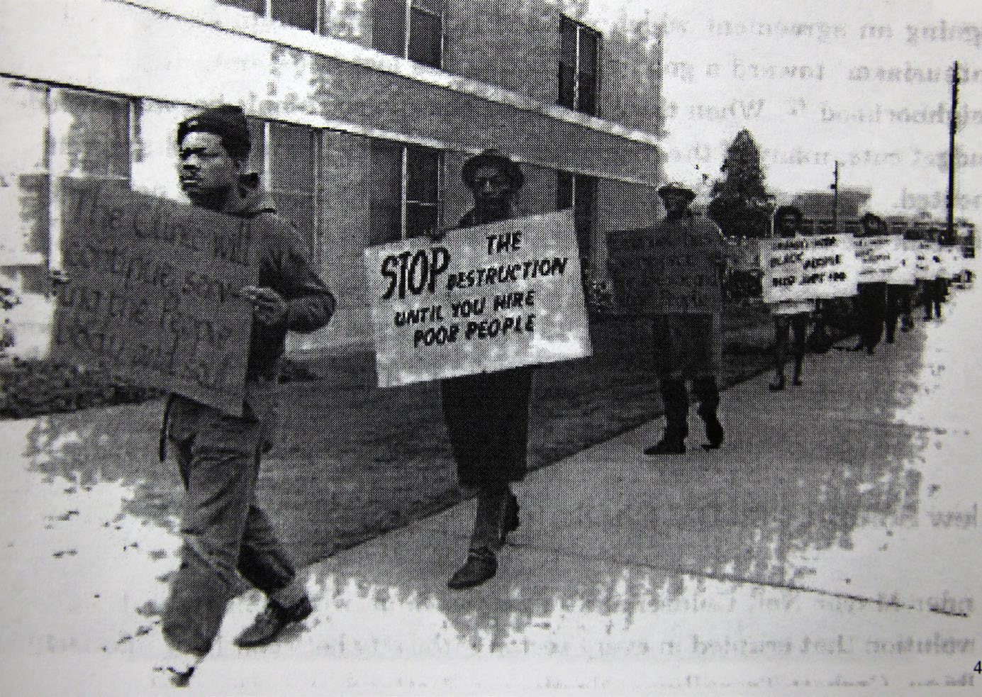

The Black community protested the expansion of Emanuel Hospital, which demolished thousands of homes in Albina’s traditional Black community. Residents were given 90 days to move out; homeowners were given a maximum $15,000, payment, and renters $4,000.

Emanuel Hospital’s expansion was funded by federal money earmarked for “Urban renewal.” The money ran out after the homes were demolished, but before construction finished. The expansion took decades to complete.

Dr. Martin Luther King Jr. states that America need to recognize the transgressions it inflicted upon the Black race in this country for all the injustices it has done to our race. This includes the slavery of our ancestors, the hangings of our people, the brutal murders of our people, the raping of Black women, destroying the economic growth in Tulsa, Oklahoma, of Black Wall Street, and much more.

The Blacks in this country has had it the toughest out of all the races. We’ve been enslaved, beaten to death, hung, raped, tortured, and killed by racist whites and police.

Dr. Martin Luther King Jr. was right. We need to amass our economic and political resources, this is the only way for our race to give ourselves a chance to advance in life. Also we must teach this to our kid(s). Our kids must be prepared to take the

reigns sometime in the future. How can we tie up our bootstraps when we are bootless?

Reparations are DUE. America need to pay what it owes to the Black race. Our ancestors and the Blacks after them HELPED building this country, Our ancestors and those after them should not die in vain. We must demand them the U.S. Government pay us what they OWE.

1969

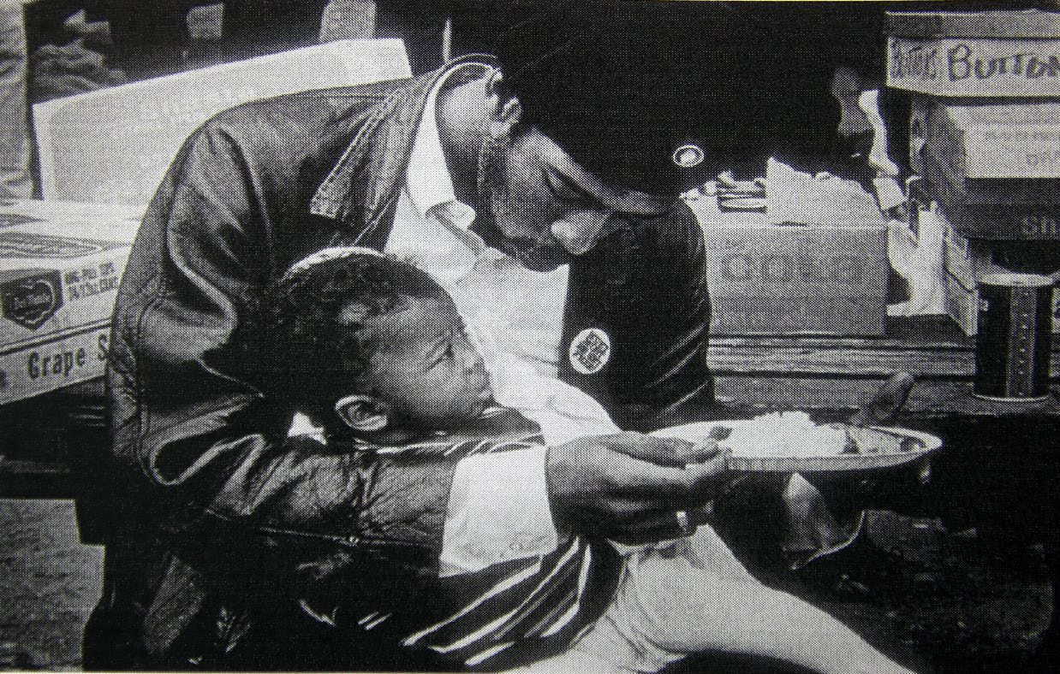

Black Panther Party
Portland chapter of the Black Panther Party was founded by Kent Ford and others, supported by Reed College students.

Portland Panthers ran a free children’s breakfast program for five year, feeding 125 chicken a day. They operated the Fred Hampton Memorial People’s Clinic, with 27 doctors, one of the longest running Panther health clinics in the county. In 1970, they founded the Panther Dental Clinic.

Portland Panthers experienced the same targeting by law enforcement as other Panthers nationally, and members of the Portland Panthers faced multiple false arrests and trials.

BLACK PANTHERS
Black Panther Party, original name Black Panther Party for Self-Defense, African American revolutionary party, founded in 1966 in Oakland, California, by Huey Newton and Bobby Seale. The party’s original purpose was to patrol African American neighborhoods to protect residents from acts of police brutality. The Panthers eventually developed into a Marxist revolutionary group that called for the arming of all African Americans, the exemption of African Americans from the draft and from all sanctions of so-called white America, the release of all African Americans from jail, and payment of compensation to African Americans for centuries of exploitation by white Americans. At its peak in the late 1960’s, Panther

membership exceeded 2,000, and the organization operated chapters in several major American cities.

Despite passage of the 19600 civil rights legislation that followed the landmark U.S. Supreme Court ruling in Brown v. Board of Education of Topeka (1954), African Americans living in cities throughout North America continued to suffer economic and social inequality. Poverty and reduced public services characterized these urban centres, where residents were subject to poor living conditions, joblessness, circumstances. Such conditions contributed to urban uprisings in the 1960’s (such as those in the Watts district of Los Angeles in 1965, among others) and to the increased use of police violence as a measure to impose order on cities throughout North America.

From the outset, the Black Panther Party outlined a Ten Point Program, not unlike those of the Universal Negro Improvement Association and Nation of Islam, to initiate national African American community survival projects and to forge alliances with progressive white radicals and other organizations of people of color. A number of positions outlined in the Ten Point Program address a principle stance of the Black Panther Party: economic exploitation is at the root of all oppression in the United States and abroad, and the abolition of capitalism is a precondition of social justice. In the 1960’s this socialist economic outlook, informed by a Marxist political philosophy, resonated with other social movements in the United States and in other parts of the world. Therefore, even as the Black Panther Party found allies both within and beyond the borders of North Amercia, the organization also found itself squarely in the crosshairs of the Federal Bureau of Investigation (FBI) and its counterintelligence program, COINTELPRO. In fact, in 1969 FBI director J. Edgar Hoover considered the Black Panther Party the greatest threat to national security.

The Black Panther Party came into the national spotlight in May 1967 when a small group of its members, led by its chair, Seale, marched fully armed into the California state legislature in Sacramento. Emboldened by the view that African Americans had a constitutional right to bear arms (based on the Second Amendment of the U.S. Constitution), the Black Panther Party marched on the body as a protest against the pending Mulford Act. The Black Panther Party viewed the legislation, a gun control bill, as a toting Black Panthers entering the Capitol were supplemented, later that year, with news of Newton’s arrest after a shoot-out with police in which an officer was killed. With this newfound publicity, the Black Panther Party grew from an Oakland-based organization into an international one with Chapters in 48 states in North America and support groups in Japan, China, France, England, Germany, Sweden, Mozambique, south Africa, Zimbabwe, Uruguay, and elsewhere.

TEN POINT PROGRAM

- We want freedom. We want power to determine the destiny of our Black Community.

- We want full employment for our people.

- We want an end to robbery by the Capitalist of our Black Community.

- We want decent housing, fit for shelter of human beings.

- We want education for our people that’s exposed to the true nature of this decedent American society. We want education that teaches us our true history and our role in the present day society.

- We want all Black men to be exempt from military service

- We want an immediate end to POLICE BRUTALITY and MURDER of Black People.

- We want freedom for all Black men held in federal, state, county and city prisons and jails.

- We want all Black people when brought to trial to be tried in court by a jury of their peer group or people from their Black Communities, as defined by the Constitution of the United States.

- We want land, bread, housing, education, clothing, justice and peace.

SURVIVAL PROGRAMS
Inspired by Mao Zedong’s advice to revolutionaries in The Little Red Book, Newton called on the Panthers to “serve the people” and to make “survival programs” a priority within its branches. The most famous of their programs was the Free Breakfast for Children Program, initially run out of an Oakland church.

The Free Breakfast For Children program was especially significant because it served as a space for educating youth about the current condition of the Black Community, and the actions that the Party was taking to address that condition. “While the children ate their meal[s], members (of the party) taught the liberation lessons consisting of Party messages and Black History.” Through this program, the Party was able to influence young minds, and strengthen their ties to communities

as well as gain widespread support for their ideologies. The breakfast became so popular that the Panthers Party claimed to have fed twenty thousand children in the 1968-69 school year.

In conclusion: The Black Panther Party was created to protect the Black Communities from police brutality and made many demands for the U.S. government to change the way Black people have been treated in this country. They wanted reparations, wanted Blacks to be provided with proper education, housing, employment, etc. as explained in the Ten Point Program. Their movement was to pave the way for us to have a better life in North America.

They put their lives on the line for us. They fought for us. The Black Panthers loved our people and did what they felt was best to see to it that don’t have to struggle and go through all the bullshit they went through.

We are glad we had these kind of people speaking for us and doing what they thought was best to try to strengthen of Black Communities economically and socially.

GANGS: CRIPS AND BLOODS THE ORIGIN OF CRIPS
There existed street organizations in South Central, Los Angeles, before the rise of he Black Panther Party. These groups, criminal in essence, were indeed the wells from which the Panthers would recruit their most stalwart members. Alprentice “Bunchy” Carter, who chartered the first L.A. Chapter of the Party was the leader of perhaps the most violent street organizations of that time – the Slausons. James Carr, former cell mate of Comrade George Jackson, and author of BAD, was a member of the Farmers. There were the Gladiators, the Businessmen, the Avenues, Blood Alley, and the Rebel Rousers to name but a few.

After the 1965 rebellion in Watts, there came an unsteady truce of sorts that caused the street organizations to focus on a larger, more deadly enemy – the
L.A.P.D. [Los Angeles Police Department]. So, by the time the Black Panther Party came to L.A., in 1968, a shaky peace existed among the larger groups. The Party offered the street combatants a new direction in which to vent their anger, respond to injustice and represent their neighborhoods.

By and large, the Party usurped the youthful rage and brought the street organizations of the time to an end. Of course, the U.S. government also did its share by drafting young brothers into the Vietnam War.

These, however, were the storm years of COINTELPRO (Counter Intelligence Program) and the Party was the focal point. Thus, by late ’69, the aboveground infrastructure of the BPP was in shambles due to its own internal contradictions and subsequently the weight of the state. Confusion set in among the people creating, if you will, a window of opportunity of which both the criminals and the counter revolutionists in the government took advantage.

Community Relations for an Independent People (CRIP) was a city funded team post (meeting place) on the east side of South Central L.A. that played host to some of the area’s most rowdy youth. One such brother was Raymond Washington, who at that time belonged to a young upstart clique called the Baby Avenues. The team post became center ground to an ever-widening group of youth who eventually took its title, CRIP, as a name and moved westward with it. With the vanguard in shambles and the local pigs turning a deliberate deaf ear, the CRIPs flourished rapidly. In its formative years, the Party’s influence was evident. For the same uniform/dress code of the Party’s influence was that of the CRIPs. Yet, a sinister twist developed whereas New African people were the targets of the young hoodlums. And with no vanguard forces readily available to teach and train these youth, they spiraled out of control, taking as their nemesis the Brims who later developed into the city wide Bloods. The founding of the CRIPs is established as 1969. Their gang color is blue, and sometimes also the color white.

ORIGIN OF THE BLOODS
Most South Central street organizations, commonly called “gangs,” “sets,” or “orgs.,” take their names from prominent streets: Slauson, Denver Lane, Piru, Hoover, etc., that run through their neighborhood. The CRIPs had already formed, were massed up and rolling together. Their strength attracted other sets to become CRIPS. As they moved into territories occupied by other South Central organizations, they clashed with and met stiff resistance from those neighborhoods sets who did not want to align with or be taken over by them.

Among those gang leaders resisting the CRIP invasion were Peabody of the Denver Lanes, Puddin of the Westside Pirus, Rooster of the thirty Pirus, and the Westside Brims, perhaps the most well known and respected of the lot, although their leader is unknown today. Using their prestige and influence, the Brims began going into other neighborhoods to start other Brims families and to recruit other sets to join their side in opposition to the CRIPs. As the various sets began hooking up with each other and the Brims, they formed a loose coalition whose main point in common was their opposition to the CRIPs. In the early 1970s, the federation solidified and formally united into the citywide Bloods. They adopted the color red as their banner; they also use the colors green or brown.

Prison is a normal next stop for many gang members. The first Bloods sent to Chino, a mainline California prison, are commonly referred to in Blood circles as the “First Bloods to walk the line at Chino.” To increase their prison membership and recruitment, they created a Bloodline (BL) Constitution patterned after the constitution of the BGF (Black Guerilla Family), a Panther-influenced group already established in the California prison system at the time. The BL Constitution contained the Blood’s code of conduct, history, and by-laws and was required reading for each new recruit. To speed up recruitment, the older “First Bloods” made reading the constitution an automatic induction into their ranks and thereafter began tricking young prisoners into reading it. Once read, the new recruit could only reject membership at the risk of serious bodily harm.

The press-ganging of young recruits at Chino set off ripples of dissatisfaction and breakaways among Bloods in other California prisons. Those disaffected centered around Peabody at Old Folsom prison who took parts from the BL and BGF constitutions and created a new United Blood Nation (UBN) Constitution designed to unify all Bloods in prison. Since then, Bloods have chosen which constitution they would come under.

Blood members under either the BL or UBN Constitution are held to a higher standard than others members; they hold positions and are similar to the Officer’s Corps of a military organization. Those Bloods not under a constitution are the foot soldiers. The BL and UBN organization spread throughout the California prison system, and are strictly prison organizations. Once a Blood leaves prison he

returns to his old neighborhood set. From South Central, the Bloods spread to Pasadena, Gardenia, San Diego, Sacramento, Bakersfield, and throughout the state and its prison system.

THE BLACK LIBERATION ARMY
COINTELPRO’s destruction of the BBP forced many members underground and gave rise to the Black Liberation Army (BLA) – a New Afrikan guerrilla organization. BLA continued the struggle by waging urban guerilla war across the
U.S. through highly mobile strike teams. The government’s intensified search for the BLA during the early 1970s resulted in the capture of Geronimo Ji-Jaga in Dallas, Dhoruba Bin-Wahad and Jamal Joseph in New York, Sha Sha Brown and Blood McCreary in St, Louis, Nuh Washington and Jalil Muntaqim in Los Angeles, Herman Bell in New Orleans, Fransico and Gabriel Torres in New York, Russell Maroon Shoats in Philadelphia, Chango Monges, Mark Holder, and Kamau Hilton in New York, Assata Shakur and Sundiata Acoli in New Jersey, Ashanti Alston, Tarik, and Walid in New Haven, Safiya Bukhari and Masai Gibson in Virginia, and others. Left dead during the government’s search and destroy mission were Sandra Pratt (Wife of Geronimo ji-Jaga, assassinated while visibly pregnant), Mark Essex, Woodie Changa Green, Twyman Kakuyan Olugbala Myers, Frank “Heavy” Fields, Anthony Kimu White, Zayd Shakur, Melvin Rema Kerney, Alfred Kambui Butler, Ron Carter, Rory Hithe, and John Thomas, among others. Red Adams, left paralyzed from the neck down by police bullets, would die from the effects a few years later.

Other New Afrikan freedom fighters attacked, hounded, and captured during the same general era were Imari Obadele and the RNA-11 in Jackson, Mississippi, Don Taylor and de Mau of Chicago, Hanif Shabazz, Abdul Aziz, and the VI-5 in the Virgin Islands, Mark Cook of the George Jackson Brigade (GJB) in Seattle, Ahmed Obafemi of the RNA in Florida, Atiba Shanna in Chicago, Mafundi Lake and Sekou Kambui in Alabama, Robert Aswad Duren in California, Kojo Bomani Sababu and Dharuba Cinque in Trenton, John Partee and Tommie Lee Hodges of Alkebulan in Memphis, Gary Tyler in Louisiana, Kareem Saif Allah and the Five Percenter-BLA-Islamic Brothers in New York, Ben Chavis and the Wilmington 10 in North Carolina, Delbert Africa and MOVE members in Philadelphia, and other doubtless too numerous to name.

THE DECADE OF THE 1980s
In June, Ali Hassan was released after sixteen years in the New Jersey state prison. Two months later, five New World of Islam (NWI) members were arrested after a North Brunswick, New Jersey, bank robbery in a car with stolen plates. The car belonged to the recently released Ali Hassan, who had loaned it to a friend. Ali

Hassan and fifteen other NWI members refused to participate in the resulting mass trial which charged them in a Racketeering Influenced Corrupt Organization (RICO) indictment with conspiracy to rob banks for the purpose of financing various NWI enterprises in the furtherance of creating an independent Black Nation. All defendants were convicted and sent behind the walls.

The 1980s brought another around of BLA freedom fighters behind walls – Basheer Hameed and Abdul Majid in the 1980s; Sekou Odinga, Kuwasi Balagoon, Chui Ferguson-El, Jamal Joseph again, Mutulu Shakur, and numerous BLA Multi- national Task Force supporters in ’81; and Terry Khalid Long, Ojore Lutalo, and others in 1982. The government’s sweep left Mtayari Shabaka Sundiata dead, Kuwasi Balagoon subsequently dead in prison from AIDS, and Sekou Odinga brutally tortured upon capture, torture that included pulling out his toenails and rupturing his pancreas during long sadistic beating that left him hospitalized for months.

But this second round of captured BLA freedom fighters brought forth, perhaps for the first time, a battery of young, politically acute New African lawyers – Chokwe Lumumba, Jill Soffiyah Elijah, Nkechi Taifa, Adjoa Aiyetoro, Ashanti Chimurenga, Michael Tarif Warren, Evelyn Williams, Joan Gibbs, Florence Morgan, and others. They are not only skilled in representing New African POW’s but the New African Independence Movement too, all of which added to the further development of the New African liberation struggle behind the walls.

The decade also brought behind the walls Mumia Abu-Jamal, the widely respected Philadelphia radio announcer, popularity known as the “Voice of the Voiceless.” He maintained a steady drumbeat of radio support for MOVE prisoners.

He was driving his cab on the night of December 9, 1981, when he happened to spot a policeman beating his younger brother.

Mumia stopped, got out his cab and was shot and seriously wounded; the policeman was killed. Mumia now sits on death row in greatest need of mass support from every sector, if he’s to be saved from the state’s electric chair.

The 1980s brought the Reagan era’s rollback of progressive trends on a wide front and a steep rise in racist incidents, White vigilantism and police murder of New African and Third World people. The CIA flooded South Central, Los Angeles with cheap “crack” cocaine and guns. It set off a tidal wave of internecine violence that eventually engulfed communities of color across the country.

Like the CRIPs, the Bloods were initially influenced by the Black Panther Party, but with the deluge of CIA-Contra crack and guns into South Central, and with no revolutionary vanguard to direct them, the Bloods took the path of least

resistance. Using their statewide network, rocks, firepower, and Blood rap videos and tapes, they spread their enterprise eastward through cities big and small.

The Reagan 1980s also brought the rebirth and reestablishment of the NOI under the leadership of Minister Louis Farrakhan, the rapprochement with the Soviet Union, a number of New Afrikan POWs adopting orthodox Islam in lieu of revolutionary nationalism, the New Afrikan People’s Organization (NAPO) and its chairman, Chokwe Lumumba’s emergence from RNA as a banner carrier for the New Afrikan Independence Movement (NAIM), the Malcolm X Grassroots Movement (MXGM), the New Orleans assassination of Lumumba Shakur of the Panther 21, and an upsurge in mass political demonstrations known as the “Days of Outage” in New York City spearheaded by the December 12th Movement and others.

The end of the decade brought the death of Huey P. Newton, founder of the Black Panther Party, allegedly killed by a young Black Guerrilla Family adherent on August 22, 1989, during a dispute over “crack.” Huey taught the Black masses socialism and popularized it through the slogan “Power to the People!” He armed the Black struggle and popularized it through the slogan “Political Power grows out of the barrel of a gun.” For that, and despite his human shortcomings, he was a true giant of the Black struggle, because his particular contributions are comparable to that of other modern-day giants, Marcus Garvey, Elijah Muhammed, Malcolm X and Martin Luther King Jr.

THE 90s AND BEYOND
In 1992, Fred Hampton, Jr., son of the martyred Panther hero, Fred Sr., was sent behind the walls. He was convicted of the firebombing of a Korean “deli” in Chicago in the aftermath of the Simi Valley, California, verdict that acquitted four policemen of the Rodney King beating which set off the Los Angeles riots.

The mid decade also brought forth a growing right wing White militia movement that had obviously studied the tactics and language of the 1960s left wing movements – and which culminated in the bombing of the Oklahoma City Federal Building causing 168 deaths and a claim of POW status by the subsequently captured and convicted suspect, Timothy McVeigh. He had been an All-American boy, a blond haired, blue-eyed patriot who enlisted in the army to defend the American way of life that he so fervently believed in. He rose rapidly through the military ranks (private to sergeant) in two years, and was accepted into the Special Forces: the elite, top four percent of the military’s forces. There he learned something that average thinking persons of color have known most of their lives.

In an October 1991, letter to his sister and confidant, Jennifer, McVeigh disclosed his revulsion at being told that he and nine other Special Forces commanders

might be ordered to help the CIA “fly drugs into the U.S. to fund covert operations” and “work hand in hand with civilian police agencies” as “government paid assassins.”

Disillusioned and embittered with the U.S. government, McVeigh soon afterwards left military service, gravitating deeper into the right wing militia circles and surfaced four years later upon his arrest in the Oklahoma City bombing case.

The period also witnessed the resprouting of Black revolutionary organizations patterned after the BPP – the Black Panther Collective, the Black Panther Social Committee, the New Black Panthers, and the Black Panther Militia – along with the NOI’s Minister Louis Farrakhan’s emergence at the October 16, 1995 Million Man March (MMM) in Washington, D.C., as an undeniable force on the New Afrikan, Islamic and world stage. In the meantime, the U.S. moved further to the right with the passage of a series of racist, anti-worker legislation. The government passed the NAFTA bill to legitimize the private corporation’s policy of sending U.S. jobs overseas. California passed Proposition 209 which killed Affirmative Action programs throughout the state. Then, it passed Proposition 187, which implemented statewide racist anti-immigration legislation. The Federal government killed Black voting districts and passed Clinton’s Omnibus Crime Bill which greatly increased the number of crime statutes, death penalty statutes, policemen and armaments; arrest of people of color; youths tried as adults; 3- Strike convictions, and prison expansion projects.

A shaky peace maintains between the Bloods and Crips despite intermitten flare- ups and constant provocations by police to reignite the conflict. Gradually some Bloods and Crips sets in the West are changing their focus and becoming more involved in endeavors that uplift and protect the New Afrikan community. The Bloods and Crips joined the armed contingent led by Dr. Khalid Muhammad and Aaron Michaels of the New Black Panthers of Dallas, Texas, which confronted the Klan demonstration in Jasper, Texas following the brutal pick-up murder there by White racists of a Black hitchhiker, James Byrd Jr.

Over the last two decades, the GDs Over the last two decades, the GDs have grown to roughly 30,000 members with GD Chapters in about thirty-five states, primarily in the midwest. The Bloods have reached New York City, and have sets in almost every state. They became the first Black street gang to spread coast to coast in both streets and prisons. Today there are approximately 235 sets of Crips in L.A. and the surrounding area. Reportedly, there are Crip sets in seventeen states and thirty-six cities, including New York. Government sources put their collective number at 90,000. Sanyika Shakur asks rhetorically, “Had we not begun as predators of New Afrikans would we have been allowed to last this long?”

On September 5, 1998, thousands of Black and other youths of color throughout the country gathered at the Million Youth March/Movement in Harlem, New York, and Atlanta, Georgia. The Million Youth March/Movement in Atlanta was

sponsored by Minister Louis Farrakhan of the NOI, Kweisi Mfume of the NAACP and Jesse Jackson of the Rainbow-Push Coalition. The major theme was that Black youth should be “God-centered” in their preparations to take the reins of leadership in the next century. The Million Youth March in Harlem was spearheaded by Dr. Khalid Muhammad of the New Black Panthers, Attorney Roger Wareham of the December 12th Movement, Attorney Malik Shabazz, and Erica Ford of The Code. The major theme centered around a Black youth “Struggle Agenda” for the coming century, namely:

-Freedom
-Reparations
-Freeing all PP/POWs
-Control of the Politics and Economics of our Communities
-Building Independent Institutions in our Communities
-Control of our Cultural and Intellectual Properties
-End Police Brutality, Harassment, and Murder of Black People
-End Racism
-Self Determination for the Black Nation

Speeches were made by Damien of Harlem’s Boys Choir, Farrakhan Huhammed – sons of Dr. Khalid, Phile Chionesu, Dr. Josef Ben-Jochannan, Dr. Leonard Jeffries, Attorneys Malik Shabazz and Roger Wareham, Ernie Longwalker and Warrior Woman, Minister Conrad Muhammed, Al Sharpton, and others. Messages were read from various PP/POWs. Valentine, a spectator and twenty-three-year-old member of the United Blood Nation, said one reason he came was “to show his organization has positives” and “to bring understanding.” He wore a red and white bandana around his head to represent his group, and a Million Youth March dog collar aound his neck. Dr.Khalid Muhammad’s speech concluded the March at which time, a police helicopter buzzed low over the dispersing crowd, and a police contingent rused the stage to cut off the sound system. A melee ensued leaving one spectator and fifteen police injured. The Harlem community was incensed a Mayor “Adolph” Giuliani and the police department for their racist/fascist posture leading up to and throughout the March, and for their brazen provocations at its end, all of which fell short of their intended effect.

The New Afrikan struggle behind the walls now follows the laws of its own development, paid for its own blood, intrinsically linked to the struggle of its own history. To know that history is to already know its future development and direction. The times are serious. Our youth, our women, and therefore our very survival as a people are at stake. We need only, both inside and out, to unite around a struggle agenda, organize, and fight for it, and we shall win without a doubt.

PART 2

INSIGHT AND UNDERSTANDING ABOUT PORTLAND OREGON’S STREET
GANG CULTURE

- WHO IS INVOLVED IN GANG-RELATED ACTIVITY AND WHAT IS THE HISTORY OF THESE GANGS?
In Portland there’s a very large gang presence. With numerous sets and sub-sets within those gangs. There is definitely a gang problem in Portland, regardless of what local city officials and politicians claim when they continue to down play the rampant and reckless violence. The dominate, most aggressive, and violent street gangs in the city are largely made up of African Americans and that associate with the BLOODS, PIRUS, CRIPS, AND the HOOVER STREET CRIMINAL GANG.

Gang members in Portland do not have any age requirement prohibiting anyone who is interested in becoming a member from joining. Therefore ages may range from as young as 12 years old up to as old as 40 and 50 plus years of age. Being brought up in the gangs primary location/neighborhood isn’t a requirement to be initiated into a Portland Street Gang. The histories of these particular gangs are different but yet have similar beginnings. Large portions of Portland, Oregon African American street gangs were established in Southern California.

For example: the ROLLING 60’s CRIP, INGLEWOOD FAMILY BLOODS GANG, AND LINCOLN
PARK BLOODS GANG and the HOOVER CRIMINALS. There is also what is known as local home grown Portland Street Gangs. We’ll name several: LOK’ED OUT PIRU’S, WOODLAWN PARK BLOODS GANG, UNTHANK PARK HUSTLERS, KIRBY BLOCC CRIPS AND COLOMBIA VILLA CRIPS.

The inception of Portland, Oregon gang culture solidified itself in the mid 1980’s right along with the introduction and explosion of crack cocaine that was transported from Los Angeles, California and proliferated through out the city of Portland, particularly within the North and Northeast section of the city.

- WHAT CRIMES ARE THESE INDIVIDUALS COMMITTING?

Murder, Attempted Murder, Robberies, Home Invasions, Assaults, Pimping and Pandering, Felon in Possession of a Firearm, as well as drug offenses. Although Portland street gangs are involved in every type of gang-related crime that you can think of, Portland street gangs are fairly more involved in gang-related

crimes that are retaliatory in nature. These crimes will usually leave multiple people shot, seriously injured, maimed.

However, the basic goal of retaliatory street gang violence is usually to murder someone. 2021 alone had seen a very high spike in gang-related shootings resulting in Portland reaching the most homicides in the city’s history. For those who are on the outside looking in gang-related gun violence it may seem like a current or new trend at this moment, but since the birth of black street gang culture, violent assaults and homicide have been the norm. One of the many reasons for the spike in gun-related violence is because of the wide spread proliferation of guns that are easily accessible, cheap to purchase and can hold 30, 50, and even up to 100 rounds inside a magazine.

Another reason for the spike in gang-related violence is the pandemic. People are mandated to wear masks or any kind of face covering to protect themselves and others’ from COVID-19. Gang members have been out there taking full advantage of that because it’s easier to get away with a crime if no one can identify you.

Also, the heavy usage of hard-core narcotics like methamphetamines, codeine, opiates, molly, ecstasy, and cocaine is perpetuating an already dire situation. In previous years gang members refrained from using any type of drugs except for marijuana and occasionally P.C.P because being an addict was frowned upon. Nowadays it isn’t. Hip-hop, especially gangster rap music has made addiction socially acceptable within the current climate of African American street gang culture.

- WHEN ARE THESE CRIMES BEING COMMITTED?
There isn’t really a particular time when gang members participate in criminal activity. In Portland, crimes may transpire at anytime within a 24-hour period on any given day. As a means of having a constant form of revenue coming in gang members will rob and sell drugs and pimp women. The more sophisticated gang members create legitimate businesses as a front for criminal activity.

However, pimping and pandering is primarily at the top of the list. When carrying out violent acts on behalf of their self or gang, crimes can be as brazen as committing a homicide in broad day light in front of witnesses or committing a home invasion robbery with young children present. Circumstance like having an opportunity to catch a rival gang member off guard can heighten the chances of committing a violent or deadly act.

- WHERE IS GANG-RELATED ACTIVITY PRIMARILY OCCURRING?

In the 1980’s, 1990’s, and the early 2000’s, gang-related activities were primarily confined to the sections of the North and Northeast district of Portland. As

gentrification began to change the dynamics as well as the demographics of districts that were traditionally African American and were negatively impacted by gang-related activity, those gangs have migrated to other parts of Multnomah County. Now locations like Southeast Portland and Gresham, which were once largely dominated by Hispanic street gangs (Southsiders) have became a hub for North and Northeast Portland African American street gangs.

- WHY ARE THESE CRIMINAL ACTIVITIES HAPPENING (e.g. individual conflicts, gang feuds, gang members acting on their own volition, or substance abuse)?

A personal conflict between two gang members who are from two different gangs is only one of the many factors that can lead up to a gang’s decision to wage a full blown street war on another gang. For instance, an altercation that leads to a fistfight between two gang members who are from two different gangs with someone losing. That loss can come with a certain amount of ridicule and embarrassment that hurts the pride of who ever lost up to the point to where he feels that he needs to prove himself by committing an act of violence that involves the use of a firearm.

When a gun is brought into the equation as a solution and someone gets injured or dies from that form of retaliation, that alone can initiate a gang feud that can last for decades or more with no end in sight.

Drug abuse with a combination of instilled hatred for a rival gang can intensify the propensity for a gang member to act upon his inner inhibitions that wouldn’t have normally even crossed their minds if he were sober. However, drug abuse can distort the way people perceive and think about certain situations. Drug abuse can also have an ability to desensitize emotions that would normally restrain a youth that doesn’t use hard-core intoxicants from doing something unimaginable.

For example: Shooting or killing innocent citizens that have nothing to do with gangbangin’ just for the thrill of it, or shooting or killing innocent children as a form of gang retaliation.

Also, most gang feuds transpire over a issue about a female. However, very few gang members of African American descent will ever admit it. Because they don’t want to be looked at by their peers as weak for having and/or showing any type of affection, sympathy, or compassion for females.

Within the sub-culture of black culture, young black males who appear to have or harbor any affectionate feelings for our feminine counter-parts is considered taboo. So more often than not, gangbanging is a veil for an altercation over a female.

MISPLACED VALUES THE LACK OF LEADERSHIP

As oxymoronic as it may sound there are upsides of being a member of the Bloods and Crips street gang. The camaraderie’s that these gang members share as well as the values these gangs instill in their members; loyalty, courage, unity, respect, integrity, and even a sense of honor.

However, the downsides of being affiliated with criminal street gangs is that values are misplaced. Values that would normally be our set of standards or moral compass become distorted. Within the Bloods and Crips values are attached to some type of criminal element.

For example:

  - Loyalty - may mean being there for one of your peers in any situation, which can range from facilitating or participating in a criminal act.

  - Courage - which is one of the most important attributes of gangbanging for various reasons (shooting, fighting, and etc.) “Having heart is what it is known as”, and without it, their peers will lack a lot of respect for you.

  - Unity - is a value that every kind of gang or group in the entire world is built upon (street gangs, sports teams, law enforcement, and etc.) and without it a gang will secure it’s own demise or it will cease to exist all together.

  - Integrity and Respect - Within African American gangs these two values often coincide with each other. As a gang member you must have enough integrity for yourself and respect for your gang and those who are within it.

  - Honor - It is also paramount to uphold yourself to the utmost standard of “the set” that is required. As far as it goes, it is the most important value for a member of a gang because when or if you are put in a position where you and peers are facing criminal charges and could possibly be looking at a lengthy prison sentence. Honor is the only quality that will keep you and your peers from testifying on each other to receive a lighter sentence. As I explained earlier, gangs do have some form of a value system that it instills in you. However, if these values weren’t misplaced these traits would be a great asset to you and your community and even a greater asset to your family.

For instance: Being a man instilled with values of being a loyal and dependable individual to your family who has the courage to discern right from wrong and

being able to make decisions that are based on rationality and good morals that can make your communities proud speaks volumes. Strong figure that always displays unity within your household to teach your family that it is wiser to be unified through thick and thin these are values that are needed in every household/family.

Also, being able to have integrity that is needed to show and teach your loved ones how to become pillars of their community. Black youth need to learn to always be honorable enough to stand up as a man, and be there for their loved ones no matter what the circumstances are. Family Before All. This means never sacrificing themselves for anything or anyone, except their family. We MUST end gang violence.

Our children’s future depends on it.

PART 3

IDENTIFYING ROOT CAUSES THAT CAN LEAD AFRICAN AMERICAN YOUTH TOWARD
GANG AFFILIATION

- LACK OF RESPONSIBLE PARENTAL GUIDANCE OR GUARDIANSHIP.

- LIVING BELOW THE POVERTY LINE/FINANCIAL INSTABILITY.

- HAVING A FAMILY MEMBER OR MORE WHO ARE ACTIVELY INVOLVED IN GANGS.

- HAVING LOW SELF-ESTEEM AND ANTISOCIAL BEHAVIOUR.

- SEEKING VALEDATION FROM PEERS OR THEIR ELDERS.

- WANTING PROTECTION FROM OTHER YOUTH/BULLIES

- WANTING TO HAVE OR FEEL POWERFUL.

- YOUTHFUL DELINQUENCY/INVOLVEMENT IN SOME FORM OF CRIMINAL ACTIVITY.

- HAVING A LOVED ONE OR KNOWING SOMEONE WHO HAS BEEN VICTIMS OF GANG VIOLENCE.
The list above isn’t all or every cause that is rooted in gang membership. This is only a brief description of things and circumstances that may persuade or lead young African Americans toward gangs. In reality, there are an abundance of factors that can be attributed to becoming a member of a gang.

To reduce Portland’s gun violence we have to put our focus on at risk youth who may become the next generation of gang members. For that reason it is imperative to know, understand and identify the root causes that can have a link between at risk youth and gang membership and aggressively address it.

PARENTING

The first rule of parenting, regardless of if you’re the biological parent or not, is being present. We are not talking about metaphorically or correspondingly. What we are referring to, is being a parent who is physically present. Parents who are within the very same household as their children already have the main ingredients needed to cultivate and facilitate proper development of a child.

Early experiences in the early stages of a child’s life will more than likely determine their perspective, behavior, mood, and how they may react to certain situations, circumstances, and interactions with other’s in the middle and later stages of adulthood.

In my earliest years I was raised by my great-grandmother and her son, which was my grandfather. Although, they vehemently expressed their lack of desire and enthusiasm of having a grandchild they knew my mother wasn’t mentally and financially incapable to raise a black child, especially a black boy.

My mother was 13 years old when she had me, so of course she was irresponsible, immature, and uncontrollable.

My grandfather had his suspicions of who my father was. However, since he didn’t hold my father in high regards from the time of my birth until I was about 3 years old, he didn’t tell my father of my existence.

My great-grandmother was very sick and old so she didn’t have the energy to deal with me like that. My grandfather practically raised me, and all of his kids by himself. He could barely take care of himself and you could tell that he didn’t want to take on the burden of raising someone else’s child.

Although, my grandparents provided me room and board, they didn’t provide me with much else. I can attest to the fact that my upbringing and development as a black male, was debilitated due to not having adequate and proper parental guardianship.

For example:
- Unconditional love
- Understanding
- Discipline
- Guidance

I had to find these things somewhere else other than in my household. Unfortunately, I thought I found what I was looking for in the streets. At the lowest and loneliest times in my life, I vaguely can recall those who were there for me when I needed it the most, except for the streets and all of my peers who played in them. As wild as it may sound, that was truly how it was and how I felt growing up as a black male without a mother and a father actually being present throughout the most important stages of my childhood. – Aaron Gee.

As Mr. Gee explained, many Blacks have a different type of upbringing. When I was growing up in Northeast Portland in the 90’s, our household didn’t have a positive role model to teach us anything meaningful in life.

It is critical that both parents are educated and present in their kids lives. Children watch everything we do so we must set great examples for them to see. If we are doing something illegally and they see us doing it, they’ll think it’s cool to do it too – because you are doing it.

For instance: Me and my fiancée have a five-year-old daughter. She hears me and her mom talk about buying and selling things online to get money. One day she said mom, I want to sell some of my toys I don’t play with anymore. My fiancée helped her set up a little stand in their parking lot and people came over to buy her toys. She made $56 and was happy. She said she want to sale stuff too. When my fiancée told me that, I smiled. I smiled because I knew what had happened. She hear us talking about buying and selling things a lot and she wanted to be a part of that. She wanted to make money too. So be cautious of what you say around your children – they are paying attention.

We are born into the world with a skin complexion that many people in other races do not like. So we grow up hearing derogatory names in elementary, middle and high school. Then we hear racist comments while living in the black community from police officers, and racist whites.

It’s very important for parents to understand that we must watch what we say around our kids. To be the most effective as we can be, we must educate ourselves in financial literacy, business, investment strategies, retirement and estate planning.

Our conversation with our kid(s), like Mr. Gee said, is way different from our white counterparts. We have to have the police talk because they’ll gun our kids down in the streets for nothing and be exonerated. A lot of us don’t grow up with family wealth, so we don’t have money for lawyers to protect our rights and receive the justice we deserve when the laws or our civil rights are violated. – Dwayne McClinton.

VISION FOR FAMILY FUTURE

Just as equally important, as a mature adult I know that it’s imperative that as parents we need to create a vision for our family. We must sit down and ask ourselves what do we want our family to look like in 10–20 years from now.

The questions below can help with you thinking about what you want for your family. Ask yourself:

- What kind of relationship do you want to have with your children’s mother? How do you want to interact and relate with her? If you are married, what do you want your marriage to look like? What do you hope she will say about you as a man, a husband and a father?

- What kind of parent do you want to be? What do you want your children, when they are grown, to remember about your family life? How would you like them to characterize their childhood?

- What do you want your kids to be like when they are adults? What do you want them to be known for…and known as?

- How do you want your children to relate to their own spouses and children? What kind of husband or wife – and mom and dad – do you want your children to be?

- How do you want your children to interact with each other in the future – and with each other’s spouses and families?

- How do you want your children to interact with you in the future? What kind of relationship do you hope to have with them?

- What are the core values that help bind your family together? What do you all believe is truly important in life?

COMMUNICATION/CONNECTION BETWEEN PARENT(S) AND YOUTH

Also, at D.R.E.A.M. B.I.I.G. we come from the streets and know that it is truly important for youth to have a great relationship with their parents. So we decided to incorporate a week of our program to each participant and their parent(s).

We have put together a list of the below listed questions for parents:

- You are here because you love your son (or daughter). Will you please look at your son and tell your son how much you love him?

- Will you please tell your son what you feel everyday when he walks out the front door of your home?

- Will you please let your son know about how you feel about him being in a gang?

- Will you tell him how much you worry about him while he’s out in the streets?

- Now, will you be willing to tell your son anything that’s on your heart that is not listed in these questions?

Parent(s): We know that it’s very important for you and your child to communicate what both of you are going through, so we wanted to have this part of our program to allow you and your child/children to have time to communicate what each other feel. This way, you and your child/children can begin understanding what each other is going through and begin building.

PARENT AND CHILD/CHILDREN WEEK
DREAM BIIG will give each parent who participate in PARENT AND CHILD/CHILDREN WEEK $250 so they can spend time with their child/children (if it’s more than one child participating in gang activity) to have: Breakfast, Lunch, Dinner, Movie and Pizza night at home.

We are hoping that one day it’s breakfast, the next day it’s lunch, etc. for five days the budget will be $50 a day. We want the parent and child/children to talk/connect at these events to gain a better understanding of each other and strengthen their bond.

Now we would like for you to say anything you want to say that wasn’t covered in the above five questions.

The point of the above questions are to give the parent(s) the opportunity to share what they really feel about their child/children gang banging, and express why they want their child/children to stop.

Note: Have each participant write at least a page and a half about how they would feel if someone killed their child?

This connection must be dealt with so both sides can share their thoughts and feelings. I remember when I was growing up in Northeast Portland in the 90’s gang banging era, my mother and father were on drugs and working a lot. Even though my mother never abandoned me and did her best to provide food, clothing and paid the bills, we didn’t discuss conversations about me gang banging often.

I actually only remember two occasions where she said something about how tired she was stressing about my gang banging activity and her not being able to sleep at night unless I came home or called to say I was staying at a friends house and I was safe. There were many nights to where I didn’t even go home or call at night. Being older and understanding the stress gang bangers cause their parents, I clearly see why my mother barely got any sleep and dealt with her stress through drug usage.

At D.R.E.A.M. B.I.I.G. we understand that the link between the youth and their parents must be brought into the equation. Each party needs to understand what the other is going through. The only way for both to understand what the other is going through the issues must be addressed, face-to-face.

What need to be understood though is this, the youth may say he or she turned to the streets because their family is poor, the parent’s drug or alcohol usage lead them to the streets, and the parent may say they started using drugs because they were stressed out due to their child gang banging activities they feared for their child’s life, etc. Whatever the issue is, it needs to be addressed.

Our mission is to hire mentors to counsel the youth and their parents so they can gain a better understanding of each other, and be given the proper tools so they can strengthen their relationship through cognitive behavior therapy and parenting skills.

MENTORSHIP

At D.R.E.A.M. B.I.I.G. our mentorship will be executed in a way that not only mentor’s at risk youth, it will also teach at risk youth how to become mentor’s themselves so when that day comes when they’ll need to step up to the plate and give back by helping at risk youth they will already be effectively and adequately prepared to help and assist their community in a time of social crisis such as gang- related violence.

Having mentors who come from the same background as our at risk youth, but have change the trajectory of their lives for the better and are now legitimate business owners who are respectable members of their community. Mentors having something in common with our at risk youth whether it is cultural, social or economical will be the most effective way to get our at risk youth comfortable enough to have a genuine and reciprocal communication/interaction with their mentors.

Since a lot of at risk youth come from broken homes it is obligated for our mentors at D.R.E.A.M. B.I.I.G. to always be compassionate and understanding with them. Not only because it’s the right and most humane thing to do. But, because it teaches our at risk youth how to do the same when they interact with others.

For too many years have our black youth been the victims as well as the perpetrators of the cycle of violence attributed to gang and gun-related violence. Our mentors will make a concerted effort to change the cycle of violence that our black youth so often get caught up in and show them how to replace it with a cycle of love and empathy.

Our mentorship will also offer one-on-one mentoring so our at risk youth can have someone who he can trust to confide in when or if he needs to talk about something that he isn’t comfortable sharing with others. Once a mentor builds a bond with an at risk youth he may even share things with his mentor that could potentially save that at risk youth or someone else’s life.

Mentors who are apart of our mentorship program know that mentoring isn’t an occupation it’s an obligation that shouldn’t be taking for granted. The responsibility that our mentors will bare is immense. However, regardless of how difficult this responsibility may be or become the bottom line is that each and every mentor at
D.R.E.A.M. B.I.I.G. was once a willing participant of the Bloods and Crips street gang in the city Portland, so the onus is own us to bring about peace.

EFFECTIVE LEADERSHIP
Leadership is the cornerstone of every organization, group, team, business, gang, race, etc. Depending on if a leader is a good leader or not determines if a certain groups desired outcome can or will be achieved. There’s a saying “leaders are born, not made.”

The truth is, there are 2 types of people who have the ability to step into a leadership role, those who are leaders naturally and those who weren’t born with leadership qualities but have the ability and also possess the tenacity and ambition to be made into one. Although these 2 types of people may have acquired their leadership skills through 2 totally different avenues, it is nearly impossible to become an effective leader without learning leadership through trial and error.

Being a leader doesn’t mean that a person will lead those who follow him toward positive goals. For instance, in contrast to a positive and influential leader like Martin Luther King, who was murdered for shifting the narrative of racism in America. Adolf Hitler was a malevolent and diabolical man. But yet, he was a very influential leader who led his people to the front gates of hell, while at the same time giving his soul up all in the pursuit of gaining the world

Portland branches of the Bloods and Crips aren’t as structured as a criminal syndicate such as the Hells Angels, Black Guerilla Family, Mexican Mafia and even the Italian mafia. Although, gangs like the Bloods and Crips may lack structural leadership they still operate on the bases of who is leading the gang at that time. For example, If one gang appears to be deadlier or more aggressive than another gang in a particular community, it usually can be attributed to the mindset of who is the most influential within the whole group at that time.

If the leader of one gang is level headed, calmer or simply indecisive when it pertains to utilizing violence as a means to an end, that particular gang will likely show a lower propensity toward Gang-related violence. On the other hand, a gang leader who lacks empathy and compassion, which is needed to respect another human-beings life, will tend to precipitate to his gang and heighten that gang’s violence. Also, these gangs at any given time can even have several individuals who have influence amongst their peers.

Effective leadership is not only needed, it is essential to the growth and development of low-income communities that struggle with the problems of gang and gun -related violence. However, effective leadership isn’t only needed to reach and teach and our youth how to think and act rationally and intelligently instead of impulsively and recklessly. Having effective leadership from people, who also reside within the same communities that are plagued with gang and gun violence, are very important as too.

This is crucial to understand because youth must respect this person. For instance, an ex-gang member who still has some degree of influence within the gang he was previously affiliated with, who would like to right his wrongs by changing the very culture that he also once participated in.

Effective leaders of today must rewrite the playbook and think outside the box when brainstorming or creating strategies to prevent, intervene, and mitigate gang and gun-related violence. I recall back in the early 90’s all the way into the mid millennium many gang-outreach programs swore that they had the blueprint for gang prevention. However, majority of the programs that have been created in the past, many are complete failures. In my opinion, that was due to lack of effective leadership, proper goals, and strategies or vision.

When we are talking about gang out-reach programs and their effectiveness on issues pertaining to gangs must understand that the success rate for curbing gang- related violence may be low If effective leadership isn’t implemented. Local news outlets all through the day broadcast Shootings in Portland with mostly people of Caucasian-decent suggesting solutions about a predominately African American social crisis such as inner-city gang –related violence.

Most of these people are very intelligent individuals who probably have barrages of degrees, doctorates, bachelors, masters, and etc. but yet, they’re still clueless about black American gang culture. Their cluelessness is predicated off of 2 different reasons. The first one is for you to truly have an understanding about the culture of black street gangs you would have had to come from that background. The second thing is you more than likely would have to be a black person as well. Only because, from our experience alone as black people in America, give us a true understanding of why at risk black youth act and think the way they do.

Leadership is imperative when a particular community is trying to solve potentially reckless, harmful, and dangerous issues that may present themselves. This is because if or when certain issues arise within a particular community a leader needs to be present and capable of handling any task at hand. Also, if an individual has a position of leadership, but doesn’t possess the skills of being a good listener or communicator, creating goals, and having a vision, then they should give up the position to someone who process the characteristics listed herein.

As Blacks, we need to start developing strategies for becoming a more competitive race.

In his book titled: “Black Labor White Wealth,” Claud Anderson, Ed.D. stated:

“Leaders are individuals who can induce others to cooperatively work towards certain goals that represent the values and motivations of both the leader and thee followers. To fully understand the nature of leadership

requires understanding the essence of power because leadership is a special form of power.”

The goal of forming new black Leadership in Portland is so that Blacks can educate our youth in Black history, business, personal finance, and show them the importance of unity, setting goals, and the purpose of achieving economic empowerment.

We created D.R.E.A.M. B.I.I.G. because we are on a mission to develop youth into Black Leaders so that we can create more positive contributors to our families, and lead other youth in the Black community.

In another book I read by Claud Anderson, Ed.D., titled: PowerNomics, he states in part:

“The social engineering effectively destroyed the Black people’s sense of community, trust and accountability. Through undocumented, many Black Americans believe that soon after its inception, meritorious manumission was merged into what we now call “Willie Lynchism.” According to popular belief, Willie Lynch came to Jamestown, Virginia in 1712 offering a mind controlling ideology to destroy Black people’s sense of community. A professional slave trainer, Willie Lynch offered the slaveholders a conditioning system that he guaranteed would instill internal controls that would effectively divide Blacks for centuries. He proposed that slave masters create divisions among Blacks and separate them along the lines of gender, age, tribe, culture, class, rank and skin color. To this day, the effects of Willie Lynchism continue to encourage Black individualism, selfishness and self-hatred.”

We felt it was necessary to put a leadership program within DREAM BIIG because we want our youth to know what we’ve been up against, and for four centuries, and for them to see what we are doing to each other plays a role right into the hands of white supremacy. The racist individuals in this country love to see us killing each other and we know that they are just sitting back laughing because we are doing the job for them. They don’t have to kill us – we are killing ourselves.

D.R.E.A.M. B.I.I.G. and other Black leaders in the Portland community will work together to combat this travesty. Our Black leaders will be great mentors for our youth because they’ll know that leadership is about coping with change. Since change Is the function of leadership, we know that by being able to generate highly energized behavior is important for coping with the inevitable resistance to change.

Leaders have a vision. They know the importance of motivating and inspiring youth is critical. The leaders at D.R.E.A.M. B.I.I.G. will not try to push youth in the right direction; their mission will be to satisfy our youth basic human needs for achievement, a sense of belonging, recognition, self-esteem, a feeling of control over

their life, and the ability to live up to their ideals. We know that such feelings touch us deeply and elicit a powerful response.

Since D.R.E.A.M. B.I.I.G. mission is to help the City of Portland and the Black Community combat gun violence, we know that it’s critical that we have several reputable Leaders in the Black Community who role will be to produce change in the way Black youth have been acting towards one another.

The vision D.R.E.A.M. B.I.I.G. aim to conquer in Portland is: Creating Unity Amongst the Youth, Revealing Black History, Professional Trauma Counseling, Offering Financial Literacy, Business, Investing and Estate Planning, and providing scholarships for those who graduate our program.

Great leaders know the importance of education. I mean, an organization can offer ways to prevent gang and gun violence, but in order to get even better results, DREAM BIIG will also show those who are interested in creating their own businesses how to read financial statements, the importance of building up their personal and business ASSET COLUMNS, and keeping their business and assets separate. We will show them how to invest their earnings.

For those who aren’t interested in creating businesses, we’ll provide them with great jobs with benefits for them and their family members, and show them how to invest their earnings as well.

It’s important for those on the outside looking in at gangs and the things they do, people must understand that something must be offered to the youth that they can clearly see it’s more beneficial than what they are doing. That is why we will have great leaders in our nonprofit that know how to SHOW youth their financial statements of their business or businesses, their investment portfoilios, and estate planning documentation for those who are willing to reveal this information. Me, I will show them mine. I don’t care if they know my Net Worth. I want to show them that I can help them get what I got or more.

We will show them that this is what they are supposed to be doing in order to create a better future for their family – not killing one another in the streets over decades of old beefs. We can conquer this objective by teaching the youth what they need to be taught by effective leaders in the Portland Community.

As we mentioned before, since we know change is the function of Leadership, at
D.R.E.A.M. B.I.I.G. we will have leaders that can motivate and inspire youth. We will live by our examples. We have to practice what we preach, and we will. For each youth who take this program, we want you to know that if you try, you CAN create the lifestyle you want.

I remember when I was growing up in Northeast Portland, Oregon, and I didn’t have anyone to teach me what I should’ve been doing. Today, for those who

participate in our program, you will have no excuse. We are lacing your boots so you can create the life you want for you and your family. Nothing else matters. I say that because I have been in prison for 21 years come 1-11-22 and as of today, only 3 homies sent me money or photos. I am revealing this to you in hopes that you take heed to what we are saying to you so you won’t waste more time in your life.

Also, we need people like you to help with our mission in getting black youth to STOP killing each other. The leaders at D.R.E.A.M. B.I.I.G., our mission is to LEAD the youth by educating each participant in our program properly, with: financial literacy, cognitive thinking, treating their trauma, help them create a vision and steer them in the right direction, so in time, you can do the same thing we are doing with each of you, to someone else.

AFRICAN AMERICAN FUTURE SOCIAL, FINANCIAL, AND POLITICAL GOVERNANCE
I don’t want anyone to take what I’m about to say personally. Look at the entire picture for what it is as I have throughout the years. We cannot ignore the elephant in the room. As the old saying goes: “A spade is a spade.”

As Blacks we need to groom our youth to become strong social, financial and political leaders.

Why?

As I will mention in Part 7, Hurricane Katrina is a great example. We all saw how Blacks were treated in New Orleans, Louisiana. Blacks were on the roofs of houses for days, floating dead in the water, rescues were from community members more government led resources. The relocation process was tragic, housing was trailers tainted with lead paint, and people from New Orleans had to figure things out on their own…with very little government assistance.

Looking back at that, and history with slavery and no reparations, we would like to suggest that Blacks create their own government within our communities so when things happen like natural disasters such as Hurricane Katrina, we can help the Black community instead of solely hoping the government will aid and assist us. There is no reason why we should be solely dependent upon the state or federal government to assist us with things like that.

However, if we choose to set up our own government for blacks, it is NOT to separate ourselves from other races, but to create great leaders in our communities, take care of blacks when we are in need of housing, employment, financial literacy, business, health care or any other kind of resources, and to make sure we will always have assistance from our people when we need it.

We should have a structure of social and political governance that regulates community institutions and represents the collective interest of Black people . As we all know, Black neighborhoods are administered and governed by Whites, even in cities where Black elected officials are already in place.

Moving forward in Portland, Oregon, we know the about the past of black people in Oregon, as my relative Marlon ‘Prxscott’ Abah wrote in his book: Black People In Oregon? He wrote about:

- Blacks being Outlawed in Oregon as stated in Oregon’s constitution, September 18th, 1857

- Vanport Flood

- Albina District
- Discriminatory Actions and Redlining
- Dominion Capital
- Injustice
- Gentrification, and
- History, Struggle, and Uncertainty

We want our youth to know the past of Oregon when it pertains to dealing with our race. Not only that, we want the youth to be aware of the direction our race need to move in so that we can create a bigger and brighter future for the generations after us. The time is now. We must set things in place so future generations don’t have to make some of the same mistakes my generations and the generations before us have.

In closing: By identifying the root cause of our youth turning towards gangs and providing solutions we can grow as a people. As we grow, we can begin seeing things more clear. That’s why we suggest that we incorporate the African American Social, Financial and Political Governance will go hand in hand with Family Banking as described in Part 7.

We feel that more Black families should have their own Family Banking system within their family, and we should create more Black Banks so we won’t have to worry about our loan applications to be denied when we present great business plans and loan packages.

UNITY
In the Portland community we need to have Unity amongst the Black culture. We are strong together and it is very important that we begin moving as one.

Why?

The future of our children depends on it. Right now their lives are being threatened by our own race. We have black men shooting up everything in sight. I mean, children are being killed, innocent bystanders, pregnant women, and other people who have absolutely nothing to do with gangs.

D.R.E.A.M. B.I.I.G. would like to teach black youth the importance of UNITY. Great examples of Unity is the way Tulsa, Oklahoma was operating in the 1920’s with the development of Black Wall Street. Blacks had created their own schools, business, law offices, hospitals, etc. and no one was left behind. Everyone was getting a piece of the pie. We need that sort of Unity in the Portland community.

Unity will be beneficial to the Portland community in a variety of ways:

- Show our children we are stronger together.

- Build black economic empowerment by doing business together.

- Work on reducing or ending black on black violence in the community together.

- Help us create a social and political structure.

- Help us produce effective black leaders in our communities.

The point of the above questions are to give the parent(s) the opportunity to share what they really feel about their child/children gang banging, and express why they want their child/children to stop.

We are strong together. Teaching our youth the importance of having unity is something that must be incorporation into our program. At DREAM BIIG, the founders of the program has seen first hand in prison how effective unity works.

In order for the youth today to put down the guns and stop killing, they must be educated on the history of our race. They need to see the struggle we have been up against since slavery began. They need see how our ancestors fought for our human rights as a whole. They must see how we were hung from tress, lash for being out at a certain time or for not leaving Oregon and other states.

Once they see how we were treated by white people way back then and how we are still being treated today whether it’s through the court system, denial of bank loans to purchase (redlining), and discriminated against for employment and housing. Our hopes are that it changes their thinking pattern and get them to see that what they are doing is wrong. We are killing our own people and our ancestors fought so hard for us to have a better life.

At DREAM BIIG, we will acknowledge our ancestors sacrifices and relate to our youth that we must have unity so we can put an end of black on black crime that’s either locking up black males or being murdered.

When you look at the Unity the Black Panthers, Martin Luther King Jr, Malcolm X, and many others created amongst our race, it shows you how powerful we are “TOGETHER.”

Unity is strength. I order for our race to gain strength we must have unity. For every black male being killed in gang related homicides, we are weakening our race as a whole because we killing off potential leaders.

I read in “Black Labor White Wealth,” by Claud Anderson, Ed.D., he stated:

“ Integration fragments blacks into even smaller groups and scatters them among the majority white society. This scattering has destroyed the cohesion of black communities.”

Lacking a sense of unity in our communities will keep us powerless, and this is another reason why we need to establish unity. We will not be able to grow as a race if we remain disunited, not working together on business deals, not spending our money with the black community, and continue killing each other through gang violence.

At D.R.E.A.M. B.I.I.G. Aaron Gee , myself and other staff, will aid and uplift the black community the best we can. We know that historically white society have rewarded blacks who identified with the larger white community placed their welfare above that of the black community. This will NOT be us. Our mission is to educate and unite blacks within our communities so in time we can acquire economic empowerment.

Once economic empowerment is achieved, then we’ll begin grooming the younger generation so they’ll know how to keep the movement going.

Our race has been oppressed by outside forces for four centuries. We were slaves, hung, killed, and denied basic human rights. I mean blacks have a very horrific past. Now, black males are being murdered by police officers, white citizens and largely by other blacks.

Since 1990 black males have been murdered from gang related homicides. It is already bad enough the police officers and white citizens are killing us, but blacks are killing each other way more police officers and white citizens. This is a real problem.

Another thing I’d like to point out is this; when a black male or female is gunned down in our communities by police, Rev. Al Sharpton, Jesse Jackson and other influential black leaders they will publicly about the killings, but when blacks kill one another through gang violence they never say anything publicly. To me, these influential people should be talking to gang leaders about this issue.

Since the inception of gang banging, blacks have killed more than of our
people. This number is higher than the civil war, World War I and II combined.

At D.R.E.A.M. B.I.I.G. we know it’s critical that we do our absolute best to get black youth to stop killing each other. The youth who take our program to educate themselves about black history so they can see what we are doing to each other is sincerely wrong.

We can’t continue to kill each other. We need unity. It’s important for us to come together collectively to put an end to black on black gun violence. Like 2Pac said in his song: White Manz World:

“ It’s not them that’s killing us, it’s us that’s killing us.”

One of our goals is to get youth to understand the importance of WHY we must have unity. Without unity we’ll remain at the bottom of the social and economic totem pole. We must have unity! It’s the ONLY way for us to grow and get stronger.

We Are Stronger Together!

PART 4

RECOGNIZING, UNDERSTANDING, AND DEALING WITH THE EFFECTS THAT ARE OFTEN ASSOCIATED WITH
GANG AFFILIATION

- TRAUMA/MENTAL HEALTH (PTSD, DEPRESSION, ETC.)

- SERIOUSLY INJURED OR MURDERED

- LAW ENFORCEMENT ROLE IN BLACK GANG CULTURE

- MASS INCARCERATION

- DRUG ABUSE AND ALCOHOL DEPENDENCY.

The list above isn’t all or every effect that is associated with gang affiliation. This is only a brief description of a few symptoms and circumstances that are identified with being an active gang member. We at D.R.E.A.M. B.I.I.G. will provide adequate and effective mental health treatment, substance and alcohol abuse counseling, and a meticulously devised plan that will be implemented to address the needs of our at risk youth. Our approach isn’t a traditional one, but yet it is still a viable means to understanding, addressing and solving issues that are often associated with the effects of being affiliated with a gang.

However, here is one thing that must be said, youth need to know when you participate in gang activity – they could be murdered. Also, law enforcement is an issue.

THE PSYCHOLOGICAL IMPACT OF GANG VIOLENCE
Grow up in Northeast Portland in the 1990’s was an experience in my life that I’ll never forget. I was shot at multiple times, some cases even up close and personal where I stood there looking at my would be killer who tried to end my life. I have also shot at a lot of rival gang bangers and even some of my own homies.

I have seen multiple friends of mine get killed right in front of me and been to over 12 funerals from friends from gang and gun violence getting killed. Also, as of today, I have over 50 dead homies. That’s a lot for an adolescent to go through. That’s why I know the psychological impact of gang violence must be addressed. Youth must be diagnosed and treated for the trauma they’ve sustained.

Gang participation and gun violence can lead to physical and mental injuries, and death. Through our research I have discovered that people injured through violence are six times more likely to suffer from Post-Traumatic Disorder (PTSD) than people injured in car accidents, and three times more likely to suffer from depression.

The New York Times newspaper did an article in their Friday, November 19, 2021, issue about Black youth and suicides. There was a young person name Joe who committed suicide because he was tired of the gun violence in a Boston neighborhood where his brother was shot in the leg. Joe said: “Sometimes I’d be so depressed I wouldn’t eat for three days.”

Our youth need to grow up feeling safe, loved and receive the right morals and principles. It is our duty as black communities to lead our youth in the right direction, and for the youth who sustained trauma growing up, we need to have them diagnosed and treated so they can make better decisions in all areas of their lives.

SERIOUSLY INJURED OR MURDERED
At risk black youth are usually oblivious to the overwhelming pain and suffering that a family may feel after they’re loved one’s have been brutally and lethally subjected to gang-related violence. Death is inevitable and although it’s a part of being alive it should always be from natural causes and never from the hands of another human being.

Gang culture teaches that murder is an honorable act if done on the behalf one’s peers or gang when in actuality it isn’t. We believe if the our youth see photographs of gang-related homicide victims along with stories told by the families of the victims explaining who their loved one’s were prior to their death will offer at risk youth another side of the story, this side is rarely told or shown.

Regardless of how detached or desensitized our youth may appear to be their morals haven’t disappeared. They are just hidden within themselves waiting to be found. Many of these kids are within the ages of 11 to 17 years old. By putting all of the negative aspects of gangbanging under a microscope for our youth to see, they will receive a first hand account of some of the worst atrocities that come from gangbanging.

Our approach will have a greater impact on breaking the reckless, senseless, and deadly cycle of gang violence. Empathy is innately within every human being unless one’s a psychopath. Which in this case they’re not. Black youth who are immersed in street or gang culture are actually misunderstood.

However, no one takes that into account when dealing with these kids. Most of them come from single parent or broken households, with no one to look toward for guidance, or genuine love. So they gravitate toward the streets or gang culture to meet those needs. In actuality, they are not bad kids. They are just doing whatever they believe they should do in order to survive.

We want to show our black youth that they are worthy of living a full, happy and successful life instead of giving their lives up behind participating in black-on-black urban genocide.

At D.R.E.A.M. B.I.I.G. we want to teach black youth how to become effective leaders of their community. Leaders who will share strong enough messages of love, compassion, experiences and triumph to other at risk black youth that will inspire them to seek life as opposed to seeking death.

DRUGS AND THE INFLUENCES THEY HAVE ON GANG CULTURE

Dwayne’s True Story
I was born in Portland, Oregon, but went back and forth from Portland to Shreveport, Louisiana. My mother and older brother and I stayed with my great grandparents. It was at the young age of 8 or 9 when I first learned what alcohol and drugs were.

There was a store across the street from my great grandparents house that had a bar in a side room. I was a minor and wasn’t allowed in there, but I was friends with an older guy name Papa. Papa lived in one of the other rooms connected to the store. The store really was nothing but a duplex turned in a store, bar and living quarters. He would always ask me to come watch him play pool and he would give me sips of his beer (Old Milwaukee) and smoke some of that dirt weed they had down there.

I remember one day I was in the bar with Papa and he flirted with another woman in front of his girlfriend. Next thing I know the women started fighting. The fight went outside and Papa’s girlfriend pulled out a knife and sliced the other woman forearm wide open. I stared in horror.

In those early years of my life in Shreveport, I also saw my mother become addicted to crack cocaine. She thought I didn’t know she was on drugs. I remember two events like it was yesterday. One day I stayed home from school faking that my stomach hurt because I wanted to watch the cartoon express network channel all day. Well, my cartoon binge came to an erupt end when my mom came into our room and said: “I need to take this TV.” I said: “For what? What are you doing with it?”

She said she needed some money so we can get something to eat and she’s taking the TV to the pawnshop. Now, at this time we had very little food, but I knew she was selling the TV and I had a feeling in my gut that I’d never see the TV again. Mind you, we had just gotten this 36-inch color TV. We had been using one of those long gray portable black and white TV’s with a 5-inch screen, so the 36-inch color TV was like a movie theater. Anyway, I never saw the TV again.

Then one night my mother came home while I was watching that lil 5 inch screen TV and I heard her knock on my great grandfather room door (my great grandmother had already passed away). I heard my mother ask him can she pawn his anniversary watch his wife gave him for one of their anniversaries. It was a solid gold watch with diamonds in the face. It was a nice watch. I was being nosey as hell so I got up to watch the exchange. My great father looked at at mother long and hard

before he said: “I know what you are doing. You are going to pawn or sell my anniversary watch for drugs.” He reached for the watch on his headboard, then said real loud: Here, take the damn watch!” He threw the watch at her. My mother didn’t say nothing. She took the watch and left. Me and my great father just looked at each other for a minute, then I returned to my lil ass TV.

1990’s
When I was growing up in Northeast Portland in the 1990’s I loss a lot of friends to gun violence. In two incidents I actually watched two of my friends get killed right in front of me. I cannot not describe the way I felt then, and over 25 years later I still feel the pain and mourn over ALL of the friends I’ve loss to gun violence.

To cope with my friends being murdered an attending countless funerals of friends I loss to gun violence, I began drinking a lot of alcohol and smoking marijuana. It is safe to say that I was an alcoholic at the youth age of 18. The traumas I sustained from getting shot at, shooting at rivals, seeing friends get killed, going to funerals, etc. really messed up my mental and desensitized me to gun violence. In my mind, nothing I was doing wrong. The alcohol and weed kept my mind numb to the pain I felt towards losing my homies, but also kept me in the mainframe of avenging their death.

In order for people in society to get an understanding of WHY gang bangers kill for each other, they must be aware of the bond. I started gang banging when I was in the 7th grade. Most of my friends at Beaumont Middle School were Bloods or Blood associates. We hung together at school and after school we ran the streets gang banging. Gang bangers are with their first joint, or had their first drank of alcohol, get jumped by rivals with one or more of their homies, etc. The bonds between gang bangers need to be understood so parents and people in the community can understand “WHY” gang bangers are doing what they are doing. They have a strong bond with their homies because they are with them more than 14-15 hours out of the day, everyday.

Another thing that need to be understood is the influence that rap music have on youth regarding drug usage. It is not my intention to try to make rappers look bad – we have some very gifted rappers. I just feel that the influence many great lyricist have over our youth, they need to be careful of the messages being sent through their songs.

Gangs have a habit of deviating from certain traditions. The structures that govern these gangs hardly ever shift, for instance:

2000’s
For example: One of my favorite rappers is the late and Great Mac Dre. He led an entire generation to get dreadlocks, do thizz (ecstasy), and other drugs. Mac Dre had a song titled: “Everythang,” where he described doing “every drug he could get his hands on.” His popularity and influence had a lot of youth doing “EVERYTHING” as well.

The generation I grew up gang banging with, we looked down on indulging in any drug except weed. We didn’t drink lean, snort cocaine, do heroin, smoke crack or do meth. With the new generation of gang bangers in Portland, Oregon, it’s all right for them to do any kind of drugs. It’s acceptable now.

The point of me talking about the above incidents is because I want to let you know that early on in my life I experienced drinking and smoking weed, and saw what crack cocaine addiction made people do. This was in the early years of my life, but when I actually began selling drugs, I saw much more wild stuff that’ll you’re your mind like mine was. I couldn’t believe most of the stuff I saw people would do for crack. It was crazy.

OREGON STATE PENITENTIARY 2016
On June 2nd 2016, an AIC by the name of Anthony Powell died from a drug overdose because he allegedly swallowed balloons filled with methamphetamine for me. He died because he was already high on suboxone. Since he was high on suboxone, when one of the balloons ruptured, he died a couple hours later.

Me and four other people were indicted by the Federal government for Conspiracy To Distribute Methamphetamine Resulting In Death (which is a Len Bias case) and Conspiracy To Distribute Methamphetamine.

Len Bias was an African American newly drafted into the NBA, to the Boston Celtics. On the night he was drafted, he went out to celebrate. It was said that he snorted cocaine and died from a overdose. There is now a law named after him.

I was already in prison serving a 29-year sentence, so this charge carried a minimum sentence of 20 years, but if a person has prior drug convictions like I did, then you can receive an even higher sentence, plus a separate sentence for Career Offender which is an additional10 years. That’s a total of 360 months. If I would’ve went to trial and lost I would’ve had a 59-year sentence altogether.

OREGON STATE PENITENTIARY 2021
The event of Mr. Powell’s death messed me up bad. I felt like it was my fault that he died. I still think about his death today. A little bit later when I made it back to OSP a certification was offered through the Mental Health and Addiction Certification Board of Oregon, and I was given the opportunity to become certified as a drug and alcohol counselor and I accepted the opportunity. I took the training course. On 8/30/21 Mental Health and Addiction Certification Board of Oregon officially certified me as a Certified Recovery Mentor (CRM). Now I have been inside these prison walls helping Adults In Custody with their drug addictions. I will do this line of work in society as well through D.R.E.A.M. B.I.I.G.

At D.R.E.A.M. B.I.I.G. we know there are a lot of youth who either are battling a drug and alcohol addiction, or both. We offer a comprehensive drug and alcohol program that we hope will help participants overcome their drug or alcohol addiction so that they can develop into the person they want to be and not be controlled by their addiction.

We know the importance of having drug and alcohol-free parents. A lot of youth today are parents, so from Mr. Gee and my experience, we were raised by parents with drug and alcohol addictions. We know what comes with that upbringing. There is very little parental guidance, if any. Therefore, a child or children will be raising themselves the best way they know how…in the streets. This can lead them to gangs, drugs and alcohol addictions, and either prison or death. – Dwayne McClinton.

DRUG ABUSE STATISTICS
America’s war on drugs has led to the arrest of numerous users and dealers belonging to all ethnicities. A concern that stands out is the disparity between arrest and the number of known users. It makes one wonder how over a million drug users can roam free and what metrics are applied on the streets to qualify for a drug- related arrest.

Another glaring statistic is the incarceration rate of black in relation to illegal drugs compared to whites. This brings forth the need to delve into the nature of drug cases involving whites and blacks further. There is a possibility that the communities within which both races resides play a big factor in the rime as ethnicity does.

- According the FBI, in 2017, 342,513 black Americans were busted for drug abuse violations, making up 27% of all those arrested.

- According to the 2015 National Survey on Drug Use Health, around 4 million Africans Americans were using illegal substances in December of that same year.

- Despite using illegal drugs at similar rates, blacks are six times more likely to face imprisonment than whites.

- More than one in four people busted for drug-related crimes in 2015 were black.

- In an ALU report, it found that blacks were 3.7 times more likely to be charged with marijuana possession than whites even though the usage rates of both ethnicities are comparable.

DRUGS AND GANGS
Drugs and gangs are like mixing oil with fire, when these 2 are combined with one another in many cases they tend to ignite into a dangerous and uncontrollable situation. Below are a few things gangs use or deal with drugs and alcohol:

  - When a gang’s primary source of revenue is mostly connected with the sell of narcotics, anything or anyone who poses a significant threat to gangs distribution of drugs poses a threat to that gangs financial stability. In turn this can lead to dire consequences such as physically assaulting someone and/or killing those whom poses the threat.

  - Since the drug trade is so lucrative other gangs who may operate within the same or surrounding proximity where a particular gang is making a substantial amount of money another gang may feel entitled to that gangs profit. When this occurs more than likely it will fuel a vicious gang war where many lives will be lost on both sides, not excluding the innocent victims who may be caught in the crossfire.

  - When gang members are under the influence of drugs, especially substances which have the tendency to effect a persons ability to think, behave, or perceive the world through rational and unintoxicated eyes, they’ll be more inclined to participate in or even commit an act of violence so heinous that it may mirror scenes from a horror movie.

Unfortunately drugs and gangs are inseparable. If our sole objective is to address gang and gun violence in the city of Portland, we must address the cities drug problem as well, and provide a solution. One problem (gang-related violence) cannot be accomplished without seeking to find a solution for the other problem (drug-related issues).

Issues that surround drugs in general have proven to be difficult and at times exhausting. However, if we take a step back and look at drug-related issues from a different perspective instead of a traditional one, we can then begin to effectively address them.

For example: If we consider drug addiction to be a disease instead of viewed as some sort of criminal behavior, then it must be treated as such. This means, we must recognize it as what it is, an illness that at times can be psychologically and physically debilitating for a person and not for what we may assume it to be, which is criminal.

All the previous approaches to this particular social-issue have been centered on punishment being utilized as a tool toward solving drug addiction. In my opinion punishing people for being sick isn’t going to solve anything, it actually makes the things worse.

Let me ask you a question. Should people who have diseases such as HIV or Cancer be punished for being sick?

When we place addicts within the same category as a criminal, we’re not only doing a disservice to those people we’re trying to help, we’re doing a disserve to our communities and ourselves as well.

Another drug-related issue that D..R.E.A.M. B.I.I.G. intends to address also, is drug dealing. However, in order to provide an effective solution to this particular social issue. First we must ask ourselves:

    - Why does a person choose to sell drugs?

    - Is it because they’re somehow criminal in nature?

    - Is it because they’re trying to meet their basic needs (housing, food, clothing, etc.)?

    - Is a person selling drugs because after weeks and/or months of trying to seek legitimate employment no one will hire him due to his prior conviction for selling drugs?

    - Is it because he lacks the education, which is required to be employed at an adequate place of employment that pays enough for a person to provide for himself and his family?

Maybe a person is selling drugs because they are in survival mode. They have been trying to find legitimate employment but they have continually been getting denied

at every turn, so they do the only thing that they know to do which are selling drugs with the hopes of acquiring intangible wealth.

Although drug dealing in comparison is completely different than drug addiction because dealing drugs is a crime and using them is not a crime. Crime is still by- product poverty. We must seek to provide solutions to address poverty, which in turn will mitigate drug dealing as a means to gaining a profit. – Aaron Gee.

LAW ENFORCEMENTS ROLE WITHIN BLACK GANG CULTURE

POLICING BLACK PEOPLE STATISTICS
Policing in the U.S. is every bit as controversial as the crimes that the authorities have sworn to eradicate. The preferential treatment against blacks and other people of color in favor of whites is glaring and has acknowledged in numerous reports from the government sector. Many of the African Americans stopped by the police have turned out to be innocent. But this has not dissuaded the authorities from detaining them more than any other race in America. And the numbers aren’t close.

- In New York City, between 2001 and 2013, blacks and Hispanics made up 82% of those arrested for misdemeanors through Broken Windows Policing and 81% of those summoned for violating New York City’s administrative code.

- Eight out of 10 black adults believe that blacks are treated less fairly by the police than whites.

- Six out of 10 white adults share the same view.

- According to a 2016 survey, 57% of black police officers believe that the death of black people at the hands of the police point to a larger concern rather than being isolated cases.

Law enforcements role within African American communities and gang culture is simple, suppress, oppress, instead of protect. These public servants were given the power and authority to preside over communities of color and many of them are white and racist towards the people in the community they patrol. The statistics over the years proves this fact.

A lot of the officers that patrol black communities do not even understand the cultural values and views of the residents who live there. They don’t understand the trauma majority of the black community residence sustained either dealing with police in the past, the many killings of unarmed black youth and men/women being shot and killed by police across the country, as well as the history of slavery and racism that course through their mind as blacks are pulled over by police…many times with officers having their hand on their service pistol as they are talking.

Majority of the blacks in this country have seen white police officers abuse their power or kill blacks without receiving any repercussions for their explicitly and

implicitly biased indiscretions. We must start having these officers to be held accountable for their actions.

Police departments lack efficacious and diligent oversight in regard to their often racist and abusive disservice to communities of color. Police departments with lack of body cams need to change their policy and procedures in order to prove or disprove complaints by citizens. There have been a lot of young black males and adults who have been brutally assaulted as well as being murdered by police because of misuses of deadly force.

This is not to say all police are inherently bad. There are actually some really good law enforcement officers. However, fear has a conscious and unconscious way of attaching itself to how human beings tend to perceive certain circumstances and situations. Therefore, when police officers, even black police officers come into contact with young black males in the outer-city streets in America, those interactions are almost never objectively based off the principles of law and order.

STOP AND FRISK
Based on the numbers, the police have tagged black people as possible threats to society while generally keeping whites from being inconvenienced by the “Stop and frisk” policy. The fact that African Americans make up a vast majority of those stopped and frisked by the police underscores the inherent bias not just in policing, but also, in part, the criminal justice system.

- The NYPD reported 13,459 police stops in 2019, in accordance with New York’s stop-and-frisk policy. 7,981 (59%) of the detainees were black, and 1,215 (9%) were white.

- Ever since 2003 – a year after the stop-and-frisk policy’s inception – until 2019, the rate of blacks detained stayed consistently above 50%. White, on the other hand, never went beyond 12%.

- Black neighborhoods were subject to 70% more frisks compared to non- black areas, even though the investigations found fewer amounts of contrabands.

- When Philadelphia’s local government addressed the seeming racial disparity through police training, the number of problematic stops dropped by 72%.

- In 2018, there were 644,710 African American victims of violent crimes, excluding Hispanics blacks and cases involving victims aged 12 and below.

- The percentage of violent crimes committed by black criminals is 1.8 times higher than that of the percentage of the black population is the U.S.

- The violent crimes committed by blacks increased from 389,340 in 2017 to 416,850 in 2018.

- Out of the 4,636,750 serious crime committed in 2018, 732,020 were committed by African Americans

- The number of serious crimes committed by Blacks increased from 639,140 in 2017 to 732,020 in 2018.

- There was a 21 ratio between black violent crime offenders and black victims in 2018.

Many police stops are often predicated off of fear-driven misperceptions of black males. On top of that some of the most vicious and dangerous neighborhoods in this country are being patrolled by racist police officers.

Prime example: Look at what happened to George Floyd. The police killed him live on national TV. Instances like this is what blacks see a lot in their community. It’s one of the reasons why we run from police, we are afraid of what they will do to us. I experienced police brutality personally…several times.

POLICE PRESENCE
In 2021, the city of Portland, Oregon, gang and gun violence is at an all time high. Reaching a number of homicides that have never been recorded in Portland, Oregon’s history. Some will argue that this spike in gun violence is correlated with the low presence of law enforcement. However, that is an opinion, not fact. The truth is, that the presence of law enforcement doesn’t affect gang violence one way or another. I am sure one of the reasons for the spike is because people are being mandated to wear masks during the pandemic so identities can be concealed while driving or walking through the city streets.

As an person who was once upon a time a full-fledged gang banger from the Lincoln Park Bloods street gang, I was an active participant who can tell you from my experience my peers and I could care less about the presence of the police, or the police in general when we were out in the streets gang banging. We were immersed in the gang culture that would do drive-by shootings, assaults and even homicides regardless of if there was law enforcement in the vicinity or not. That is how reckless and brazen the gang culture is.

If you pay attention to the alarming spike of gun violence throughout this whole country, a lot of those cities that have high-rates of homicides have a heavy presence

of law enforcement. Regardless of police presence it does not mitigate any gun related violence. In some instances, the presence of police can heighten gun violence.

There are a plethora of factors that can have an effect on the rise of gang-shootings. A member of a gangs siblings, children, parents or peers have been murdered by a rival gang, a member was shot and feels a need to retaliate. As a result, it invites and incites the opposing side to respond in like fashion.

Spikes in gang and gun violence can also be attributed to a gang or gang members visually and verbally blatant and open disrespect of another gangs deceased loved ones candidly on social media platforms such as facebook, twitter, instagram and etc. Also, through exploiting music streaming outlets like soundcloud, Itunes, dat piff. com to record rap music that is known as “ diss records” solely dedicated toward a rival gang, must be stopped. Also, what I am saying is that just because a city may have a heavy police presence, do not mean that gun violence will just magically disappear or slow down.

Law enforcement agencies are very aware of these specific factors that actually fuel gang-related activity within the outer-city. However, instead of trying to make a consorted effort to effectively prevent urban street violence, I have seen many officers ignite gang wars. Mr. McClinton told me that some of the officers in the 1990’s wanted us to kill each other in Portland, Oregon. He said White police officers on the Gang Task Force would drive around in the Bloods neighborhood and say: “Hey, the Crips are hanging out on Albina. Why don’t you guys go over there and shoot them up.” Then pull off laughing. – Aaron Gee

Black-on-Black Crimes Statistics
Rather than racial bias, two bigger factors in the staggering rates of black-on-black violence have surfaced, familiarity and proximity. According to the FBI’s annual crime report in 2018, most murder victims are acquaintances of the suspects in cases where the relationship between both parties was identified. Crimes committed by friends and family also exceed those perpetrated by strangers.

From a risk management standpoint, there would be less of a struggle, and the threat level is more or less calculated in harming people one is familiar with. This doesn’t mean that strangers pose less of a threat compared to friends and peers, which is certainly not the case. But what the data really conveys is for us to be more vigilant, especially in reading social cues.

- According to the 2018 National Crime Victimization Survey, 70.3% of the violent incidents suffered by black victims were committed by black offenders.

- Of the 6,000 homicides cases in 2015 where the FBI had known the ethnicity of the victim and the killer, 2,380 were black victims accosted by black killers. 2,574, on the other hand, were whites killed by whites.

- This represents an 8% increase from 2014.

- The proportion of black-o-black homicides to the number of black people killed was at 89.3% in 2015, the first time since the dawn of the 21st century that rate fell below 90%.

POURING MORE MONEY INTO THE PORTLAND POLICE BUREAU NO IMPROVEMENT
The police utilize black on black crime for the purpose of conveying misinformation and falsified reasons why our city is in complete chaos in return for appropriation of more funds for alleged resources that law enforcement definitely do not lack.

The government has poured and continues to pour millions of dollars into law enforcement.

For instance: look at all of the resources they already have on hand, militarize equipment, drones, k-9 units, Intel from informants and etc. What other resources are needed? Law enforcements as a whole have to be willing to take aggressive measures to tear down that structural white supremacy organization of policing and re-build a better and more progressive way of policing. Changing the culture of policing in America will ultimately change the culture of the Streets.

For now, all Portlander’s regardless of race, gender, religion, or social class who are currently being affected by gun violence from our youth who many may feel unloved, misunderstood, and moving with revenge on their mind from losing a family member or homie to gun violence, as well as trauma from combat in the streets, need to step in and engage these youth instead of being afraid of them. Majority of the youth in the streets feel like the system don’t care about them, no love them.

They do not have any guidance and hope for tomorrow and need to take matters in their own hands, by first recognizing who they are dealing with, and in most cases it is children.

As a community we must learn to have compassion for our youth. Especially our black youth. Before formulating a solution to curb gang and gun violence, we must first:

- Learn who the very young men are who were brought up within our communities.

- Then we must parallel that variable with the economical and financial problems of our particular community.

We must never forget that crime is usually a by-product of poverty and a lot these young males of color come from economically and financially unstable situations. Instead of continuing to give law enforcement funds for resources, it should be reallocated and re-invested back into the community or into community based gang prevention and intervention programs.

Communities under siege cannot continue to have faith within a system that do very little to curb gang violence. We cannot keep having faith within a system that solution is to warehouse young black males like commodities with outrageous and inhumane sentences. A system that has continued to destroy the structure of the black family by neutralizing black youth and adults judicially.

However, I do believe there is a need for law enforcement in certain circumstances. Issues that involve stepping in and curbing gang violence aren’t one of them. Majority of those who are associated or affiliated with gangs are often unwilling to talk with the police to figure out any possible solutions to prevent or intervene between to warring gangs if a problem is ensuing.

In the streets this mindset is attributed to two reasons.

  - The lack of trust that gang members have for law enforcement.

  - The lack of faith in truly believing that the police have their best interest at heart.

In order to make a lasting impact on the gang culture within Portland, we have to understand it for what is , and not for what it appears to be on the surface.

Black Crimes Should Be Better Addressed
Racial disparity is evident on most counts when one looks at incarceration rates, arrests, victims, and police detainments, among others. Blacks, on paper, really do figure more in crimes if we slice America’s population down to ethnic proportion. The fact that 2.5% of the entire black male population in America is behind bars speaks volumes of their involvement in crimes.

However, this does necessarily mean that African Americans are the most threatening ethnicity on American shores. Based on the policing numbers, many of them are detained and arrested even if they didn’t break any law. Just search for

these cases online, and you would find dozens, if not hundreds, of documented cases on paper and video.

Rather than focus on the color of one’s skin, the authorities are better off surveilling the communities where the perpetrators of violent crimes came from. They would likely unearth systemic, instead of racial, concerns plaguing the locales. Factors like poverty, unemployment, limited access to basic needs and education, and astronomic healthcare expenses are known to influence crime. Those have nothing to do with one being born to black parents.

MASS-INCARCERATION OF BLACK MEN

INCARCERATION OF BLACK FACTS
Another area of great racial disparity is imprisonment, especially of juveniles. People of color account for a majority of the prisoner population in the US despite having a smaller collective population than Caucasians. If they are incarcerated at the same rate as whites are, the number of inmates would drastically decline.

This poses the question if people of color live in more violent communities or if the local brand of justice is inherently selective. Experts have long been debating this matter.

- Around 2.5% of the US black male population was in prison by the end of 2016.

- 2,417 per 100,000 US black male residents were incarcerated by the end of 2016.

- There were 467,000 sentenced black male prisoners and 20,400 black female prisoners in the US in 2016. these figures exclude black with Hispanic origins and those with sentences that are one year or less.

- In 2015, 59% of black prisoners sentenced to more than a year in prison were detained for a violent crime.

- 18-19-year-old black males are 11.8 times more likely to be incarcerated than white males belonging to the same age group.

- In 2016, 34% of black inmates were doing time for public order offenses.

- While blacks and Hispanics comprise about 32% of the US population, they accounted for 56% 0f the US prison population in 2015.

- Blacks are five times more likely to be incarcerated than whites.

- If blacks and Hispanics share the same incarceration rates of whites, the prison population will decrease by 40%.

- As of 2001, one in three black males born in the said year would likely face a prison sentence in his lifetime.

- As of 2016, 48.3% of prisoners serving life and virtual life sentences are black.

- The number of whites and blacks charged with prison sentences of over 1 year declined in 2016.

- 13% of the inmates belonging to the 18 to 24 age group are black.

American politics is a very devise and money driven game with numerous hidden agendas and a plethora of ulterior motives. Politicians have the biggest and most influential platform in this whole country at their disposal. Republicans and Democrats utilized race baiting rhetoric and hyper-exaggerated depictions and portrayals of impoverished black youth. Black youth and adults are spoken of as being: lawless, thugged-out, gang bangin’, crack cocaine selling, white women raping, machine gun toting serial killers, etc.

Both parties constantly fan the flames of fears that White Americans had harbored for young outer-city black males for so long, then they promised to keep those middle class and upper middle class white neighborhoods safe from these so-called hooligans. Some of these neighborhoods that didn’t even have black residents, let alone violent crime, voted these political figures into office. In exchange for their votes, which would continue to keep them in their tenures, many of these political figures accumulating millions of dollars and are putting a large portion of it into the pockets of big pharma, the prison industrial complex and corporate America. However, I am not saying ALL politicians do this, but I am sure many do.

As a result, laws that applied to each and every American citizen were directly targeted at black youth became harsher. For non-violent crimes like selling or possessing, what is considered a small amount of marijuana and crack-cocaine, therefore gave rise to mass-incarceration of black men. Warehousing black bodies in exchange for political power and clout. Instead of doing what is right, which is to thoroughly examine and gain understanding about the socioeconomic plights of blacks who live within the outer-cities of America and find solutions that will mitigate, as oppose to perpetuating the problem.

For example:

  - RE-ALLOCATING AND RE-INVESTING FUNDS BACK INTO IMPOVERISHED INNER-CITY COMMUNITIES.

  - FOCUSING ON REVERSING THE EFFECTS OF UNEMPLOYMENT BY CREATING MORE JOBS.

  - RE-VAMPING AND RE-IMAGINING EDUCATION. (K-12)

  - ESTABLISHING ADEQUATE DRUG AND ALCOHOL TREATMENT CENTERS.
  - ESTABLISHING AN EFFECTIVE COMMUNITY-BASED GANG INVENTION AND GUN VIOLENCE PREVENTION PROGRAMS.
Resources are limited because there isn’t money being circulated within black communities. Employment is scarce due to local businesses being re-located to safer and profitable areas. Rent has sky rocketed, which got a lot of low income receiving blacks, particularly single-parent mothers evicted and thrown out into the cold streets.

Once they get to this point, rational thinking and morals is going out of the window. Then, they will begin to gravitate toward whomever and whatever in an attempt to fulfill those needs as well as compensate for all of the losses they have ever taken in life.

Trust me when I say this, life is meant to be enjoyed. Live your life to the fullest. Mr. McClinton have been in prison for 21 years and have 8 more years to go. I have been in prison for 17 years. Life is passing us by. The only things that keep us motivated is educating ourselves, our motivation to create better lives for our families and looking forward to helping our youth. Prison life is NOT the place to be. This experience it isn’t worth sacrificing your livelihood, your family, and your freedom in exchange for a modern day plantation. The words from the wise, instant gratification and a hollow reputation in the streets that you aren’t able to take to the bank it is a worthless street rep, a facade that we manifest and wear as a mask in order to hide our true emotions from the world.

I personally know individuals who are currently serving 20, 30, 40, 50 years and life sentences all because of their poor decisions and not knowing the law. Even though most of them were adults physically, mentally they move through life with a child’s mindset.

A lot of them didn’t have regular childhoods themselves because they had to pick up the burdens and responsibilities that the adults who were around were suppose to do, but didn’t. Consequently, since guidance and knowledge were absent, a culture of gangs, drugs and alcohol filled the void as a viable and profitable means.

Also, the lack of resources can lead to poverty, and poverty leads to crime, and crime leads to incarceration. There are many things black people encounter inside any one of the ghettos of America every single day. A place also referred to as “the trap”, because that’s exactly what it is, it’s a trap!

AIDS, crack, street crime, gang violence, homeless, and arrest rates all exploded throughout the Black colonies. The prison population on June 30, 1989, topped

673,000, an incredible 372,000 increase in less than a decade, causing the tripling and doubling of prison populations in thirty-four states, and sizable increases in others. New York City prisons became so overcrowded that they began using ships as jails. William Bennett, former U.S. Secretary of Education then so-called Drug Czar, announced plans to convert closed military bases into concentration camps.

The prison-building spree and escalated imprisonment rates continued unabated. The new prisoners were younger, more volatile, with long prison sentences, and were overwhelmingly of New Afrikan and Third World nationalities, including women who were being incarcerated at increasing rates. Their percentage of the prison population rose to five percent in 1980 from a low of three percent in 1970.

Whites continued to be arrested at about the same rate as in Western Europe while the New Afrikan arrest rate surpassed that of Blacks in South Africa. In fact, the U.S. Blacks imprisonment rate was now the highest in the world., with ten times as many Blacks as Whites incarcerated per 100,000 population.

The “War on Drugs” sent Blacks and other people of color more to prison in droves while allowing White offenders to go free. Five grams of crack worth a few hundred dollars is punishable by a mandatory five-year prison sentence, but it takes 500 grams, or $50,000 worth of powdered cocaine, more commonly associated with wealthier Whites, before facing the same five years. In the mid ‘90s, 1600 people were sent to prison each week, every three out of four were Black or Latino, with the rate of Afrikan women imprisonment growing faster than that of Afrikan men.

Blacks were ninety percent of the federal crack convictions in 1994. The normal assumption follows that Blacks are the majority of crack users, but were less than four percent of the crack convictions and no White person had been convicted of a Federal crack offense in the Los Angeles area since 1986 nor ever in Chicago, Miami, Denver, or sixteen states according to a 1992 survey. As a result, there are now more Afrikan men in prison than in college and one out of every three African men aged nineteen to twenty-nine are in prison, jail, or on probation or parole. Most of the convictions were obtained by an informant’s tainted testimony only, no hard evidence, in exchange for the informants’ freedom from prosecution or prison.

After lobbying Congress for a few years, Families Against Mandatory Minimum (FAMM), a predominately White lobby group, succeeded in getting the harsh mandatory sentences lowered for marijuana and LSD convictions. Both drugs are more commonly associated with White offender and FAMM’s success resulted in the release of numerous White offenders from long prison sentences.

Blacks and other prisoners of color patiently waited for similar corrections to be made to the gross disparity between crack and powered cocaine sentences. Several years passed before the answer came during a 1995 C-SPAN TV live broadcast of the Congressional session debating the disparity in sentencing. The Congress voted to continue the same 100 to 1 disparity between crack and powder cocaine sentences.

Instantly, prisons exploded in riots, thirty-eight in all, although most were whited- out of the news media across the country, prison officials instituted a national federal prisons lock down. The disparity in crack/powder cocaine sentencing laws remains to date; the only change made was the removal of the C-SPAN TV channel from all federal prison’s TVs.

Only two prison elements grew faster than the Afrikan prison population. One was the number of jobs for prison guards and the other was prison slave labor industries. A California guard with a high school diploma makes $44,000 after seven years, which is more than the state pays its PhD public university associate professors and is $10,000 more than its average public school teacher’s salary. The national ratio for prison is one guard for each 4.38 prisoners, meaning that each time the state locks up five new prisoners, usually Black or other of color, they hire another prison guard, usually White, since most prisons are built in depressed, rural White areas to provide jobs to poor, unemployed White populations.

After decades of the U.S. loudly accusing China of using prison labor in their export products, the U.S. quietly removed its ban against the sale of U.S. prison products to the public. It set off a stampede by Wall Street and private corporations – Smith Barney, IBM, AT&T, TWA, Texas Instruments, Dell Computers, Honda, Lexus, Spalding, Eddie Bauer, Brill Manufactures – to shamelessly invest in prisons, set up slave labor factories in prisons and to exploit every facet of the prison slave labor industry for super profits while callously discarding civilian workers for prison slave laborers.

In Oregon, Kevin Mannix created Ballot Measure 11 which is mandatory minimum sentences for certain felony convictions, like murder, manslaughter, robbery, rape, etc. What a lot of people don’t know is, Kevin Mannix is a shareholder in Oregon Corrections Enterprises where slave labor is being exploited on prisoners. Bottom line is, Kevin Mannix have a vested interest to keep prisoners in prison so he can continue to use their labor to make him and his associates wealthy.

It is imperative for you to understand why the United States incarcerates so many of its citizens. Think about this, when a person is in our communities committing crime whether it’s selling drugs, gang banging, robbery, murder, etc., they are brining down the value of that community. When the property value is brought down, then it effects the economy of that community and that State/County begins its gentrification process and redlining minorities because no one want to do business in a crime ridden neighborhood.

People who commit crime are having such a negative impact on their local economy and they become liabilities because they aren’t contributing to their particular state’s economy in a positive fashion, so they are placed in prison for long periods of time.

Even though some people may think that locking criminals up are the answer, but for someone on the inside looking out, prison is NOT helping anything. I say that because prisons aren’t designed to rehabilitate the prisoners they have in their custody.

Why?

Because there are many different kind of people in prison for different crimes. There are no specific programs for people in prison for Murder, Robbery, Attempted Murder, Assault 1 and Rape, etc. It baffles me to sit here thinking we are the only ones who see this problem.

It is without question that prisons must have programs tailored for different crime categories so as a collective we can figure out why convicted felons do what they are doing.

- What makes them commit their crime(s)?

- Do they actually need help to figure things out for themselves?

We have to figure this out. That’s why a part of DREAM BIIG’s mission is to create these programs for prisoners in the near future. This MUST happen. If not, these prison doors will keep opening and closing for the same people, over and over. They have to receive the right treatment.

Mass incarcerating is a problem. I say that because the State will close down schools because of budget cuts, but I personally only heard the State mention anything about budget cuts with prisons one time, but it’s rarely ever in discussions for budget cuts for prisons in Oregon. The money that’s being used to house prisoners that not being rehabilitated is a total waste. That money can be used to fund schools because our children are our future. Schools should ALWAYS be over prison. – Dwayne McClinton

However, from 1980 to 1994, prisoners increased by 221 percent, prison industries jumped an astonishing 358 percent, and prison sales skyrocketed from
$392 million to &1.3 billion. By the year 2000, it predicted that 30 percent of prisoners (or 500,000) will be industry workers producing $8.9 billion in goods and services.

Although crime has been decreasing for five straight years, as we approach the new millennium, we find that prison expansion has continued at record pace and that the prison population has mushroomed over the last decade to an astonishing 1.75 million souls – the majority of whom are black, period – not counting the half million persons in county and city jails for a grand sum of 2.25 million prisoners total. The prisons/jails have been majority Black since 1993 when Blacks ascended to fifty-five

percent. Other prisoners of color made up eighteen percent and Whites shrunk to twenty-seven percent of the prison population. There are now over two Blacks for every White prisoner, and the ratio-increased daily.

BLACK WOMEN IN PRISON
While there are far fewer black women than men in prison, the disparity in the imprisonment rates between black and white women is striking. And the gap is even wider if we are to zone in on just juvenile incarceration.

  - There were more white women (49,000 inmates) in prison than black women (20,400) and Hispanic women (19,300) at the end of 2016.

  - However, the imprisonment rate of black females (97/100,000) is nearly 50% higher than that of their white counterparts (49/100,000).

  - 18-19-year-old black females are 3.1 times more likely to be incarcerated than white females belonging to the same age group.

The incarceration of women continues to accelerate. There are over 90,000 women in prison today, fifty-four percent are women of color and the vast majority of women in prison are single mothers. Upon imprisonment they lose contact with their children, sometimes forever. There are 167,000 children in the U.S. whose mothers are incarcerated.

BLACK VIEWS ON THE JUSTICE AND SAFETY

Due to the racial disparity in policing, sentencing, and incarceration, many people have cast doubts on the impartiality of the country’s criminal justice system. In fact, a majority of Caucasians think that local justice as a whole is skewed against African Americans. Blacks were expectedly downcast on the state of race relations, and in the way authorities treated them.

If we delve deeper into the stats, the views of African Americans are reflective of the dangers that their communities pose. For them to acknowledge acts like violent crimes and gun violence as serious national concerns, criminal elements are likely to be more pervasive in their communities.

- According to the Pew Research Center in 2018, 87% of black adults believe that blacks are less favored by the criminal justice system compared to whites.

- The same view is shared by 61% of white adults.

- 79% of black adults think that the unfair treatment of the criminal justice system of ethnic minorities is a huge concern in the US.

- 32% of white adults think the same way.

- 82% of blacks view gun violence as a serious problem in the country, while 47% of whites share the same opinion.

- 75% of blacks think that violent crime is a big problem in this country; only 46% of whites agree with this.

- 38% of blacks believe that crime is a serious concern in their local community as opposed to only 13% of whites thinking the same way.

- A Pew Research Center survey in 2017 reported that blacks are twice as likely to admit that they live in a dangerous neighborhood compared to whites.

- 71% of Black Americans believe that race relations in this country aren’t good.

- 84% of blacks believe that their slavery has placed them at a disadvantage in society, while 78% think that the country has failed to do enough to give them equal rights with whites.

The term “crime” has become a code word for “Black and other people of color.” They cry for “Law and order,” “lock ‘em up and throw away the key,” and for “harsher prisons” is heard everywhere. Nothing is too cruel to be done to prisoners. Control units and control prisons abound across the landscape and prison brutality and torture is the order of the day. The “War, actually a pre- emptive strike, on people of color” knocks out our youth – our warrior class – and to decrease our birth rate, destabilize our families, re-enslave us through mass imprisonment, and ultimately to eliminate us. The treat is serious and real. To ignore it would be our own peril.

Incarcerated Workers Organizing Committee
Prison Slavery
We, the Incarcerated Workers Organizing Committee (IWOC), are a prisoner-led section of the Industrial Workers of the World. We struggle to end prison slavery along with allies and supporters on the outside. On September 9, 2016 we were part of a coalition of inside and outside groups that launched the largest prison strike in US history. Resistance to prison slavery continues with work stoppages, hunger strikes and other acts of resistance to business as usual. But it will take a mass movement - inside and out - to abolish prison slavery. We have hundreds of members in over 15 prisons and our membership continues to grow.

We invite all those who agree with our statement of purpose to join us and to start a local group in their prison, city, or trailer park. IWW membership is free to those incarcerated, and is based on income for those on the outside. We ask supporters to sponsor a prisoner’s membership for just $5 a month.

Incarcerated people are legally slaves as per the 13th Amendment which abolished "slavery and involuntary servitude, except as punishment for a crime". We are legally slaves. If you've been to prison you'd know we are treated like slaves. Billions are made annually off our backs. Outrageously priced or grossly inadequate privatized 'services' like health care, food, phone calls, assault our humanity – they feed us like animals, suck our families dry, and when sick leave us to die. The government spends as much as an elite college tuition per person to keep each of us incarcerated, but this money does not develop us as human beings, reduce crime or make our communities safer.

They also profit from our labor. At least half of the nation's 1.5 million of us imprisoned in the United States have jobs yet are paid pennies an hour, or even nothing at all. Many of us perform the essential work needed to run the prisons themselves – mopping cellblock floors, preparing and serving food, filing papers and other prison duties.

Others of us work in "correction industries" programs performing work in areas such as clothing and textile, computer aided design, electronics, and recycling activities. Some of us even sub-contract with private corporations such as Sprint, Starbucks, Victoria's Secret, and many more.

As incarcerated workers, we are some of the most exploited workers in the country. There is no minimum wage for prison labor. The average wage is 20 cents an hour, with some states not paying a wage at all. Up to 80% of wages can be withheld by prison officials. There are very few safety regulations and no worker's compensation for injury on the job. While in prison, we try to earn money to support our families, ourselves, and pay victim restitution yet these wages prevent us from

that. We believe that as workers we are guaranteed the same protections and wages as other workers. We are working to abolish prison slavery and this system that does not correct anyone or make our communities safer.

Industrial Workers of the World
In addition to abolishing prison slavery, we are also fighting to end the criminalization, exploitation, and enslavement of working class people in general. We are part of the larger Industrial Workers of the World (IWW), are volutionary union that has been fighting oppressive systems for over one hundred years. When first founded, the IWW was the only union open to all- regardless of race, gender or nationality. Fierce campaigns waged by miners, dockworkers and agricultural workers led to significant gains in wages and workplace conditions.

Our revolutionary politics and refusal to sell out led to massive and widespread crackdowns by the US government as part of the Red Scare, and beyond. Despite this, the union persisted and to this day continues to organize for a new world. Like, IWOC, the IWW is seeing resurgence, with membership steadily growing since 2000.

IWOC's Statement of Purpose July 31,2014
- To further the revolutionary goals of incarcerated people and the IWW through mutual organizing of a worldwide union for emancipation from the prison system.

- To build class solidarity amongst members of the working class by connecting the struggle of people in prison, jails, and immigrant and juvenile detention centers to workers struggles locally and worldwide.

- To strategically and tactically support prisoners locally and worldwide, incorporating an analysis of white supremacy, patriarchy, prison culture, and capitalism.

- To actively struggle to end the criminalization, exploitation, and enslavement of working class people, which disproportionately targets people of color, immigrants, people with low income, LGBTQ people, young people, dissidents, and those with mental illness.

- To amplify the voices of working class people in prison, especially those engaging in collective action or who put their own lives at risk to improve the conditions of all.

SLAVE LABOR IN THE STATE OF OREGON
In 1865 did slavery get abolished or not? In all actuality slavery wasn’t abolished it was just modified. After President Andrew Johnson pardoned the pro-slavery confederates who lost the civil war some decided to run for office.

Once they were elected they personally made it their duty to make sure that in the very same amendment, which allegedly abolishes enslavement would include a clause that would allow slavery to still exist in certain circumstances.

The 13th Amendment of The United States Constitution reads “Neither slavery nor servitude, except as a punishment for crime whereof that party shall been duly convicted, shall exist within The United States…”

Being relegated to enslavement or involuntary servitude for being convicted of a crime is a egregious, inhumane and a Structurally racist clause purposely placed in The 13th Amendment by former slave holders turned politicians with the intent of exploiting former slaves by creating racially tailored laws such as the infamous black codes.

Which in turn allowed blacks to be charged with any miscellaneous crime so they could lawfully be leased as slaves to work off debt on some former slave owner’s plantation, sometimes being placed on the very same plantation that they may have been enslaved on pre-civil war.

In the Oregon Constitution Article 1, Section 34 is almost plagiarized from the United States Constitution 13th Amendment.

Section 34 of article 1 of the Oregon State Constitution reads: “ there shall be neither slavery nor involuntary servitude in the state otherwise, than as a punishment for crime, whereof the party shall have been duly convicted.”

The State of Oregon also has a law known as Measure 17 that was voted in by Oregonians. Measure 17 gave The Department of Corrections the power to force every inmate in their custody to work 8 or more hours for free in some cases or for PRAS Points that are transformed into wages that vary from $8 to $82 a month.

If an inmate decides that he cannot meet his basis needs he can apply for O.C.E. in which you can receive any where from $100 to at least $400 a month while O.C.E. puts the rest in their pockets.

This is the best definition of SLAVE LABOR. If any inmate disagrees with this inhumane treatment he will be receive a disciplinary report and placed in segregation for 7 to 21 days and fined $50 until he sees that there isn’t any other options other than being a slave.

MEASURE 17
(1994)

OREGON STATE PRISON INMATES REQUIRED TO WORK FULL TIME
It is the perfect time to open the eyes of the American public, and to find out where people stand at morally in regards to slavery. For those who know me, I’m the guy who refuses to sugarcoat things – I like the raw and uncut delivery especially on subjects as slavery.

Oregon prisoners are being exploited for political and corporate gains. We want to show Oregonians how ballot Measure 17 created a pathway for political figures in Oregon and corporations to legally capitalize on inmates SLAVE LABOR. The Measure requires state inmates to work or train 40 hours per week and allowed both the public and private sector to utilize inmates later.

Here is an example:

At the Oregon State Penitentiary I have a friend who works in Oregon Correction Enterprises (O.C.E.) Laundry. O.C.E. contracts with various hospitals in Oregon. I am not aware of the amount of these contracts, but what I do know is this. Inmates cannot work for actual cash, they can only be awarded PRAS Awards that is a point- based system. See the chart below.

Points Earned | Amount | Points Earned | Amount
16 – 75 | $8 | 212 – 232 | $54
76 –79 | $24 | 233 – 253 | $58
80 – 85 | $26 | 254 – 274 | $62
86 - 106 | $30 | 275 – 295 | $66
107 – 127 | $34 | 296 – 316 | $70
128 – 148 | $38 | 317 – 337 | $74
149 – 169 | $42 | 338 – 358 | $78
170 – 190 | $46 | 359 - 999 | $82
191 - 211 | $50

My friend job allows him to make 16 points. As you can see for the chart he’s paid
$ 164 a month. He max’s out at $82 and OCE matches what he make $82, so he makes $164. He also works overtime that he paid $1 an hour, so he makes an extra
$154 or so. However, on his time card OCE Laundry is documenting that he’s being paid $16 an hour.

The entire year of 2021 my friend worked in OCE and made $3,818.10. So basically, OCE received $31,800.66 off of my friend’s labor, which is 94% of the gross income. My friend received 5-½% of the $35,618.76. Think about this for a minute.

The current Oregon prison system is designed to exploit its prisoners labor. Just because someone is convicted of a crime and sent to prison do not mean the State of Oregon, political figures and corporations should draft Ballots like Measure 17 for the purposes of exploiting inmates labor.

The State of Oregon or political figures who created Ballot Measure 17 cannot make it make sense as to why inmates are not being paid prevailing wages for their labor. Prisoners have family, kids and people they still need to support financially, as well as save up while they are in prison so they can re-enter in society with a solid plan and the financial backing to help get him or her where they want to be.

Bottom line, what is being done to Adults In Custody is totally wrong.

The State of Oregon, political figures and its citizens (voters) need to understand that SLAVERY is wrong. It doesn’t matter what race, gender, religious or whatever it’s being used on. No one should capitalize on another person’s labor.

At DREAM BIIG we want the youth to be aware of this as well. If our youth join gangs, then they need to know they’ll be exploited for their labor if they ever come t prison. No want to be treated like a slave. It’s just sad that after centuries of slavery there are still states in this country that can’t shake the need to exploit people labor for their capital gain. We must change this.

PART 5
TRAUMATIC EFFECTS OF BEING EXPOSED TO GANG CULTURE

TRAUMA
The traumas that come with gang banging is colossal. Most young outer-city black males are affiliated with street gangs in one way or another. This association with gangs can go as far back as birth or as late as their early teens because of an older family member (parents or siblings) who were actually the ones heavily involved within the gang culture. Maybe their peers are gang members or they’re an active member of a gang themselves. There are a multitude of circumstances that place young black males within the reach of gangs, so there’s behavior that parallel with it. Therefore, it is apparent that they’ve been deeply affected by what comes with being exposed to an unhealthy culture or lifestyle, at a very young age. Some would even argue that this transpired throughout the most crucial and critical times of a child’s life. We agree.

The cultivation of human being begins at infancy. Imagine a young child always being exposed to constant gunfire at any given time without warning. A child who has probably already lost a parent, relative, or friend to gun violence, who have witnessed random unprovoked verbal and physical violence on a daily basis, or maybe even witnessed a homicide.

- How do you think that child would feel emotionally, physically, or psychologically?

- Do you think the child will be afraid, paranoid, defeated, post-traumatic, and angry?

- Do you think they wouldn’t feel anything?

- Or all of the above?

Youth can become desensitized to the surroundings of his everyday environment. The mental anguish that young black males endure everyday who actively affiliate or even only associate with gangs can actually become overwhelming to the point where violence becomes an outlet as way of directing and releasing repressed feeling’s of hurt, disappointment, stress, and self-hatred. The far-reaching effects from years of being immersed within the culture of gangbanging can lead to

becoming dependent upon narcotics or alcohol in order to numb themselves from the everyday realities of the outer-city ghetto.

However, the most shocking and least visible trauma of all is the seed of suicide thoughts that are planted and begins to grow within the brain of the youngest and most precious of our youth. Their young minds can become deteriorated beyond repair, and their spirits can be completely broken, due to the horrendous and ungodly acts that they may have participated in or seen. Mental health traumas attributed to gangs are effects of the same symptom and can be treated with a thorough mental health plan.

It is imperative that mental health treatment be provided to every youth who will be participating in D.R.E.A.M. B.I.I.G.’s gang outreach program. Gang bangers are not only putting their physical well being in jeopardy, they are also putting their mind in harm’s way as well. As a former gangbanger who has been shot, and who was deeply immersed in the culture of gangbanging I can attest to the fact that I have PTSD from trauma that I have experienced growing up in the streets, and it has literally changed who I am as a human being.

These psychological changes started to drive me (or at least I felt like it did) toward the brink of insanity. In order for me to shift my reality I began to drink alcohol and experiment with hardcore drugs like ecstasy and various different kinds of prescription pills on top of getting high so I could get by. I also began to commit more and more violent acts on behalf of the gang and on multiples occasions I considered ending my life.

This emotional avalanche that I felt crushing my brain when I was gangbanging wasn’t only happening to me, it was also happening to my friends. However, we didn’t have enough courage to express what we were going through because we didn’t want are peers labeling us as weak. It wasn’t until later in my life when I would find out I wasn’t the only one out of our group who shared the same thoughts I had.

Portlander’s have a tendency to downplay the magnitude of this social crisis that is transpiring throughout the outer-city streets of Portland, Oregon. In order for Portland to regain order and return safety in our community. We must first recognize that it is a war going on in the streets of Portland along with trauma that’s attached to it. If we are unwilling to accept that aspect of the problem then how can we effectively address it?

A war is war, regardless of where a war is being fought at is inconsequential. In my opinion, a war that was lawfully authorized by congress or unlawfully authorized by a group of teenagers is inconsequential. What is significant is the fact that on top of war being a deluge of horrific and ungodly events, experiencing such a thing can engrave an indelible wound known as PTSD into a person’s brain and alter it forever. – Aaron Gee.

A PART OF MY STORY
Dwayne McClinton

Being a former gangbanger I know from first hand experience that all gang bangers have PTSD. When gang bangers are roaming the streets they must always watch their surroundings for rival gang bangers who are trying to kill them.

Not only that, they are watching out for police as well. Real gang bangers always have a gun or two on them at all times, so to try to avoid going to prison for a gun charge, they run from police. As the gangsta saying goes: “I rather be with it than without it.”

I remember when I was gang banging in Portland’ streets, I had to run from the police on MANY occasions. I ran for a variety of reasons. In the Black community police will beat us up, handcuff us and drop us off in our rivals neighborhood, plant drugs and guns on us, and even have their K-9’s to bite us while we are in handcuffs. This actually happened to me one night. I was handcuffed on the ground and one of the officers said, “get him.” The K-9 bit me on my leg and arm. There were six officers standing in a circle laughing as the K-9 attacked me.

Also, as I stated before, I have seen some of my homies get killed, and I have been shot at on numerous occasions – some of them up close.

For example: An incident occurred in 1997 where I went to my cousins house but he wasn’t there. When I walked back to my car my cousin’s 3 years old daughter followed me back to my car with her hand stuck out, that’s her way of asking me for money. I gave her a couple dollars and told her to go back inside.

I walked off the curb so I could get back in my car, but I saw a car coming so I had to wait to open my car door. I looked at the car and it was occupied by rival gang bangers. I saw a gun hanging out the passenger window as the car was approaching me, when the car reached me I was literally 2 feet away from the passing car. The passenger shot five times point blank range but missed. I thought I was dead, I was just waiting on my body to drop.

Dwayne’s True Story
- I can speak from my own experience. When I was growing up in Northeast Portland in the 1990’s, I saw a few of my friends get murdered right in front of me. Imagine you and one of your friends standing outside in your neighborhood laughing and joking, then someone drive by shooting and kill your friend right in front of you. He’s laying on the ground on his back looking up at you saying please don’t let him die. You have to look down at him telling him he’ll be all right but you know he’s not going to make it. This happened to me once…I can still remember this day like it was yesterday.

- I have been shot at point blank range multiple times. It’s nothing more frightening than being shot at point blank range hearing bullets wiz by your head. What’s even crazier is I remember the very first time I was shot at, I was 13 years old. One of my friends pulled his gun out and started shooting in the air in front of his girlfriend’s house. We all stood there like we didn’t have a care in the world, then all of a sudden police cars came from every direction so we all ran. A Portland Police officer jumped out the car and didn’t say: “Stop! Freeze! Or I will shoot!” He just open fired on a group of teenagers. I ran towards a wooden fence and a bullet hit the wood next to my head. I dived over the fence and kept running.

- I remember when I stood on the corner of 16th and Alberta in the summer of 1994 dressed in an all red Dickie suit with long cornrows with red rubber bands on the tip of my braids. The police pulled up and told me to go home. It was about 1pm or so, I said I don’t have to go nowhere. The police said I was putting my life in danger being dressed like that. I told him to mind his own business and he jumped out the police car and handcuffed me. He threw me in the backseat of the cop car and drove me to North Portland where my rivals hangout at and pulled up by Jefferson High School in front of my rivals. He opened the back door to the cop car and told me to get out. I got out and he uncuffed me and looked at my rivals and said: “He’s all yours.” He got back in his car and drove away. My rivals and I sat there for a minute staring at each other. One of them said: “Gangsta Wayne, get up out of here. We don’t want it like that.” I didn’t think twice, I started walking back towards my neighborhood about 10 blocks away.

COMBAT TRAUMA
Combat Trauma describes a spectrum of distressing reactions a soldier (or gang banger or former gang banger) may have to the trauma of combat. These reactions could include anything from a normal, relatively mild tensions associated with transitions known as Acute Stress Disorder (ASD) family life (Reintegration issues), all the way up to severe conditions known as Acute Stress Disorder (ASD) and Posttraumatic Stress Disorder (PTSD).

ASD and PTSD occur in those who have been exposed to a traumatic combat- related event (or series of events), which involved actual or threatened death or serious injury and caused an emotional reaction involving intense fear, panic, helplessness or horror. The symptoms for both disorders are:

- A persistent re-experiencing of the event(s) through nightmares, intrusive thoughts or dissociative episodes

- Obsessive avoidance of any stimuli associated with the event(s), and

- Feeling “keyed up” (aroused, angry, sleepless, jumpy) at all times. The difference between these two disorders is how long the symptoms persist: one month for ASD, no time limit for PTSD.

After a traumatic event, your brain knows that it just had an incredibly close call, and it is determined to be ready to react if the danger comes by again. Good idea – except if it gets stuck in that mode, which is especially what PTSD is. It’s like the ice- walker tiptoeing two miles of sidewalk to get home.

The shock physically alters part of your brain. Your reactive pathways modify, your brain chemistry changes and becomes hypersensitive, overeating to normal stimuli. Your hippocampus – the part of your brain that interprets and calms your emotional responses – shrinks and works less effectively. Your left and right brain hemisphere have trouble communicating and balancing each other – so you’re either all emotion and unordered, or you are emotionless, cold, withdrawn and not much fun to be around. Sometimes each of them inside of five minutes.

PTSD SYMPTOMS
Since the American Psychiatric Association defined Posttraumatic Stress Disorder in 1980, and with additional research done since then, experts seem to agree that there are three classic categories of symptoms that characterize this disorder. Read through the list that follows and shade in the “circle” for any symptoms that you have experienced in the past or are currently experiencing.

  - REEXPERIENCING Symptoms memories and images of the traumatic events may intrude into the mind of those with PTSD. They occur suddenly without obvious cause. They are accompanied by intense emotions, such as grief, guilt, fear or anger. Sometimes they can be vivid a person believes the trauma is actually recovering.

MEMORIES SYMPTOMS

Yes | No
O | O | Nightmares, night terrors
O | O | Sleepwalking, sleep fighting
O | O | Unwanted daytime memories, images and thoughts
O | O | Flashbacks, feeling like you’re reliving the traumatic event
O | O | Somatic flashbacks
O | O | Fixated on war experience, living in the past

O O Spontaneous psychotic episodes
O O Panic attacks, undefined dread or fear
O O Phobias
  - Avoidance Symptoms traumatized individuals attempt to avoid situations, people or events that reminds them of their trauma. They feel numb, emotionaless, withdrawing into themselves trying to shut out the painful memories and feelings. Friends and family feel rejected by them, or they are unable to show appropriate affection and emotion.

Yes | No
O | O | Avoiding anyone or anything that reminds of the traumatic event
O | O | Physical/ Emotional reaction to things that remind of the
 |  | traumatic event
O | O | Self-isolating, dread of social interaction
O | O | Anxiety in crowds, traffic
O | O | Despair, depression, sadness, emptiness, loneliness
O | O | Inability to trust others
O | O | Very reluctant to talk about your traumatic event
O | O | Lack of interest or motivation regarding employment,
 |  | recreation, former hobbies, sex, exercise
O | O | Relationships that were once close and even imtimate are
 |  | now strained, cold, distance, requiring too much
 |  | energy to maintain
O | O | Emotional numbness, flat, can’t be happy or sad, “dead
 |  | inside”
O | O | Subtance abuse to numb yourself
O | O | Suicidal thoughts
O | O | Suicidal attempts
O | O | Physical fatigue
O | O | Neglect/ Personal care, hygiene, nutrition and exercise

  - Arousal symptoms. Fearing further trauma, PTSD suffers are always on the alert, on guard, jumpy, unable to sleep, angry, irritable. Many also have concentration and memory problems.

Yes No
O O Anger, irritability, “short fuse”, fits of rage

O O  O | O O  O | Hyper vigilance (always on guard )  Easily startled, react to loud noises, jumpy Substance abuse to “un-numb” yourself (drugs,
 |  | alcohol/food)
O | O | Reduced cognitive ability (slow thinking, confusion, poor
 |  | problem solving, concentration)
O | O | Poor memory
O | O | Trouble falling to sleep or staying asleep or insomnia
O | O | Night sweats
O | O | Accelerated heart rate, rapid breathing, heart palpitations
 |  | for no good reason
O | O | Questioning/ abandon faith, feeling of be betrayed or
 |  | abandoned by GOD, mad at GOD
O | O | Fear of being violent
O | O | Becoming violent
O | O | Homicidal thoughts
O | O | Anniversary reaction (becomes anxious nearing the
 |  | monthly or yearly anniversary of the traumatic event)
O | O | Adrenaline junkie (taking risk, getting hyped-up)
O | O | Self-mutilation, cutting, excessive tattoos

Post-traumatic stress disorder is what happens to some people after having experienced a life-threatening event, or series of such events, such as combat, natural disaster (e.g., tsunamis), terrorism, serious accidents, or violent personal assaults (e.g., rape). Rescuers and witnesses can get PTSD, too. PTSD sufferers tend to relive the event(s) through flashbacks, intrusive thoughts, and nightmares, with resulting behaviors such as avoidance of activities or places associated with the trauma, emotional numbness, chronic insomnia, sleep disorders, panic attacks, and violent outburst. A key to treatment of PTSD is early identification of these symptoms. Factors that place one at a higher risk for developing PTSD include a history of childhood abuse, family dysfunction, and preexisting psychological disorders. Around 8 percent of U.S. citizens will suffer from PTSD in their lifetime, with occurrence among women twice that of men. This relatively a small portion of those who report having experience a traumatic event in their lives- 60 percent of men report experiencing trauma, 51 percent of women. -- Rachel Yehuda

Rachel Yehuda (Bronx Veterans Affairs Medical Center) finds that PTSD sufferers have lower base levels of cortisol than normal, thus allowing adrenaline to roam free during the trauma. Adrenaline, as we know from the section on memory, serves to help imprint strong emotional events – it acts like a photographic “fixer.” Yehuda observes that cortisol levels tend to hold adrenaline levels in check. Therefore, a

person with a lower base levels of cortisol would be that much more like to form a strong memory of the trauma. PTSD sufferers also evidence atypical brainwave activity, reduction in the size of the hippocampus, overactivation of the amygdale, excessive arousal of the sympathetic nervous system (i.e., the stress response), and production of higher-than-average levels of bodily opiates (i.e.., endorphins). They are very likely to suffer from other disorder, such as depression, alcohol or drug abuse, phobias, or conduct disorders.

Jerome Groopman (“The Grief Industry,” New Yorker, January 26, 2004, pp. 30-38) was interesting in what it takes to prevent a trauma from leading to PTSD. Specifically, he wanted to know if so-called “group grief counseling” was effective. This approach, developed by Jeffery Mitchell in the 1970’s, builds on the assumption that persons who have experienced a common trauma (such as 9/11) can avoid permanent injury by sharing and reliving the experience. The seven-step approach must occur between 12 and 72 hours after a catastrophe.

However, recent research suggests that such reliving or debriefing is at best useless, at worst counterproductive. In one study of persons experiencing severe burns, those receiving group debriefings were more likely to develop PTSD than controls who received no treatment. Some find that the group experiences tend to create memories that weren’t there – “ Did I see that? I must have. Oh, my goodness, I have not even been aware of that. That’s terrible.” And so on. It is not helpful to overly psychologize a trauma victim’s mental state. Groopman reports that most people recover spontaneously over time after such trauma, without therapeutic intervention. Troublesome behavior immediately after a trauma is regarded as a natural part of the recovery process and not in need of treatment. All that appears to be needed is basic comfort and support; just give the victims time and nurture. In one follow-up study six months after 9/11, only 1.7 percent of New Yorkers were found to have symptoms of PTSD, thus invalidating some grief counselors’ claims that all are at high risk. We suspect that there is a certain trait profile that puts one at higher risk, perhaps N+O+A ( persons who are worriers, imaginative, and caring).

In support of Groopman’s observations, George Bonanno (2004) of Colombia University’s Teachers College finds that traditional “grief work” practices – focusing on dredging up negative, painful memories and processing them with the help of a grief counselor or support groups – are actually harmful to the griever. He recommends instead four paths to recovery from trauma (loss of a loved one, near death experiences) that have been traditionally considered deleterious:

- Hardiness. Pursuing a purposive life, believing in one’s personal control and power, and believing that one can grow and learn from negative events.

- Self-enhancement. Overlooking one’s “warts” and seeing oneself, in essence, in a more positive light than others might; Bonanno points out this

characteristic, though helpful for recovery, is not always endearing in relations – narcissists can be a pain.

- Repressive coping. Ignoring or simply not reporting any negative symptoms or experiences, although physiological measures might suggest otherwise; although repression has traditionally been considered harmful, Bonanno finds support for repression as an effective coping strategy for many trauma sufferers especially sufferers of childhood abuses; such repression appears to aid the trauma victim in adapting to new circumstances, with subsequent better adjustment.

- Positive emotion and laughter. This is a particular social strategy, one needs a social support network in order to express optimism and to engage in laughter.

In a large study (Time, July 12, 2004, pp, 35-36) of pre- and post-service in Afghanistan and Iraq in 2003, researchers made several key findings:

- About 12 percent of those deployed in Iraq showed symptoms of PTSD (compare this with about 30 percent of those deployed in Vietnam showing symptoms).

- About 6 percent of those deployed in Afghanistan showed PTSD symptoms.

- Risk of PTSD symptoms was correlated with number of firefights experienced, which accounts for the lower incidence of symptoms for Afghanistan deployments.

- Soldiers experiencing one or two firefights showed PTSD symptoms around the 9 percent level; more than five firefights, around 19 percent.

- Before deployment, about 5 percent of the soldiers showed PTSD symptoms, comparable to the civilian population.

- Soldiers with the most symptoms were least likely to seek treatment.

- Regular army and marines were less likely to show symptoms than National Guard personnel, who were typically less intensively prepared.

Gangs have a habit of deviating from certain traditions. The structures that govern these gangs hardly ever shift.

For example: Blood and Crips have a violent past dated back to the 70’s. These two groups have committed some of the most horrific and monstrous crimes in the name of red and blue bananas. The differences between the gangs back then and

some of the gangs now is, back in the day there wasn’t any truce amongst the rival gangs, but now there are gang bangers who are willing to set aside their differences to conquer an agenda.

TUPAC
When it comes to trauma, a great example to utilize is Tupac Shakur. The trauma African Americans face in its gang/street culture must be rectified before we can begin to grow as a people.

Like many African Americans before Tupac, our parent and grandparents suffered from trauma before we were born. The trauma that generations before us experienced, all of it can play a role in why we move the way we move today. We are taught from people with undiagnosed and untreated trauma. It is well known in psychiatry that when a person experience trauma, a certain part of their brain do not function properly an it affects how a person think, learn and effect decisions they make.

When Tupac was shot the first time at the recording studio in Manhattan, in his mind, the late Notorious B.I.G. had him set up. The trauma he sustained from that incident of being shot five times, sent him on war path to talk shit and disrespect damn near every known rapper on the East Coast. Once that happened the media started hyping up the beef for dollars – we all know people love reading drama.

As we all know now, the events from the recoding studio shooting of Tupac is ultimately what lead to Tupac’s death. He raged in his songs about revenge from the shooting, on record, which is a deadly game.

Not only did Tupac get shot and became traumatized, he also saw how the police treated his mother, Afeni Shakur and Black Pather associates. Ms Shakur was dealing with trauma before Tupac was conceived, while he was in her womb, and even after he was born. She wasn’t treated for her trauma and eventually turned to drugs.

Tupac Shakur was raised by a single mother who was a dedicated member of the Black Pather Party who was falsely accused of crimes that she didn’t commit which was shown by her representing herself and being acquitted on all the charges.

RAP MUSIC AND ITS INFLUENCE ON YOUNG BLACK MALES
A half a century ago the voices that captivated young black Americans and influenced their ways of life were divided between the black church, leaders of the civil rights movement and black musicians/ black music of that particular era.
However, around the mid 80’s and early 90’s those voices that once inspired a generation shifted and were beginning to be replaced with a phenomenon known as Rap music. Since it was like C.N.N. or the FOX NEWS of the outer-city ghetto’s resonated deeply with young black Americans, particularly black males.
Rap music addressed social issues that primarily affected black people. That nobody really wanted to discuss, such as police brutality, gang and gun violence, the crack epidemic, etc.
It has gone on to become one of the biggest platforms for black youth in this country. Although millions of people of every spectrum are enamored by its sound, conversations surrounding rap music’s content and the influence it may or may not have on young black males have been, and still are, controversial.
This is in part, due to many rap artists’ inability to take accountability for what messages are conveyed through their music. Also because of their nonchalant way of dismissing the notion of somehow being accountable for the actions of others’.
Even though, I am one of rap music’s biggest fans, I do believe that rap artists’ have some kind of responsibility for what they say, and believe that they are to a degree accountable for others’ actions, because their lyrics are very influential and inspiring. Depending on what message is being received by young people of color who are born into low-income single parent households, it can be potentially detrimental to them.
Since younger black males tend to already identify with a lot of the most famous and influence rap artists’ (G-Herbo, Mozzy, 21 Savage, Don Diego, Mitchy Slick) on a social and cultural level, it isn’t difficult for them to be incited by what is said and consciously or even unconsciously allow those lyrics. A lot of their lyrics are often referring to homicide as if it is a right to passage to be a man, and to be the catalyst for committing a violent act.
Regardless of what anyone’s opinion is about the influence that rap music may or not may have on young black males, the fact is it does have an influence on our culture.
For instance, at the height of my involvement with the Lincoln Park Bloods Street Gang, it was gangsta rap music’s subliminal influence that compelled me to take it to that level.

RACIAL TRAUMA
Historical Racial Trauma: Trauma shared by a group rather than an individual; it often spans multiple generations.

Microagressions: Minor racist hassles in large numbers of people can add up and wear down a person, making them vulnerable to poor health.

Personal Racial Trauma: when a person directly experiences racism that result in racial trauma.

Physical Racial Trauma: Racially motivated physical violence.

Transgenerational Racial Trauma: the experience of trauma transmitted across a specific family line.

Vicarious Trauma: The trauma that results after one sees hears the secondhand, detailed trauma stories of the deceased or survivors.

Racial profiling: When people of color are considered suspect and are stopped by the police without cause.

Stop and Frisk: When people of color are considered suspect without cause and are stopped by the police and are patted down in a search for contraband.

Definitions pertaining to racial trauma are referenced from the glossary section of a book written by an author named Sheila Wise Rowe called; Healing Racial Trauma The road to resilience.

Racial trauma that is associated with racism can also be attributed to several different factors.

- Being apart of a group who are constantly and consistently the target of another’s racially motivated behavior.

- Being apart of a group who has historically been enslaved and treated as sub-human because of the groups differences.

- Being apart of a group who can visually and verbally equate or connect similarities of their current social, political and economic plights with the previous ones of their marginalized ancestors.

The effects of slavery are so far reaching that the vestiges of enslavements debilitating venom can be passed down from one generation to the next, this is

called Transgenerational trauma. Black people in America have experienced over 400 years of injustice and mistreatment because of the color of our skin.

This collective or Historical race-related trauma is borne out of centuries of various forms of racism that we as African Americans as a whole have endured and continue to face, for instance; Enslavement, Lynchings, The black codes, Jim Crow laws, Redlining, The divestment of black communities, disenfranchisement, white flight, the war on drugs, Mass-incarceration, Police brutality and everything else that was created to adversely effect every and any aspect of black life.

As an African American who was raised in the outer-city of southeast San Diego and who also was living in the outer-city of Portland prior to my incarceration. I have personally experienced racism in every aspect and I have a profound understanding of what it does collectively to the physical, psychological, economical and emotional health of black people. Rather it was microaggressions like “Aaron you’re sure intelligent for a black person ” or “ Aaron you don’t act like the typical black man.”

I also have been personally, physically, and vicariously traumatized on more occasions than I can count.

For instance: like having white police officers assault me while calling me racial slurs (nigger, monkey and etc.) all because they were racial profiling me and wanted to stop and frisk me. But instead, I refused to allow them to illegally search me without probable cause or on any given day having to observe a deluge of racist white police officers terrorize the very same communities they swore to protect and serve and mistreat and abuse people who resemble me without receiving any consequences for their egregiously bad and irreparable conduct. – Aaron Gee

PSYCHOLOGICAL EVALUATION FOR UNDIAGNOSED AND UNTREATED TRAUMA
Each participant that take our program will receive a psychological evaluation to determine whether or not that they suffer from a mental illness that need to be treated. There are a lot of gang bangers and ex-gang bangers living with undiagnosed and untreated trauma.

In order to help our youth be able to make better decisions, we must help them understand the trauma they’ve sustained and how it affects their life. According to the Diagnostic and Statistical Manual of Mental Disorders, an event is traumatic when both of the following are present:

- The person experienced, witnessed, or was confronted with an event or events that involved actual or threatened death or serious injury, or a threat to the physical integrity of self or others, and

- The person’s response involved intense fear, helplessness, or horror.

After a proper and professional assessment of a mental Health Evaluation has been completed and youth have been diagnosed for PTSD, Depression, Anxiety, etc., determined by a certified clinician that a psychological evaluation would be presented to our Review Board to be reviewed. At that point, it will be revised, rejected, or approved. If or when it reaches approval status, the review board will conclude what type of therapy is the most effective for treating whatever mental health problem the youth has been diagnosed with.

We believe that in our pursuit of gaining mental health wellness, we will be able to unlock all of our youth hidden talents and abilities that are within us so we can obtain financial, spiritual, emotional, and physical wellness as well. Our mental health approach toward at risk youth who are affiliated or associated with gangs isn’t only privy to the youth who involved in our Gang Outreach Program. It will also be expanded and implemented within our youth’s household/family development.

It would be completely pointless for us to address mental health issues pertaining to our youth without addressing their household’s mental health/trauma related issues as well.

In knowing that our youth’s mental health problems are more than likely
synonminous with or connected to their living circumstances prompts us at
D.R.E.A.M. B.I.I.G. to implement programs that will directly address this issue.

For example: We’ll offer Family Functional Therapy (FFT), Multidimensional Treatment Foster Care (MTFC), and MultiSystemic Therapy (MST). In addition, we will offer Parenting Skills and Family Relationship Programs and in order to strengthen the family unit and solidify mutual respect between the child and parent (guardian).

As equally important, in a part of our mission we’ll offer a Early Childhood Home Visitation Program for first time mother’s who are low income earners or receives welfare assistance from the State so they can receive professional assistance pertaining to information, advice and resources that will aid and teach them how to effectively raise a child and learn financial literacy so they can support their child or children with government assistance programs.

Helping heal the mental health of a young person who had or has some kind of involvement surrounding gangs, would be a crucial step toward combating and mitigating criminal gang activity.

In order to have a clearer understanding and mindset of gangs, the active members, and the roles at risk youth who affiliate or associate with them play, we must first offer one-on-one based therapy sessions with qualified and certified state licensed therapist for a rigorous hour session ____days a week for a total of weeks.

We will also offer a rigorous mentorship by individuals who themselves were once immersed within the gang culture. Individuals who can relate to these young men or women’s lifestyles as well as their plights. Depending on each of these individuals’ mental capacities, medication may be required and administered if approved after a mental health evaluation by a state licensed psychiatrist.

One of our many goals will be to reprogram a gang members thinking, and change their counterproductive behavior, which is potentially a conduit of criminal activity. Therefore we’ll have a better vantage point at reacclimating and reintroducing our young men and women into society with ambition and a clear understanding and perspective of one’s self. As well as a new purpose in life that is constructive instead of destructive.

MOOD OVER MOOD
By Dennis Greenberger, PhD / Christine A. Padesky, PhD

MEDICATION
Even though medication may offer relief from anxiety, they can interfere with lasting improvement. Research suggests that this is probably because medications often reduce opportunities to learn, practice, and develop new skills, such as those taught in this book. In addition, when people approach their fear while they are on medication, they tend to think that the drugs are the reason for their success.

For example: Imagine you succeeding in staying for a long time on one of the steps of your Fear Ladder. If you do this while you are on a medication, you might think your success is due to the drug and not to your skills and coping practice.

An important part of overcoming anxiety is learning to tolerate feeling anxious. If medications reduce your feelings of anxiety, then you don’t have the change to manage these feelings. To develop skills to manage anxiety, you need to feel anxious and learn how to reduce and/or tolerate it. You cannot fully appreciate the effects of mindfulness and acceptance, breathing, progressive muscle relaxation, imagery, changing anxious thoughts, and overcoming avoidance if you are taking medication. One benefit of an initial high level of anxiety is that this increases our motivation to learn and practice coping skills. When we are very anxious, our desire to learn new methods to manage anxiety is very high.

The effectiveness of any intervention, including medication, is measured by relapse rates as well as by immediate effect. Relapse rates record the number of people helped by an intervention who reexperienced the same symptoms when the treatment ends. People who have been successfully treated for their anxiety disorders with only medication experience high rates of relapse. That is, the majority of people who benefit from medication as their only treatment for anxiety have a return of anxiety within a year they stop taking medication. In contrast, studies show that most people treated successfully with CBT for anxiety are still anxiety free up to one year after the end of treatment. CBT teaches skills for managing anxiety that lead to long lasting improvement. In other words, once you get better with CBT, you are like to stay better. The same cannot be said of medication.

THERAPY/TREATMENT
The Merriam-Webster dictionary defines Therapy as treatment of bodily, mental, behavioral disorders.

When it pertains to mental health issues such as PTSD, depression, anxiety, etc., therapy isn’t only an important aspect toward regaining a person’s mental and behavioral health, it is actually the only way for a person to process the trauma they’ve sustained and free themselves from a potential lifetime of psychological imprisonment.

However, in African American communities, we are taught by our family members and peers that talking to psychiatrist you are crazy or weak. This is the message passed down from generation to generation in Black communities. These unsubstantiated beliefs are often held by many individuals in our race.

We will keep funds allocated in a Health Services account in our nonprofit that will be used to hire psychologists who will perform a psychological evaluation on each participant who join our program and psychologists who specifically perform Eye Movement Desensitization Reprocessing.

Most of our treatment will be Eye Movement Desensitization Reprocessing (EDMR). We will be open to other treatments but our main objective is to stay away from pharmaceutical therapy – we are against utilizing drugs to treat trauma.

EYE MOVEMENT DESENSITIZATION AND REPROCESSING
(EMDR)
What we discovered at DREAM BIIG is a way to treat trauma with a natural process called Eye Movement Desensitization and Reprocessing (EMDR). It has been thoroughly discussed amongst the creators of this nonprofit to do our best to stay away from medication to treat PTSD or other mental health diagnoses for any participants at D.R.E.A.M. B.I.I.G. EMDR fits right into our vision because each participant will be treated without medication if they agree to utilizing the EMDR process.

What is EMDR?

EMDR is an 8 Phase approach to psychotherapy that is internationally recognized as an empirically supported treatment when provided by a clinician who has completed an EMDRIA Approved Basic Training in EMDR.

Scientific research has shown that EMDR is effective for trauma; in addition, clients and clinicians are reporting that EMDR is successful in treating other issues:

- Addictive Behaviors
- Anger
- Anxiety
- Creativity – “Flow” Development
- Depression and other mood disorders
- Emotional eating
- Experiencing/Memories that are painful to recall
- Loss and Grief
- Pain reduction
- Performance enhancement: Athletic/academic/musical/professional/general
- Procrastination/avoidance behaviors/indecision
- Relationship enrichment/healing
- Self-esteem improvement
- Stress management
- Trauma: violence/abuse, car accidents, natural disasters

EMDR 8 Stage Protocol

- History Taking
- Preparation
- Assessment
- Reprocessing
- Installation
- Body Scan
- Closure
- Re-evaluation

Most of the time your body routinely manages new information and experiences without you being aware of it. However, when something out of the ordinary occurs and you are traumatized by an overwhelming event (e.g. a car accident) or by being repeated subjected to distress (e.g. childhood neglect), your natural coping mechanism can become overloaded. This overloading can result in disturbing experiences remaining frozen in your brain or being “unprocessed.” Such unprocessed memories and feelings are stored in the limbic system of your brain in a “raw” and emotional form, rather than in a verbal “story” mode.

This limbic system maintains traumatic memories in an isolated memory network that is associated with emotions and physical sensations, and which are disconnected fro the brain’s cortex where we use language to store memories. The limbic system’s traumatic memories can be continually triggered when you experience events similar to the difficult experiences you have been through. Often the memory itself is long forgotten, but the painful feelings such as anxiety, panic, anger or despair are continually triggered in the present. Your ability to live in the present and learn from new experience can therefore become inhibited. EMDR helps create the connections between your brain’s memory networks, enabling your brain to process the traumatic memory in a very natural way.

What is an EMDR session like?

EMDR utilizes the natural healing ability of your body. After a thorough assessment, you will be asked specific questions about a particular disturbing memory. Eye movements, similar to those during REM sleep, will be recreated simply by asking you to watch the therapist’s finger moving backwards and forwards across your visual field. Sometimes, a bat of moving lights or headphones is used instead. The eye movements will last for a short while and then stop. You will then be asked to report back on the experiences you have had during each of these sets of eye movements. Experiences during a session may include changes in thoughts, images and feelings.

With repeated sets of eye movements, the memory tends to change in such a away that it loses its painful intensity and simply becomes a neutral memory of an event in the past. Other associated memories may also heal at the same time. This linking of related memories can lead to a dramatic and rapid improvement in many aspects of your life.

How long does treatment take?

EMDR can be brief focused treatment or part of a longer psychotherapy program, EMDR sessions can be for 60 to 90 minutes.

In closing: As stated previously we want to provide participants with a psychological evaluation to see if they are suffering from a mental disorder. If a participant is diagnosed to have a mental disorder our team will have certified clinicians that will figure out the proper treatment plan. We will always utilize medication as a last resort. We want to get the trauma our youth sustained processed instead of simply using medication to help them cope with their mental disorder. That’s why we want to focus more on EMDR than medication.

PART 6

COGNITIVE BEHAVIOR THERAPY
Cognitive behavioral therapy (CBT) is a psychosocial intervention that aims to reduce symptoms of various mental health conditions, primarily depression and anxiety disorders. CBT focuses on challenging and changing cognitive distortions (e.g. thoughts, beliefs, and attitudes) and behaviors, improving emotional regulation,[ and the development of personal coping strategies that target solving current problems. Though it was originally designed to treat depression, its uses have been expanded to include the treatment of a number of mental health conditions, including anxiety,[ alcohol and drug use problems, marital problems, and eating disorders. CBT includes a number of cognitive or behavior psychotherapies that treat defined psychopathologies using evidence-based techniques and strategies.

CBT is based on the combination of the basic principles from behavioral and cognitive psychology. It is different from historical approaches to psychotherapy, such as the psychoanalytic approach where the therapist looks for the unconscious meaning behind the behaviors and then formulates a diagnosis. Instead, CBT is a "problem-focused" and "action-oriented" form of therapy, meaning it is used to treat specific problems related to a diagnosed mental disorder. The therapist's role is to assist the client in finding and practicing effective strategies to address the identified goals and alleviate symptoms of the disorder. CBT is based on the belief that thought distortions and maladaptive behaviors play a role in the development and maintenance of many psychological disorders, and that symptoms and associated distress can be reduced by teaching new information processing skills and coping mechanisms.

When compared to psychoactive medications, review studies have found CBT alone to be as effective for treating less severe forms of depression, anxiety, post- traumatic stress disorder (PTSD), substance use disorders, eating disorders and borderline personality disorder. Some research suggests that CBT is most effective when combined with medication for treating mental disorders such as major depressive disorder. In addition, CBT is recommended as the first line of treatment for the majority of psychological disorders in children and adolescents, including aggression and conduct disorder. Researchers have found that other bona fide therapeutic interventions were equally effective for treating certain conditions in adults. Along with interpersonal psychotherapy (IPT), CBT is recommended in treatment guidelines as a psychosocial treatment of choice.

At DREAM BIIG, a part of our mission is to teach youth strategies, methods and skills that have been shown to be helpful with mood problems such as depression, anxiety, panic, jealousy, guilt, and shame. We will provide solutions for dealing with conflict/relationship problems, how to handles stress better, improve the youth self-esteem, become less fearful, and grow more confident. These strategies will also help youth who are struggling with alcohol and drug use.

“Cognitive” refers what we think and how we think. Cognitive behavioral the therapy emphasizes understanding the thoughts and beliefs, and behaviors connected to our mood, physical experiences, and events in our lives. A central idea in CBT is that our thought about an event or experience powerfully affects our emotional, behavioral, and physical responses to it.

For example: If we are standing in line at the grocery store and think, “This will take a while. I might as well just relax,” we are likely to feel calm. Our bodies stay relaxed, and we may start a conversation with someone standing nearby or pick up a magazine. However, if we think, “They shouldn’t have such a long line. They should hire more clerks,” we may feel upset and irritated. Our bodies become tense and fidgety, and we may spend our time complaining to other customers and the clerk.

We will create a Cognitive Behavior Therapy program within DREAM BIIG because we know that CBT must be implemented in order or our program to be more effective to our youth, and their parent(s) sibling(s).

The goal for DREAM BIIG is to return a sense of control, self-confidence, and predictability to the youth, and reduce escape and avoidance behaviors

A typical CBT program would consist of face-to-face sessions between patient and therapist, made up to 6-18 sessions of around an hour each with a gap of 1-3 weeks between sessions, for instance after one to three months.

The effectiveness of any intervention, including medication, is measured by relapse as well as by immediate effect. Relapse rates record the number of people helped by an intervention who reexperience the same symptoms when the treatment ends. People who have been successfully treated for their anxiety disorders with only medication experience high rates of relapse. That is, the majority of people who benefit from medication as their only treatment for anxiety have a return of anxiety within a year after they stop taking medication. In contrast, studies show that most people treated for successfully with CBT for anxiety are still anxiety-free up to one year the end of treatment. CBT teaches skills for managing anxiety that lead to long- lasting improvement. In other words, once you get better with CBT, you are likely to stay better. The same cannot be said of medication.

One additional caution regarding antianxiety medications is to be aware of their addiction potential. Many of the medications recommended to treat anxiety are tranquilizers. Tranquilizers have addiction potential. People who take tranquilizers

for an extended period of time may develop tolerance, which means that it takes greater and greater amounts of tranquiller for an extended period of time, many people experience withdrawal symptoms if they suddenly stop taking the medication. Withdrawal symptoms include nausea, sweating, jitteriness, and an intense craving for the medication. Withdrawal and tolerance are two of the most primary characterists of addiction.

This does not mean that medication should never be used in the treatment of anxiety. However, most research suggests that when antianxiety medication used, it should be used short-term basis only – for weeks instead of years. Also, research indicates that medication will rarely be enough to create enduring improvement. Learning anxiety management skills in CBT should be part of a treatment plan to maximize the likelihood of long-lasting results.

TRAUMA INFORMED TREATMENT PROGRAMS CBT
Researchers at Gorge Mason University carried a met-analysis to assess the effectiveness of trauma-informed treatment programs for justice-involved youth and youth at risk of justice system involvement that experienced some form of trauma in their lives. Trauma-informed treatments include specialized interventions that focus on treating symptoms of trauma, such as post-traumatic stress disorder, depression, anxiety, and other affective disorders. The researchers set out to analyze data from a number of independent studies on the subject in an effort to examine overall trends. They researched 24 electronic databases and identified 29 publications that met the eligibility criteria. Eligible studies included evaluations of trauma-informed programs for youth who were involved in the juveniles justice system. Also, eligible were evaluations of trauma-informed programs for youth who were not involved in the juvenile justice system, but that included delinquency as an outcome, or that included an outcome highly associated with later delinquency (e.g., aggression, substance use, antisocial behavior). Both experimental (random assignment) and quasi-experimental studies that included a credible comparison group were eligible.

The 29 publications included 30 programs for analysis. Six of the programs focused specifically on justice-involved youth. The researchers found that the evidence base from these studies did not allow for any strong conclusions about the effectiveness of the trauma-informed programs for youth already involved in the justice system. The remaining 24 programs served at-risk children and youth who experienced trauma. Findings suggest that these programs as a whole can produce meaningful reductions in problem behavior and may reduce future delinquency among youth with histories of trauma.

The researchers highlighted Cognitive Behavioral Therapy (CBT) – specifically Trauma-Focused Cognitive Behavioral Therapy (TF-CBT) as an effective approach reducing problem behaviors in youth with histories of trauma. We would like to do more research in regards to the effectiveness of CBT and TF-CBT for justice-involved youth. – U.S. Department of Justice, Office of Justice Programs, National Institute of Justice Journal, Issue No. 283, pgs 33 and 34.

At DREAM BIIG we will incorporate both of these programs into our nonprofit and stay updated on CBT programs that we can use to provide the youth we are providing services the best programming we can. We are aware that trauma our youth sustained in their lives must be dealt with so they can move through life with treated trauma instead of untreated trauma like majority of my generation and the generations preceding me have lived with. We have to treat mental health issues first, so our youth can live a more prosperous life and make better decisions in heir lives.

MULTISYSTEMIC THERAPY
Multisystemic therapy (MST) is an intense, famiy focused and community-based treatment program for juveniles with serious criminal offenses who are possibly abusing substances. It iis also a therapy strategy to teach their families how to foster their success in recovery.

The goals of MST are to lower rates of criminal behavior in juvenile offenders.
There are several things MST therapy must include:

- Integration of empirically based treatment to acknowledge a large variety of risks factors that may be influencing the behavior;

- Rewards for positive changes in behavior and environment to ultimately empower caregivers; and

- Many thorough quality assurance mechanisms that focus on competing objectives set in treatment.

Multisystemic therapy (MST) is a home and community based intervention for juvenile offenders and is used predominately to address violent offending, sex offending, delinquency, and substance abuse. In this intensive intervention, at least one team of two to four therapist and a therapist supervisor provides around 60 to 100 hours to direct services, typically over the course of three to six months. MST draws upon many practices from strategic family therapy; therapist address individual, family, peer, school, and neighborhood risk factors that lead to antisocial behavior. MST also is informed by the theory that the family is the key to affecting

change. MST works to improve parenting practices and family relationships and functioning in order to reduce antisocial behavior.

Therapist follow a process called the MST Analytic Process (or “Do Loop”) in which they work with the client and family to identify and address “drivers,” or factors which could contribute to antisocial behaviors. “Drivers” could include many factors that affect the client, such as caregiver unemployment, substance use, or lack of supervision, and client association with deviant peers and lack of involvement in school. Treatment depends on the “drivers” and often may involve establish pro- social behaviors and peer groups. Overall, treatment is individualized depending on the social systems surrounding the youth. Although treatment is highly variable, it always includes nine core principles. These are:

- The client exists within a series of systems

- Practitioners use existing positive systems to help client create change

- Interventions should include increased responsibility of family members

- MST is present-focused and action-oriented

- Each interventions targets a specific behavior

- MST interventions should match the developmental age of the child for which they are created

- Family members are needed to enact interventions

- Evaluation of interventions occur from multiple perspectives

- Each intervention is made to be used long term and in multiple settings.

In addition, adaptations to MST have been created that provide intensive family and community-based treatment for a variety of challenges that face youth. These include MST-CAN (Child Abuse and Neglect), MST-Psychiatric, for youth with psychotic behavior or who are at risk of suicide or homicide, and MST-HC (Health Care), for youth with chronic health conditions and challenges with treatment adherence.

At D.R.E.A.M. B.I.I.G. we will include Multisystemic therapy in our program line-up because we learned that it targets the usual tactics in that it hone in on criminogenic factors related to an individual’s social environment, particularly within the family system. It has been identified as a promising treatment model for juvenile offenders by the U.S. Surgeon General in reducing rates of recidivism. Also, we know it’s essential that we cover a wide variety of different therapeutic methods.

MULTIDIMENSIONAL TREATMENT FOSTER CARE
(MTFC)
Multidimensional Treatment Foster Care (MTFC) is an intensive therapeutic foster care alternative to institutional placement for adolescent who have problems with chronic antisocial behavior, emotional disturbance, and delinquency. MTFC activities include skills training and therapy for youth, as well as behavioral parent training and support for foster parents and biological parents. Participating youth are closely monitored by the foster parents. The length of the program varies and ranged from 5 to 15 months.

This analysis is on MTFC for adjudicated youth who are sentenced to out-to-home placement. The studies in this meta-analysis compared MTFC to treatment as usual, which typically involved placement in a group home. Treatment group youth were in MTFC for 197 days, on average, and comparison youth were typically in group homes for 189 days. In included studies that reported demographics, 23% of participants were youth of color and 58% were female.

At D.R.E.A.M. B.I.I.G. we want our programming to cover a variety of therapy options and this one caught our attention as well because we know that a lot of youth from the black community end up in foster care or group homes. We felt it necessary to cover this base too.

RACIAL TRAUMA
Racial trauma is real. Every day in the United Sates and across the world women, men, and children of color experience racism and witness lives and livelihood devalued or lost as if they do not matter. The result is that people of color are carrying unhealed racial trauma.

Racial trauma can be defined as the physical and psychological symptoms that people of color often experience after a stressful racist incident. These personal or vicarious incidents happen repeatedly, causing our racial trauma to accumulate, which contributes to a more insidious, chronic stress. When we experience a threat, our brains are wired to prepare our bodies to fight or flight. This stress response causes our nervous system, hormones, mind, and body to be on high alert. We believe we need to take immediate action against an actual threat. However, if the risk or the traumatic stress is not dealt with, our brains and bodies don’t fully stand down, and we get stuck in an endless loop. Our traumatic stress triggers a physical and emotional response that then feeds our traumatic stress.

GENERATIONAL TRAUMA
The trauma experienced by the survivors of internment may directly or indirectly affect their children. Donna K. Nagata, writes:

“ Despite the silence, or perhaps because o f it, the Sansei who had a parent interned felt the effects of that experience in numerous ways. They are sad and angry about the injustice and attribute some negative consequences in their own lives to their parent’s internment . These include feelings of low self-esteem, the pressure to assimilate, an accelerated loss of the Japanese culture and language, and experiencing the unexpressed pain of their parents.” -Healing Racial Trauma: The Road To Resilence, by Shelia Wise Rowe.

Healing Historical and Transgenerational Trauma

The journey of healing racial trauma also involves confronting the trauma of past generations and its effect on the present. Historical trauma is said to include “Disease, warfare, colonization, cultural genocide, and poverty, yet it is also a story of ongoing resistance – it is a history of devastation and survival.

Our family and community stories of resilience, activism, and aspiration are important; they counter oppressive stereotypes and narratives. Our stories of resistance and persistence help heal transgenerational trauma and bring life messages of resilience and well-being. – Healing Racial Trauma: The Road To Resilence, by Shelia Wise Rowe.

Racial Trauma Healing Groups
At D.R.E.A.M. B.I.I.G. we will have a racial trauma healing group to discuss racial trauma for youth and their parents/guardians. We feel that we must address this issue as well because it affects our lives also. Any traumatic events that occur in our lives must be discussed through treatment so we can correctly process it.

In regards to our mission around racial trauma healing groups, we’d like to utilize a meeting program similar to the one described in: Healing Racial Trauma: The Road To Resilence, by Shelia Wise Rowe.

We would like to have Four Meetings.

- Chapters 1 thru 3 will be followed by Meeting 1.
- Chapters 4 and 5 will be followed by Meeting 2.

- Chapters 6, 7, and 8 will be followed by Meeting 3.
- Chapters 9 and 10 will be followed by Meeting 4.

Racial trauma is something that every person in the Black community experience at one point or another in their life. At D.R.E.A.M. B.I.I.G. we want to cover multiple forms of therapy for our youth and parents, as well as have a racial trauma healing group so we can work through that too. Future generations need to know how to deal with racism in an intelligent way instead of through violence.

I would to end this section with this quote by Booker T. Washington:

“The circumstances that surrounds a man’s life are not important. How that man respond is the circumstances is the ultimate determining factor between success and failure.”

PART 7 FINANCIAL LITERACY

The Importance of Financial Literacy
Financial literacy is very important for you to acquire on so many levels. With our financial literacy program within DREAM BIIG we hope that each individual who take this Financial Literacy Workshop, hopefully there’s a spark that ignites a deeper desire to further your studies so you can become financially literate. Once financial literacy is achieved in our program you’ll be equipped with a lot of tools that can help you get to where you really want to be in your life.

I want you to be able to THINK entirely different from the masses in society who lack financial literacy and move around aimlessly and find themselves constantly struggling in a nation where wealth can be acquired more easier than all other nations.
As I learned in my studies, you MUST have financial literacy and KNOW how to navigate in the GAME OF COMMERCE. That’s why we are implementing this workshop at D.R.E.A.M. B.I.I.G. because we know it’s essential for our youth to understand the difference between creating your own business and being an employee. Also for me to explain the importance of financial literacy, and why financial planning is crucial if you want to have a financial successful future for you, your family and future generations to come…if that’s in your GAME PLAN.

Now, if you really think about it, I’m sure you know a lot of people in your life who are employees of companies that struggle financially and often wonder why they can’t seem to get ahead. To shed some light on one of the reasons it’s important to note that fifty years ago, the financial planning profession did not exist. When it did become a profession majority of our grandparents were busy with work, taking care of their homes, and didn’t create the time to educate themselves on the subject of financial planning. So since our grandparents failed to acquire an education in financial planning to pass on to our parents, and because majority of our parents failed to acquire financial literacy either, they couldn’t pass on the education to us. So working as an employee was the norm in many of our households.

Below are things I learned from a book titled: “Rich Dad Poor Dad,” by Robert T. Kiyosaki. I also incorporated some of my personal thoughts as well.

What I learned and what employees of companies need to understand is the difference between an employee (worker) and an employer (business owner), as well as the difference between assets and liabilities.

To gain a better understanding of the differences of an employee and employer, and what an asset and liability is, financial literacy should be acquired so you can fully understand these essential things and more. The purpose of being equipped with financial literacy is so that you can make informed decisions for you and your family, and give you traction to gain control over your financial future.

In regards to Financial Literacy we will teach the below:
- How To Set Goals
- The Importance of Financial Literacy
- How To Establish and Maintain Excellent Credit
- Research The Business or Career They Want To Pursue
- Loan Agreement Option
- Employee, Employer, or Investor
- Learning To Read Financial Statements
- Hiring a Financial Advisor/Planner/Retirement
- Taxes and Tax Strategies
- Estate Planning
In “Rich Dad Poor Dad”, Robert T. Kiyosaki stated:

“Most parents tell their children to study hard in school, get good grades so you can find a safe, secure job with a big company that has excellent benefits. Now a person can go to school to acquire an excellent education, and eventually secure a high- paying job, but more than likely they will have money problems because they never learn anything about money in school. On top of that, school train student’s minds to believe in working for money instead of teaching students to earn money and learn to have money work for them. So by having the former mindset, they think that by making more money will solve all their problems and don’t realize that it’s their lack of financial education that is the problem.”

Employee vs. Employer
Robert T. Kiyosaki also states: “The average employee live their lives chasing checks, pay raises, promotions and job security because of the emotions of desire and fear, not really questioning where those emotion-driven thoughts are leading them. Many only thinking short-term and fail to plan ahead for their retirement years and beyond. And without financial intelligence, money that’s earned is money soon gone. The more a financially uninformed person earn, the more they will spend, which will cause major problems for their retirement years and beyond because they are unaware of paying themselves first and always working towards building up their asset columns. What they fail to realize is, no matter what a person’s profession is, you must always mind your own business. To become financially secure, a person must understand that your business means building up your asset column, not your income column.”

He further states:” Another thing that really make things hard for employees, and is the number one expense that’s breaking their back – TAXES. Many people think it’s income tax, but for most Americans, their highest tax is social security. As an employee, it appears as if social security tax combined with the Medicare tax rate is roughly 7.5 percent, but it’s really 15 percent since the employer must match the social security amount. It is the money the employer can’t pay you. You still have to pay income tax on the amount deducted from your wages for social security tax, income you never received because it went directly to social security through withholding.
How do some business owners generate great wealth while most employees barely get by?
A person who understand the tax advantages and protections provided by a corporation (or other entities) know that a business owner can get rich so much faster than someone who is an employee. It is the knowledge of the corporate legal structure that really gives the rich a vast advantage over the poor and middle class. What many people who never formed a corporation don’t know is that a corporation is not really a thing. A corporation is merely a file folder with some legal documents in it, sitting in some attorney’s office and registered with a state government agency. Corporations are popular because the income-tax rate of a corporation is less than the individual income-tax rate. In addition, a corporation with pre-tax dollars can pay certain expenses.

Employees don’t have the same benefits. Most employees today work five to six months for the government just to cover their taxes. In 2021, here are the amounts for taxable income for the below individuals and heads of households:

Tax Brackets and Rates, 2021
Married Filing Jointly or
 |  | Qualifying | Married Filing | Head of
Rate | Single Filers | Window(er) | Separately | Household
10% | $0 to $9,950 | $0 to $19,900 | $0 to $9,950 | $0 to $14,200
12% | $9,951 to $40,525 | $19,901 to  $81,050 | $9,951 to $40,525 | $14,201 to  $54,200
22% | $40,526 to  $86,375 | $81,051 to  $172,750 | $40,526 to  $86,375 | $54,201 to  $86,350
24% | $86,376 to  $164,925 | $172,751 to  $329,850 | $86,376 to  $164,925 | $86,351 to  $164,900
32% | $164,926 to  $209,425 | $329,851 to  $418,850 | $164,926 to  $209,425 | $164,901 to  $209,400
35% | $209,426 to  $523,600 | $418,851 to  $628,300 | $209,426 to  $314,150 | $209,401 to  $523,600
37% | $523,601 or more | $628,301 or more | $314,151 or more | $523,601 or more

So, that’s 10% up to 37% an individual will be paying on taxes depending on their income amount. On the flip side, a corporation can do many things that an individual cannot, like pay expenses “before” paying taxes. Employees earn and get taxed, and they try to live on what is left. It’s one of the biggest legal tax loopholes that the rich use. They’re easy to set up and are not expensive if you own investments that are producing good cash flow.

For example: By owning your own corporation, your vacations can be board meetings in Hawaii, car payments, insurance, repairs and health club memberships are company expenses. Also, most restaurants meals are partial expenses, and on and on. But it is done legally with pre-tax dollars.

Business Owners Employees Who Work
With Corporations: For Corporations:
  - Earn 1. Earn
  - Spend 2. Pay Taxes
  - Pay taxes on 3. Spend what’s What’s Left Over Left Over

This is why having financial literacy for each of us to acquire so we can have more options at our disposal and we’ll know how to get ahead by taking advantage of using corporate, limited liability companies or other legal entities to cut a lot of our personal expenses, and create an investment account within our business for the purpose of giving ourselves a cushion to get through rough times, purchase new equipment, invest in new technology for our business or simply to expand with. The possibilities are endless. But to paint an even clearer picture, we must know the difference between an asset and a liability as well.

Assets and Liabilities
Robert T. Kiyosaki also stated: “ A lot of people struggle financially because they do not know the difference between an asset and a liability. An asset puts money in your pocket, and a liability takes money out of your pocket. Rich people acquire assets. But the most important rule is to know the difference between the two. Once you understand the difference, concentrate your efforts on buying income- producing assets. If you keep doing that, your asset column will grow. Keep liabilities and expenses down so more money is available to continue pouring into the asset column.

It is also important to know that a business has a financial statement, a stock certificate is a reflection of a financial statement, and each individual human being has a financial statement”.

EVERYTHING, regardless of whether it’s a business, stock, real estate or a human being, if it transacts money, it has an income statement and balance sheet. This is very important for you to know. People who are not aware of the power of a financial statement, as Robert T. Kiyosaki states: “Often have the least money and the biggest financial problems”.

So actually whoever wants to be rich, you must have “at least” four financial statements, but many more if you’d like to acquire true wealth. Your goal should be to have the excess cash flow from your assets to be reinvested into the asset column. The more money that goes into the asset column, the more your asset column grows. The more your assets grow, the more your cash flow grows. Again, when you keep your expenses less than your cash flow from your assets, you will grow more and more richer with more and more income from sources other than your physical labor.

Financial Literacy
Robert T. Kiyosaki also states this: “ American’s current educational system focuses on preparing today’s youth to get good jobs by developing scholastic skills. Their lives will revolve around their wages or their income column instead of their asset column. And since many of us leave school without financial skills, millions of educated people pursue their profession successfully, but later find themselves struggling financially. They work harder but don’t get ahead. What is missing from their education is not how to make money, but how to manage money once they make it. It’s called financial aptitude, what you do with your money once you make it, how to keep people from taking it from you, how to keep it longer and how to make that money work hard for you”.

I learned all the above from Robert T. Kiyosaki’s first book: “Rich Dad Poor Dad”. His first three books are a MUST read if you seek financial independence. They are:

Rich Dad Poor Dad #1
Rich Dad’s Cash Flow Quadrant Rich Dad’s Guide To Investing

Furthermore, financial literacy is important to have as you move through life working towards conquering your goals and dreams because there will be many expenses along the way that must be taken into consideration so you’ll be prepared to take each one on.

Here are eleven things you need to be prepared for:

- Protect yourself and your family against financial risks. What are those risks? The four major ones are injury, illness, death and lawsuits. Protect yourself with insurance, living trusts and lawyers.

- Eliminate personal debt. You must make sure you don’t outlive your income, and that means you’ve got to accumulate assets so you can support yourself for a lifetime. That’s impossible to do if you have debt, so you must eliminate them.

- Plan for retirement for longer life expectancy. Research suggests that people will continue to live longer and longer. To determine how much money you’ll need in retirement, you need to project how long that retirement might be. If you plan to retire at 65 and are assuming a life expectancy of age 90, you’re assuming a 25-year retirement.

- Cost of raising children. According to the USDA, a baby born in 2020 will cost highest income families $284,570 annually per child. The lowest income families will still spend $233, 610 annually per child, while those in between will rack up expenses of $59,200–$107,400, and that’s per child.

- Pay for college. The average college tuition is: $41,426 for a private college tuition, $11,260 for in state residence tuition and $27,120 for an out-of-state tuition.

- Pay for your daughter’s wedding. The average cost is: $33,900.

- Purchase a car. The average price of a new car is: $36,718.

- Purchase a home. Americans devote the largest portion of their incomes to housing. Consequently, how you handle the purchase of you home will have far-reaching implications on virtually every facet of your financial life. I suggest that you not purchase a home the traditional way, and purchase one through a foreclosure due to delinquent property taxes owed to the county where you’d like to live so you’ll get the home much cheaper. The only downside really is, you will need to fix it up to your liking.

- Be able to retire when and in the style you want. Invest in the right type of retirement plan and other income-producing assets.

- Pay for the cost of long-term care. The average annual cost of a nursing home now is $225.00 a day and that’s $6,344 per month for a semi-private room, for a private room it will cost you $253 a day which equals to $7,698 a month. Neither your health insurance nor Medicare will pay for it.

- Pass wealth to the next generation. This is only a part of financial planning. The expenses will be setting up one or multiple trusts to protect your property, assets and finances so you can pass what you’ve accumulated to the next generation, or generations to come.

Imagine life as being a Game of Chess, and the world is your chessboard. By having financial literacy, you’ll know how to strategically plan and move all of your chess pieces to positions that will allow you to be rewarded for developing into a master chess player, and in return, great wealth will be your compensation. Just like a KING is protected by each piece on the chessboard, your financial literacy is your chess pieces that gives you the ability to create sound written financial plans, teach you how to read financial statements so you can make informed decisions in each of your investments and/or acquire already established businesses, build up your asset column, and protect ALL of your assets, finances and property. Thus, keeping the IRS, governmental agencies and any other rogue agents who want a piece of your in check.

Taking things further, it’s imperative to understand that we live in a litigious society. Everybody wants a piece of your action. The rich hide much of their wealth using vehicles such as corporations and trusts to protect their assets from creditors. When someone sues a wealthy person, they are often met with layers of legal protection and often find that the wealthy person actually owns nothing. They control everything, but own nothing. The poor and middle class try to own everything and lose it to the government or a fellow citizen who like to sue the rich. I also learned this from Robert T. Kiyosaki.

In conclusion: By having the knowledge and understanding in knowing the disadvantages of being an employee, and the advantages of creating a corporation to become an employer/business owner to use your business to buy your assets, using the corporation or other legal entity for it’s tax benefits and to pay for some of your personal expenses, knowing the difference between an asset and a liability, and simply possessing financial literacy – gives you the ability to “see” more options and make better financial moves in your life that will lead you to making sound financial decisions. If you want to build wealth, all you have to learn is how to “mind your own business”. Meaning, start buying income-producing assets, NOT liabilities, and continue to reinvest income produced from your assets to buy more and more assets so your asset column can grow by feeding itself. This is how you gain true wealth – through financial literacy.

FINANCIAL LITERACY MITIGATES CRIMINAL ACTIVITY
Growing up in crime-ridden neighborhoods, committing illegal activity to make a living isn’t anything new for a lot of blacks. Since the early and mid-1900’s criminal acts have been committed by blacks that truly felt within their hearts that in order to make a better living that they had to sell drugs, rob people, pimp women or some other sort of criminal activity to take care of their family like their White counter parts.

Why?

Because of the lack of knowledge which prevented blacks from controlling their own destiny, and discriminatory practices of job opportunities from other races employers.

Many black males were denied jobs because of their criminal records, racism, segregation, and laws that was made to limit one’s prosperity and progress, so they simply gave up the will to fight for what they desire. However, we truly believe that Blacks with criminal records, even with racism and segregation, if a person want something bad enough, nothing will get in their way.

However, criminal activity in connection with meeting one’s economical needs from my point of view was only supposed to be a tool used as a conduit to get black people where they need to be financially.

We refuse to be judgmental when it comes to thinking criminal activity is the only way for Blacks to make money. I will say this though, times have change significantly when it come to racism and segregation. Although race relations still exist today, blacks are afforded the right to same education and wealth as white people.

Also, we believe a part of the problem is the public school system not teaching financial literacy in (K-12). It is very important for schools to teach literacy, so the younger generation can learn how to manage and invest their money, and learn how to be business owners instead o f workers.

As for wealth, blacks are currently at the low end of the spectrum. On the other hand, a lot of whites are usually born into wealth that’s passed down from generation to the next. For the one’s who acquired wealth on their own volition either discovered it or was taught at an Ivy League University, like Harvard or Princeton the secrets of wealth by way of privileged means.

Today, majority of our black youth as well as black adults lack financial literacy that’s needed to achieve the goal of generating wealth, and ascending to unknown heights that many blacks feel like they can’t reach. This is attributed to two different reasons:

- THEIR PARENTS AND GRANDPARENTS ARE FINANCIALLY ILLITERATE.

- TRADITIONAL EDUCATION (K-12) DOESN’T TEACH FINANCIAL LITERACY.

Many black youth and adults believe they have to stand on the corner with a firearm within their waistband, to selling a small amount of drugs, while at the same time risking their lives, and jeopardizing their freedom to make some money. Some even have the audacity and willingness to turn the mother of their children into prostitutes so they can pimp on them to grab what is known as “ the bag.”

Our mission is to curb this type of activity and be able to replace it with a legitimate and lucrative means of creating and sustaining wealth that can be passed down from generation to the next generation.

For example:

- KNOWING THE IMPORTANCE OF REAL ESTATE.

- KNOWING HOW TO MAKE YOUR MONEY WORK FOR YOU, INSTEAD OF WORKING FOR YOUR MONEY.

- UNDERSTANDING THE PROS OF BECOMING AN ACCREDITED INVESTOR.

- UNDERSTANDING THE DIFFERENCE BETWEEN A LIABILITY AND AN ASSET, A LIABILITY IS BUYING A $400 PAIR OF JORDAN’S; AN ASSET IS BEING THE PERSON OWNING THE BUILDING THAT THOSE JORDAN’S WAS SOLD OUT OF.

- LEARNING HOW TO USE OTHER PEOPLE’S MONEY TO MAKE MONEY THE LEGAL WAY.
For emphasis, I would like to share an excerpt from one of my most respected older homies as well as my mentor, Mr. Dwayne McClinton. To the streets and prison system he’s also known as Gangsta Wayne. He’s a former Woodlawn Park Blood Gang member who was an active full fledge participant who was gangbanging on the deadly and dangerous streets of Portland, Oregon in the 1990’s. He is currently in prison for manslaughter in the first degree for street drama. – Aaron Gee

“I sit in these prison walls many nights thinking about the sacrifices our ancestors made in order for us to have a better life. But when I know that I once participated in harming and even killing people in our communities on some black on black gang banging shit, I feel fucked up. It’s like a slap in the face to them. That’s one of the reasons why I checked myself and no longer participate in that BS. It’s bad

enough we already have all these other races in the world that don’t like us in public, but want to be just like us behind closed doors. They love our music, swag, slang, culture and even our beautiful women, but ACT like that can’t stand us. In knowing this too, it makes the issue of us killing each other over a COLOR, TERRITORY WE DON’T OWN or THE REVENGE CYCLE even worse.

NOW, I “Believe In” doing my part to lead as many of our people as I can in the right direction. I tell all these gang bangers in here that what we were taught growing up is some BS. We must break that cycle or this vicious cycle of killing our own people will go on and on for generations to come. We need to find a way to end these atrocities that plague our communities. We need more people like me on the frontlines offering solutions. The first part of the solution is education. A part of our plan in creating D.R.E.A.M. B.I.I.G. is to begin educating our people. Our non- profit will teach:

- Black History
- Insight and Understanding About Portland, Oregon’s Street Gangs
- Identify Roots Causes That Lead Youth Towards Gang Affiliation
- Recognizing, Understanding, And Dealing With The Effects That Are Often Associated With Gang Affiliation
- Traumatic Effects of Being Exposed To Gang Culture
- Cognitive Behavior Therapy (CBT)
- Financial Literacy
- Business Mindset
- Recreating Yourself

This way they’ll be able to see that they have more option available to use. Then once they have acquired education in an array topics we’ll begin to put the financial, business and investment strategies to work. Just like we have to do to our Family, we must rewire the minds of the younger generation of our people.

Bottom line is, I believe in the old saying: “Each One Teach One.” Our race is killing each other by the thousands – every year. And a lot of us are locked up, which many of us can have a very positive impact on society. I believe we need to “Stand Up” and do our absolute best to try to stop all of this black on black violence. – Dwayne McClinton

FINANCIAL LITERACY
AND INVESTMENT STRATEGIES IN BLACK COMMUNITIES
When financial literacy is acquired, Blacks will be able to teach their children what many in past generations failed to teach our parents and grandparents. This is one of the reasons why majority of Blacks lack financial literacy. Our parents and grandparents can’t teach us what they don’t know.

Mr. Gee and me felt that it is imperative for us to incorporate a financial literacy feature within D.R.E.A.M. B.I.I.G. because we know for a fact that many schools in the Black communities do not teach financial literacy. We also know that it doesn’t matter if you’re an employee or a business owner, you must have financial literacy.

I remember being in a prison segregation unit when I ran across an article from a Ebony magazine stating that majority of Black people pass away with debts, fail to create wills, or don’t know anything about estate planning.

D.R.E.A.M. B.I.I.G. will start off by teaching the youth the basics of financial literacy so they will know what:

- Assets and liabilities are;

- How many different incomes there are, and know what kinds they are working for;

- Show them various ways to invest their money;

- Tell them the importance of acquiring a lot of property and businesses;

- How to protect their property, assets and finances through comprehensive estate planning

By Learning Financial Literacy Blacks Can Achieve
Economic Empowerment.
It is time for us to take a hard look at where we have come from and where we are going. We must create a road map so we can see where we are going.

Think about this. If we continue to kill one another over gang related black on black violence, what kind of future will our children have?

We need more leaders in our black communities. As equally important, we need for blacks in gangs to stop killing each other and get back to the place where gangs were created to protect our black communities from police brutality, and help out black community members in any way we can. We “have” to get back to that place, somehow, some way.

Not only are we killing black children, fathers, mothers, sons and daughters – future generations will continue to be taught from gangs to kill our black children. We must stop this genocide amongst our race.

What is also troubling is, the wealth gaps between majority white society and blacks are widening. As blacks, we need to acquire economic empowerment so we can build our own schools: academics, business, technology, financial, coding, real estate, political, law, etc.

In order for us to advance as a people we must acquire a higher education. We have to put ourselves in position. Think about this, if we create black political people and put them in position to represent our communities, then we can stop gentrification, redlining, and discrimination practices that is currently the norm in black impoverished neighborhoods across the country. No other race will care about our plight as we will. So we need to groom our children in order to “prepare” them for these much needed roles we need them to fill in our communities. If our children continue to kill each other, then we will never prosper as a whole.

Below is something myself and Aaron Gee read in, Claud Anderson, Ed.D. “PowerNomics” book:

“Racism is a wealth and power based competitive relationship between Blacks and non-Blacks. The sole purpose of racism is to support and ensure that the White majority and its ethnic subgroups continue to dominate and use Blacks as a means to produce wealth and power.”

Something else to think about. As long as Blacks continue to be involved in gangs and participate in criminal activity – five things will always remain:

- Blacks will continue to fill up prisons and work within prisons for free and subjected to being paid slave wages. In most cases, like $30 to $50 for a whole month of work.

- Blacks will continue to die from black on black violence.

- Black children will be raised without a dad because he’s in prison or dead.

- The Black race will have very little say so in representing the Black community.

- Black communities will lack economic empowerment and Blacks will always be at the mercy of Whites for employment. Thus, our struggle will continue.

We want our youth to know that prison is only modern day slavery. It’s a legal business where our bodies are being used as collateral for debts through “warrants.” Don’t worry, D.R.E.A.M. B.I.I.G. will explain this and more.

However, our main priority pertaining to business is to show the youth how to create businesses so you can invest through them. We want the youth to pass this knowledge down to the next generation and the next generation will be required to do the same. We need economic empowerment and we can conquer that mission together.

Another reason “why” Black people need economic empowerment.

Remember Hurricane Katrina? There were hundreds of people stranded on roof tops for days without help from the U.S. government.

We already know that the U.S. government doesn’t give a damn about Black people and our communities. If they did, we would have had “reparations” a long time ago, and they wouldn’t be flooding Black communities with guns and drugs. We have to use our minds to fight back. Through education and financial literacy.

Knowing how the U.S. government has treated us, view us, we must consider putting together our own Black government. When natural disasters occur like Hurricane Katrina, Black people can depend on us to come get them. It is our responsibility as a people to look out for our own. We shouldn’t have to call the U.S. government for assistance because we’ll have it covered. That is our Business. On that day…they thought the same exact thing. Their non-action showed us that.

THE KEYS TO BLACK ECONOMIC EMPOWERMENT

BLACK BANKING
“Banks are the drivers of wealth creation for any society, and banking policy is integrally tied up with politics and power and yet scholars have all but ignored the black banking industry’s unique role in black wealth development.” – The Color of Money, by Mehrsa Baradaran

From 1900 until 1934, some 130 black banks came into being, 88 of which were formed between 1900 and 1928. This did not include approximately 50 savings 7 loans and credit unions formed by blacks during this time. The resources of these institutions grew steadily, but the most robust expansion of black banking came from 1918 to 1929. The peak year of black banking came in 1926, when total assets held by these institutions reached roughly $13 million (this was still only 0.2 percent of all U.S. bank assets). – The Color of Money, by Mehrsa Baradaran

LIST OF BLACK-OWNED BANKS AND CREDIT UNIONS:

FINANCIAL INSTITUTIONS HEADQUARTERS

Alamerica Bank | Birmingham, AL
Commonwealth National Bank | Mobile, AL
Broadway Federal Bank | Los Angeles, CA
Industrial Bank | Washington, DC
Howard University Employees  Federal Credit Union | Washington, DC
Phi Beta Sigma Federal Credit Union | Washington, DC
FAMU Federal Credit Union | Tallahassee, FL
Citizen Trust Bank | Atlanta, GA
1st Choice Credit Union | Atlanta, GA
Credit Union of Atlanta | Atlanta, GA
United Neighborhood Federal Credit Union | Augusta, GA
Carver State Bank | Savannah, GA
Omega Psi Phi Fraternity Federal  Credit Union | Toccoa, GA

GN Bank | Chicago, IL
South Side Community Federal  Credit Union | Chicago, IL
South Teachers & Parents Federal credit Union | Baton Rouge, LA
Liberty Bank and Trust Company | New Orleans, LA
The Harbor Bank of Maryland | Baltimore, MD
OneUnited Bank | Boston, MA
First Independence Bank | Detroit, MI
Hope Credit Union | Jackson, MS
St. Louis Community Credit Union | St. Louis, MO
Carver Federal Savings Bank | New York, NY
Urban Upbound Federal Credit  Union | Long Island City, NY
Mechanics & Farmers Bank | Durham, NC
Greater Kinston Credit Union | Kinston, NC
Toledo Urban Federal Credit Union | Toledo, OH
First Security Bank | Okalahoma, OK
United Bank of Philadelphia | Philadelphia, PA
Hill District Federal Credit Union | Pittsburgh, PA
Community Owned (C.O.) Federal Credit Union | Charleston, SC
OPTUS Bank | Columbia, SC
Brookland32 Federal Credit Union | West Columbia, SC
Tri-State Bank of Memphis | Memphis, TN
Citizens Savings Bank | Nashville, TN
Mount Olive Baptist Church  Federal Credit Union | Arlington, TX
Unity National Bank of Houston | Houston, TX
Faith Cooperative Credit Union | Dallas, TX
Oak Cliff Christian federal Credit  Union | Dallas, TX
Virginia State University Federal  Credit Union | South Chesterfield, VA
Columbia Savings and Loan | Milwaukee, WI

Jesse Binga

Jesse Binga was born in Detroit in 1865. He knew that in order to get ahead in life that he had to learn about business, banking and real estate. His father was a barber and his mother, who was Binga’s inspiration throughout his life, created a food shipping business while dabbling in real estate development.

He moved to Chicago’s black belt district and opened a real estate business in 1896. Having a business mindset, Binga thought of a way to profit from segregation and the neighborhood turnover by buying houses at below market rates from whites desperate to sell, fixing them up and selling them to black buyers.

Just as discrimination and while flight led to his real estate success, he turned to white banks refusal to lend to his real estate clients into another source of profit. When the white-owned McCarthy Bank on 35th and State failed in 1907, Binga purchased the building and chartered “Binga State Bank.”

Binga’s bank deposits grew from $300,000 to over $1.1 million between 1921 and 1924.

In 1926, Binga’s bank located in the center of the black belt. Was the most expensive property in the district, valued at $120,000. He owned over $500,000 in other real estate as well. On the eve of the Great Depression, Jesse Binga, sixty-four years old and at the height of his success, began collecting capital to start a second bank. Binga unparalleled success made him a storied leader in the black community, and so the funds flowed in. The 1929 stock market crash, however, shattered his plans. By the end of the year, Binga’s bank became the “canary in the coal mine” for bank failure in Chicago. His bank was the first in Chicago to fail during the great Depression.

In closing: I loved the fact that Jesse Binga had the right idea to learn business, banking and real estate. He knew that in order for us as a whole to generate wealth, we need our own banks. When we have our own banks, we can lookout for our own people who seek mortgages, business and car loans, etc. It is a great idea to keep our dollars in our community. Binga had it figured out, but the Great Depression and Racism knocked him off his square.

- 20 black-owned banks in the third quarter of 2020.

- The typical white family has eight times the wealth of the typical black family, according to a 2019 Federal Reserve Survey. This gap exists in part because of past U.S. policies as well as banking industry practices, which historically excluded black Americans from access to credit and banking services.

- Savings bank of the Grand Fountain United Order of Reformers in Richmond, Virginia, became the first chartered black-owned bank in the United States, later opening in 1889. More black-owned banks followed.

- One United Bank is the nations largest black-owned and FDIC insured bank. It was established by combining black-owned banks from across the country.

- One United offers fully online banking nationwide, financial workshops for members, and has financed over $100 million in loans in recent years in low- and middle communities.

- “ The number one reason for the sharp decline in black bank has been lack of access to capital,” James told insider. “Some of that has to do with small scale, being privately held, and the like. Also, are relative smaller scale has meant that our banks haven’t been able to achieve the economies of other, larger banks, hamper our opportunities to grow and expand.” – Robert E. James II, Chairman of the National Bankers Association, a trade organization and advocacy voice for the nations minority banks.

In order for Blacks to acquire economic empowerment we need the right combination of skills, the correct mind-sets, clear direction, a sense of group self- interest and a competitive group spirit to compete and win. We need to acquire the skills in the areas I mentioned previously.

Another part of our plan at D.R.E.A.M. B.I.I.G. is, we are going to show the youth how to:

- Create businesses;

- Have their own business (es) convert personal expenses into business expenses (saving money to invest);

- Invest in income-producing assets (so we can begin creating wealth);

- Keep your assets separated.

- An array of other things surrounding money/investment strategies.

Also, by having our own business, we can have great health care for our family members, and have each member in our family to begin investing in a retirement plan through the business.

In my mind, I know it will be useless to create D.R.E.A.M. B.I.I.G. if we do not have something to offer the youth that will help them acquire an education and financial independence. No one wants to struggle.

Money is a tool that’s needed in life so people can live the life they want to live, and can be used to help family members bring their dreams to fruition. So we are offering education on various ways the get money, legally.

SETTING GOALS
Opening statement: “ You have absolute control over but one thing, and that is your thoughts. This is the most significant and inspiring of all facts known to man. It reflects man’s divine nature. This divine prerogative is the sole means by which you may control your own destiny. If you fail to control your own mind, you may be sure you will control nothing else. If you must be careless with your possessions, let it be in connection with material things. Your mind is your spiritual estate. Protect and use it with the care to which divine royalty is entitled. You were given a willpower for this purpose.” - Denis Kimbro and Napoleon Hill

If it’s one thing we have learned in life, at DREAM BIIG we know it’s mandatory that a person set goals. First of all, when you set goals, you will have direction. Meaning, you’ll have something to work towards conquering. This will provide organization in your life, give you purpose, and at the same time you are making your goals and plans come to fruition.

Here’s a message from Denis Kimbro and Napoleon Hill, in their book: “Think and Grow Rich – A Black Choice”:

This is the great idea that you will encounter again and again in your quest for personal fulfillment. You are a living magnet, constantly drawing to you the things, people, and circumstances that are in accord with your thoughts. In other words, you are where you are in experience, in relationships, even in financial conditions, because of what you are in thought.”

For Example: If I would’ve went to school and then to college to become an accountant I would’ve educated myself in that field so I could pursue that career. Since I choose to sell drugs, rob and gang bang, I ended up in prison because that’s where all three of those could lead to as well as death.

Throughout the years of studying, if it’s one thing I learned that stuck with me, are successful people set educational and financial goals. I also discovered that a lot of people fail to acquire financial success in their lives because they:

  - Failure to realize the importance of setting goals.

  - Inability to set goals.
  - Fear of Rejection.
  - Fear of Failure.
  - Allow friends and family to deter them.

At DREAM BIIG, we will do our absolute best to drill this important game in youth minds. We know that when a person know that importance of goals, how to write goals, and execute them, the more they’ll accomplish in their life. From this moment forward we want you to move through life setting goals leading all the way up to your ultimate goals.

We want you to:
- Write down a clear, concise statement of what you want most in life.
- Outline your plan of achieving this major goal.
- Set a definite timetable for achieving your goal.
- Memorize your chief aim and your plan.

Most importantly, put your plan into action! Plans and goals are vital – essential. They are wasted without action. You must take the necessary steps to implement your plans.

Change your thoughts Will Change Your Life
Very successful people know the importance of setting goals. As you write your goals, realize that there are only so many hours in a day, so your gals should be properly prioritized so you can conquer them one at a time leading up to your ultimate goals.

A very simple way to se goals ate to use three time frames:
- Short term – Specific goals that can be achieved within a day to a year.
- Medium Term – Specific goals that can be achieved within one to two years.
- Long term – Major pursuits hat may take five to twenty years to achieve.

Denis Kimbro and Napoleon Hill also stated in “Think and Grow rich,” the requirements for goal setting are simple:

  - Goals must be conceivable, capable of being put into words.

  - Goals must be believable, within the realm of possibilities.

  - Goals must be achievable, doable within your given strengths and abilities.

  - Goals must be desirable, something “you” desperately want to accomplish.

  - Goals must be just out of reach, but within your grasp. Aim high!

  - Goals must be measurable. What gets measured, gets done.

  - Establish timetables for the completion of al goals. If you are unable to reach your goals in a specified time frame, simply reset the goal.

  - Create a workable master plan. Describe precisely what you intend to give in return for the realization of that which you desire. Remember, there is no such thing as something for nothing. Describe clearly the plan through which you intend to reach your objective. Success demands a price that must be paid in advance, in full.

  - Put your goal into action every day.

In closing: So what we ask each of you to do is, think long and hard to figure out what you want to accomplish in your life. When you determine what you want to do, then set your goals and go after what it is you desire. Remember, DREAM BIIG.

PART 8 BUSINESS MINDSET
BLACK-OWNED BUSINESS STATISTICS AND TRENDS FOR 2021
- Black entrepreneurs make up a crucial part of our small business economy. According to the 2019 Annual Business Survey (ABS), approximately 18.3 percent of all U.S. businesses are minority-owned.

- The majority of Black entrepreneurs (at 77%) started their own independent business, as opposed to buying franchise location or an existing small business.

- About 24% of surveyed Black-owned small businesses have lost revenues due to the COVID-19 pandemic in 2020, and (22%?) were closed temporarily. In spite of this, 53% OF SURVEYED Black respondents did not receive financial aid via Paycheck Protection (PPP) or Economic Injury Disaster Loan (EIDL).

- On top of the normal challenges of running a black business, Black business owners must also navigate a considerable funding cap between White and Black-owned businesses. It is because injustices occur in the financial system, wherein Black business owners had been historically oppressed and discriminated against.

As we all become more aware of economic and social injustices, let’s dive deeper into some current trends and additional statistics that prove the current state and positive outlook for the black business community.

- There are more than 2 million Black-owned businesses in the United States.

- Black-owned businesses generated 150.2 billion in gross revenue as of 2012.

- Seventy percent of Black businesses owners are happy with their business.

Source: Posted 03/11/2021 in General by Nationally Black Owned

As Blacks, we are way behind economically as a people because most of us don’t know anything about business and financial literacy. In part, we discussed financial literacy, so now that we shared some knowledge about the importance of acquiring financial literacy it’s time to move on to educating ourselves in business so we can begin moving towards creating wealth. The reason “why” is because when we create a business we can convert some of our personal expenses into business expenses. When we do this, then we’ll have more money to invest into more investment opportunities and our community.

A huge part of the problem as to why a lot of Blacks gang bang is because they weren’t shown anything different. I mean, I can speak for myself, I had no one in my family or the people I ran the streets with families ever talked to me or their kid(s) about business. One of the reason “why” is because they were working long hours to pay their bills, rent, put food on the table and clothes on our back. They never took the time to study business – so they were only workers caught up in the rat race, barely getting by. They took care of their family’s as best as they could or knew how.

This generation must change this narrative. In order to create the life you want for you and your family, you must educate yourself in business. You must lead your family by showing the younger generation how to form Corporations, Limited Liability Company’s, etc.

BLACK-OWNED BUSINESS STATISTICS AND TRENDS FOR 2021
- Black entrepreneurs make up a crucial part of our small business economy. According to the 2019 Annual Business Survey (ABS), approximately 18.3 percent of all U.S. businesses are minority-owned.

- The majority of Black entrepreneurs (at 77%) started their own independent business, as opposed to buying franchise location or an existing small business.

About 24% of surveyed Black-owned small businesses have lost revenues due to the COVID-19 pandemic in 2020, and (22%?) were closed temporarily. In spite of this, 53% OF SURVEYED Black respondents did not receive financial aid via Paycheck Protection

At DREAM BIIG we will teach youth and their parents the importance of having a business mindset. The reason for this is because we know that in order for our youth and their families to succeed in life, it’s mandatory that they educate themselves in personal finances, investing, and business.

The youth our communities need something else to focus on instead of what’s going on in the streets. We must provide youth with more things to do and reward them for their achievements. That’s why we came up with the incentive to provide youth who complete our program a scholarship or money award.

The only thing that they must do before they receive the scholarship or money reward, is everything they have learned and accomplished taking our program has to be presented at the end of their graduation. This would be similar to what high school kids must be required to do when they become seniors in particular states in order for them to graduate and receive their diplomas.

We will call this part of the program, Recreating Yourself and Identifying Your WHY. Upon completion we want them to give us a complete and detailed presentation of where they were in life before enrolling in this program, what they learned from the program and what they want their future to be like. We want them to paint a vivid picture so they can vision their future, because we know that what ever a person can conceive, believe, they can achieve.

For those who do this, we will provide them with either a scholarship or money award of $2,000 to $5,000 so they can begin moving towards the goals they set when they were in our program.

We felt that this part of our program is very important as well. Why? Because in order for us to create a better life for ourselves, we have to have a business mindset. Meaning, we must get on the mission to run our own businesses, purchase income- producing assets through our businesses, and convert personal expenses into business expenses. We have to learn how to play the GAME OF COMMERCE.

I can speak for myself and experiences I had growing up pertaining to the lack of business, investing, etc. No one in my family ever talked about creating their own businesses, all the adults in my family were workers. Not one person in my family even hinted at anything about running their own businesses. That’s why it’s important for our generation and your generation to begin laying the foundation for future generations.

Since you were born into this world, make GREAT use of your time so you can build something monumental for your family and the generations that follow. Basically, I’m saying, make your time here count. Being a gang banger will only lead you to prison or dead sooner or later. Make the right choice about your life, for YOU!

It took me a very longtime to get to where I am today. For a longtime I allowed gangbanging to control my life because I felt obligated to do certain things. What began to open my eyes was the fact that my family (mom, sister and aunt) kept paying for gang banging fines when I assaulted someone for murdering or shooting one of my homies while in prison. I did a total of 11 years in the hole during the 21 years I been in prison.

My mother, sister or aunt shouldn’t have to pay my fines off. That gangsta lifestyle has nothing to do with them. The homies are supposed to be paying those fines off, but they don’t. Think about that when you are thinking of putting in work for “ the homies.”

Take control of your own destiny. Create the story you envision, and never give up on your dreams… your vision. There will be many people that try to deter you from your goals.

It is important for us to have a business mindset because it can help us save money by getting family medical and dental plans, life insurance, creating a retirement plan and receiving tax deductions, credits or exclusions. The GAME is to take advantage of the tax laws. Hire a great accountant so you can receive all the deductions, credits and exclusions. Great know how to get your tax bill down to smallest amount possible, so make sure you take advantage of this.

What I like about creating businesses is the fact that you as a business owner “Above the line” deductions, you can take advantages of all the below ordinary and necessary trade and business expenses:

  - Employee Business Expenses
  - Retirement Plan
  - Self-Employment Tax
  - Moving Expenses
  - Legal Fees
  - Health Savings Accounts
  - Meals and Entertainment Expenses
  - Travel expenses
  - Hotel expenses
  - Gifts
  - Educational expenses
  - Reimbursable Employee Business Expenses
  - Transportation Expenses

Also, you can deduct the below trade and business expenses of your employees:

  - Meals and Entertainment expenses
  - Travel Expenses
  - Hotel Expenses

  - Gifts
  - Educational Expenses
  - Reimbursable Employee Business Expenses
  - Transportation Expenses

There are many more deductions you can take advantage of, but I just wanted to let you know about some of the real good ones. When you create your business make sure you hire a fantastic accountant. Remember, your job is to keep your tax bill low so you’ll have more money to invest in other income-producing assets.

As equally important to the above, whenever you create any business, MAKE SURE you create an INVESTMENT ACCOUNT within your business. The purpose of the investment account is so you can invest in income-producing assets to generate more income for your business.

An investment account in a business will provide a cushion when times get hard, and it can also be used to purchase new equipment or help you expand your business. By having an investment account inside your business you’ll have two incomes working for you, your regular income from the profits of your sales and your investment income. With your investment account invest into crypto currency, tax liens, tax deeds, stocks, bonds, etc. – spread your investment activity around.

Setting up the investment account within your business allow you to have your business generating money two places instead of one. The investment account is a no brainer so make sure you take full advantage of it as well.

Separating Your Assets
You have a trucking business, expensive tractor-trailers and equipment, a valuable trademark, a ten-unit apartment building, and a million-dollar brokerage account.

How should you structure your affairs? One strategy is as follows:
McClinton, Equipment,LLC Tractor-trailors
McClinton Trucking Corporation Operating Business
McClinton, IP LLC
Trademark

Lease Agreement

McClinton Apts., LLC Twelve-plex Building
McClinton Equities, LLC Brokerage Account

An LLC offers much better asset protection than a corporation (unless it is a Nevada corporation). And you are better protected segregating assets from each other. For example, if you were sued over your ten-plex you wouldn’t want your brokerage account or the valuable trademark to be in the same entity. It is far better to have them in separate entities, protected and apart.

Likewise, because a creditor could sue you personally and reach your shares of your Trucking Corporation, you don’t want a lot of valuable assets in the corporation. As such, the equipment is in a separate entity and then leased to the corporation. Someone suing the corporation or you as an individual is not going to reach the valuable equipment. If they do gain control of the corporation, what do they get? Not much. A typewriter. Some computers and a number of bills.

Sophisticated entrepreneurs know you don’t want a lot of assets in a corporation that deals with the public and is subject to being sued. Better to have it relatively empty, with valuable assets in separate protected entities. As with the above structure, the good assets are best protected when segregated with separate entities away and apart from the operational entities.

As well, you don’t want a lot of assets in one LLC (or LP). An LLC that holds ten properties is a much bigger target than ten LLC’s each holding one property. In the first case, a fall at one property exposes the other nine properties to attack.

Having a Business Mindset in this day and age is crucial for African-Americans. We are constantly targeted by police and a lot of us have felonies on our record, have criminal convictions, or been to prison before, and are denied employment for our these past felonies, criminal records or imprisonment. This is why it’s imperative that we educate ourselves and use our minds to create our own businesses. We shouldn’t have to be dependent upon other races to hire us. We must carve our own lane.

At DREAM BIIG we will stress this point and offer a business program that will show our youth how to create a business, draft business plans, the importance of tax advantages, business investments strategies, and how to protect our business by separating our assets from initial business.

Here’s a quote by HENRY GEORGE:

“Taxation must not take from individuals what rightfully belongs to them.”

If you don’t know what is rightfully yours in regards to taxation, then you will be taken advantage of. Your job is to make sure you are only paying what you actually owe.

It’s important for you to understand that you do not need to know everything about taxes, you can use delegation by hiring your own tax accountant. If you want to get ahead in business, real estate or even investing – you must put your team together. Establishing a business has many tax advantages.

At DREAM BIIG we will show any youth or adults who complete our program to take advantage of all the tax credits, deductions and exclusions they can receive for their personal taxes and business taxes.

In closing: In order for us to change our lives for the better, we must have a business mindset so we can move different. That’s why at DREAM BIIG a part of our mission is to provide youth with all of these tools – we want our youth to become leaders of our communities. The only this can be done is through education, getting them treated for their trauma, and guiding them in the right direction.

Aaron Gee and I have experienced a lot growing up in the streets and in prison. We know what’s missing out there. Our program will be designed like no other gang outreach program in Portland. We will cover a lot of different areas in our youth lives that we know need to be fed the right kind of information, thoughts, views, ideas and GAME.

PART 9

RECREATING YOURSELF
It’s well known that you begin to believe what you repeat to yourself. Whether you tell yourself something that’s false, or something that’s true, is irrelevant. My own life is illustrative. My older cousin started calling me Gangsta Wayne when I was 13 years old, and from that moment I allowed all my family members and friends to call me that. We all know what Gangsta’s do, so I joined a gang and began moving through life as a Gangsta. The Universe gave me what I asked for. There are six things that come from being a Gangsta.

- Getting shot
- Being Paralyzed
- Seeing Your Homies Get Killed (Going To Funerals)
- Post-Traumatic Stress Syndrome
- Going To Prison
- Getting Killed

Now, if I would’ve stayed in school and told myself I wanted to graduate from high school, go to college so I can be a lawyer, own my own home, and invest in rental properties. Then, my future would have been totally different.

I would’ve graduated from high school, went to college, purchased my own home, and would have investment properties.

What you think about most is what manifest in you life. So if you want to change you’re the way your life is going, you MUST change what you think about most.

By us being your MENTOR I like to ask you if you are interested in writing a story about how you want your life to be. Also, if you are willing, I’d like you to write about you living a drug and alcohol free life. It will be your story. Write about how “you want your life to be.”

Step 1

RECREATING YOURSELF
Write out the new story of your life that you want to live. Make it explicit.

After you have your words written down, follow the steps below to make sure this principle becomes habit:

Find a spot where it’s quiet and you will not be disturbed. Alone in your cell works best. Read the words you wrote down out loud to yourself.

As you do this, try to visualize yourself already in possession of the character traits or state of being you want to acquire. Imagine yourself as the person you want to be.

Repeat this program every night and every morning until you see it happening in your life. (I still do it because prison is so negative, and I don’t want to slip back into an old frame of mind.)

Place a written copy of your words where you can see them every day. Read them anytime you feel yourself slipping into an old mindset.

I want you to write down the story you want your life to be so you can acquire a vision in your mind. By creating your own life story and constantly reading what you want to do, and what type of person you want to become – you’ll begin to move towards that vision. What you think about most will manifest in your life.

Think about it, “right now,” your circumstances are prison, parole, probation, and more prison. It’s a never-ending cycle. Your attitude has been one of acceptance. You’ve been accepting that prison is where you belong. But you don’t belong in prison, any more than the tiger belongs in a zoo. The difference between you and the tiger is that you have the power to change your thoughts and free yourself. The tiger can’t. He is truly a victim held captive by his keepers and dependent on their mercy.

So why continue to accept prison as the place where you belong? Why not in the corporate boardroom? Why not in the classroom of a major University? Why not on the floor of the New York Stock Exchange?

Your job is to plug yourself into any scenario and it would fit your talents and abilities. You only have to “believe.”

Right now, your field of vision is being limited by your experience, instead of being led by your imagination. First your attitude must change, then everything else will begin to change.

We felt this part of the curriculum is very important for the youth and adults to understand. If we want Black youths to move different, then we must teach them to think different.

We understand that what a person thinks about the most is what will manifest in their life. So another one of our missions at D.R.E.A.M. B.I.I.G. is to teach youth how to create a vision, and set goals, by having them write a story about the lifestyle they want to live.

We feel that if a person write about the lifestyle they would like to live – it’ll provide them with a vision, a plan to execute and give youth some direction. Not only that, we want them to read their story every day and every night before bed.

As everything else in life that’s been created, whether it’s a car, skyscraper, house, etc., the creator had a vision. We must do the same exact thing in our lives. It is very important that we have something to work towards.

As discussed above, by recreating yourself, you’re giving yourself a vision and moving towards conquering your goals. Believe us, this is very important for you to understand.

I moved aimlessly until I was 28 years of age. Now, I set small goals to conquer that is leading up to my long-term goals. Goals allow you to move with a purpose. At
D.R.E.A.M. B.I.I.G. we will show you how to set goals so you can see your vision and begin working towards it.

Recreating yourself is a great tool that can help youth move through life with a purpose.

It is important for you to create positive goals that you would like to accomplish in your life. Goals that you can one day be proud of. Giving the chance wouldn’t you want to put you and your loved one’s into a position that could be beneficial and actually may change the trajectory of your destiny, which in turn will change the direction of your loved one’s as well. Hindsight is 20/20 when looking back and reflecting on all of the ignorant things that you did, as an adolescent. However having an ability to use one’s foresight, is like becoming a modern day prophet.

For instance, if you know the exact day you were suppose to be murdered on wouldn’t you do everything in power to change the outcome or would you just accept your fate?

Do not allow yourself to be deceived into believing that gang bangin’ is that for you. Exercise your foresight, and have enough intelligence to understand and see that bangin’ doesn’t have any future worth pursuing.

The O.G.’s who created this chaotic culture, actually didn’t intend for it to morph into the monster that it transpired into, but like the saying goes: “all roads paved to hell were paved with good intentions.” Gang culture has no end game, other then being laid in a cemetery or serving a life sentence inside a cage like a dog, in a maximum security facility in the middle of nowhere being treated inhumane and unjustly like a slave by racist white hillbilly prison guards who have never dealt with young black males at all.

For the sake of your well-being and sanity, it’s imperative to look within one’s self and re-evaluate and re-invent who you are as a person, because you weren’t put on this earth to cause destruction, reek havoc and pillage your community whoever told you that is a complete fool. Believe me when I say, you were born to do great things. If you can play sports, you should focus on your god given talent and becoming the best at it. If you are able to sing or rap, perfect your craft in order to become one of the greats, a legend, like Tupac Shakur, Notorious B.I.G, and even like the late great Nipsey Hussle, without becoming a statistic of gang and gun violence.

However if you’re not good at any of that, maybe you’re so intelligent that you have the ability to retain and process information above what is perceived to be exceptional to a vast curiosity to seek out knowledge, which is typically not sought by those who spend their time all day trying to learn how to commit murders without leaving a trace.

You should definitely get involved into S.T.E.M (SCIENCE, TECHNOLOGY, ENGINEERING, AND MATH) or a computer-coding program, because gang bangin’ isn’t profitable, nor is it a sensible way to live. No-matter what you were taught or told to believe or how to behave, there have been many young black men, and even more before you ever arrived on the scene that was indoctrinated to have and maintain faith in, and sacrifice it all, including their own lives to pledge allegiance and to serve a red, blue, burgundy, green, or an orange handkerchief. A paisley printed bandanna that was initially made for people to sneeze in, wipe their sweat with, or blow their nose’s with.

The sad and disturbing thing about all of this is, we were deceived by the very people that said that they loved us, into submitting and surrendering every drop of our blood, loyalty, and devotion into something that isn’t designed to be able to reciprocally gave us those things in return. Don’t ever become complacent with the crosses that we carry as black men. Awaken from that deep slumber and think about WHAT YOU WANT AND WHERE DO YOU WANT TO BE IN LIFE!!!

Step 2

Identify Your Why
We know that it’s important to get our youth to identify their WHY. We want them to sit down and really think about what they want to do with their lives. As I mentioned below, real estate and personal finance is what I’m interested in because I plan to create generational wealth for my family, and show the younger generation in my family and other youth to acquire and hold wealth for their families for generations to come.

I have gained a deep interest and passion to learn the ins and outs of real estate investing and other various personal finance investment strategies.

WHY do I have a deep interest and passion to learn the ins and outs of real estate investing and other various personal finance investment strategies?

Answer: Because learning to invest in real estate and other various personal finance investment strategies is a great way for me to teach the younger generation of in my family and other youth how to create and hold wealth for their family unit for generations to come.

WHY do I want to teach the younger generation of my family and other youth how to invest in real estate and other various personal finance investment strategies so that the younger generation of my family and other youth can create and hold wealth for our family unit?

Answer: When I was growing up in NE Portland in the 90’s, I didn’t have anyone to teach me real estate investing or personal finance investment strategies. So I want the younger generation in my family and other youth to have an array of options at their disposal as they continue to grow so they can be equipped with the tools they need to make better decisions in their lives.

WHY do I want the younger generation in my family and other youth to have an array of options at their disposal so they can continue to grow so they can be equipped with the tools they need to make better decisions in their lives?

Answer: If I would have had someone to take the time to teach me about financial literacy when I was growing up…I know my life would have turned out different. So by me experiencing what I went through, I want the younger generation in my family and other youth to have many options to choose from so they won’t have to go through the things I went through growing up. I want to break the lack of knowledge and poverty cycle in my family and other youth families.

WHY do I want to break the lack of knowledge and poverty cycle with the younger generation in my family and other youth so they won’t have to go through the things I went through growing up?

Answer: It’s critical that I help in breaking the lack of knowledge and poverty in my family and other youth because by doing so I can also help with creating Effective Leadership in my family and our youths families as well.

WHY do I want to create effective leadership with the younger generation in my family and other youth?

Answer: The younger generation in my family and our youth are our future. It’s imperative that we begin guiding our family and our youth so we can provide our families with structure and make sure that we acquire and hold wealth in our families for generations to come.

WHY do I want to guide the youth in my family and our youth families, provide structure, acquire and hold wealth for generations to come?

Answer: I sincerely believe that as blacks, we are in the position we are in economically because we lack financial literacy and majority of our families do not have any structure. When we rectify this issue, we can make better financial decisions as a whole, and curb a lot of our youth joining gangs so they can truly enjoy LIFE.

This is WHY I am doing what I’m doing. I am contributing to our race in a positive manner and I will encourage more individuals from my generation to do so as well. We need to turn this black on black crime down. So I’m contributing what I can.

- Dwayne McClinton.

STEP 3

LEGACY
Regardless of all of the adversities, obstacles, and struggles that black people have had to endure. We’ve prevailed through it all. And although, we who weren’t born in the 80’s, 90’s, and the early 2000’s and weren’t there to personally witness and actually experience things like slavery, Jim crow, and the civil rights movement. However, history shows us the achievements, strides, and sacrifices that were made by our ancestors just for us to be here.

The legacies that were left behind by black people like Harriet Tubman, Fredrick Douglass, Booker T. Washington, Marcus Garvey, Thurgood Marshall, Malcolm X, Martin Luther King, and many, many more. Those who are known and unknown, those who changed the lives and the rights of every African American, but also left such a positive and impactful imprint on the entire world. Their names will be known forever for their selfless and heroic contributions they’ve made.

The question is, do you want to leave a real legacy that will be admired and never forgotten or would you rather leave a street legacy that will be attached to bodies riddle with bullets and life sentences and not much else, for instance:

STREET LEGACY

- BECOMING A VICTIM OF HOMICIDE

- RECEIVING A LIFE SENTENCE

- CONTINUING THE PERPETUATING CYCLE OF VIOLENCE

- LEAVING YOUR LOVED ONES DISAPPOINTED, CONFUSED, SADDENED, AND ANGRY

- YOUR MEMORY FADES AS THE YEARS PASS

REAL LEGACY

- POSITIVE AND LONG LASTING CHANGE

- GENERATIONAL WEALTH, KNOWLEDGE, AND GUIDANCE

- OPENING DOORS AND PROVIDING PLENTIFUL OPPORTUNITY

- LEAVING YOUR LOVED ONES PROUD OF YOU

- NEVER BEING FORGOTTEN

The bottom line is, the illusions that veil the culture of gangs and the streets in general, deceives us into believing that it is more important to leave a legacy in the streets. Than to leave a real legacy that your ancestor’s would be proud of and those whom will come after you, can be proud of as well.

SCHOLARSHIPS
Upon completion of the 12-month program at D.R.E.A.M. B.I.I.G. we will provide a scholarship to each graduate. The maximum amount shall not exceed $2,500. The purpose of us providing a scholarship is because after all the hard work they have put in our program, we’d like to award our youth.

However, the only way a graduate can receive the scholarship, they must do a presentation in front of an audience explaining what they were in when they enrolled into our program, and what they plan to do in the future.

Whatever endeavor (s) the graduates decide 6to pursue, we want to provide them with some money so they can begin their journey.

We want each graduate to succeed so a part of our mission is to have our staff or their mentor at D.R.E.A.M. B.I.I.G. to do follow-ups every three months for one year.

D.R.E.A.M. B.I.I.G.
1. DREAM BIIG Program (Gang Prevention Nonprofit)

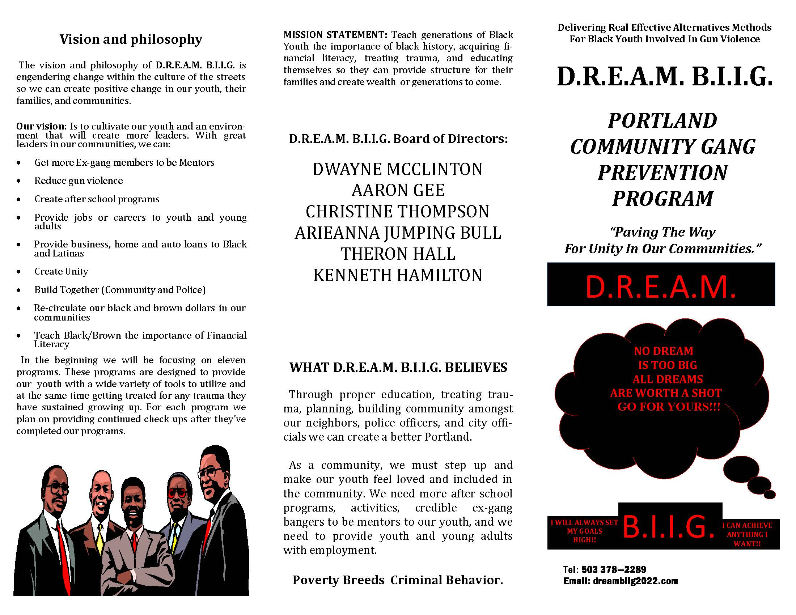

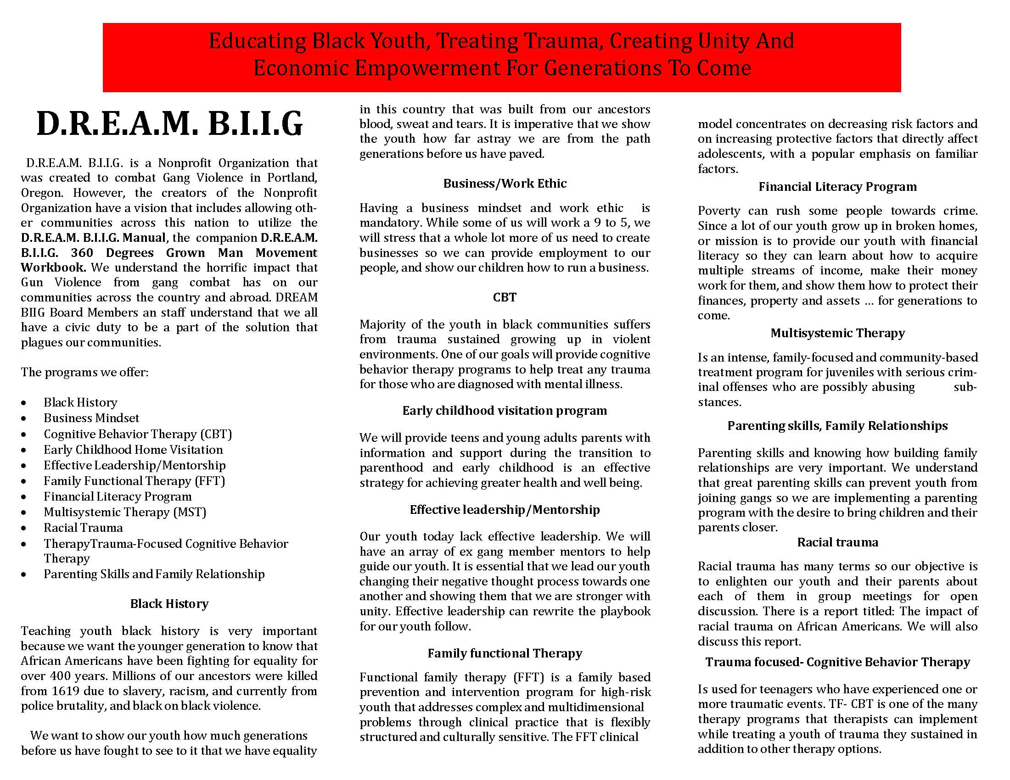

Bibliography
Part 1 Black History

- The Photobiography of Martin Luther King, Jr., by Clarles Johnson & Bob Adelman
- Red Summer, Wikipedia
- Red Summer, based on George Edmund Haynes' report, as summarized in the
New York Times (1919).
- W.E.B Dubois published “ returning soldier”(page 5 of 33)
- Oregon Black History, by Waldah Imarisha
- Black Labor White Wealth, by Claud Anderson, Ed.D.
- Black People In Oregon, by Marlon “Prxscott” Abah
- Black Wall Street and The Destruction of an Institution, by Josie Pickens on May 31, 2013 www.ebony.com/black-history/destruction-of-black-wal- street/
- Martin Luther King Jr., Memphis, April 2, 1968, by Photos
- Photos of martin Luther King Jr., by
- William York in 1805
- The Provisional Government of Oregon declared slavery illegal, 1844, 13. 1865
14. 1902
- 1925-1950’s The Coon Chicken Inn
- 1970 The Black Community Protested The Expansion of Emanual Hospital,
- 1969 Portland Chapter of The Black Panther Party,
- Gangs: Cripa and Bloods The Origin of Crips, by The New Afrikan Prison Struggle, Sundiata Acoli, pp. 144-145
- Origin of The Bloods, by The New Afrikan Prison Struggle, Sundiata Acoli, (Page 28 of 33)
- The Black Liberation Army, (Page 29 of 33)
- The Decade of The 1980’s (Page 29 of 33)
- The 90’s And Beyond, (Page 31of 33)
- A Shaky…pp.159 (Page 32 of 33)
24. On September, 1998, pp.160-161 (page 33 of 33)

Part 2
Insight and Understanding About Portland, Oregon’s Street Gang Culture

Part 3
Identifying The Root Cause That Can Lead African American Youth Toward Gang Affiliation

Part 4
Recognizing, Understanding, And Dealing With The Effects That Are Often Associated With Gang Affiliation

  - The New York Times, Friday, November 19, 2021 (2 of 30)
  - Drug Abuse Statistics (7 and 8 of 30)
  - Policing Black People Statistics (11 of 30)
  - Stop and Frisk (12 and 13 of 30)
  - Black on Black Statistics (14 and 15 of 30)
  - Black Crimes Should Be Addressed Better (16 and 17 of 30)
  - Incarceration of Blacks Facts (18 and 19 of 30)
  - However, from 1980 to 1994, prisoners increased by 221%… (23 of 30)
  - Black Women In Prison (26 and 27 of 30)
  - Incarcerated Workers Organizing Committee: Prison Slavery (26 and 27 of 30)
  - Oregon Department of Corrections PRAS Award System (29 of 30)

Part 5
Traumatic Effects of Being Exposed To Gang Culture

- The Combat Trauma Healing Manual, By Chris Adsit pp.22, 24,26,27 (4 thru 7 of 20)
- PTSD – Rachel Yehuda (7and 8 of 20)
- Jerome Groopman (“The Grief Industry,” New Yorker, January 26, 2004, pp. 30 – 38 (8 and 9 of 20)
4. Time, July 12, 2004, pp.35 – 36 (9 of 20)
- Racial Trauma, by (12 of 20)
- Diagnostic and Statistical Mental Disorders, by (14 of 20)
- Mind Over Mood, by Dennis Greenberger, Ph.D/Christine A. Padesky, Ph.D
- Medication (16 of 20)
- Eye Movement Desensitation And Reprocessing (EMDR, Client Handbook
– www.emdria.org. (18 and of 20)
EMDR 8 Stage Protocol www. Emdria.org. (19 of 20)
- What happens when you are traumatized? (19 of 20)
- What is an EMDR Session Like? www.getselfhelp.co.uk, adapted from
www.thetraumacentre.com (19 of 20)
- How Long Does Treatment Take? www.thetraumacentre.com (20 of 20)

Part 6
Cognitive Behavior Therapy (CBT)

1. Trauma –Informed Treatment Prgrams, U.S. Department of Justice, Office of Justice Programs, National Institute of Justice Jornal, Issue No. 283, pp. 33 and 34

Part 7 Financial Literacy

- Rich Dad Poor Dad, Robert T. Kiyosaki (2 and 3 of 20)
- IRS.gov 2021 (Tax Brackets and Tax Rates) (3 of 20)
- Rich Dad Poor Dad, Robert T. Kiyosaki (4 of 20)
- Rich Dad Poor Dad, Robert T. Kiyosaki (5of 20)
- Truth About Money, by Ric Edelman (5 of 20)
- PowerNomics, by Claud Anderson, Ed.D (12 of 20)
- The Color of Money, by Mehrsa Baradaran (14 and 15 of 20)
- Black-Owned Banks and Creit Unions: Where to find them, by Spencer Tierney, Feb 1 2021 – Nerdwallet (15 of 20)
- Jesse Binga story, in The Color of Money, by Mehrsa Baradaran (16 of 20)
10.20 Black-Owned Banks, by Spencer Tierney, Feb 1 2021 – Nerdwallet (16 of 20)
- The Typical White Family, by Spencer Tierney, Feb 1 2021 – Nerdwallet (16 of 20)
- Savings Bank of The Grand Foundation United Order –
- 32 Black-Owned Banks and Credit Unions, Sorted by State, by Ryan Wangman, CEPF and Leslie Quander Woodrige, Updated Feb. 1, 2022 (17 of 20)
- One United (17 of 20)
- One United offers (17 of 20)
- The Number One Reason…. (17 of 20)
- Think And Grow Rich: A Black Choice, by Denis Kimbro and Napoleon Hill (18 of 20)

Part 8 Business Mindset

1. Black-Owned Business Statistics And Trends For 2021, Source Posted 03/11/2021 in General by Nationally Black Owned (1 of 7), (2 of 7), (3 of 7), (4 of 7).

Part 9 Recreating Yourself
- AIDS… by The New Afrikan Prison Struggle, Sundiata Acoli, (20 of 30)

Part 10 Overview and Graduation

