PHOTOS OF MY WIFE, DAUGHTER

FAMILY AND FRIENDS

MY WIFE CHRISTINE & OUR DAUGHTER MCKEEVA

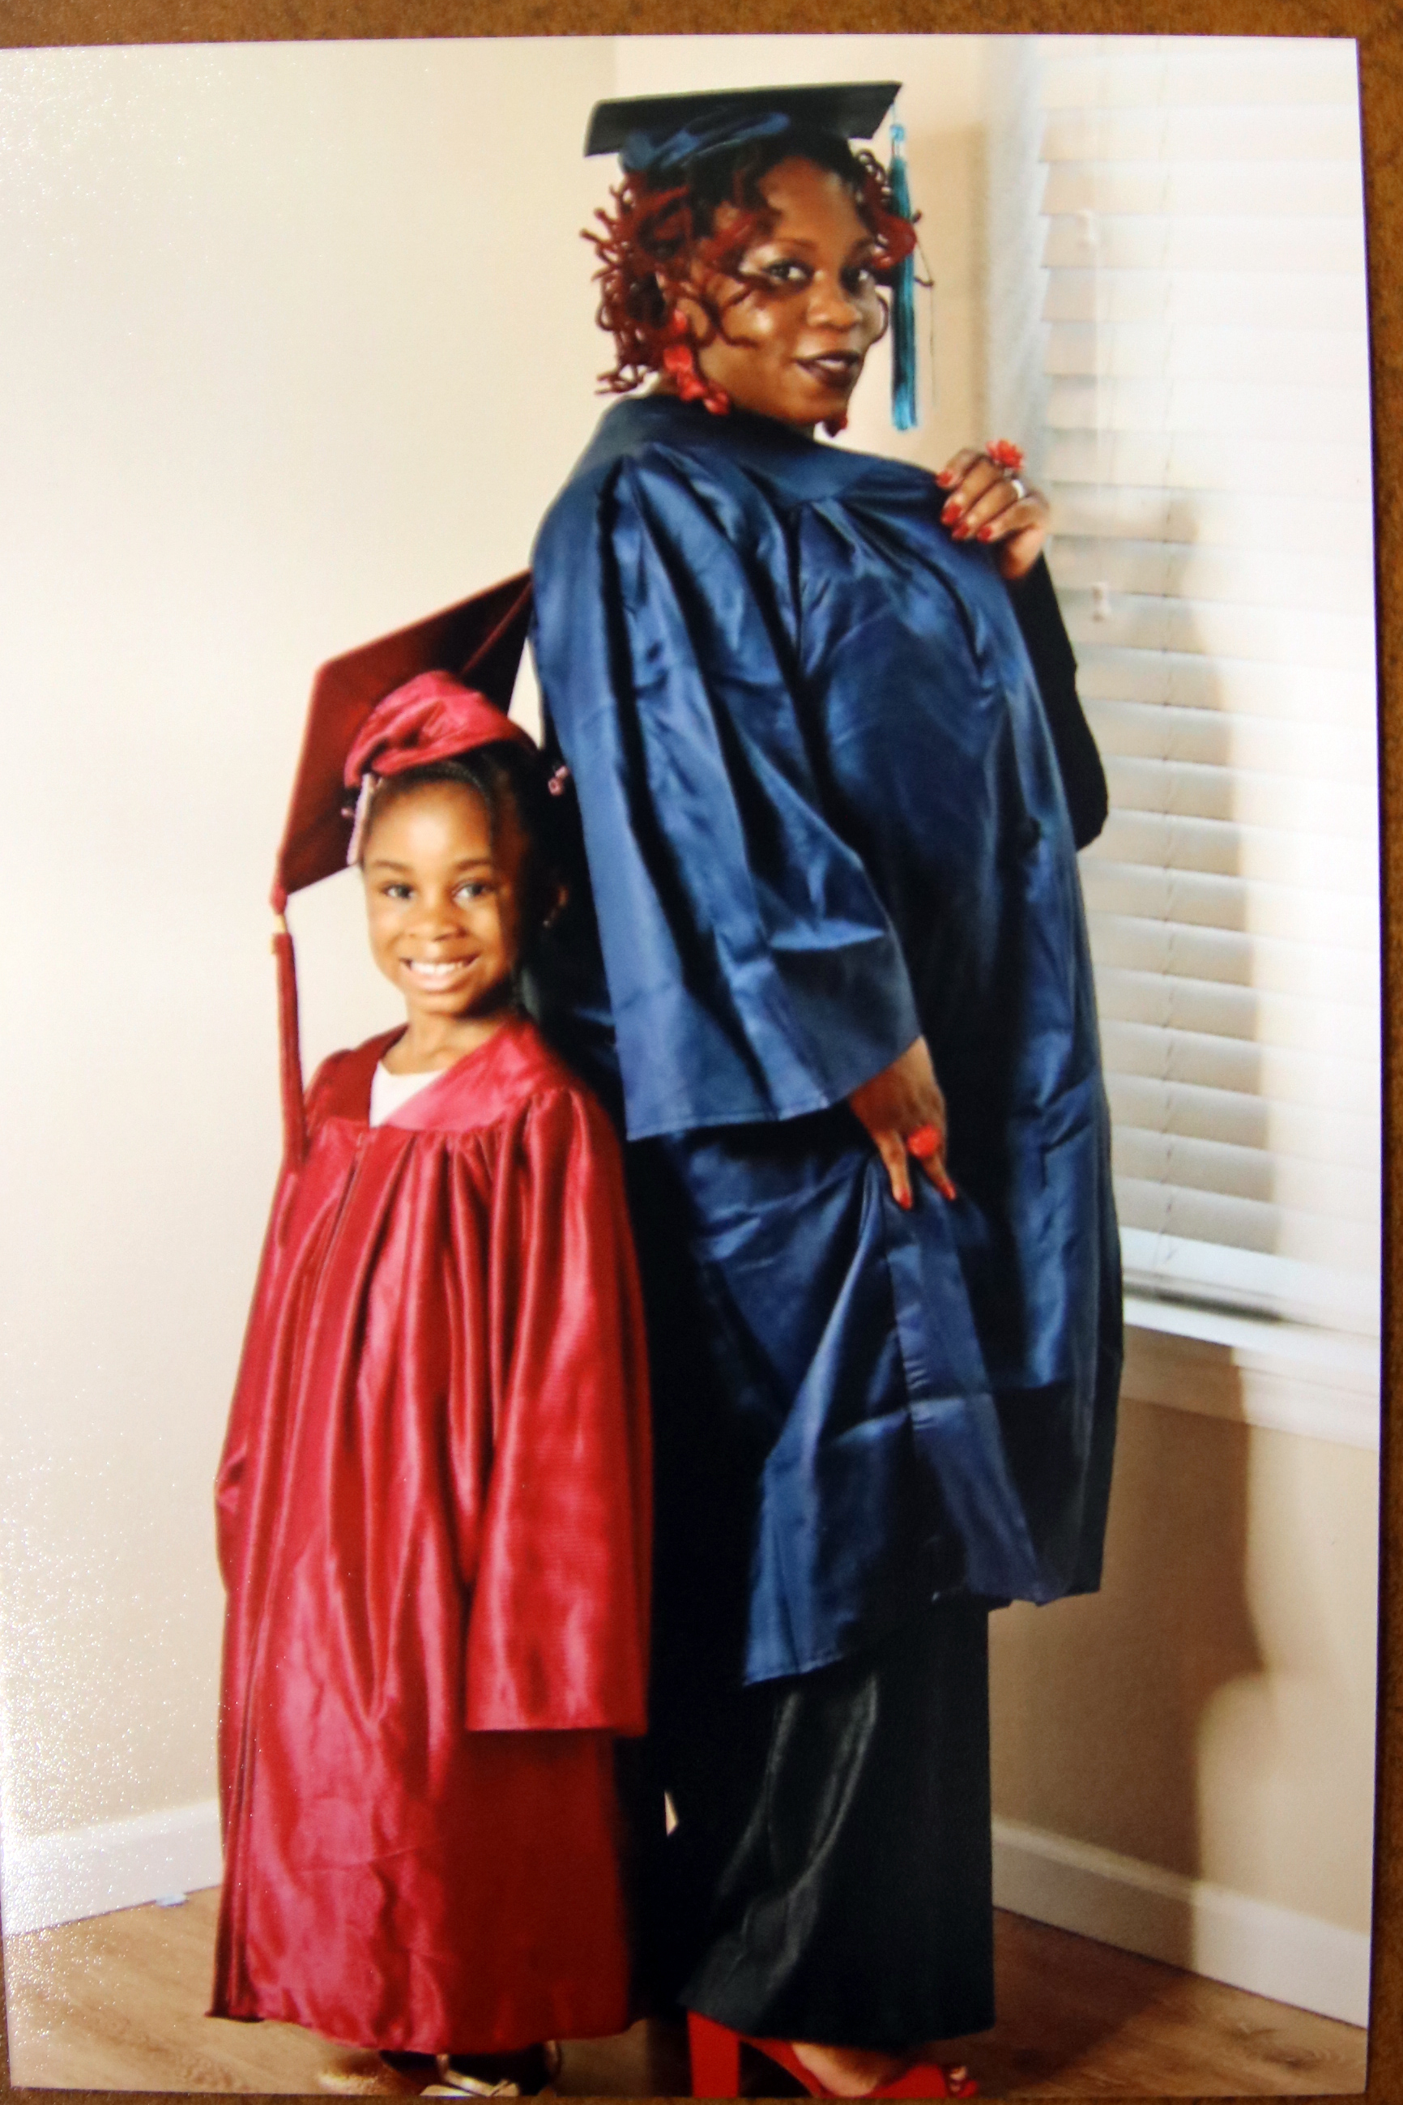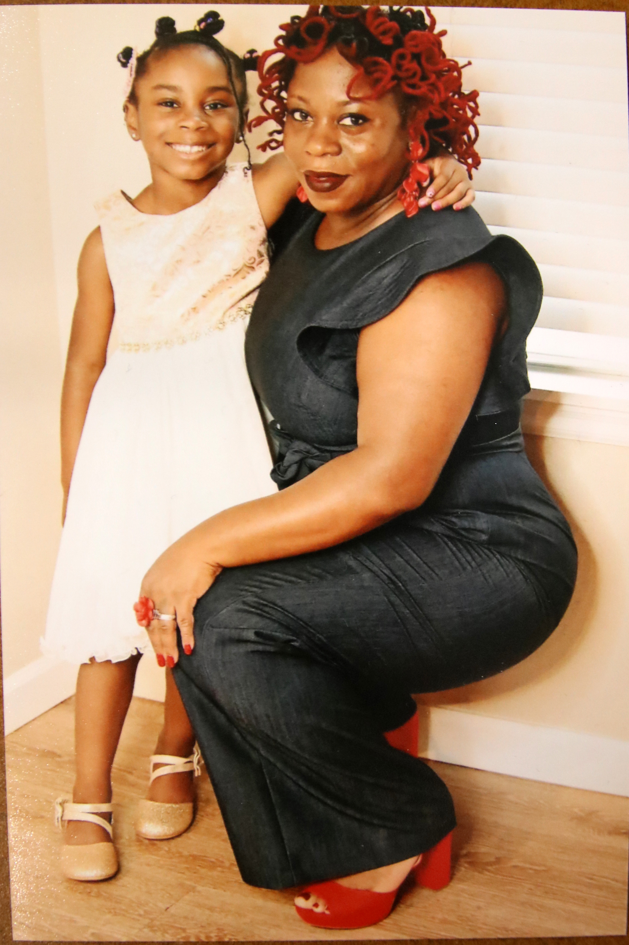

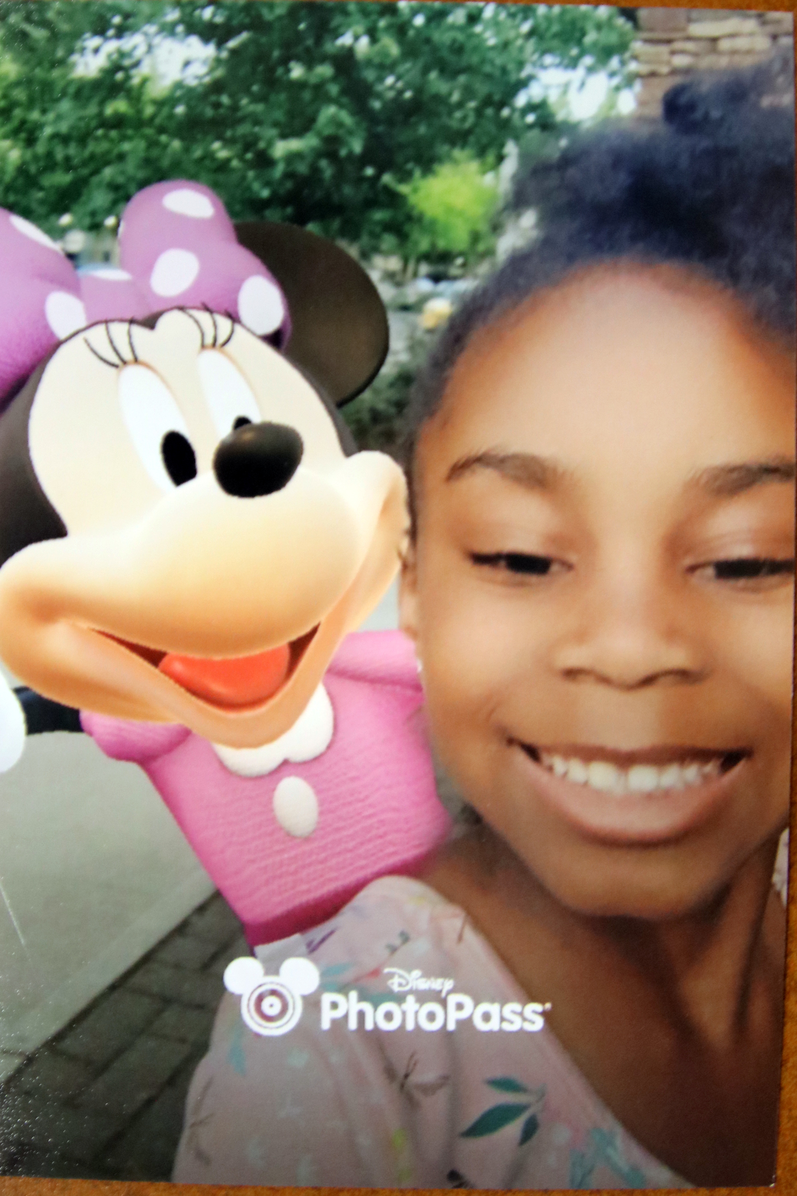Christine McClinton
McKeeva Coleman


Me
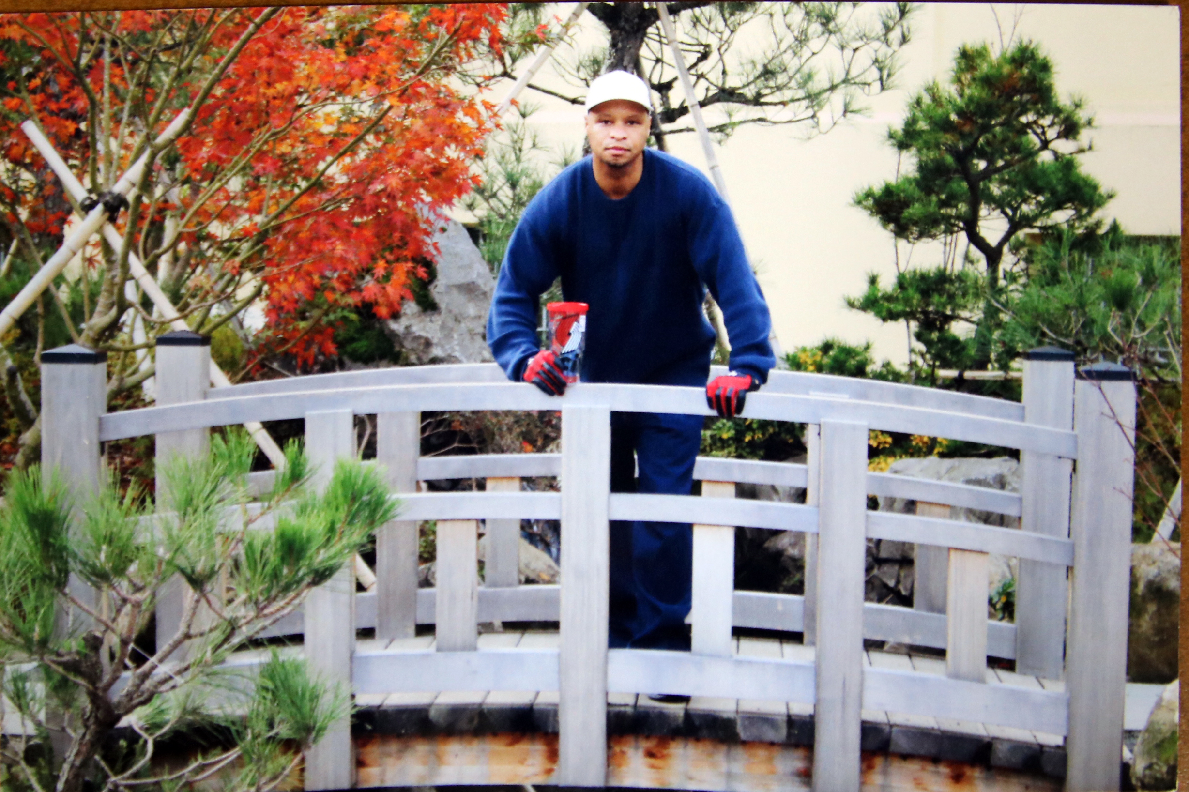

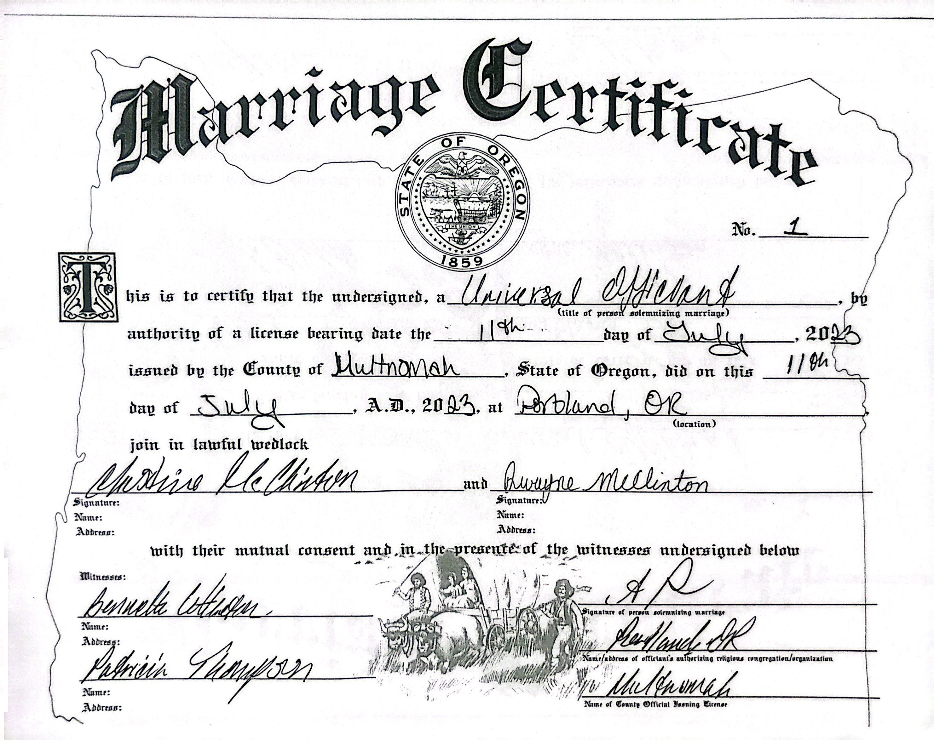
Got married 07/11/2023

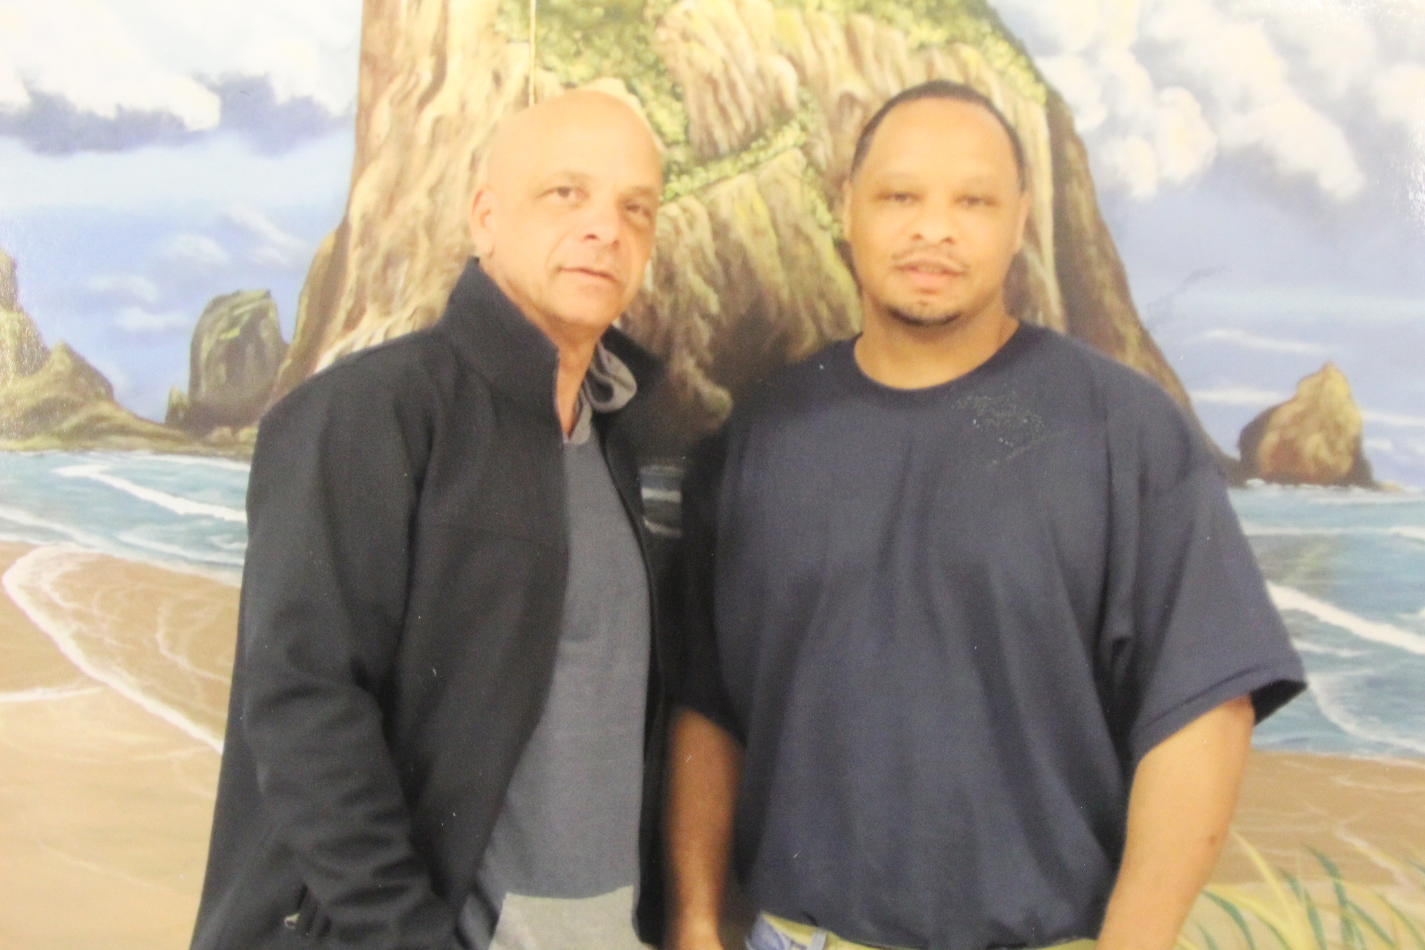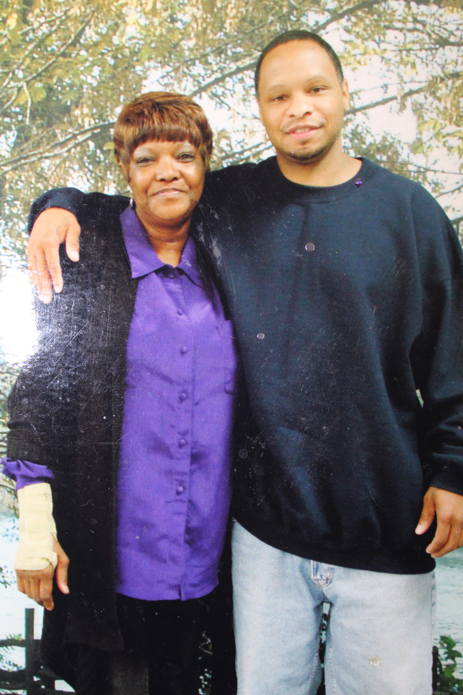Me and My Mother Me and My Father

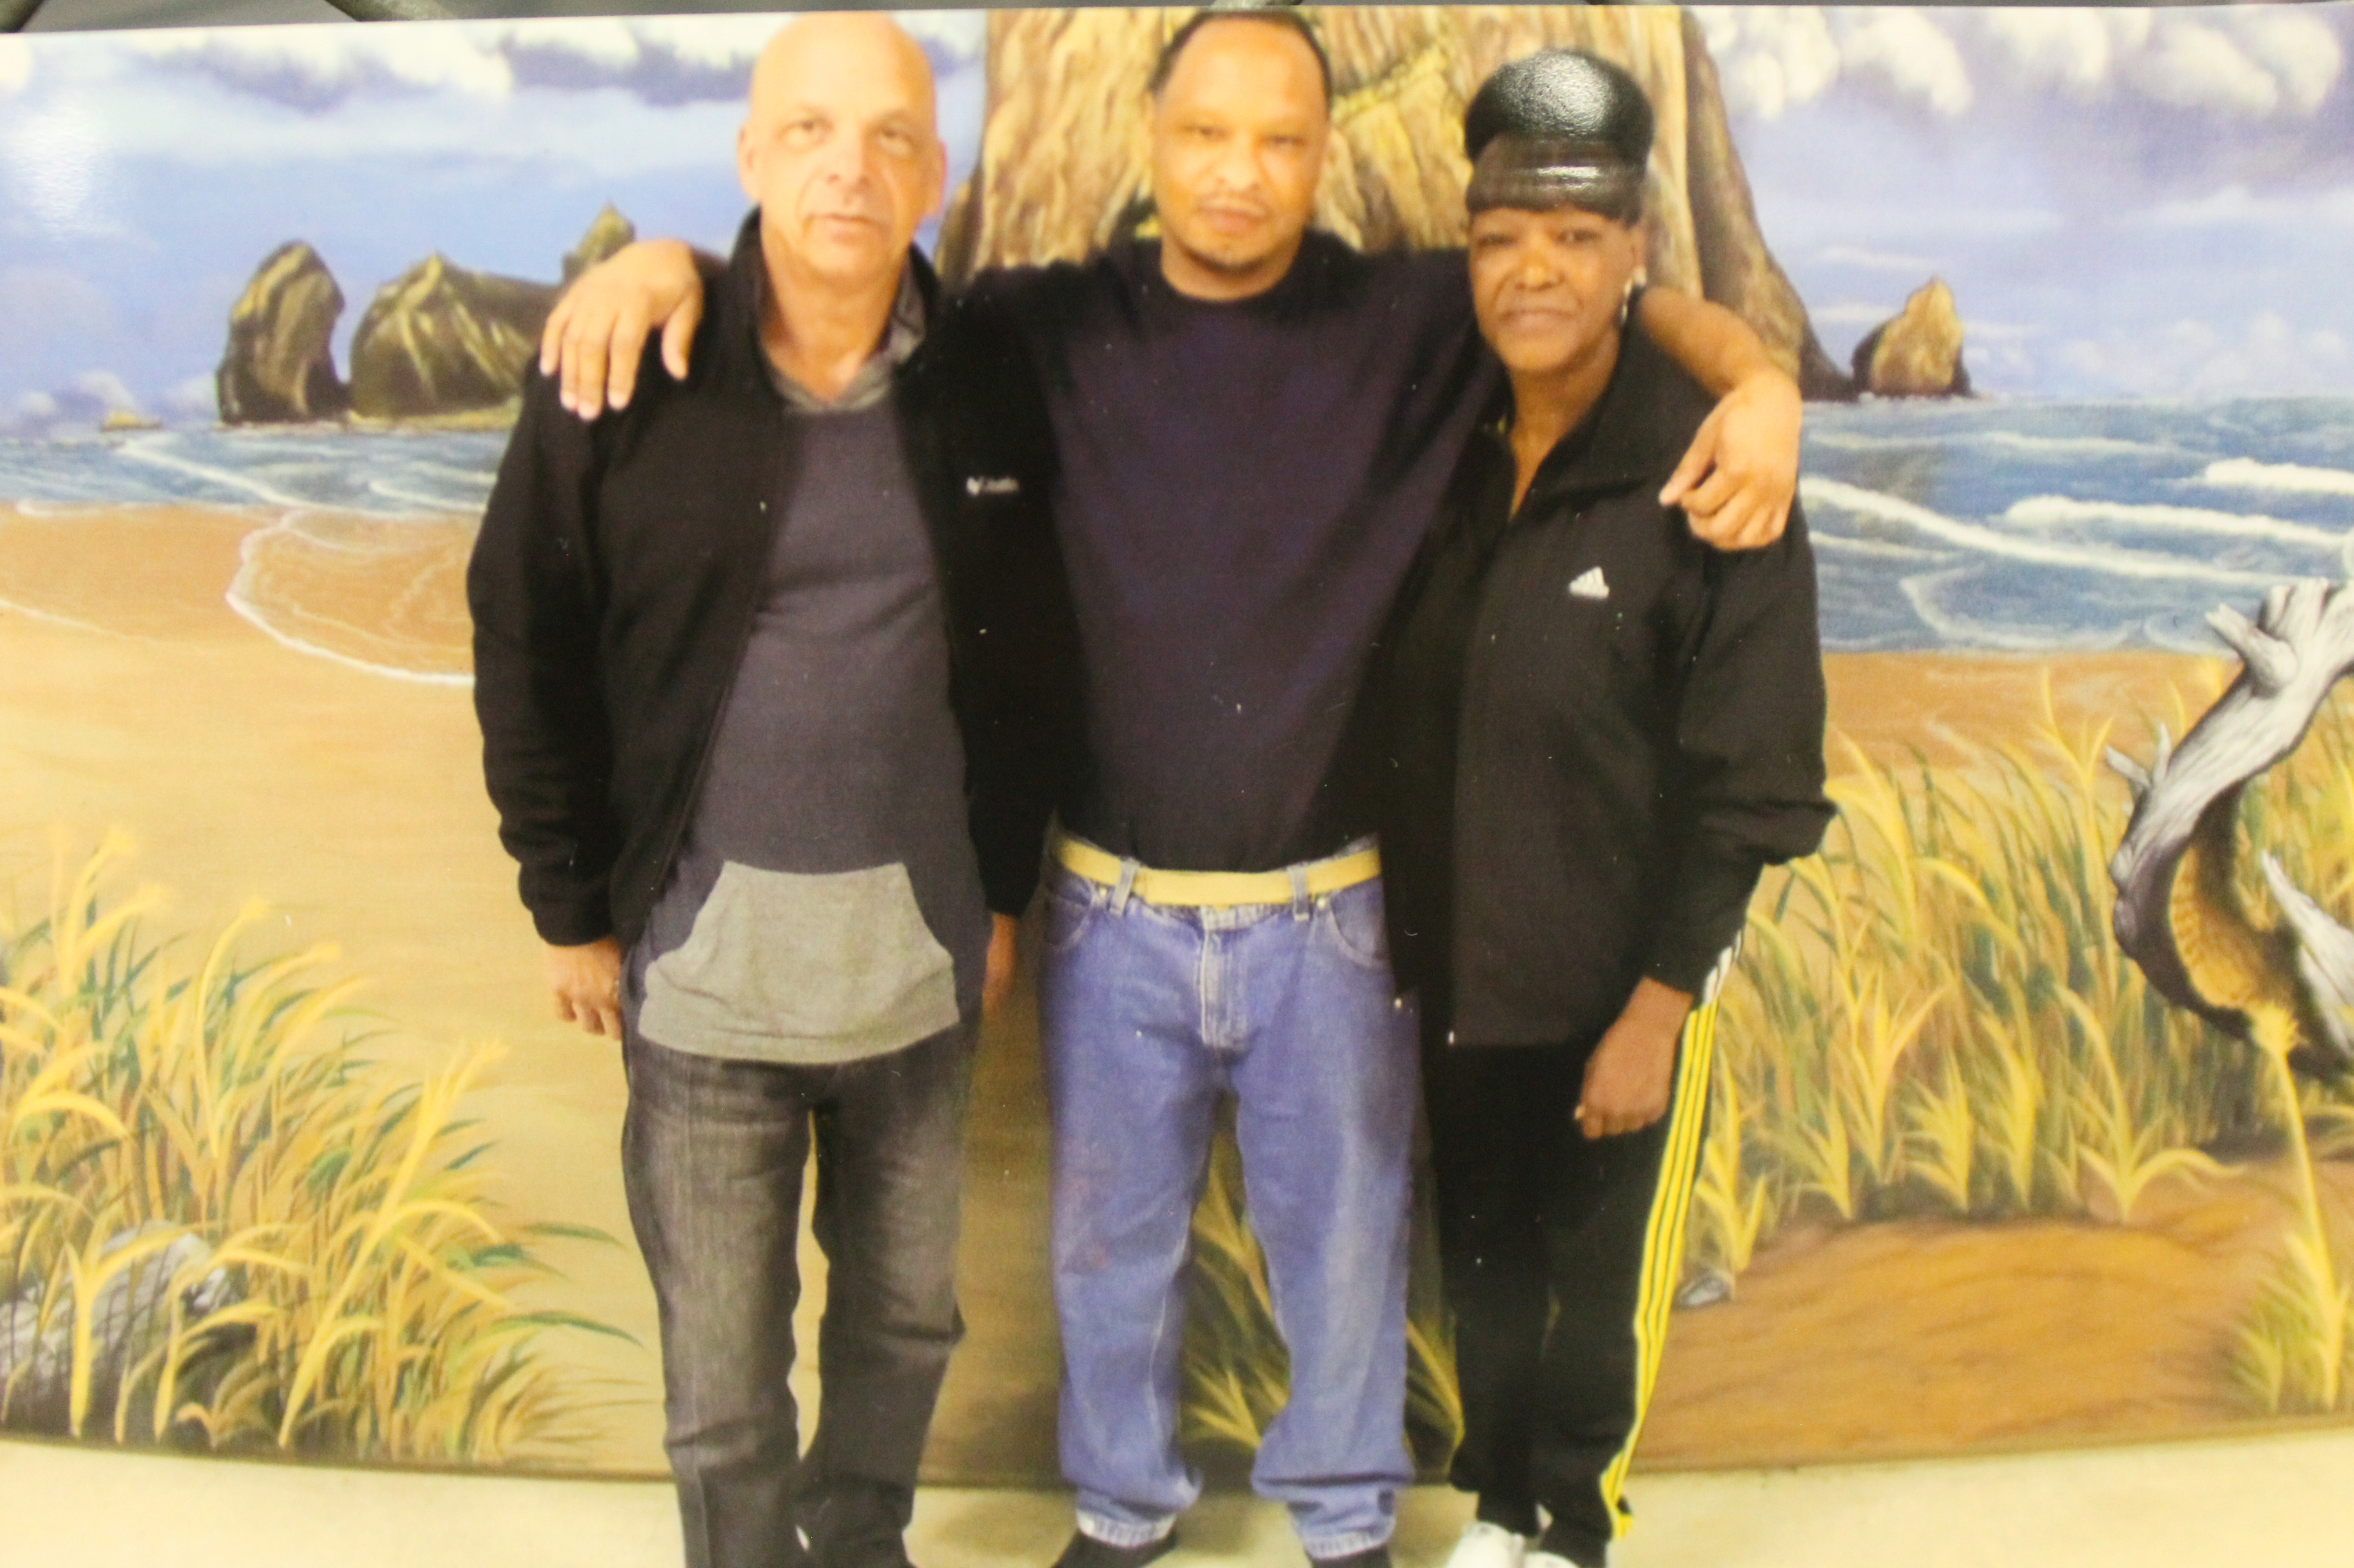 Me, My Mother & Father
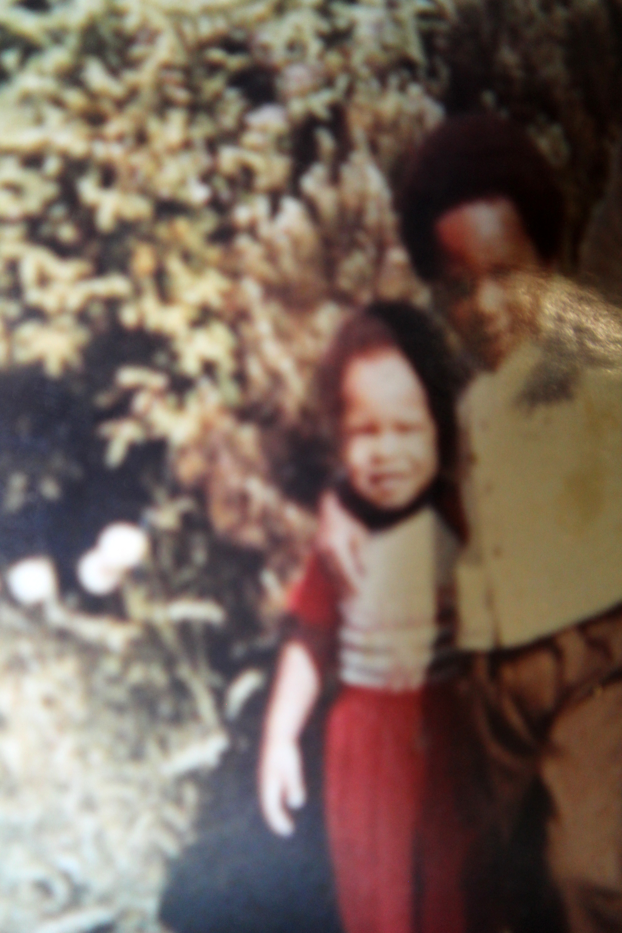
Me and
My Brother

Me, My Mother, My Little Cousin Justus, and Her Mother Edna

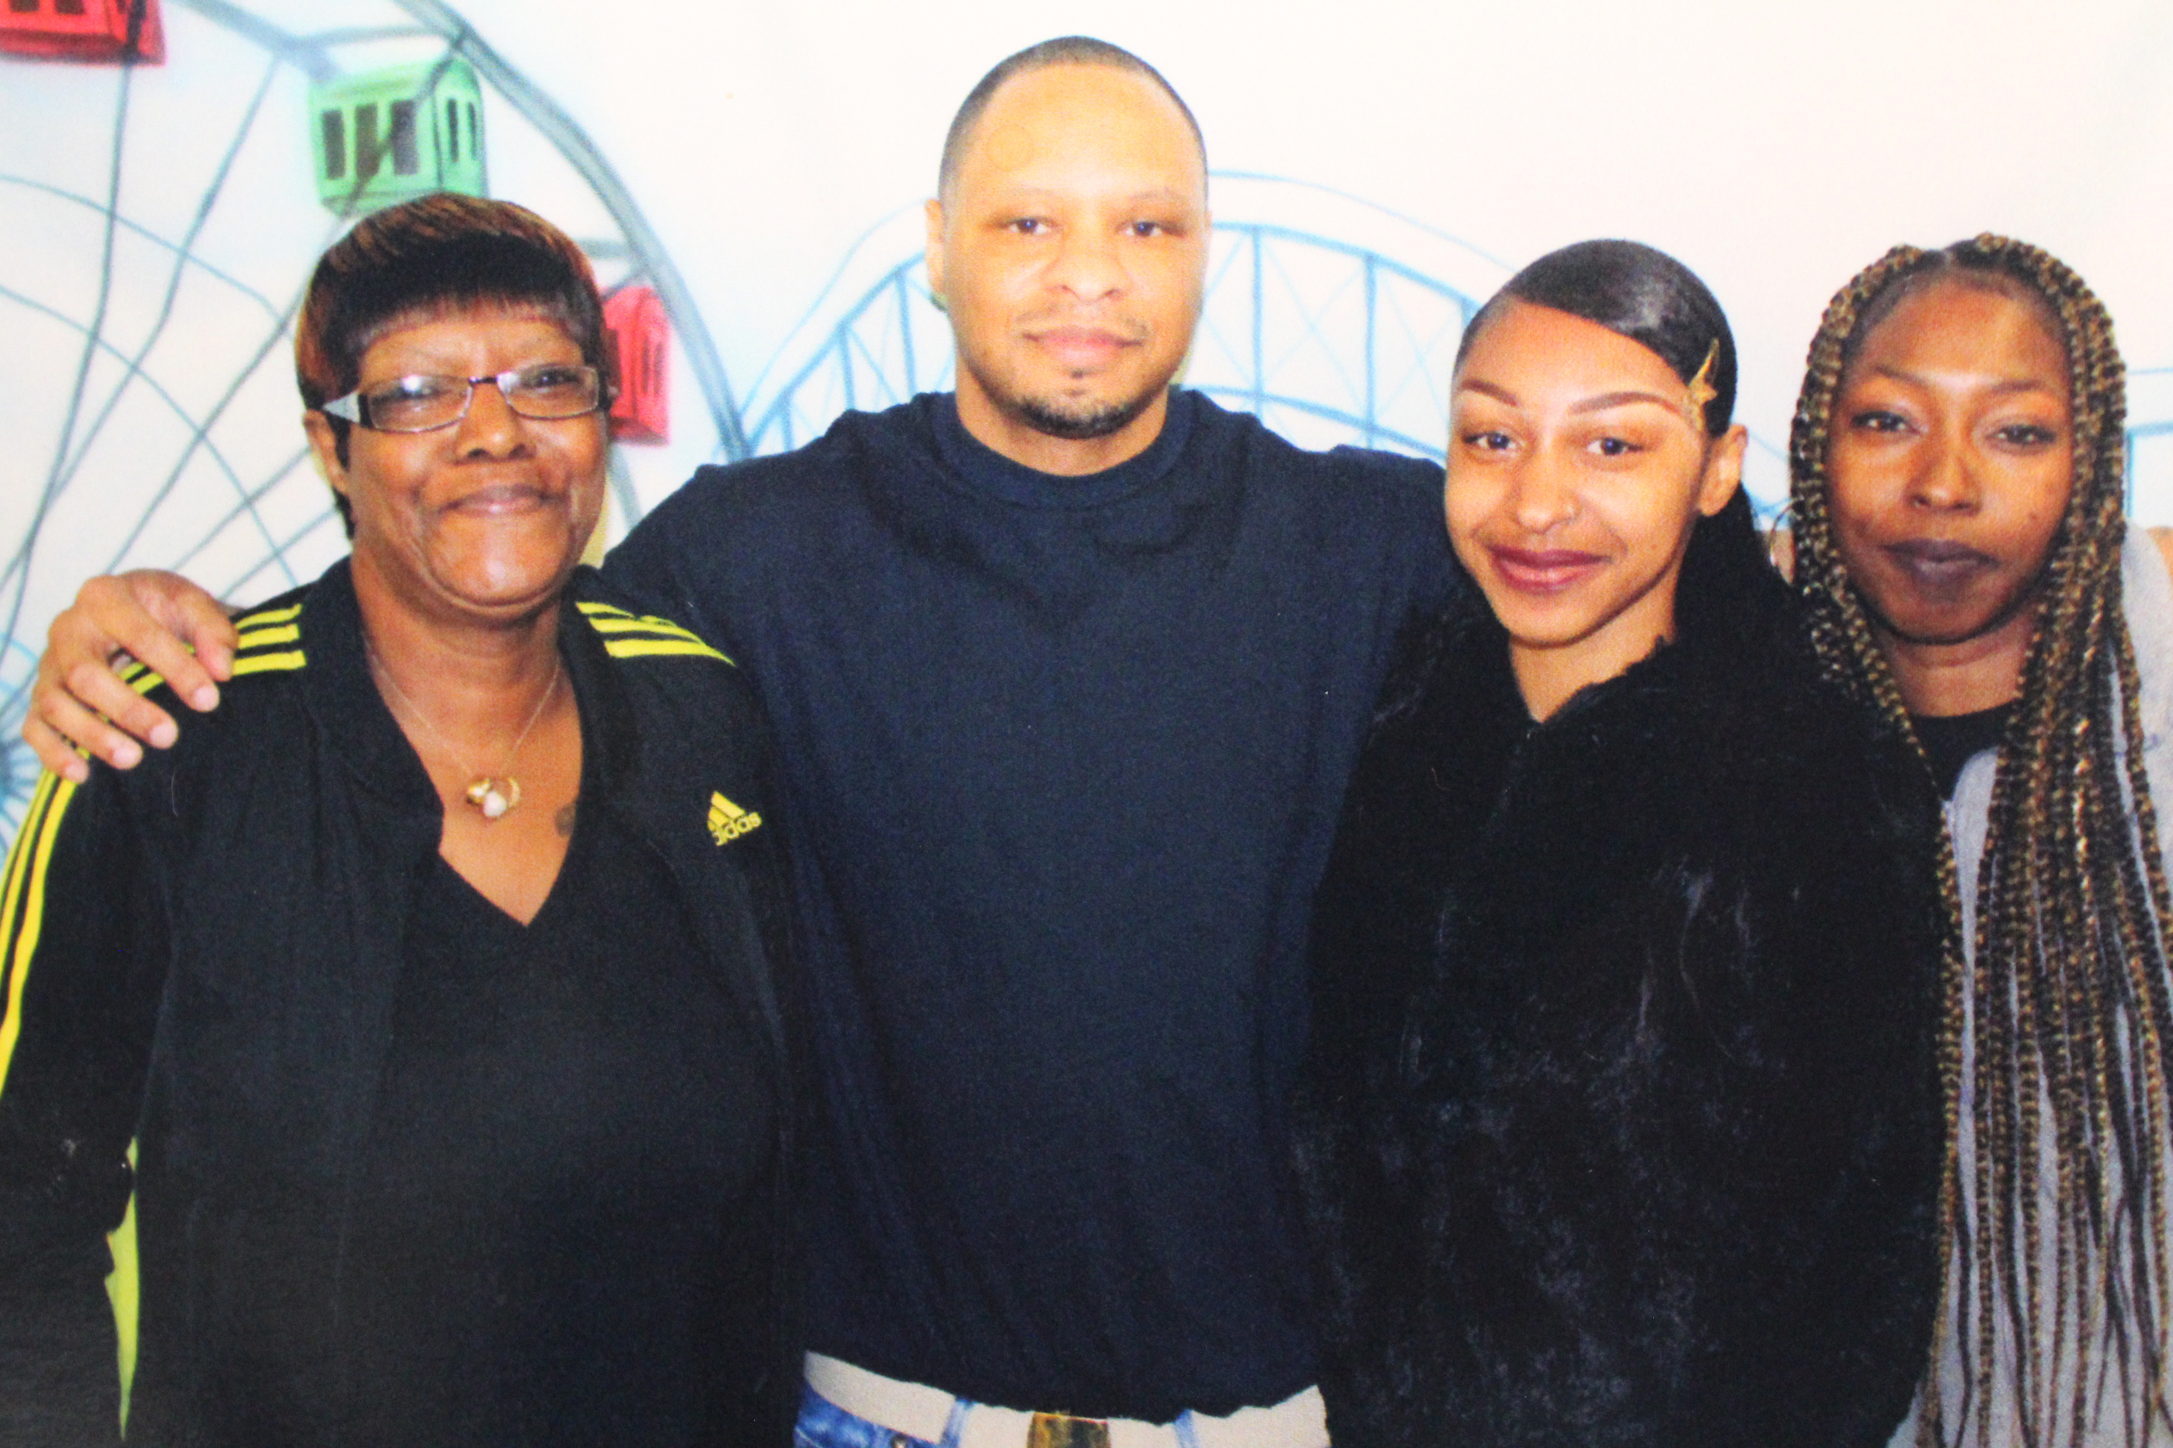

Me, My Cousin Edna, and Her Daughter Justus
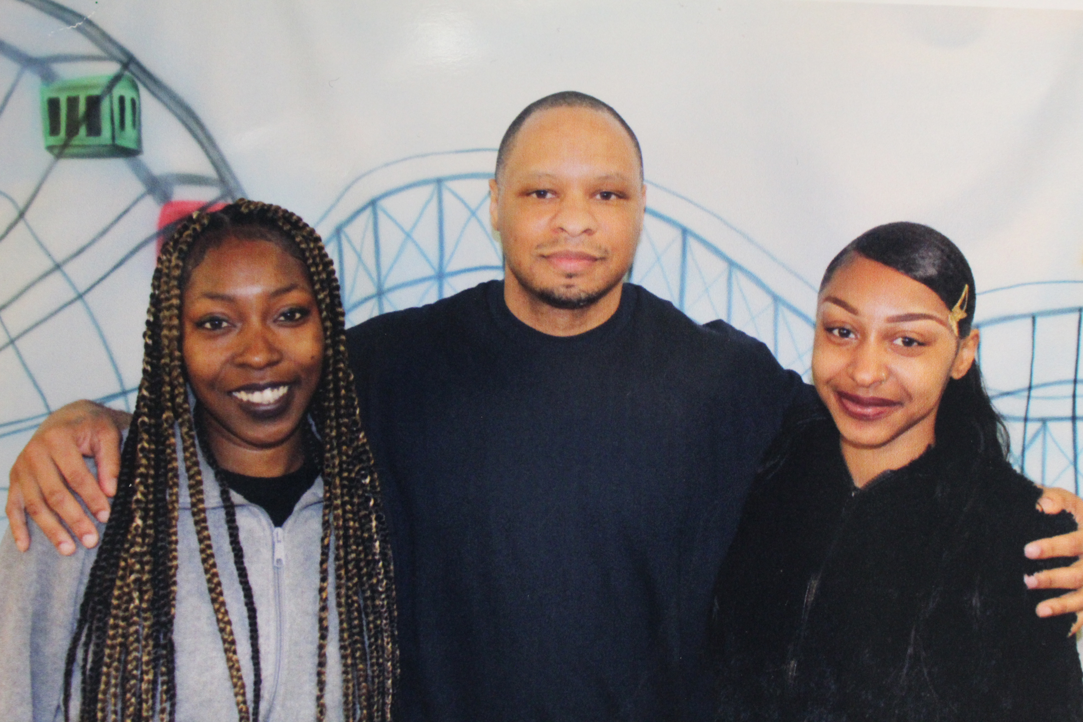

Christine, McKeeva, Patricia and Christine’s Brother, Freddy Celebrating Christine Graduating from College
My Fiancée Christine, Our Daughter McKeeva, and Christine’s Mother Patricia Thompson

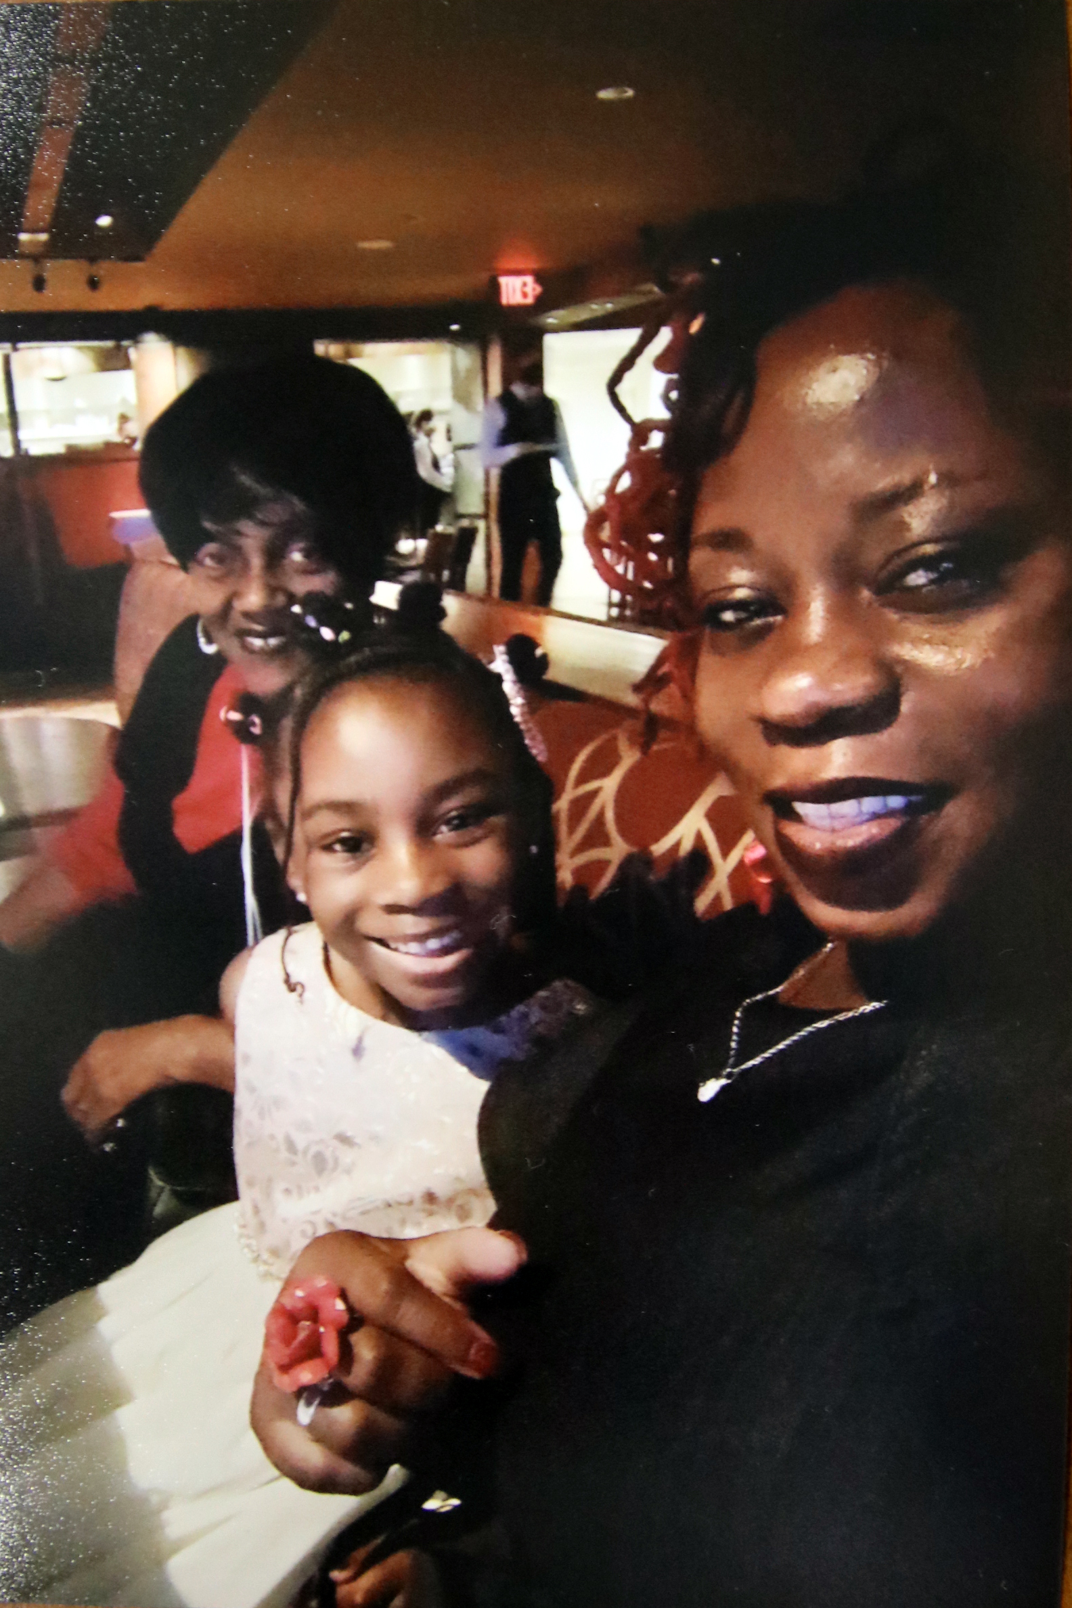
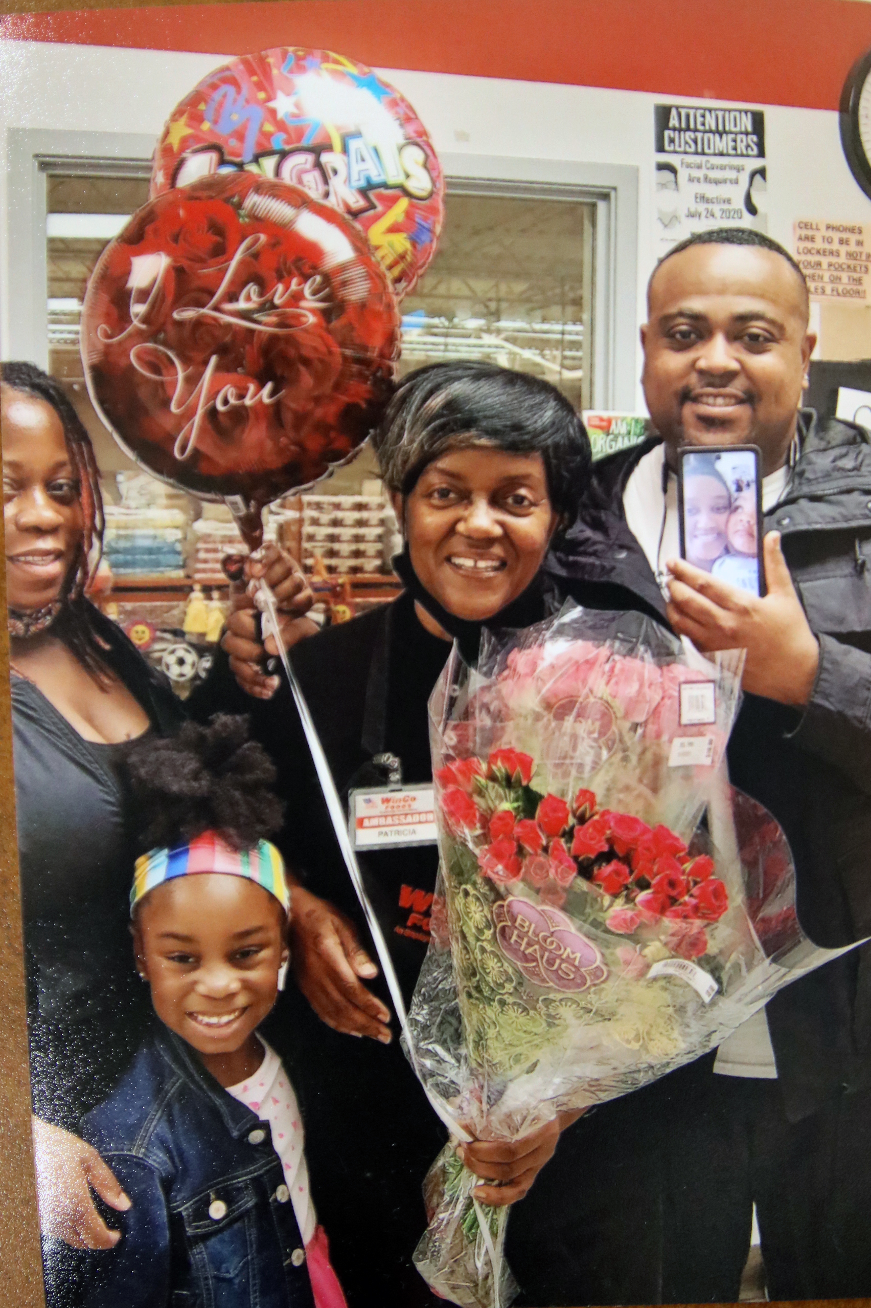

My nephew Aaron Campbell Jr. Aaron Campbell Sr. was shot and killed by Portland Police in January of 2010. I am going to help my sister raise Jr., and his two sisters.

My niece Miya, age 2
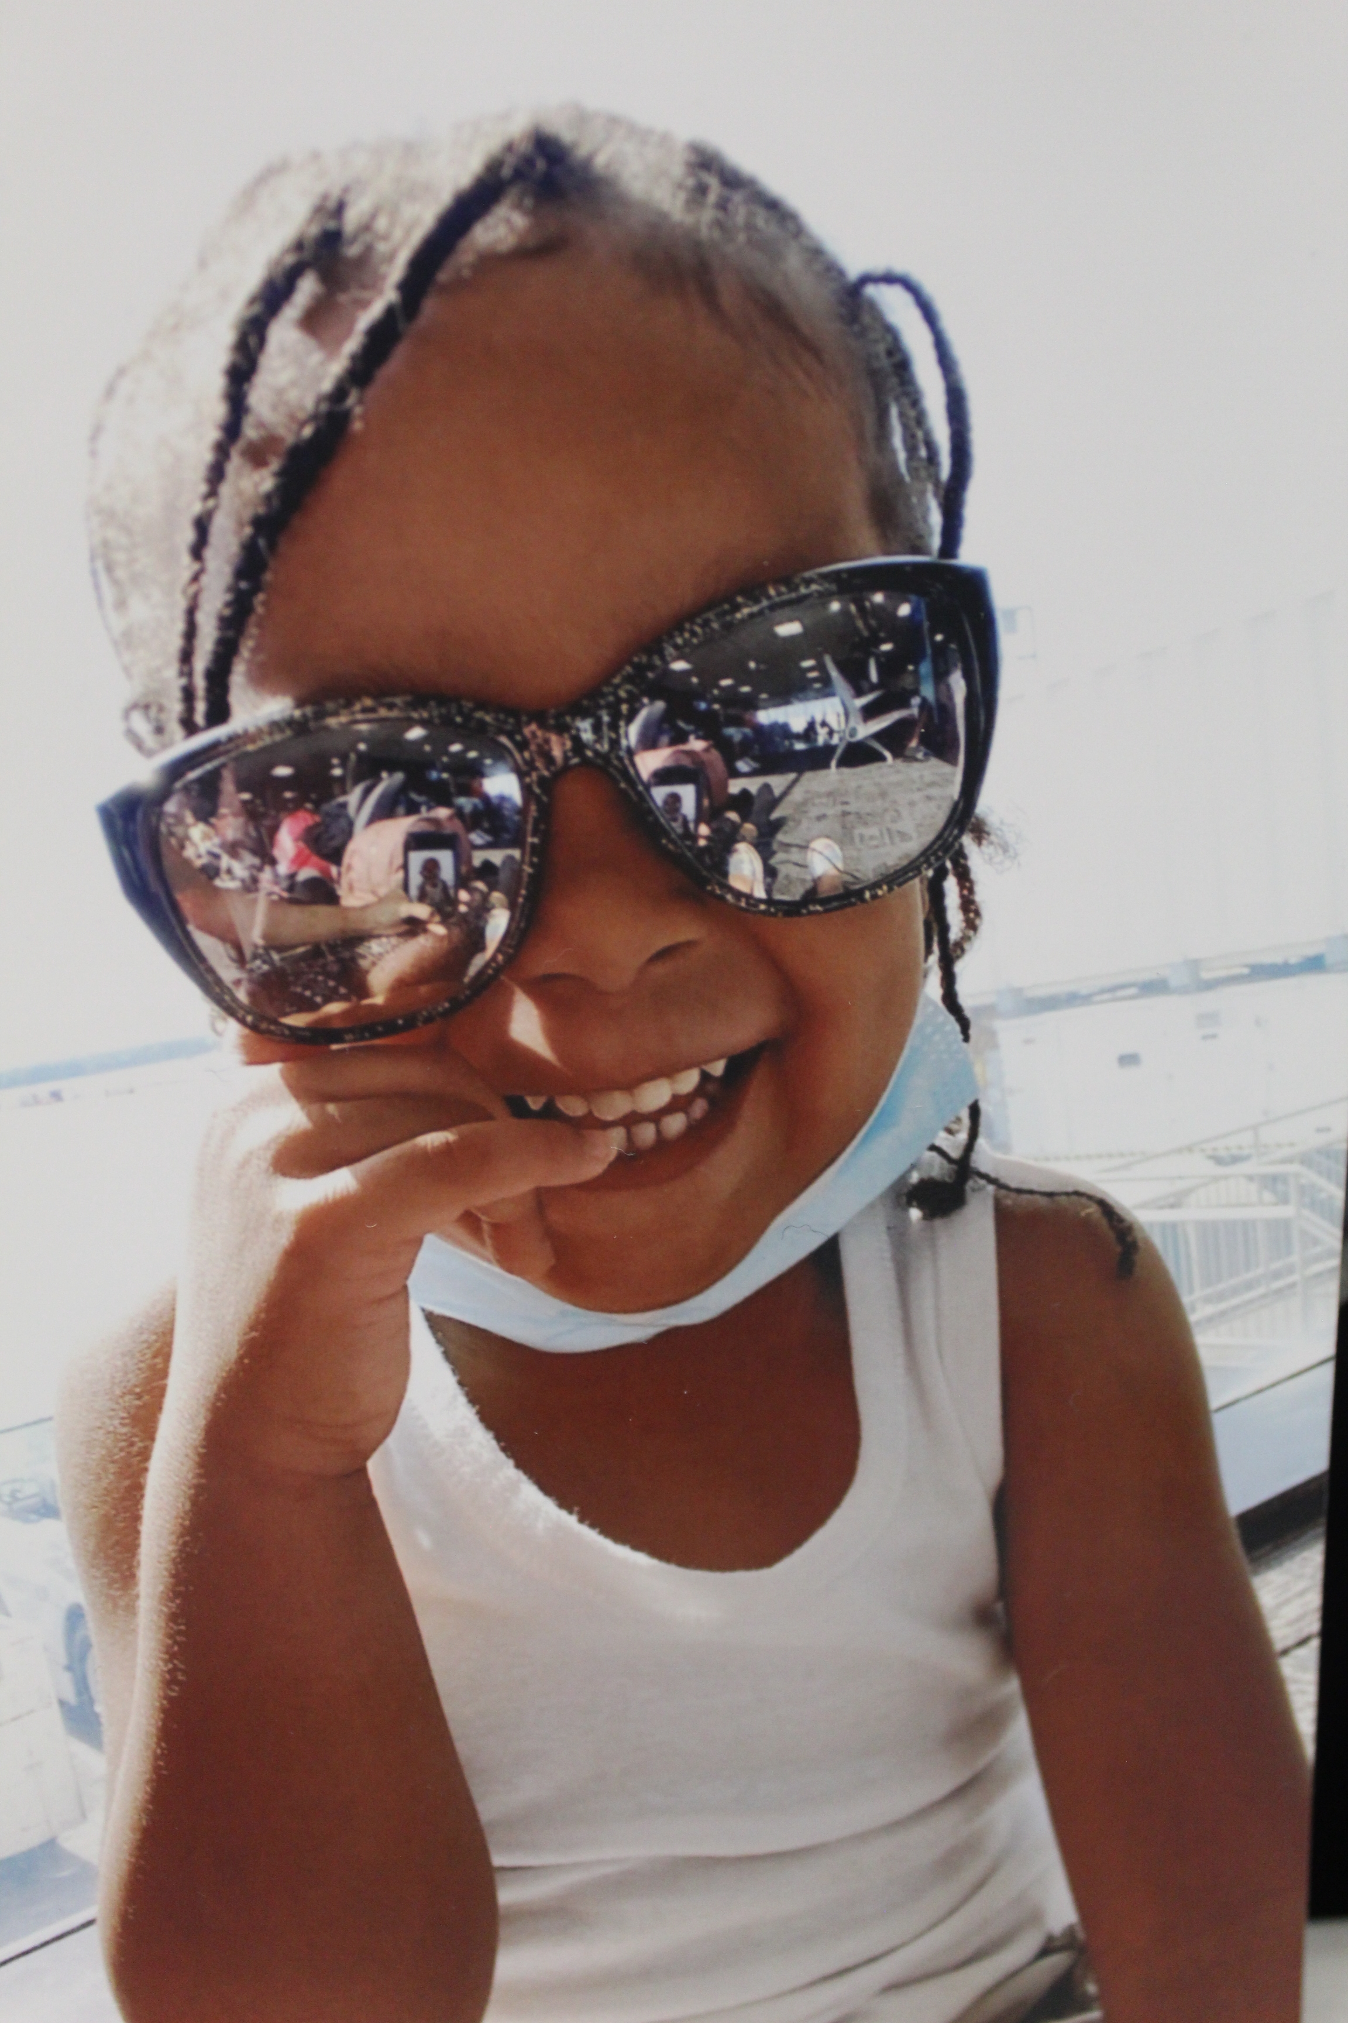
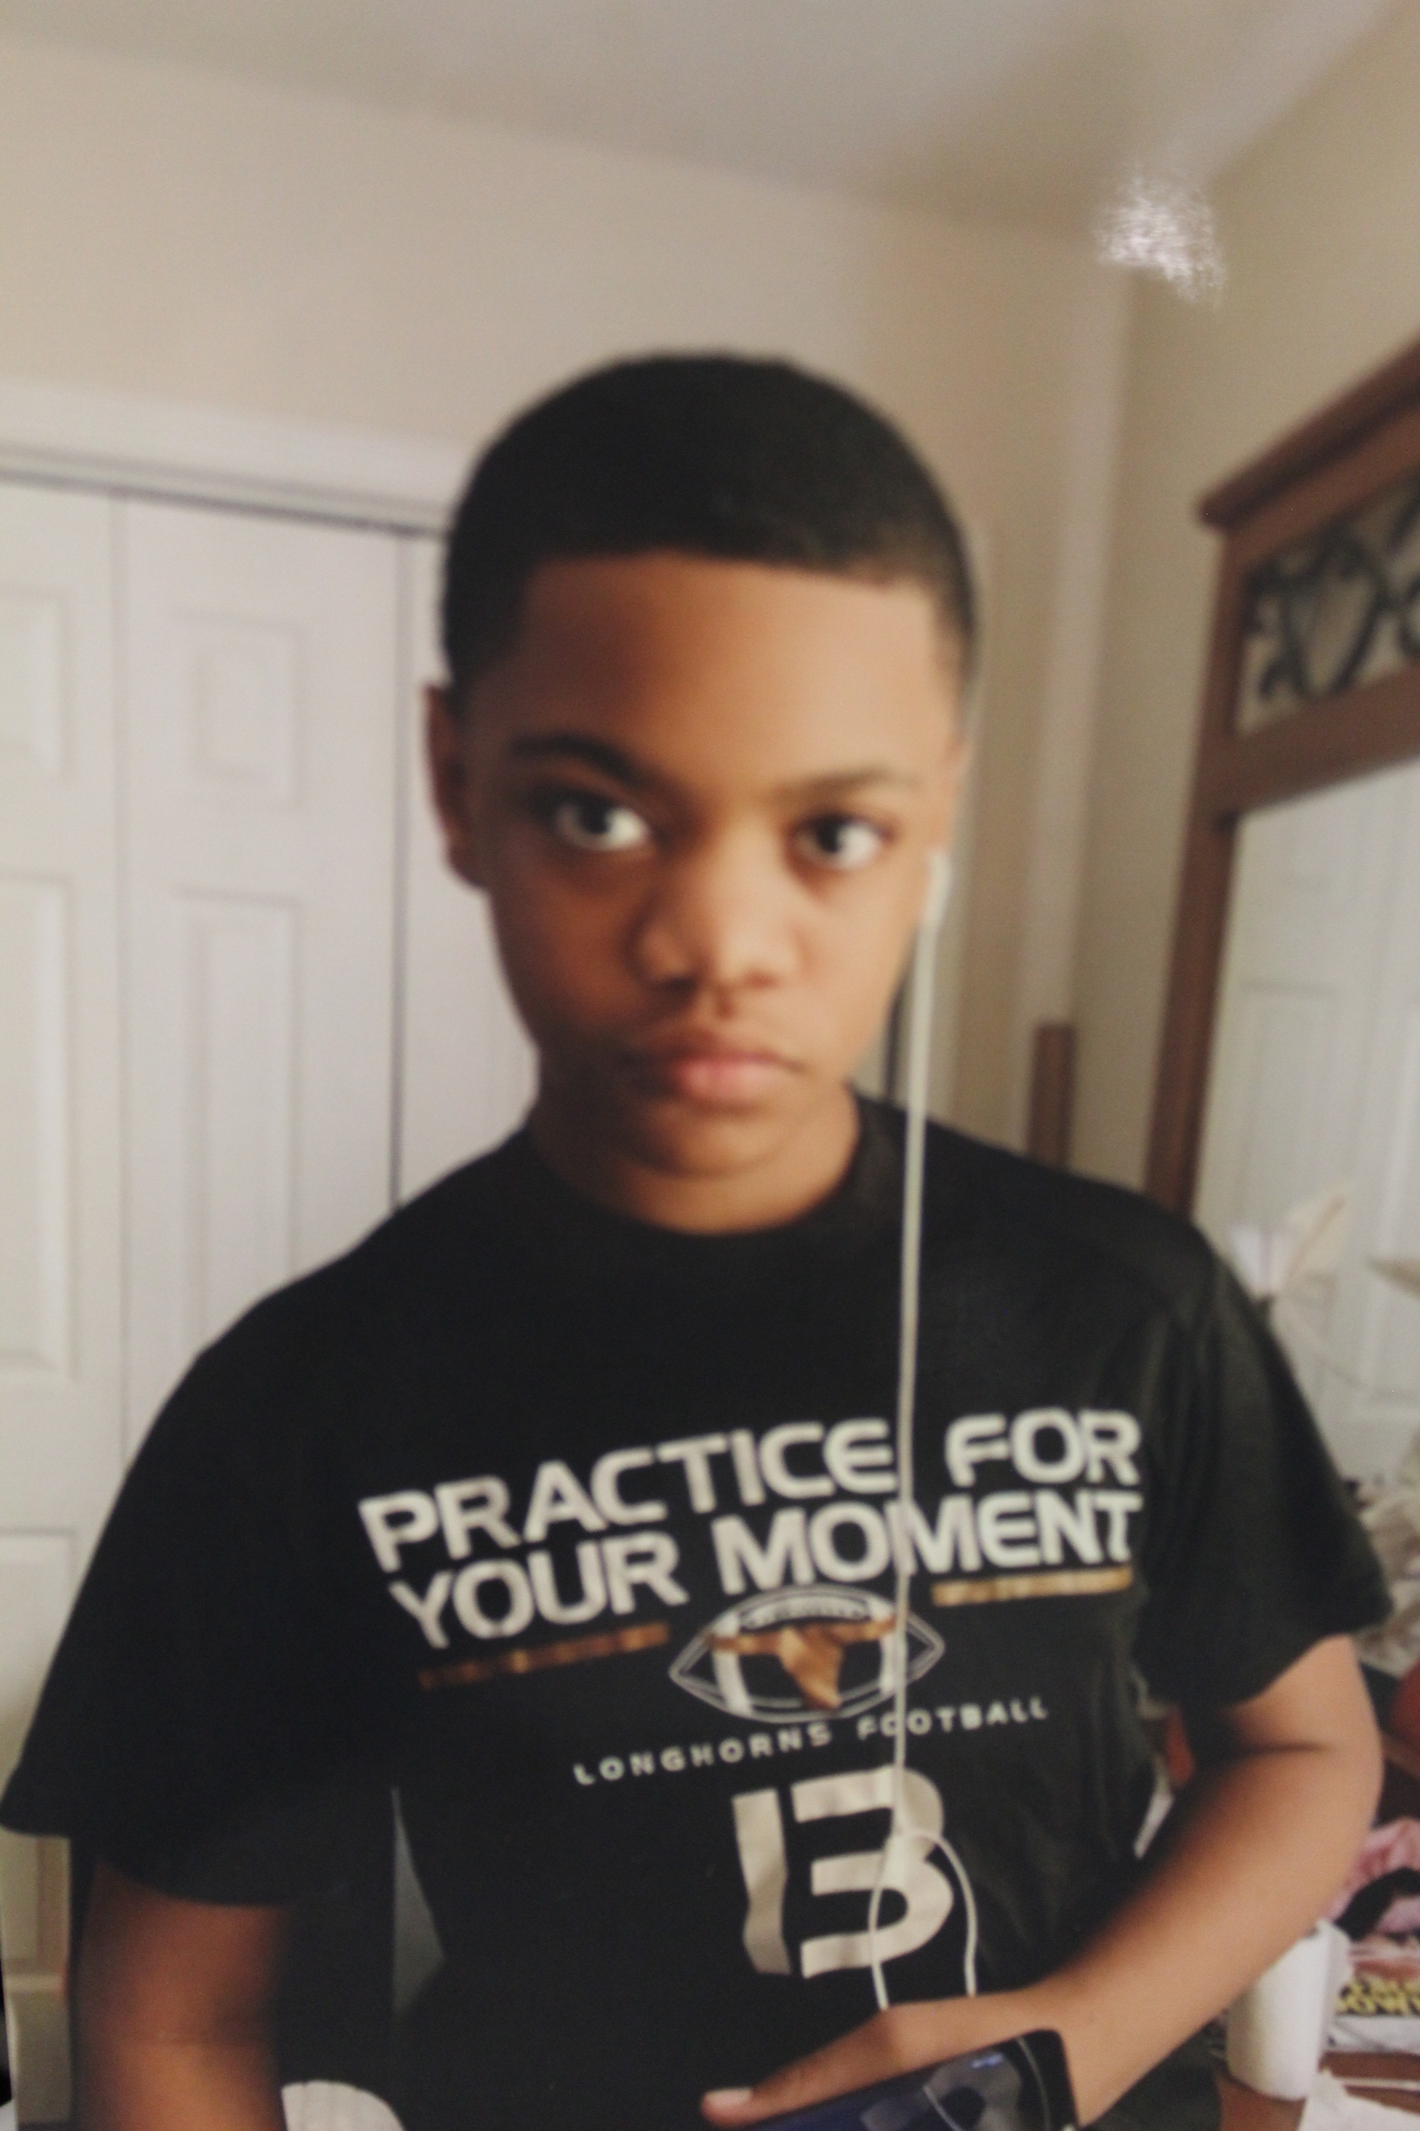

My older niece Jaeda, and My Sister Ayanna

Me and My Beautiful Niece Miya
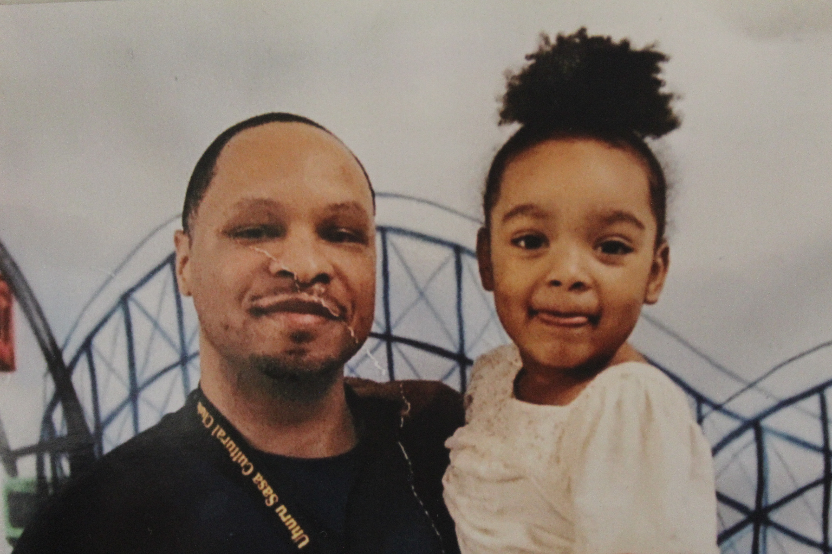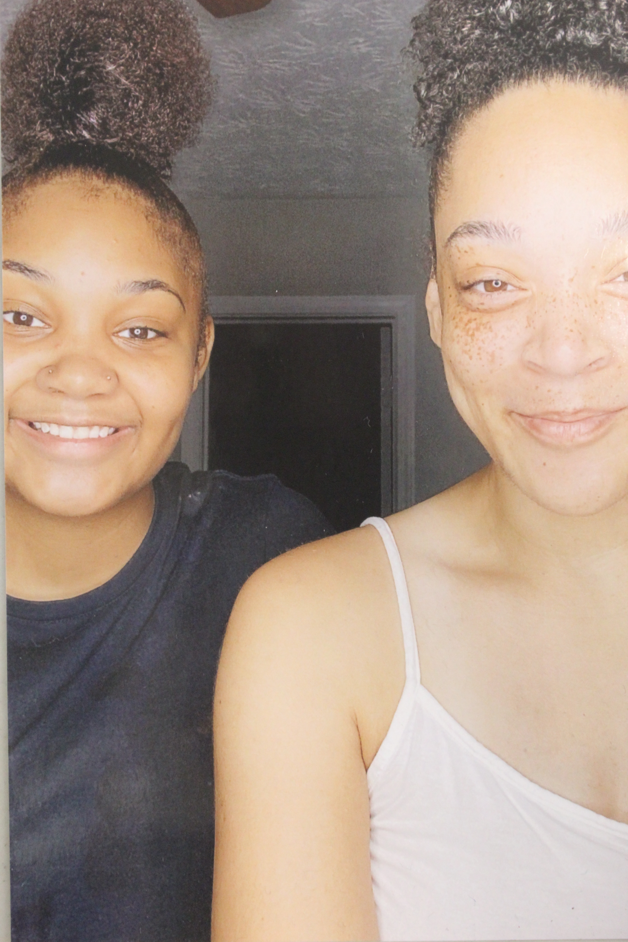

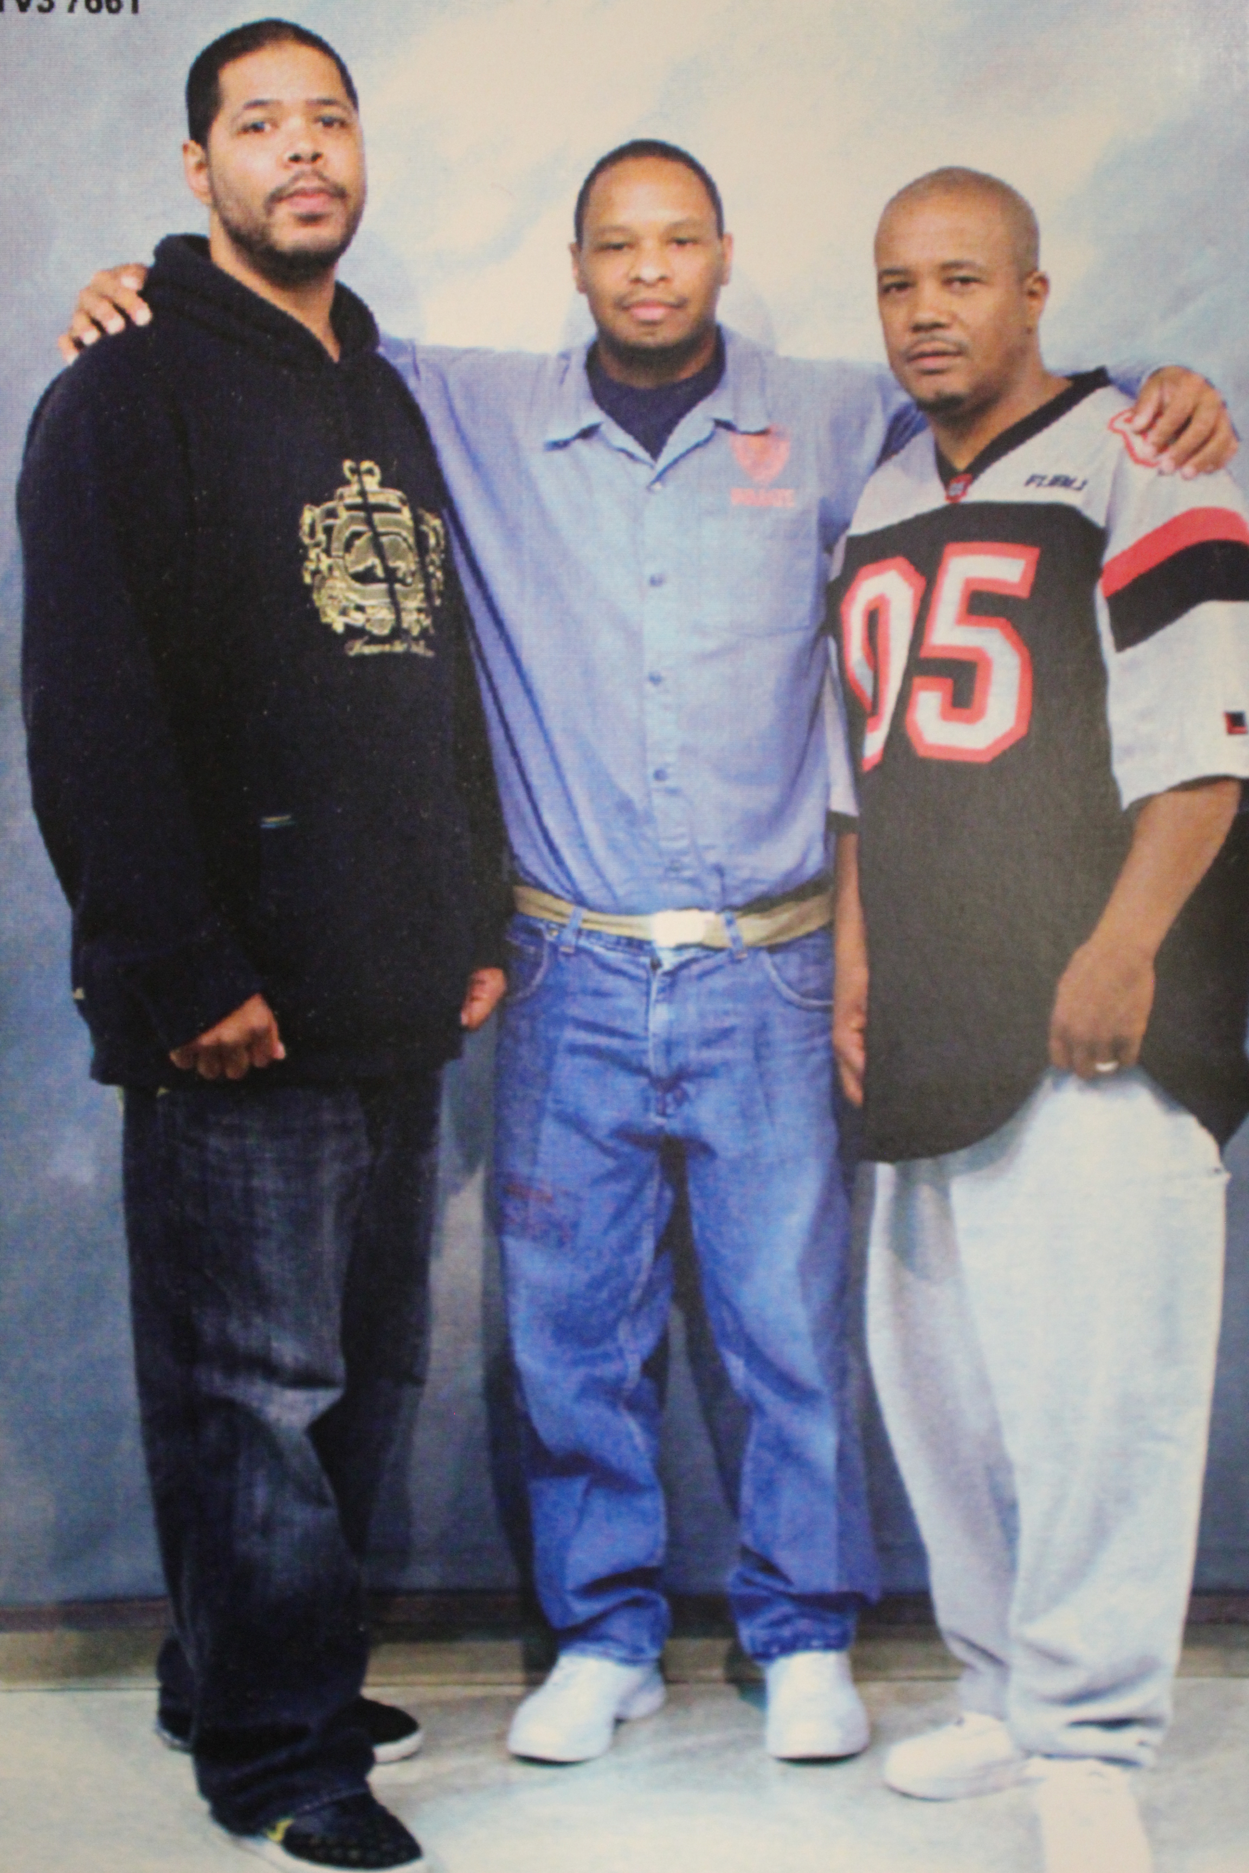
Me and Older Cousin Maurice Greene Vibing
Me, My Older Cousins Jerald, and Michael McClinton Showing Love

