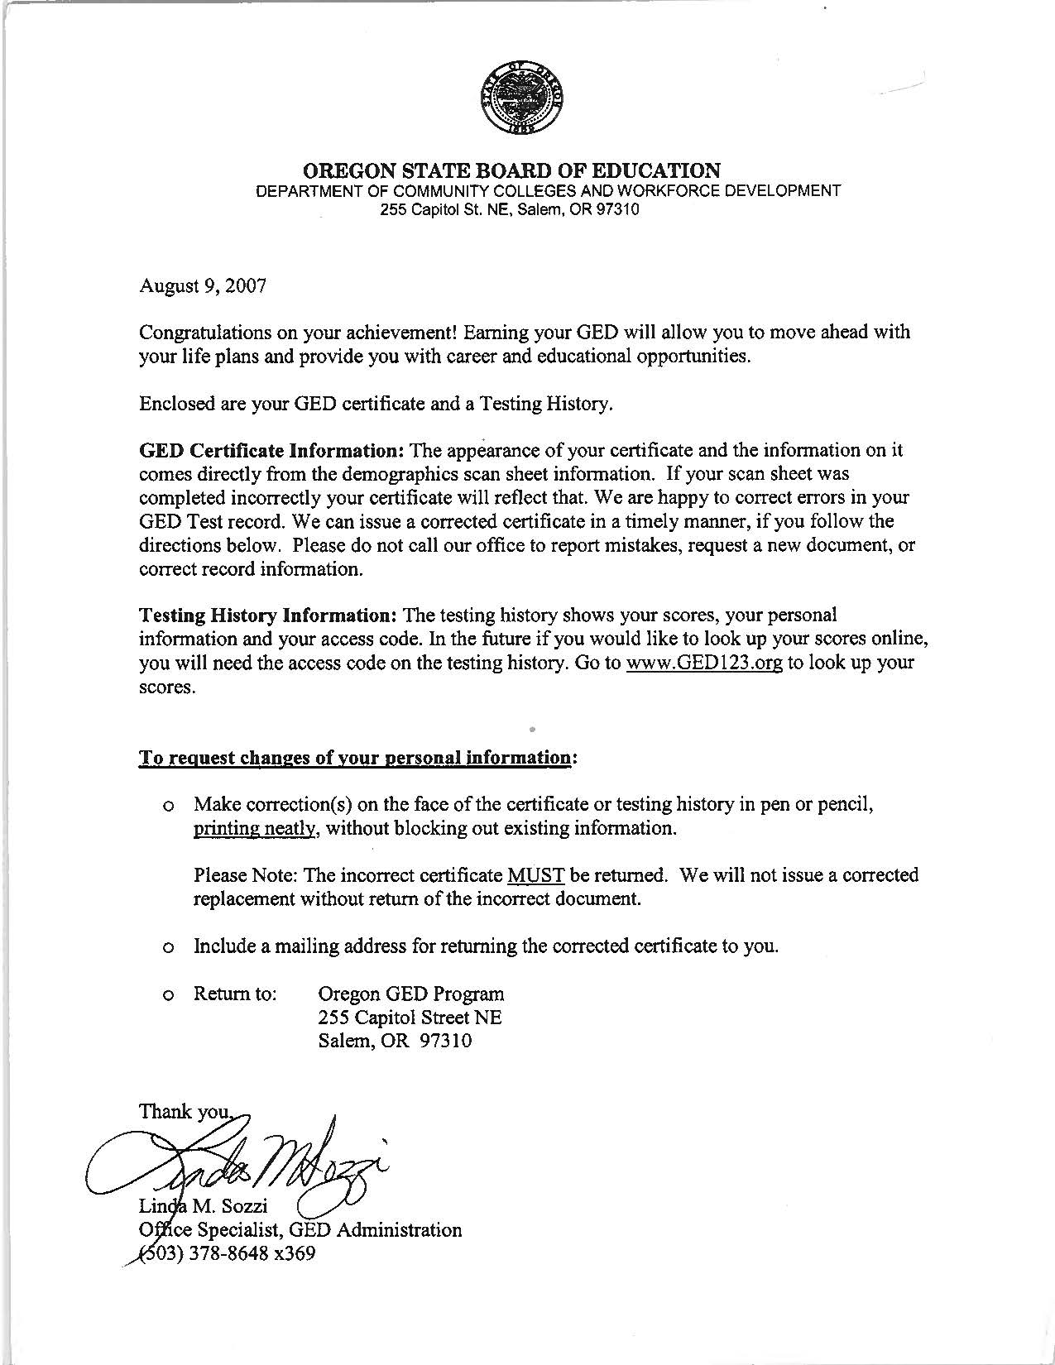

1. General Education Transcript

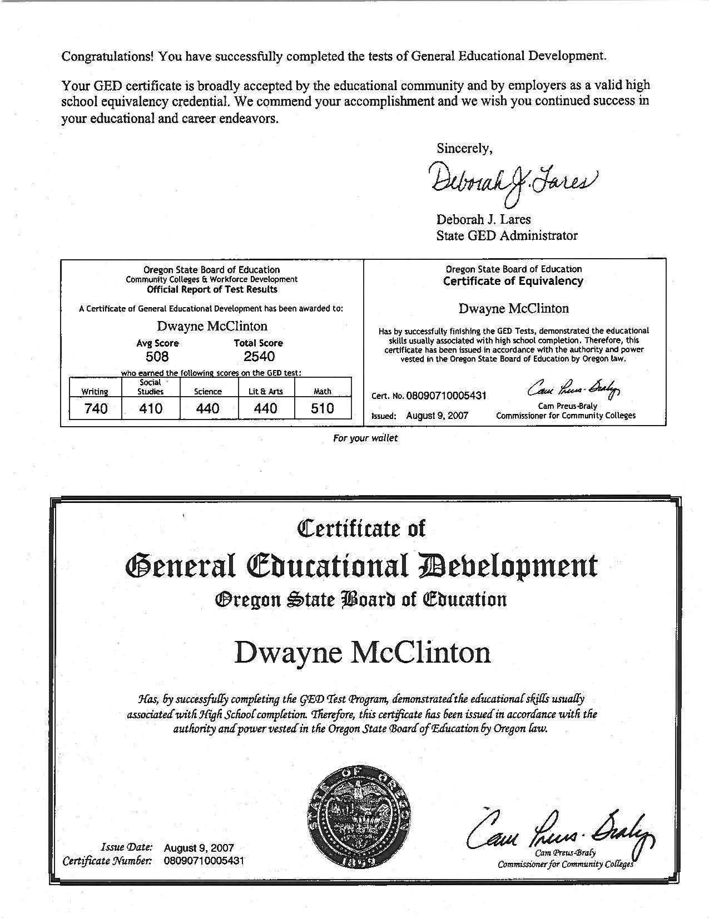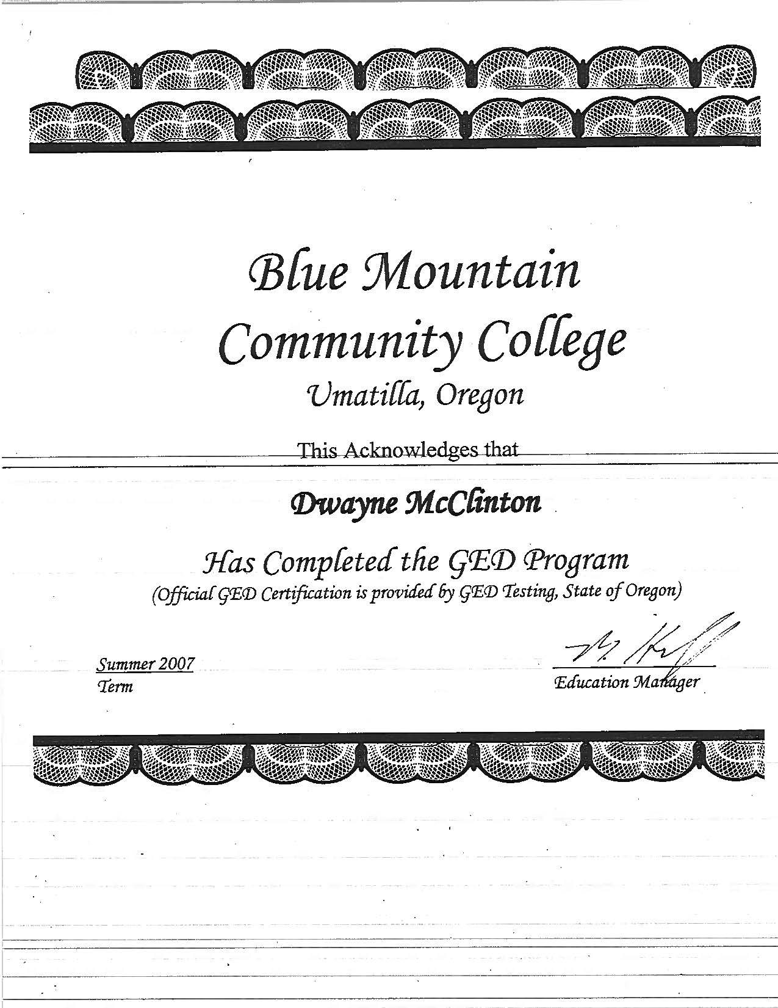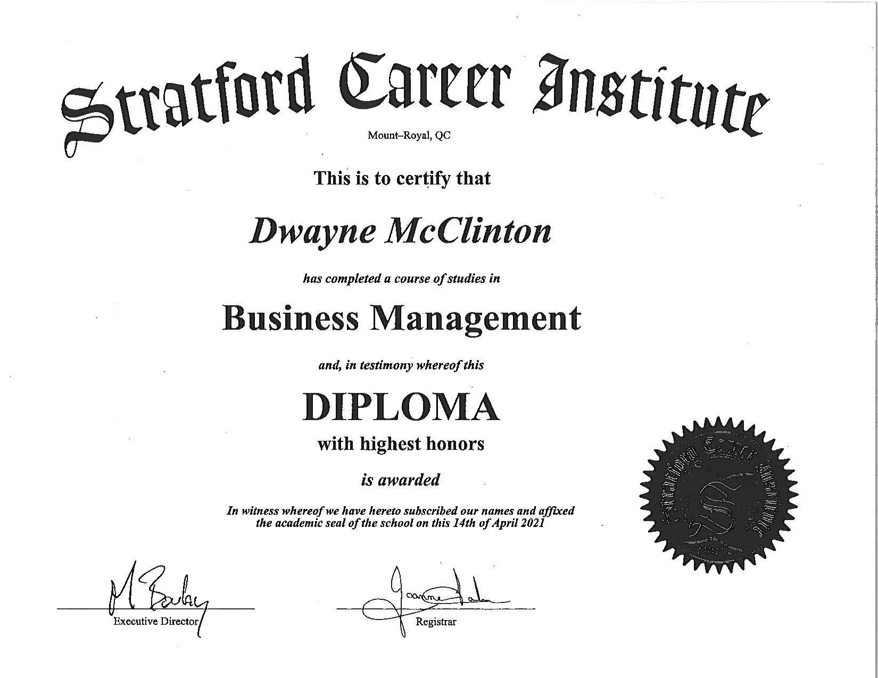

2. STRATFORD CAREER INSTITUTE - Congratulation on the completion of my Business Management course

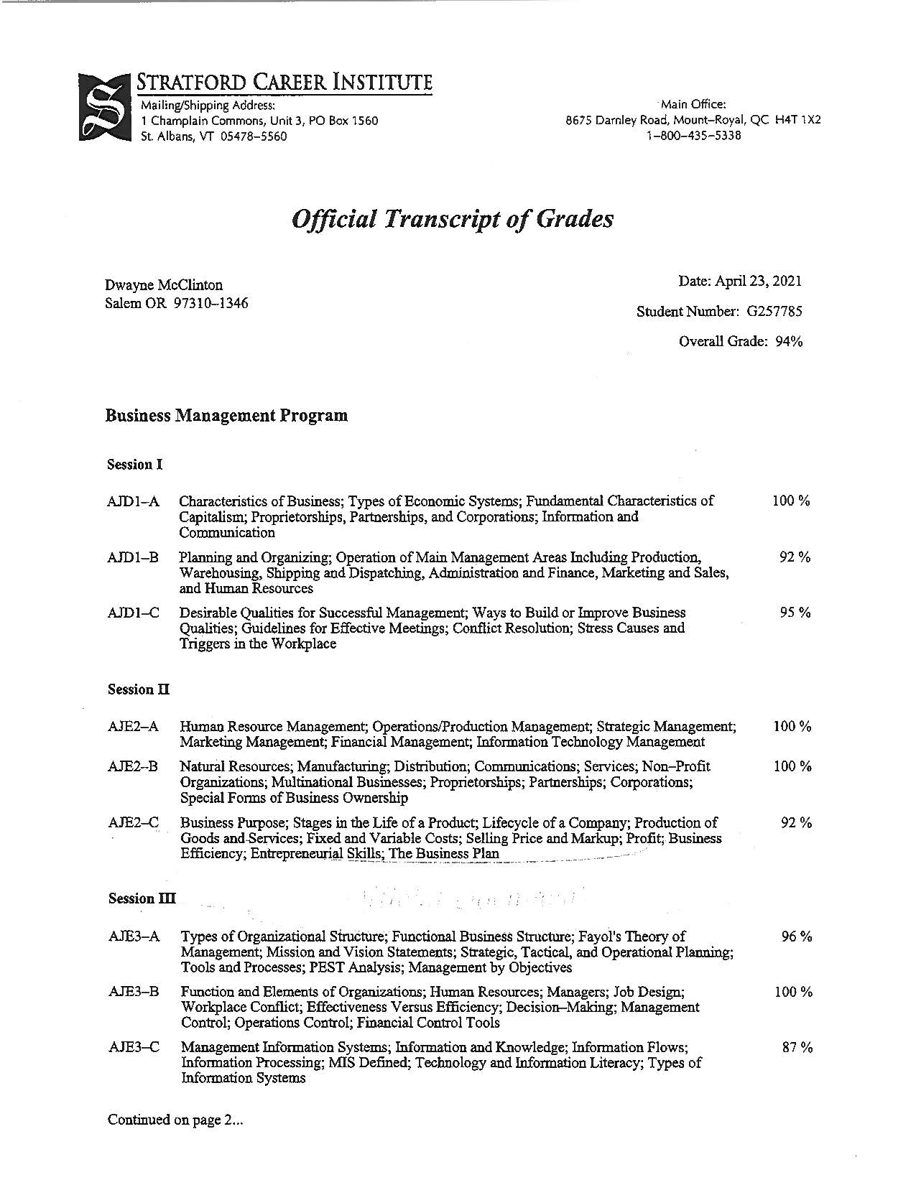
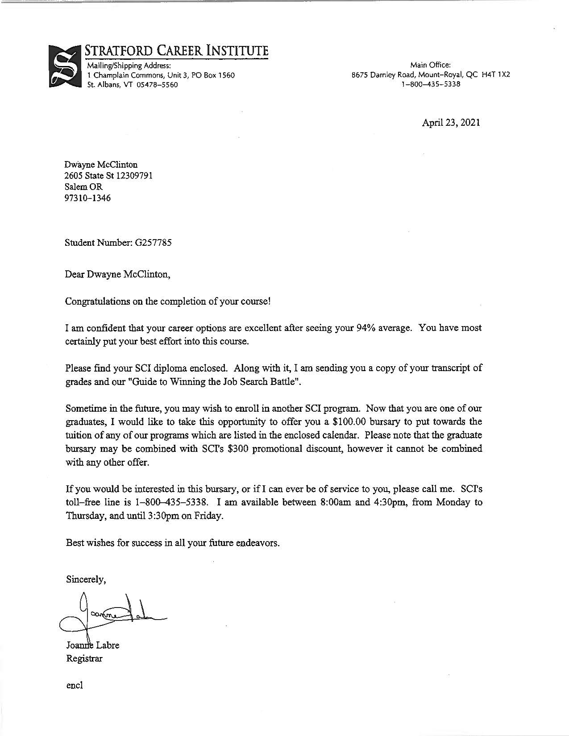
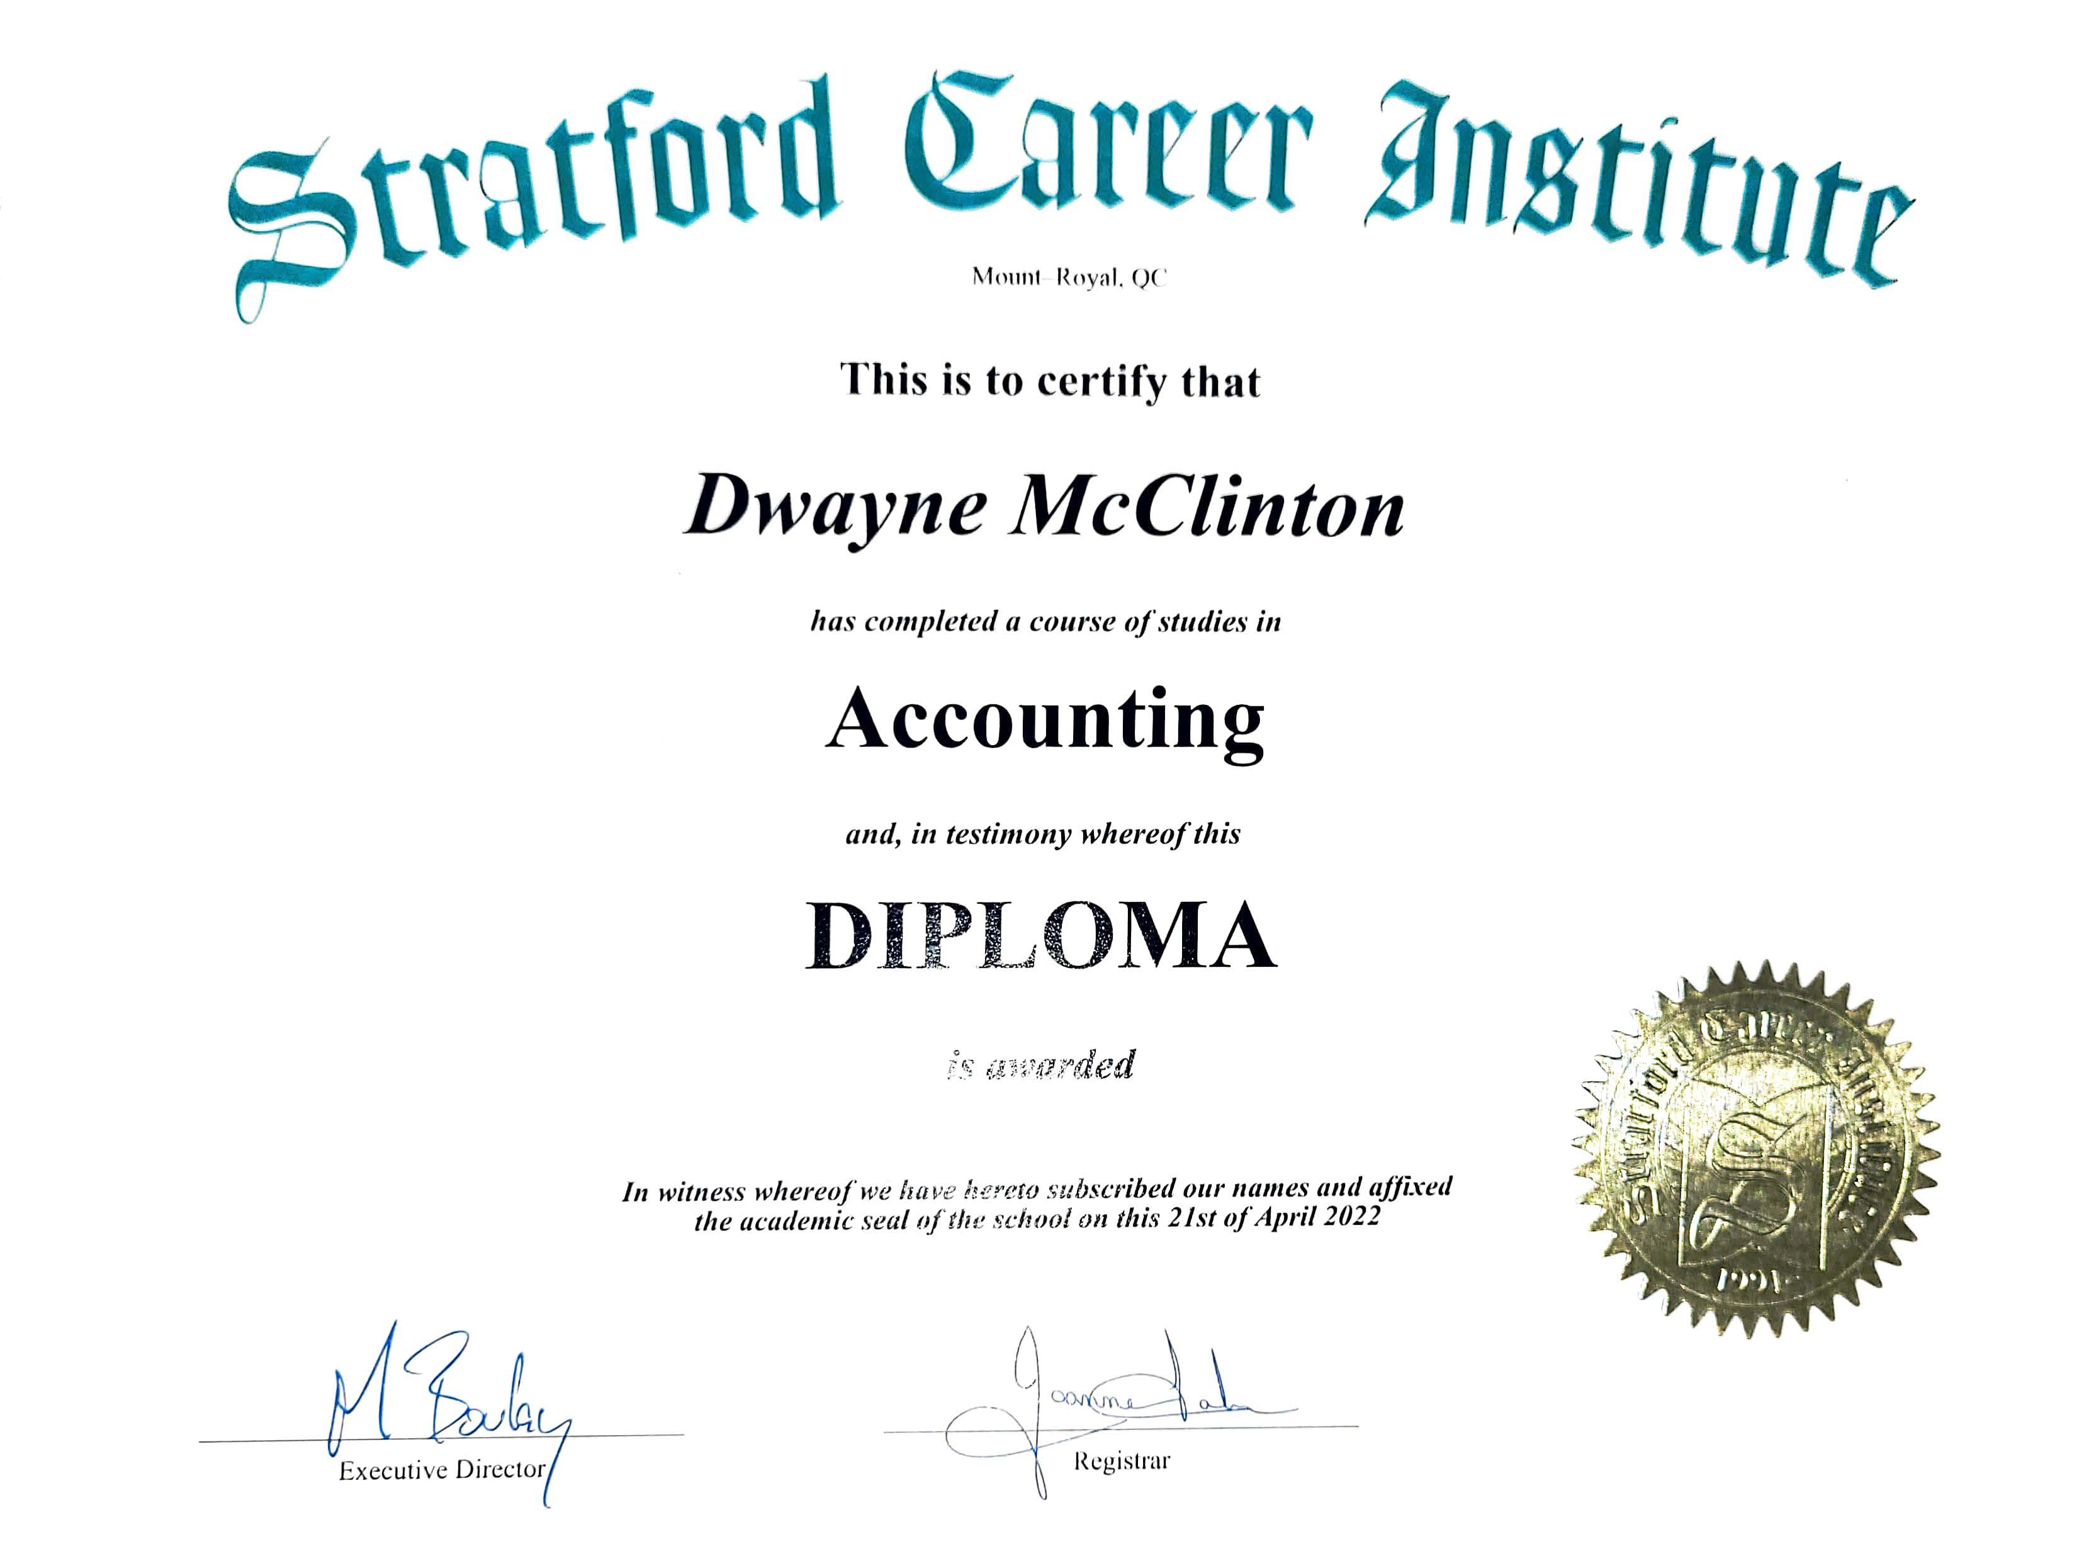
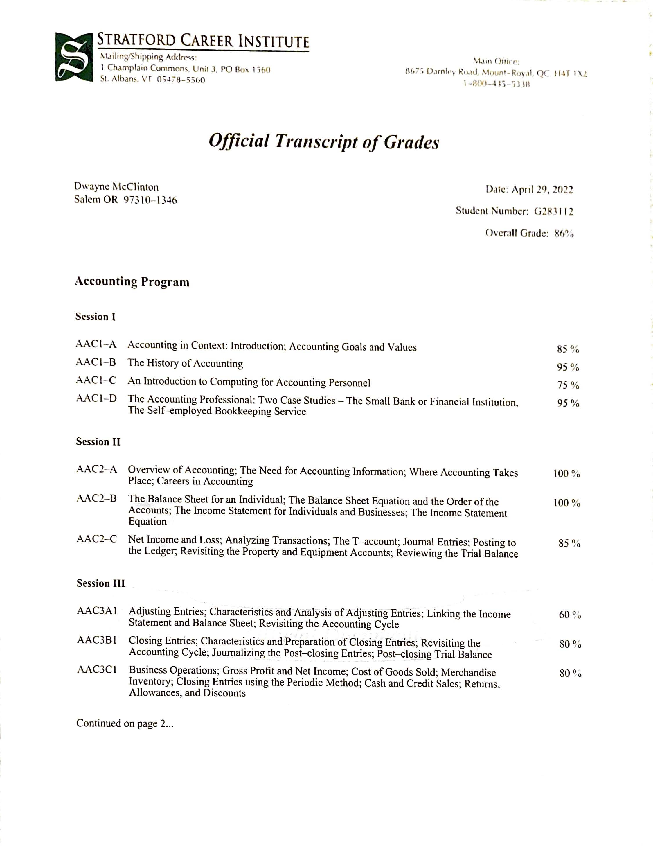
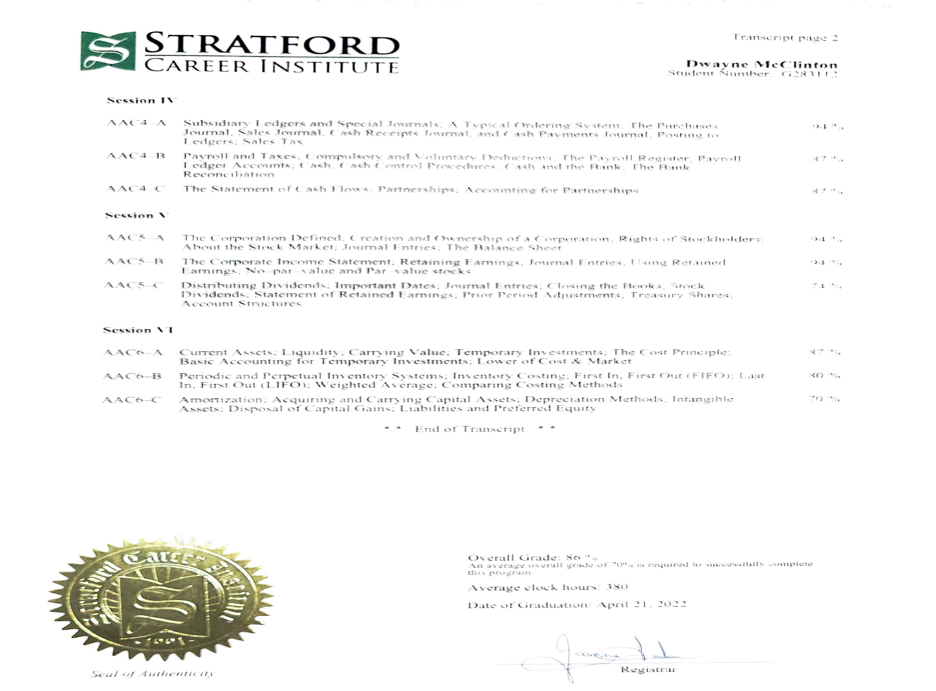
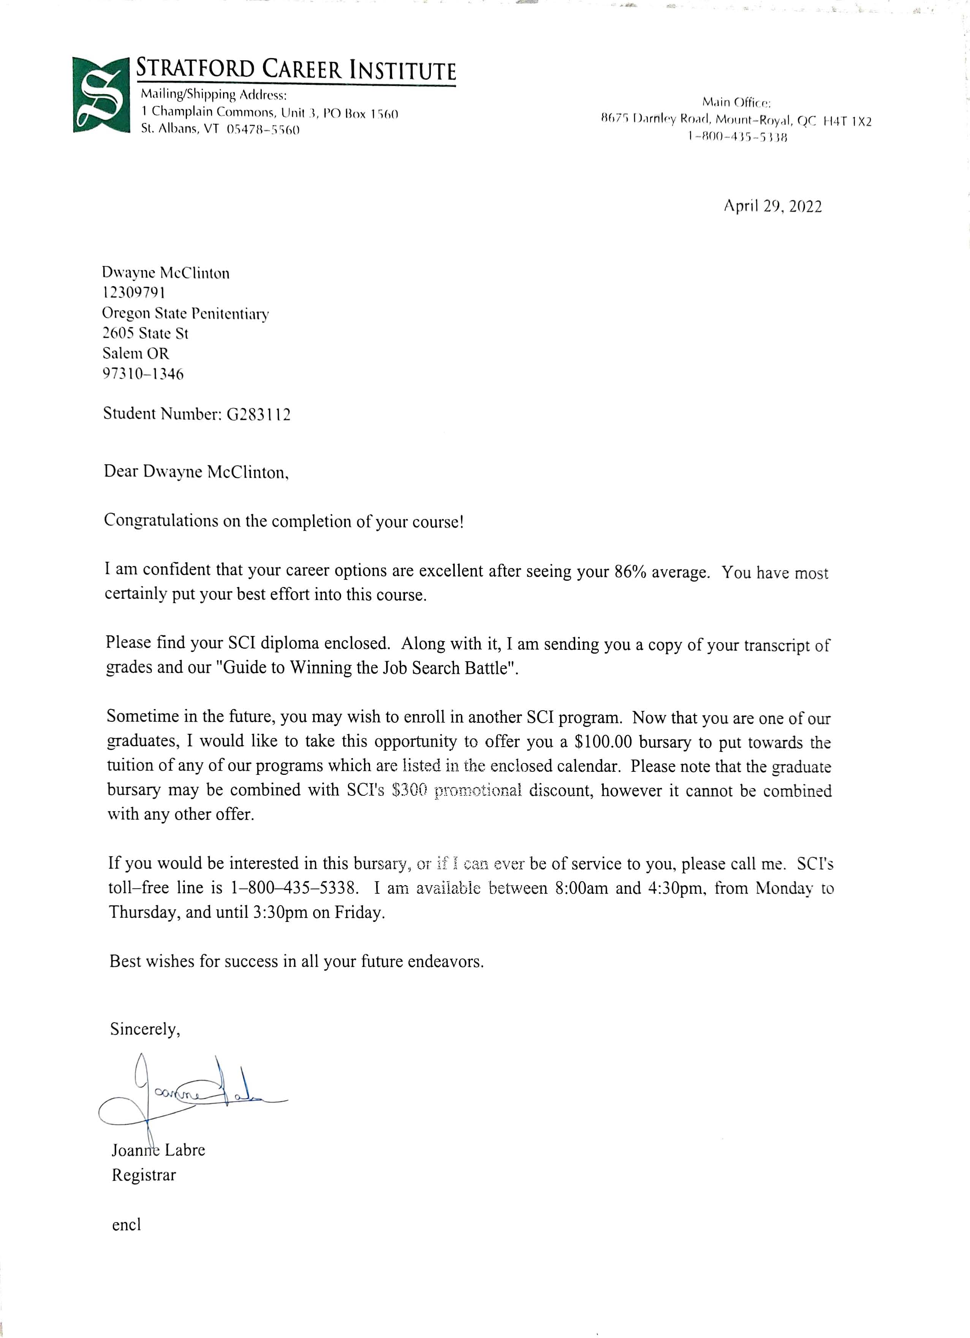
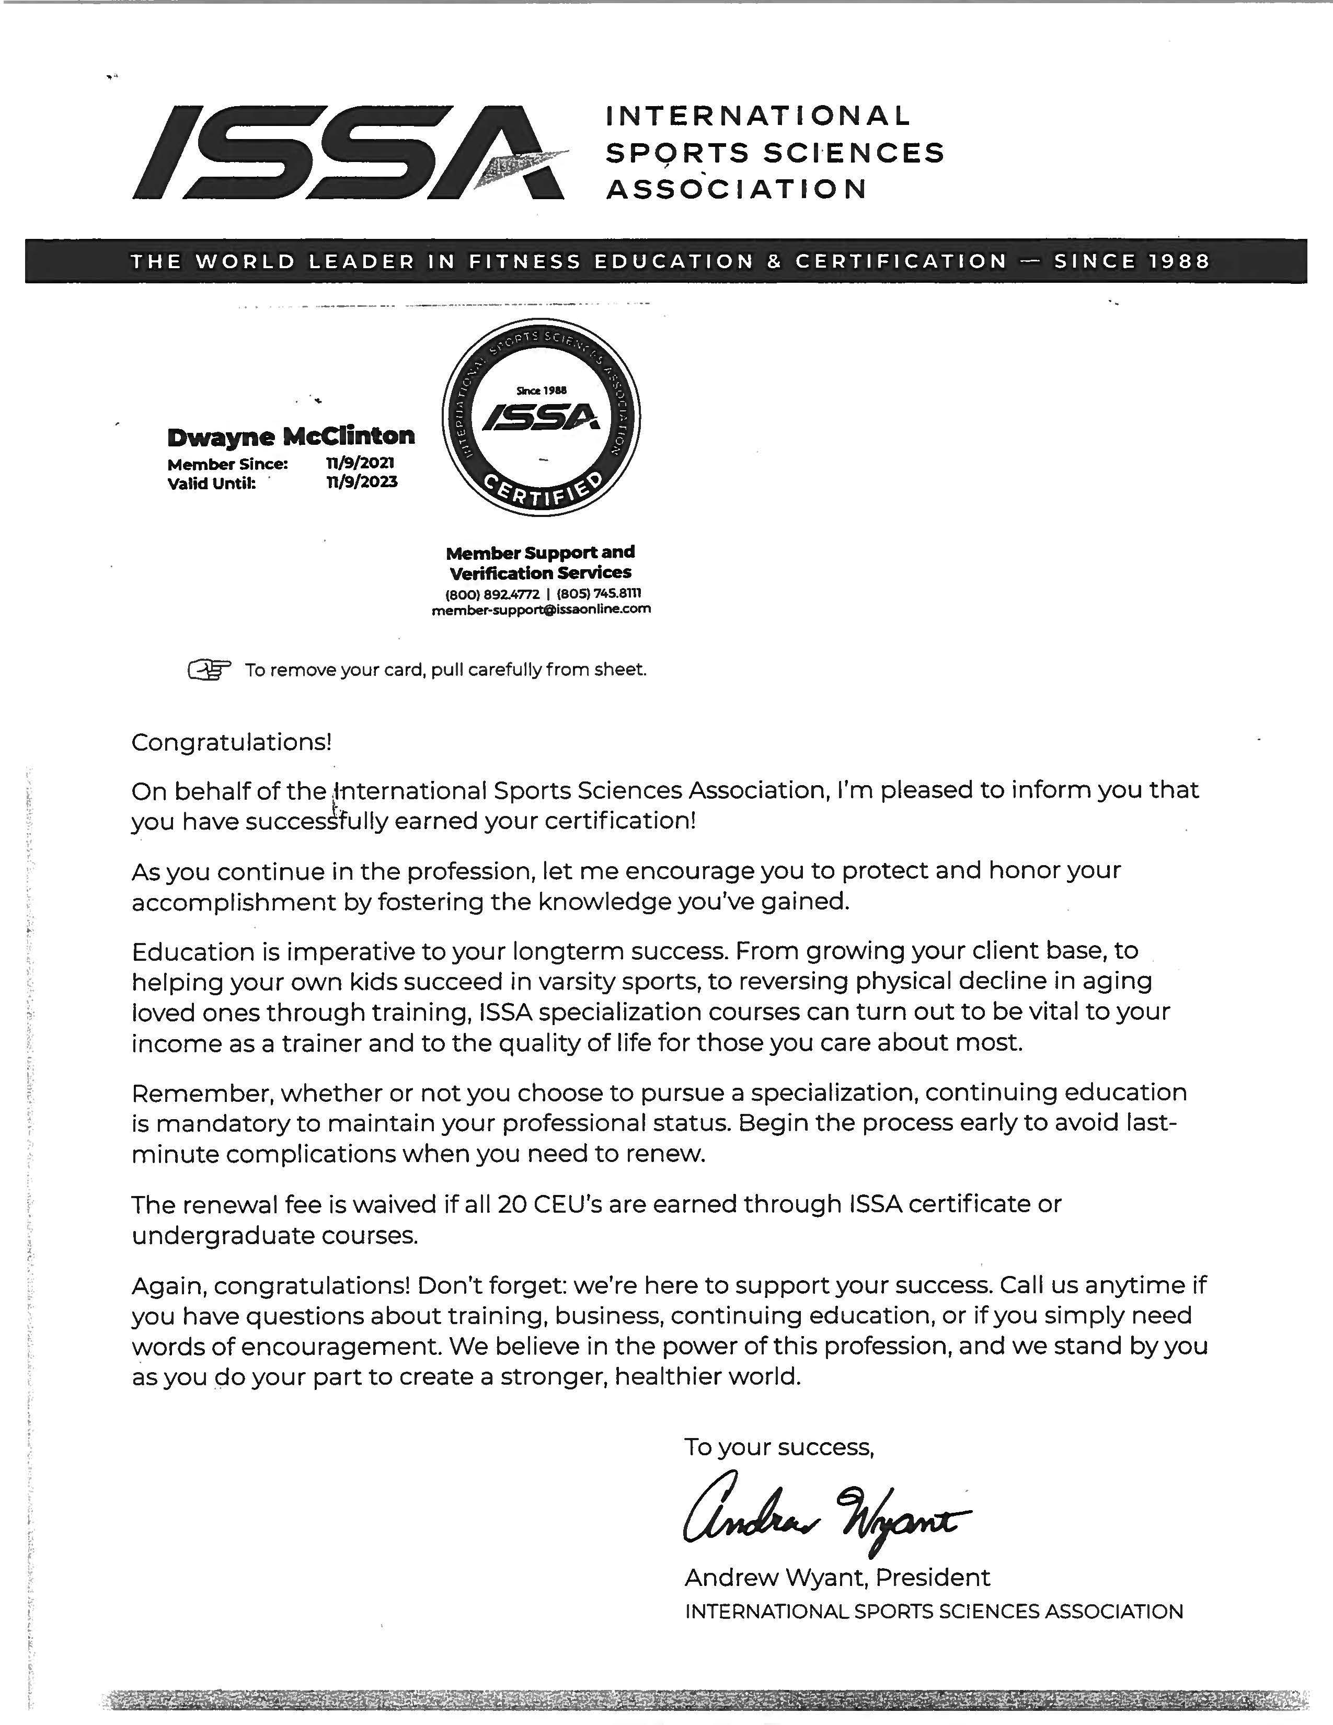

ISSA Certification


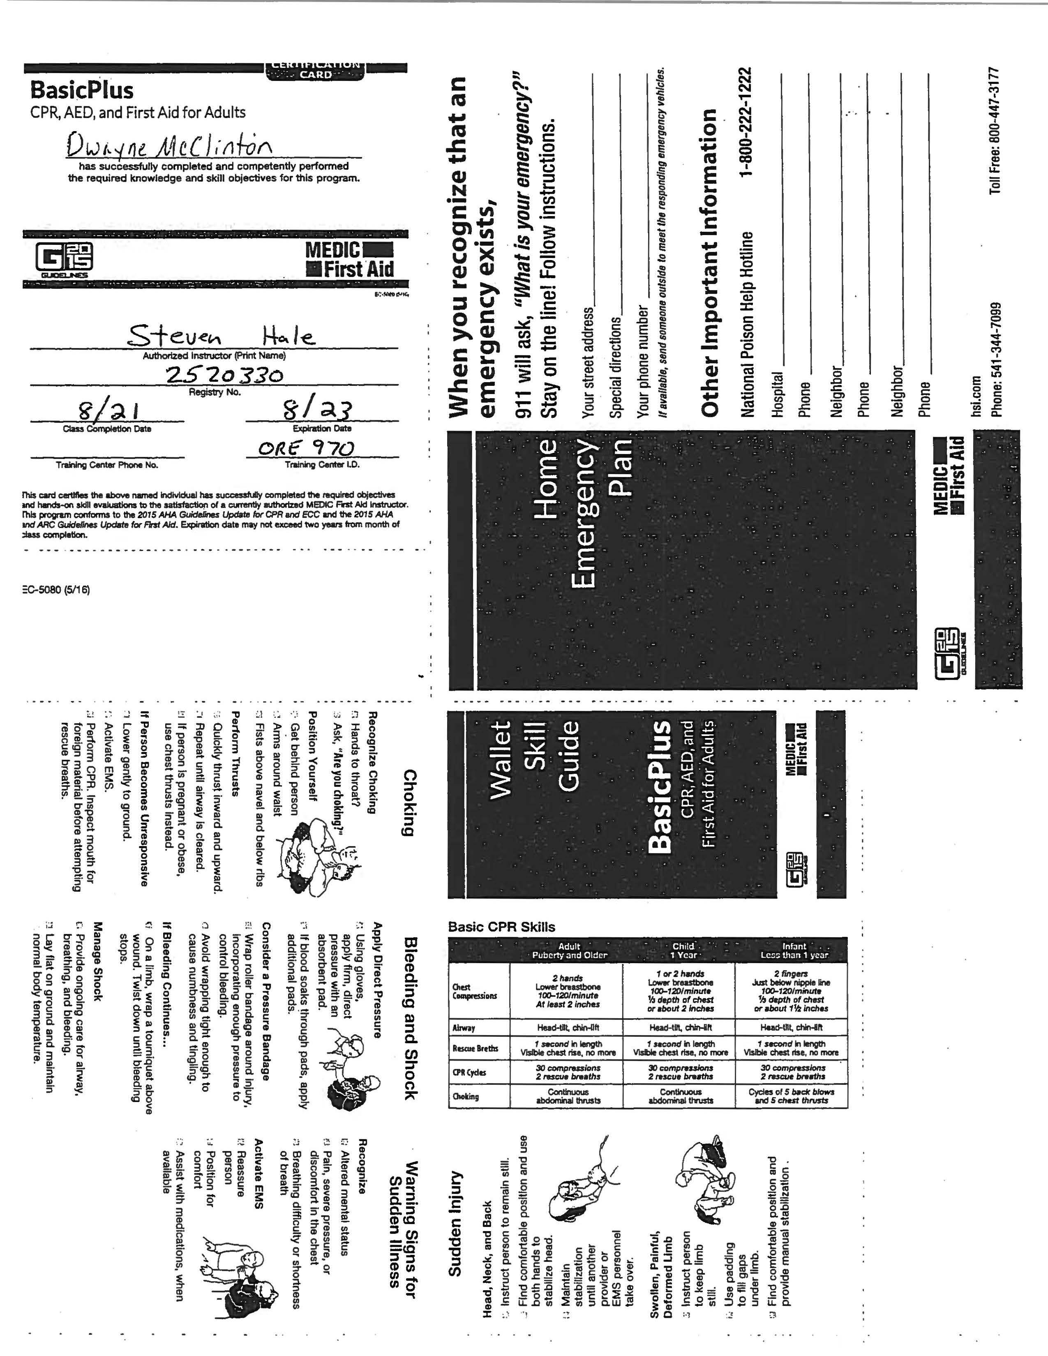
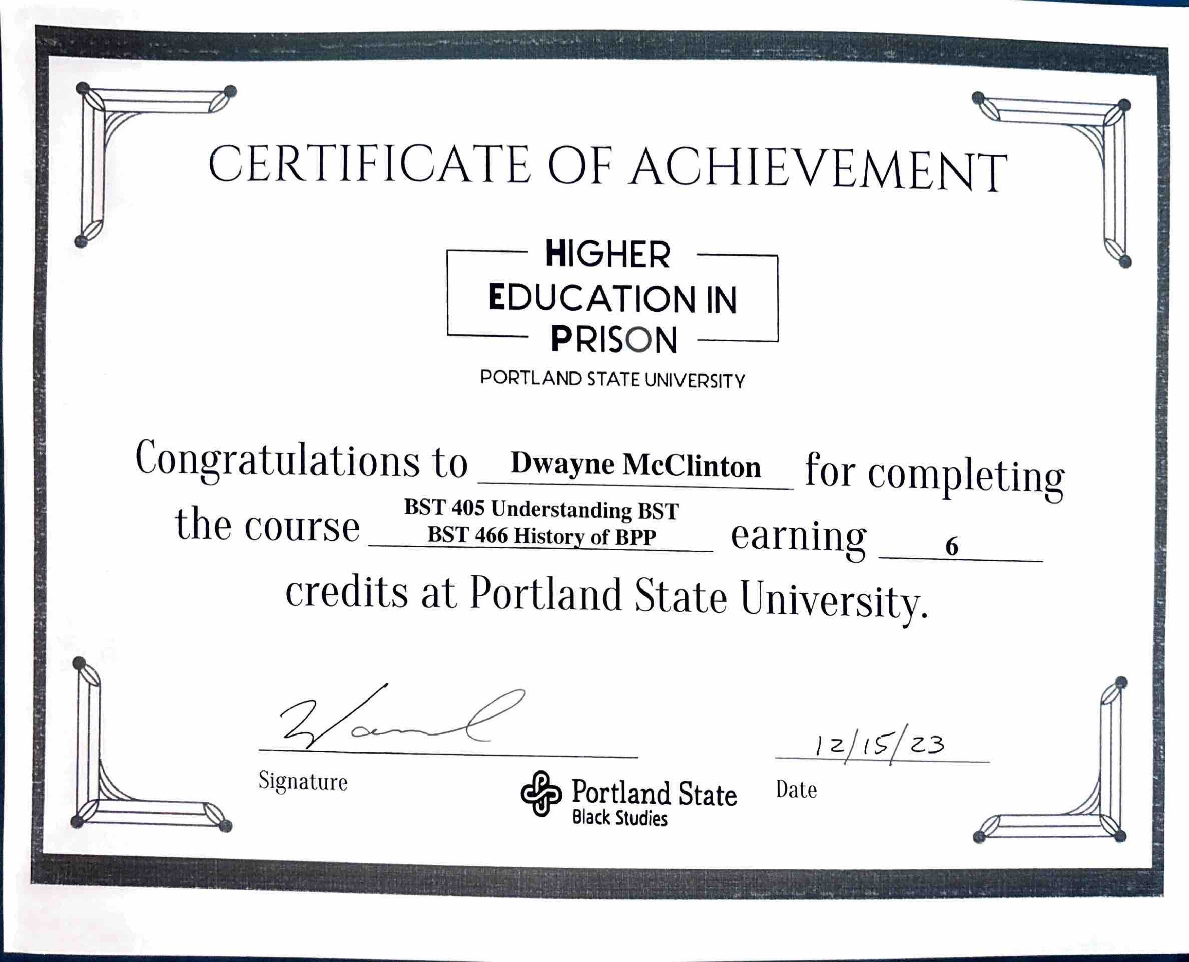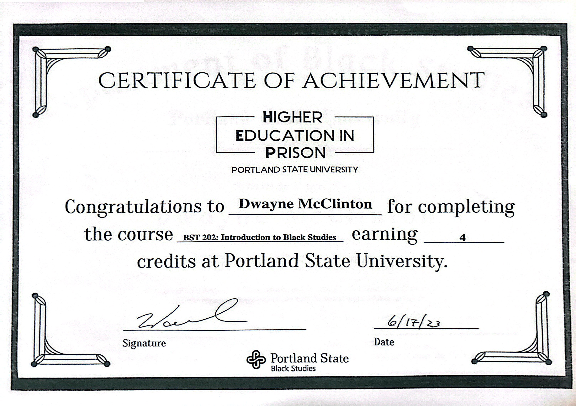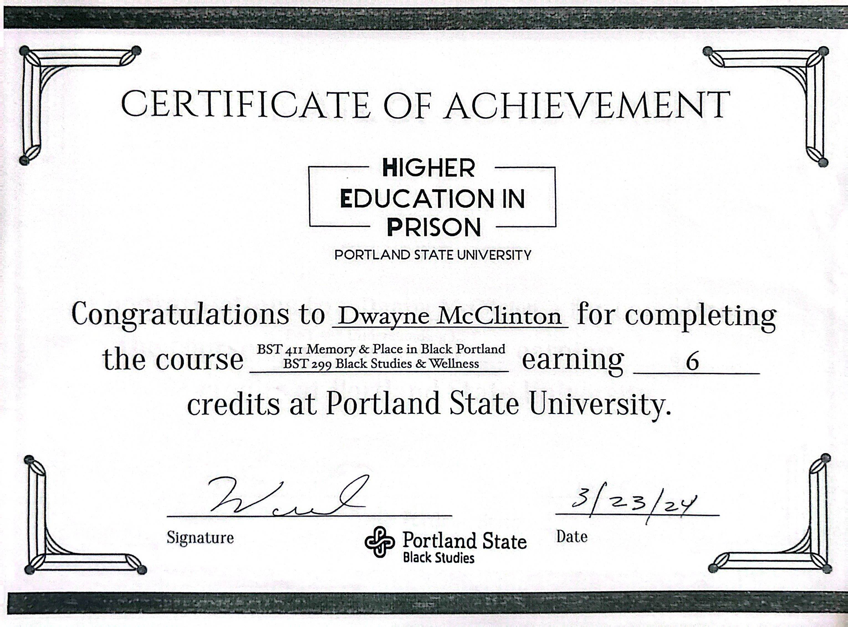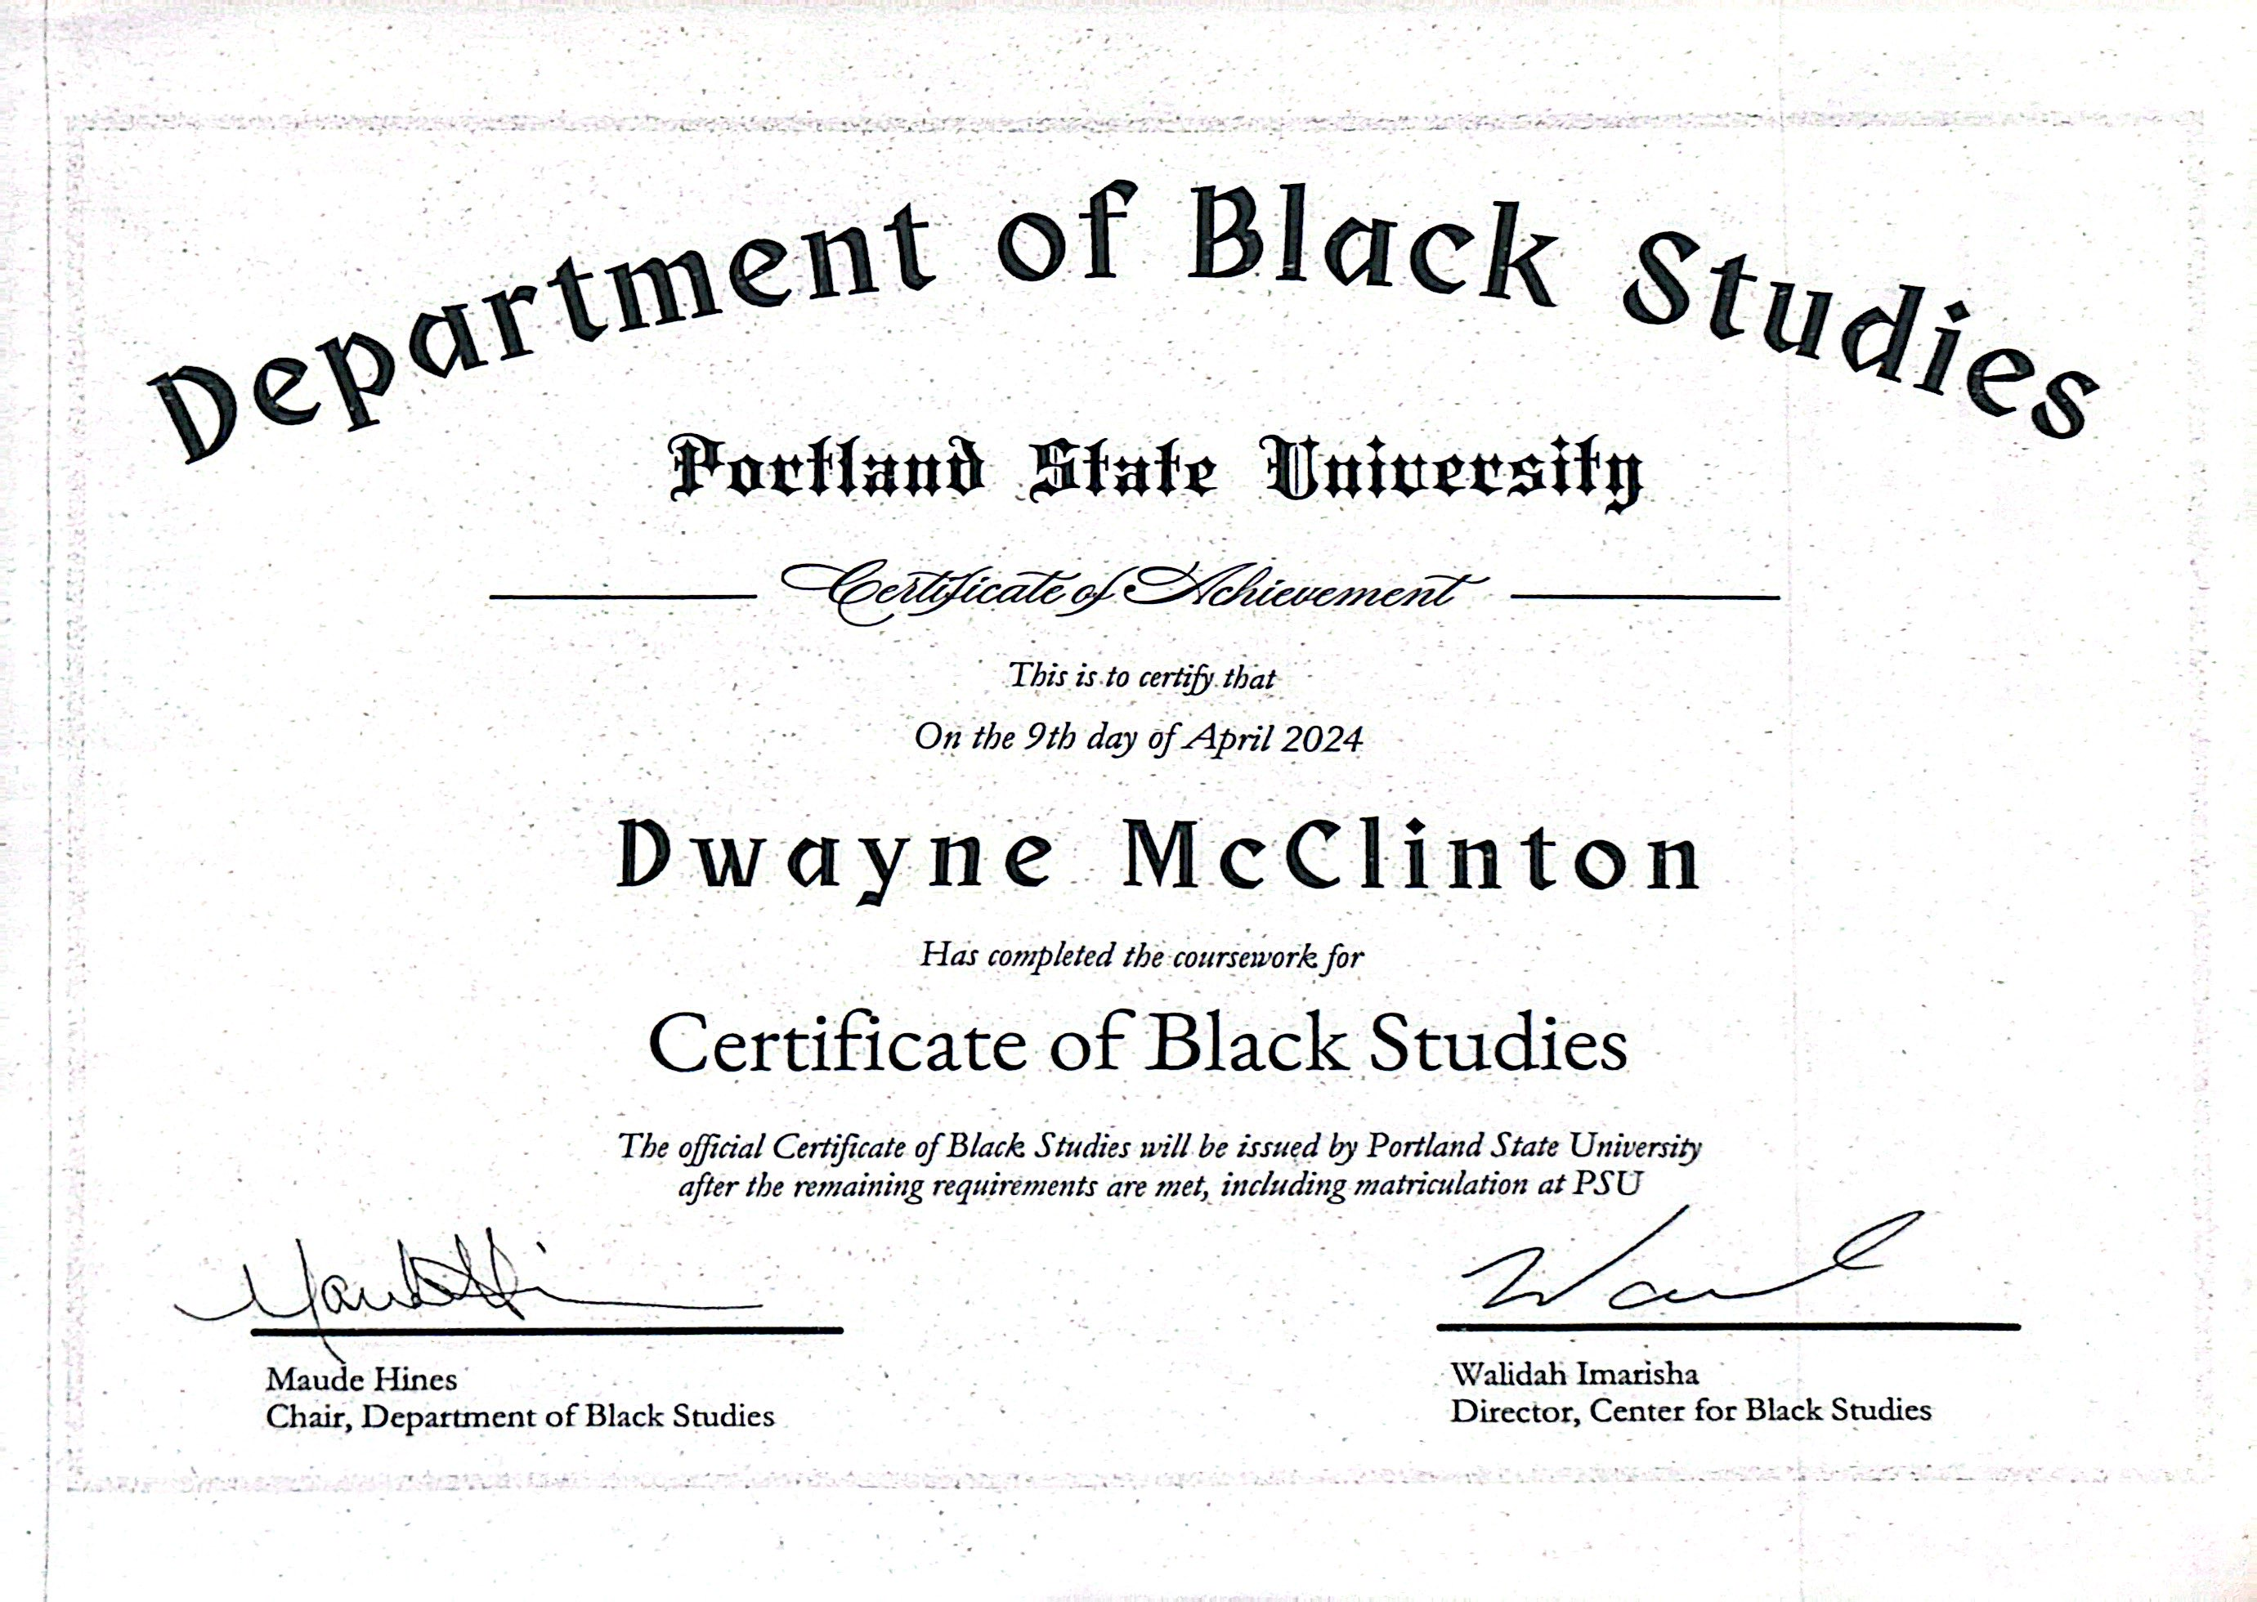

Education behind bars

pdx.edu/news/education-behind-bars
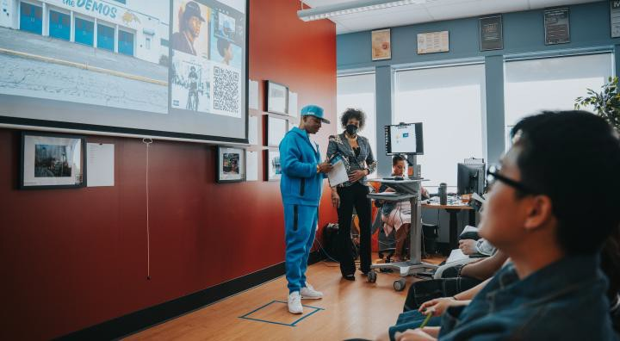

Kenny Hamilton, a formerly incarcerated student who is now majoring in Black Studies at PSU, and Prof. Walidah Imarisha during the "Memory & Place in Black Portland: A PhotoVoice Project" event, a showcase of the Oregon State Penitentiary cohort's work during class. (All photos by Jeremy Chun Sajqui)

For Theron Hall, the Portland State certificate means more to him than just a piece of paper. It means that he has worth. That he’s more than his gang past and the crime that landed him in prison as an 18-year-old more than 20 years ago. That he’s more than his disciplinary history.
He says he never saw himself as someone who could go to college. And yet here he is, with 16 college credits to his name. It’s something he’s proud to share with his nephew and niece.
“I set a standard for myself,” says Hall. “I rose to a level of new potential and I can’t make excuses anymore.”
Hall and 15 other incarcerated students at Oregon State Penitentiary make up the first cohort — on or off-campus — to complete coursework toward the revamped certificate in Black Studies as part of a partnership between PSU’s Black Studies department, the Higher
Education in Prison program, Uhuru Sasa, a Black cultural group inside the prison, and the Oregon Department of Corrections.
In 2023, Black Studies revised its certificate, reducing the number of credits from 36 to 16 to make it more accessible to more students, including incarcerated students. The hope is that an early sense of accomplishment will encourage certificate students to continue on to a major or minor in Black Studies.
“If we want to change the environment in here and in our community, this is what we need,” said Dwayne McClinton, president of Uhuru Sasa. “We need more education. This can help transform minds.”
The men were celebrated April 9 at a ceremony inside the Salem prison that featured spoken-word poetry and testimonials about the impact the classes have had on them. They received a certificate of course completion and a copy of “Freedom Dreams” by Robin D.G. Kelley.

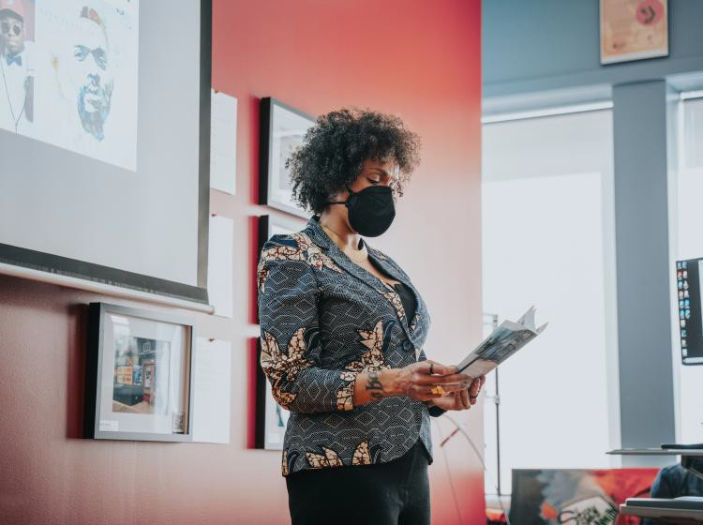

A DREAM COME TRUE

The effort has been years in the making with Walidah Imarisha, an associate professor of Black Studies, leading the way. Imarisha has volunteered with Uhuru Sasa for more than a decade and several years ago, the club leadership approached her to teach a Black culture workshop at the penitentiary. She worked closely with them to build a curriculum that met their needs and interests, and offered the first class during summer 2019.
Imarisha intended to offer it again the following year, but COVID had other plans as Oregon prisons were closed to visitors and volunteers for more than two years. By the time they reopened, Imarisha had rejoined Black Studies as a full-time faculty member and director of its Center for Black Studies.
Imarisha says it’s been her dream for Black Studies to be able to offer degree programs for incarcerated students. She didn’t think it would come together as quickly as it has but she credits the tireless dedication and energy of Deb Arthur and Nahlee Suvanvej from PSU’s Higher Education in Prison program and Sam Wilson, who until recently served as the coordinator of Project Rebound, PSU’s re-entry program. HEP has provided degree paths to students at Coffee Creek Correctional Facility since 2019. This was their first foray into the maximum-security Oregon State Penitentiary — and it won’t be the last.
Now that federal Pell grants have been reinstated for incarcerated students, HEP is facilitating the PSU admissions process for all the students so they can matriculate and officially be awarded the certificate — the first cohort in HEP to earn a credential.
“Let this achievement be the indicator of many accomplishments to come,” Suvanvej said.

TAPPING INTO THEIR POTENTIAL

For the last year, Imarisha has made the trek to Salem on Saturdays for the early 7:15 a.m. class start time. She taught four courses: Introduction to Black Studies; History of the Black Panther Movement; Memory and Place in Black Portland co-taught with Professors Lisa Bates and Ryan Petteway; and Afro-Futurism/Black Science Fiction.

Imarisha said the students are some of the most engaged she’s ever had the pleasure of teaching in her career — they read everything closely and often connect materials from one week to another and engage in discussions so deep that they run out of time.
“I’m proud beyond words about what you’ve all accomplished and getting to say I’m your professor and you’re my students,” she told them.
Bates, a professor of urban studies and planning and Black Studies, says the class energized her and made her a better educator.

“What you as students have created was a level of intellectual and creative inquiry more than I could have imagined,” she said.
Final projects have included a zine that showcased Black culture and a photovoice project exploring Portland’s history of Black placemaking. For many of the students, this was the first time they were learning about Black history and contextualizing it within their own experiences, identities and communities.
Stressla Johnson, the cohort’s oldest student at 67, says it was refreshing to learn the truth and not a watered-down version. He proudly showed off his poster that connected slave ship roots to the Black Panther Party and the future of the struggle, what he calls the “unfinished revolution.” He’s become a mentor to the younger students and began hosting weekly study and discussion sessions.
“It’s never too late to educate yourself,” he said, adding that he reads all the time now. “Spend your time doing something of worth, of value. We want to build assets to go back out into the community.

